**Appendix materials S**

**Nonlinear characteristics of vegetation ecosystem and its response to climate and ecological restoration in China**

Tiantian Chen1,2, Qiang Wang3, Yuxi Wang1, Li Peng4,*

*1 Chongqing Key Laboratory of Surface Process and Environment Remote Sensing in the Three Gorges Reservoir Area, Chongqing Normal University, Chongqing 401331, China, 2 Chongqing Field Observation and Research Station of Surface Ecological Process in the Three Gorges Reservoir Area, Chongqing 401331, China, 3 Chongqing Institute of Surveying and Monitoring for Planning and Natural Resources, Chongqing 401121, China, 4 College of Geography and Resources, Sichuan Normal University, Chengdu 610101, China*

**\*** Corresponding author (Li Peng): pengli@imde.ac.cn

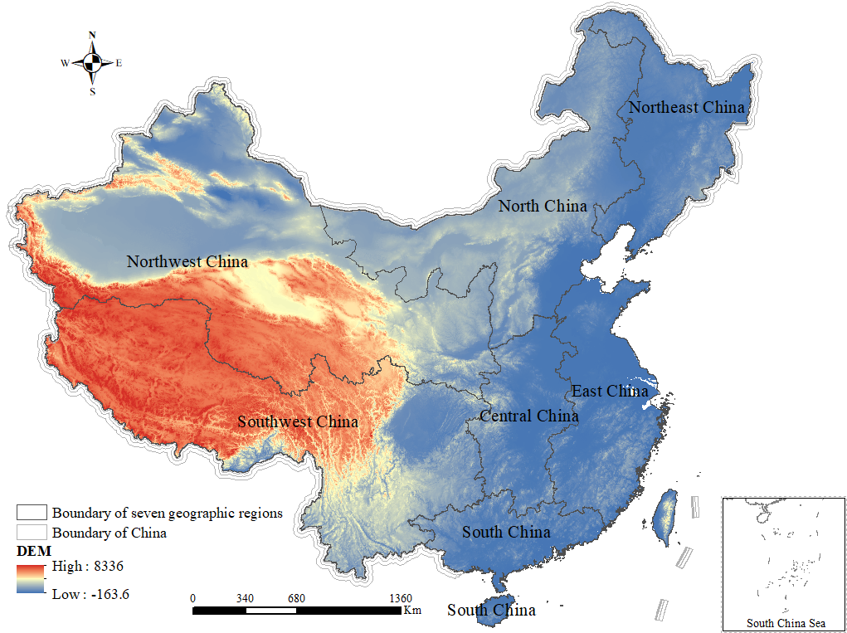

**FIGURE S1** Location map of study area

|  |  |
| --- | --- |
|  |  |
| China | Central China |
|  |  |
| East China | North China |
|  |  |
| Northeast China | Northwest China |
|  |  |
| South China | Southwest China |

**FIGURE S2** Breakpoint detection using the BFAST algorithm

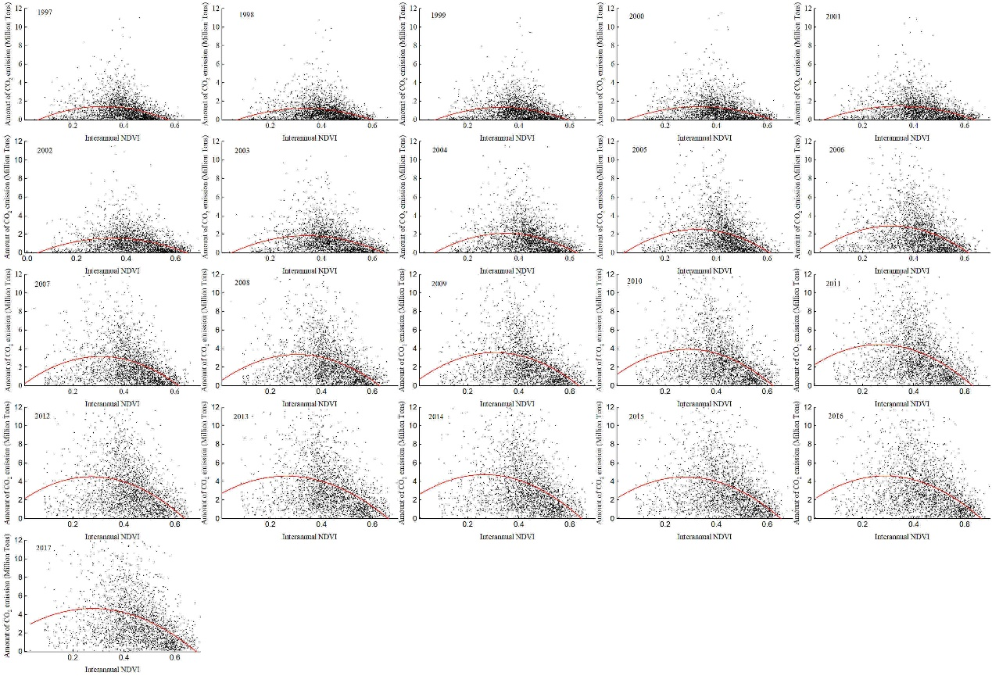

**FIGURE S3** Relationship between the amount of CO2 emission and NDVI

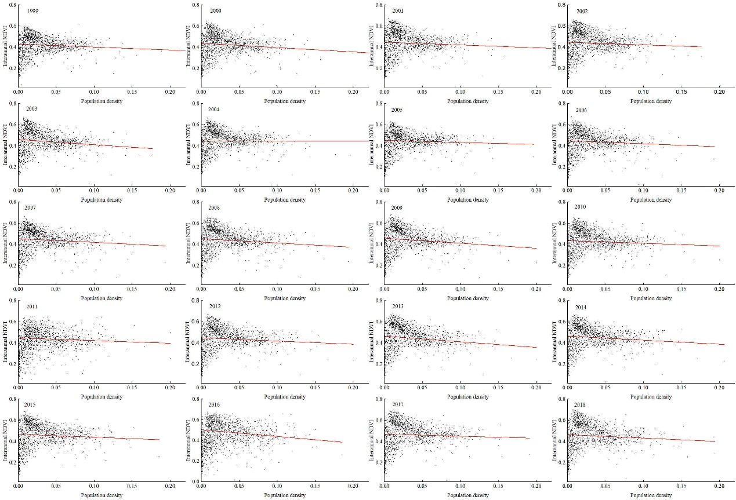

**FIGURE S4** Relationship between population density and NDVI

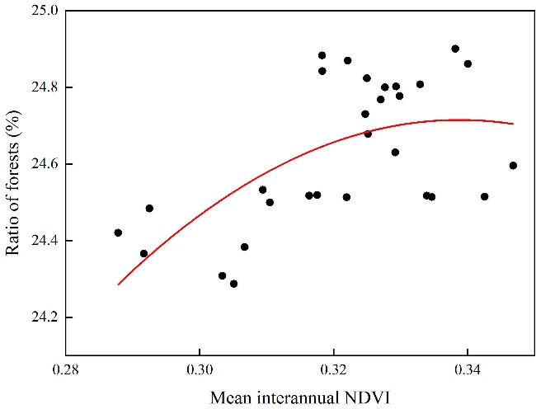

**FIGURE S5** Relationship between the ratio of forests and NDVI