

**Supplementary Figure 1.** Alignment of *E1* mutations nucleotide sequence with wild type. The premature translation stop codons for mutations were marked by black boxes.



**Supplementary Figure 2.** Alignment of *E1* mutations amino acid sequence with wild type. Nuclear location signal marked by red squares. The B3-like domain was marked by dashed red squares. NLS, nuclear localization signal.

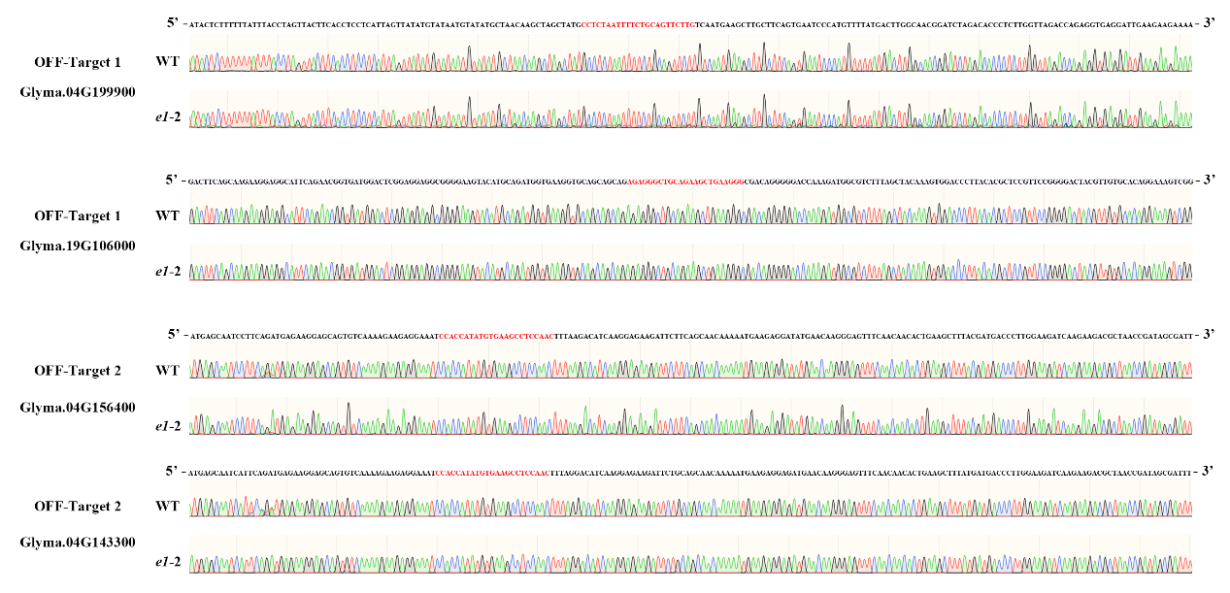

**Supplementary Figure 3.** Analysis of potential off-target sequences in T1 transgenic plants. The dotted line indicates that the potential off-target site exists in the antisense strand.



**Supplementary Figure 4.** Flowering time in *e1* mutant of T1 generation. (A) Compare with *e1* mutation and TianLong1 under LD conditions. (B) Flowering time. The error bars in (B) indicates standard deviation. ***P<0.001, as determined by one-tailed Student’s t-test.

**Supplementary Table 1** Primer sequences used in this study

|  |  |  |
| --- | --- | --- |
| **Primer** | **Primer sequence (5’→3’)** | **Purpose** |
| *E1-F* | AACACTCAAATTAAGCCCTTTCAACCT | To amplify the target site(*E1*) |
| *E1-R* | ACCAGGAAGTACTAGTGCAATGAGTC |
| *TUA5-F* | CCTTCTGTTGTTCCTGGTGGT | To amplify the reference gene (*GmTubulinA*) |
| *TUA5-R* | CAAACTTGTGGTCAATGCGAG |
| *Dt1-F* | GCTGGTTTTGCCACTGCAA | qRT-PCR experiment (*GmDT1*) |
| *Dt1-R* | AAGTTATTTGAAGCCACATGTGAA |
| *Dt2-F* | AGACAATGCAAGGAGGAACACCA | qRT-PCR experiment (*GmDT2*) |
| *Dt2-R* | CCTAACTAGTCAGACATGCAGCGC |
| *GmFT2a-F* | ATCCCGATGCACCTAGCCCA | qRT-PCR experiment (*GmFT2a*) |
| *GmFT2a-R* | ACACCAAACGATGAATCCCCA |
| *GmFT5a-F* | AGCCCGAACCCTTCAGTAGGGA | qRT-PCR experiment (*GmFT5a*) |
| *GmFT5a-R* | GGTGATGACAGTGTCTCTGCCCA |
| *E1La-F* | AAACACTCAAAGCCCGATCA | qRT-PCR experiment(*E1*-*La*) |
| *E1La-R* | ATCCTCTTCATTTTTGTTGCTGA |
| *E1Lb-F* | GTGTAAACACTCAAAGTCCTT | qRT-PCR experiment(*E1*-*Lb*) |
| *E1Lb-R* | CTCCTCTTCATTTTTGTTGCTGC |
| *e1-sg1-1-F* | TGCAAACACTCAAAGCCCGAT | To amplify the potential off target site 1-1 |
| *e1-sg1-1-R* | ATAGGCATAATATATTGGCCATTGC |
| *e1-sg1-2-F* | GTGTAAACACTCAAAGTCCTT | To amplify the potential off target site 1-2 |
| *e1-sg1-2-R* | GATTTGAAAGTAAAATAAAGCTAACACTT |
| *e1-sg2-1-F* | AGGCCCTTATGTTGGACGAA | To amplify the potential off target site 2-1 |
| *e1-sg2-1-R* | TCAAATGAGGCAGGGTTTGAA |
| *e1-sg2-2-F* | CTCACCTCCTCCCCAAGAAC | To amplify the potential off target site 2-2 |
| *e1-sg2-2-R* | CTGGTGGACAGGTAGCTTCG |
| *Bar-F* | TGCCAGTTCCCGTGCTTGAA | To amplify a part of T-DNA elements (*Bar*) |
| *Bar-R* | CTGCACCATCGTCAACCACTA |

**Supplementary Table 2** Analysis of potential off-target sites in T1 generation

|  |  |  |  |  |  |  |
| --- | --- | --- | --- | --- | --- | --- |
| **Target** | **Physcial position** | **Position** | **Target sequence** | **No. of mismatch** | **No. of plants sequenced** | **No. of off-target plants** |
| Target1:CAAGAGCTGCAGAAACTGAAGGG | Glyma.04G199900 4: -44066653 | Intron | CAAGAaCTGCAGAAAaTtAgAGG | 4 | 22 | 0 |
| Glyma.19G106000 19: +35482272 | Exon | agAgGGCTGCAGAAgCTGAAGGG | 4 | 22 | 0 |
| Target2:GTTAGAGGCTTCGCATATGGTGG | Glyma.04G156400 4: -28294190 | Exon | GTTgGAGGCTTCaCATATGGTGG | 2 | 22 | 0 |
| Glyma.04G143300 18: -25740216 | Exon | GTTgGAGGCTTCaCATATGGTGG | 2 | 22 | 0 |

The red letters represent mismatched bases. +, sense strand. -, antisense strand.

**Supplementary Table 3** Transgene-clean homozygous mutants from T1 generation

|  |  |  |
| --- | --- | --- |
| T1 Generation | No. of plants identified | No. of trans-clean plants |
| *e1*-1 | 6 | 2 |
| *e1*-2 | 5 | 4 |
| *e1*-3 | 1 | 0 |
| *e1*-4 | 9 | 0 |