D:\MS\Manuscripts\1994 Mindoro Tsunami - Marine Geology\Frontiers\Frontiers_Word_Templates\Comments\Revised\Revised 2\Revised 3\Response\Supplementary_Figure_1_Frontiers_1994_Mindoro_tsunami_Ramirez et al.tiff

**Supplementary Figure 1.** Shoreline change in Baco, Oriental Mindoro as observed from multiple infrared satellite imagery. Darker colors represent wet surfaces (e.g. water bodies, swamps) while lighter colors represent dry land or clouds. The trace of the shoreline (white) from the preceding satellite imagery are also indicated for panels B-F, as well as the location of the geoslicer sample MAL-G3 which intercepted the 1994 Mindoro tsunami onshore deposit (see Figure 2). **A-B**: At least 50 m of shoreline retreat was observed in San Andres (near MAL-G3) between 1992 and 1998, which is likely contributed by the 1994 Mindoro tsunami. **B-D**: Shoreline retreat at the same location was slower between 1998 and 2006, with a net retreat of ⁓20 m. **D-F:** On the other hand, shoreline retreat of at least 120 m were observed for the same location between 2006 and 2019. Two (2) turbidity current-producing typhoons, Reming (Durian) in 2006 and Nina (Nock-Ten) in 2016, also occurred within the same period, as documented by Sequeiros and others (2019). The January 1992, September 1998, and September 2006 images utilized the near-infrared band (Band 5; 1.55 - 1.75 µm) of the Landsat Thematic Mapper 5 at 30-m resolution; the April 2002 image utilized the pan-chromatic band (Band 8; 0.52 - 0.90 µm) of the Landsat Enhanced Thematic Mapper + at 15-m resolution; the February 2016 image utilized the near-infrared band (Band 5; 0.85 - 0.88 µm) of the Landsat 8 Operational Land Imager at 30-m resolution); and the April 2019 image utilized the near-infrared band (Band 8; 0.842 µm) of Sentinel-2 at 10-m resolution.

D:\MS\Manuscripts\1994 Mindoro Tsunami - Marine Geology\Frontiers\Frontiers_Word_Templates\Comments\Revised\Revised 2\Revised 3\Response\Supplementary_Figure_1_Frontiers_1994_Mindoro_tsunami_Ramirez et al.tiff

**Supplementary Figure 2.** The 20 m resolution, 2011 bathymetry data used in this study, provided by the National Mapping Resource and Information Authority (NAMRIA). The location of the depth soundings from the 1950s topographic map are also shown, with the corresponding depth change.

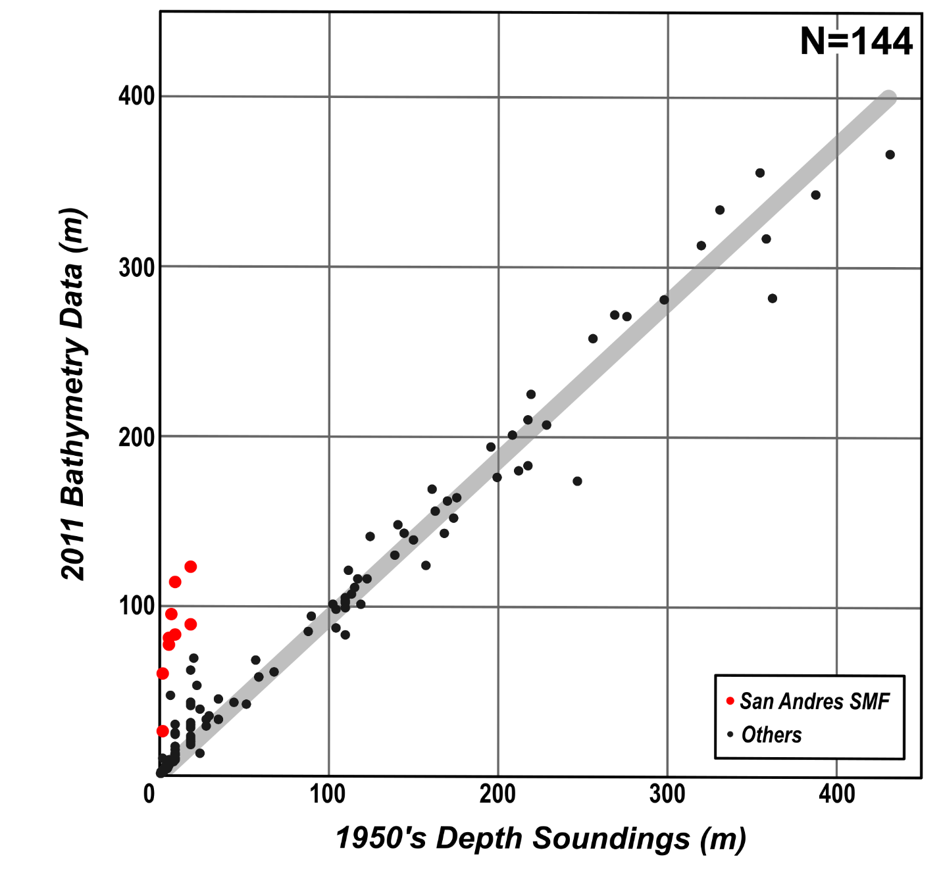

**Supplementary Figure 3.** High positive correlation between the 1956 depth soundings and 2011 bathymetry data, with a regression equation of y = 0.929x**,** and a coefficient of determination (R2) = 0.95. The location of the depth soundings are shown in Supplementary Figure 2. Significant net erosion (>20 m) was observed for points within the San Andres SMF (SASMF) relative to the rest of the South Pass in the Verde Island Passage.

D:\MS\Manuscripts\1994 Mindoro Tsunami - Marine Geology\Frontiers\Frontiers_Word_Templates\Comments\Revised\Revised 2\Revised 3\Response\Supplementary_Figure_4_Frontiers_1994_Mindoro_tsunami_Ramirez et al.tiff

**Supplementary Figure 4.** Virtual water level gauges at Tacligan, San Teodoro and Wawa, Calapan in northern Oriental Mindoro. Tsunami wave heights are sampled every 25 s. At least 2 tsunami waves can be observed, consistent with the local anecdotes.