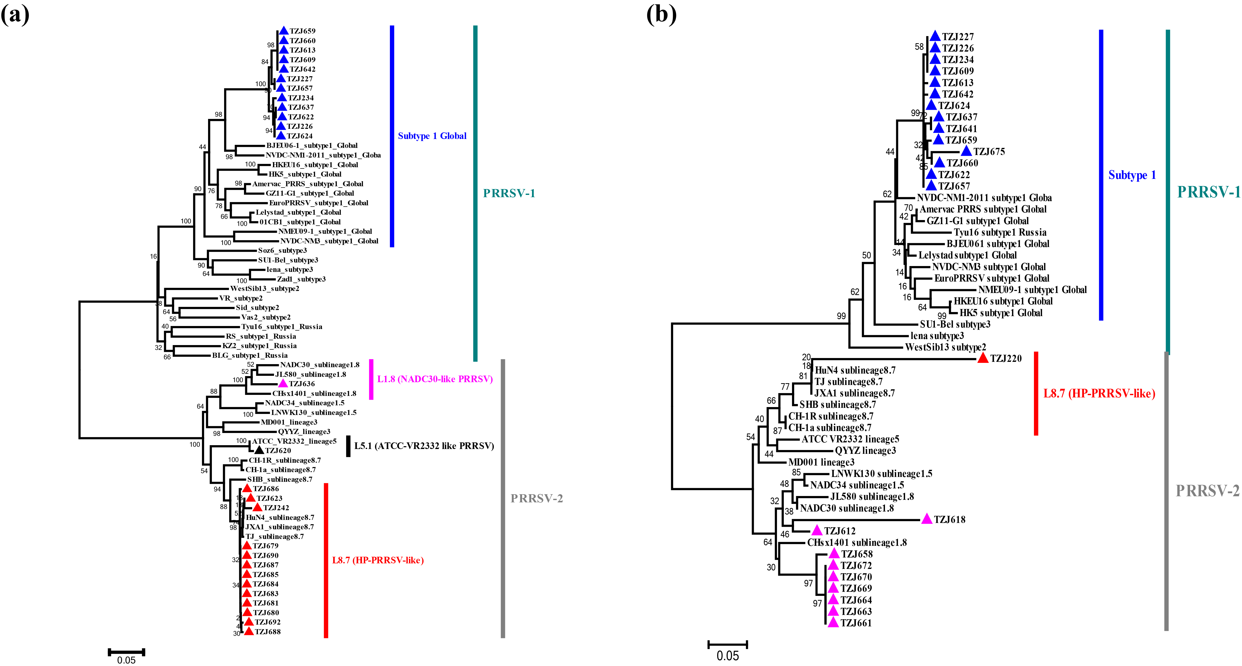

FIG S1. Phylogenetic analysis of PRRSV isolates from the investigated pig producer. (a) Phylogenetic tree constructed based on the ORF5 genes of PRRSV isolates and reference PRRSV strains from each lineage. (b) Phylogenetic tree constructed based on the partial ORF7 gene sequences of PRRSV isolates and reference PRRSV strains from each lineage. PRRSV strains from this farm are indicated by triangles, with different colors representing different lineages.