Supplementary Material

# Supplementary Figures

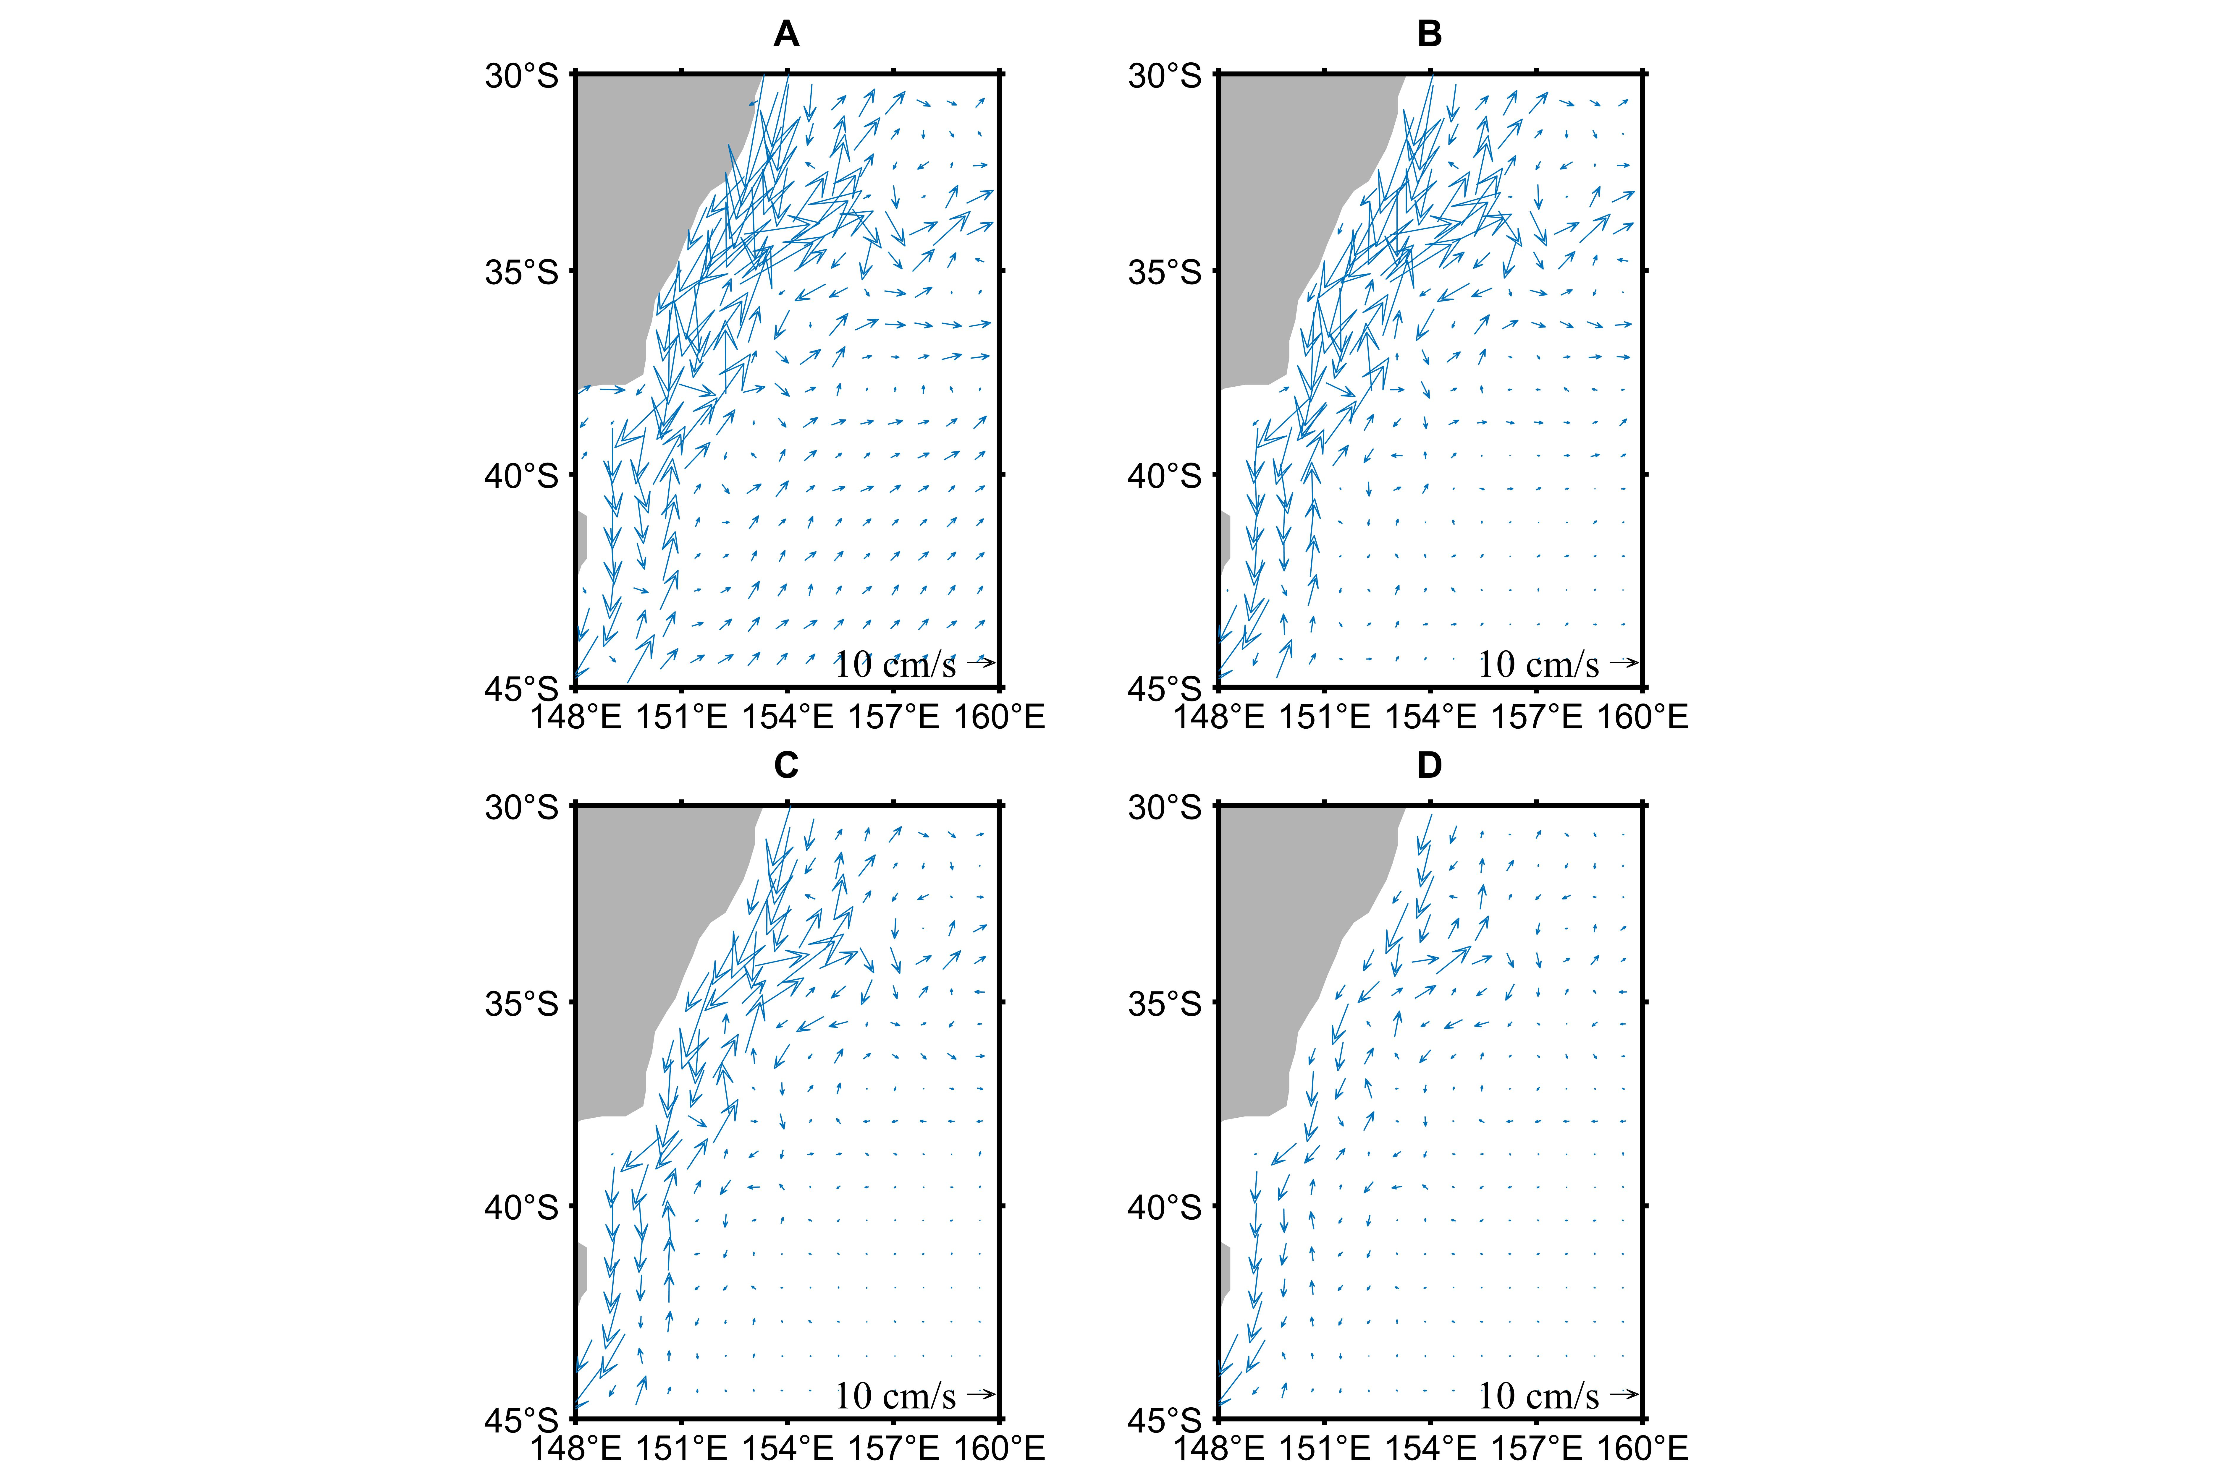

FIGURE S1 (A) surface (B) 100 m (C) 300 m (D) 500 m currents (arrow) in the EAC region (148°E-160°E, 30°S-45°S) from OFES during July 1999-October 2009. The velocity vector represents the direction, and the length represents the magnitude of the velocity (10 cm s-1).

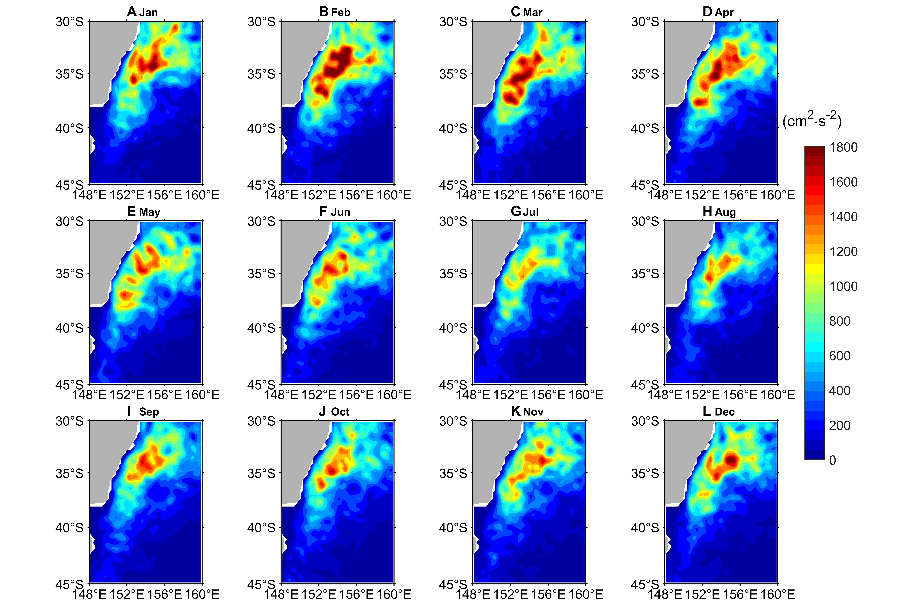

FIGURE S2 Monthly mean surface eddy kinetic energy (EKE, Unit: cm² s-²) distribution from AVISO during January 1999-December 2019 for (A) January, (B) February, (C) March, (D) April, (E) May, (F) June, (G) July, (H) August, (I) September, (J) October, (K) November and (L) December.

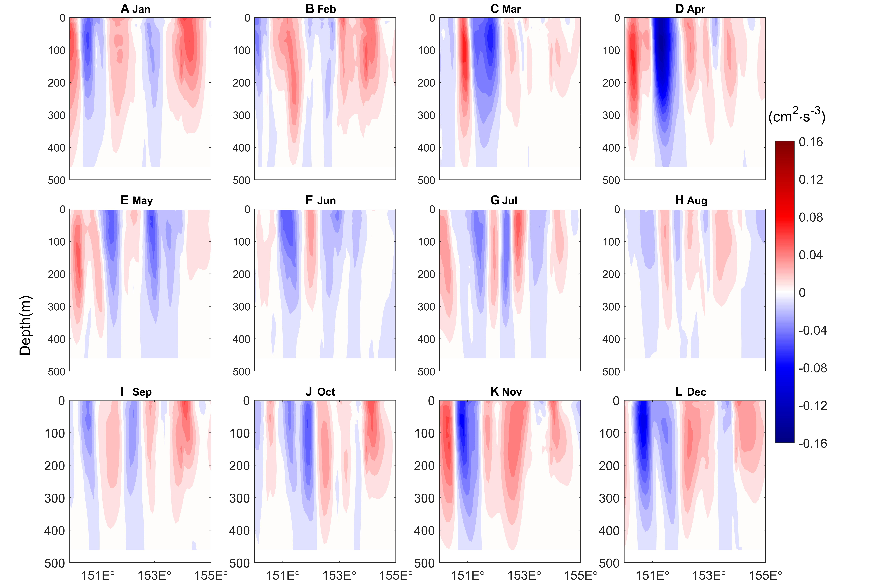

FIGURE S3 Zonal distributions of barotropic conversion rate (BTR, Unit: cm2 s-3) averaged between 30°S and 45°S from OFES during July 1999-October 2009 for (A) January, (B) February, (C) March, (D) April, (E) May, (F) June, (G) July, (H) August, (I) September, (J) October, (K) November and (L) December.

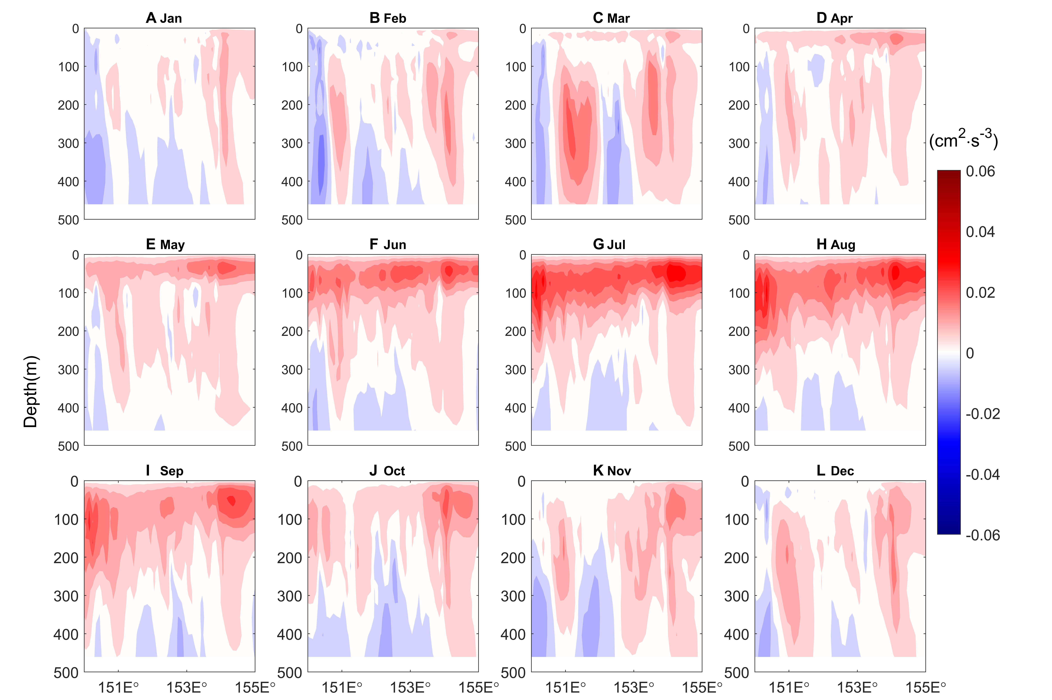 FIGURE S4 Zonal distributions of baroclinic conversion rate (BCR, Unit: cm2 s-3) averaged between 30°S and 45°S from OFES during July 1999-October 2009 for (A) January, (B) February, (C) March, (D) April, (E) May, (F) June, (G) July, (H) August, (I) September, (J) October, (K) November and (L) December.