**SUPPLEMENTARY MATERIAL**

**SUPPLEMENTAL METHODS**

**Notes on *Bd* Record Dataset and Analysis**

To detect *Bd* occurrence and intensity in African amphibians, we collected swab samples from 2,972 museum preserved amphibian specimens as well as 1,076 live animals in the field (4,048 samples total). We also include data for an additional 575 field-collected samples from Cameroon (Hirschfeld *et al.*, 2016) collected and processed using the same methods, making the total number of records 4,623 in our study (“our data”).

We also gathered data from the literature amounting to 12,297 *Bd* records (“published data”). When compiling the data, we found that most records published in Doherty-Bone *et al.* (2008) were also included in Hirschfeld *et al.* (2016), and we therefore did not include Doherty-Bone *et al.* (2008) so as not to duplicate those records. Of the 12,297 records, 63 were from studies that did not report both *Bd-*positive and *Bd-*negative samples, and therefore were not included in our calculations of the frequency of *Bd* occurrence. Those 63 records were used in our *Bd* risk model as *Bd* positive localities.

When deciding which data to include from the literature, we focused on continental Africa for this project. However, we made an exception to include islands in the Gulf of Guinea. This was because we acquired field-collected samples from Bioko Island (Equatorial Guinea) to include in our analysis, and we therefore decided to include data from other islands in the Gulf of Guinea as well (Sao Tome and Principe), but we did not include other regions outside of continental Africa (Madagascar was outside the scope of our paper).

When binning our data by decade, records associated with a range of years across multiple decades were included in the decade with most overlap as long as dates extended no more than 3 years into another decade. Records that extended more than 3 years into a consecutive decade were excluded from our analysis of *Bd* occurrence by decade.

For analysis of *Bd* infection intensity in Cameroon and Kenya by decade, we included data from three previous publications in addition to our generated data (Cameroon: Hirschfeld *et al.*, 2016; Zimkus *et al.*, 2020; Kenya: Kielgast *et al.*, 2010). These studies reported the same methods for qPCR that we used, and so we calculated the infection intensity for those samples as we did for our samples (multiplying reported GE by a dilution factor of 80 and log-transforming the resultant ZE + 1). For Kenya, data for the 2000s were all collected in 2006 and previously published in Kielgast *et al.* (2010). Their infection intensity data was available in a summary table that reported the average GE from each of 31 *Bd* positive populations. Therefore, after calculating our log transformed ZE from those average GE values, we took the weighted mean of their reported means using the R function wtd.mean, and calculated the variance of the distribution of their reported means using wtd.var. Standard deviation and standard error were calculated from the variance across populations (N=31 *Bd* positive sites) (see error bars in Figure 1D for 2000–2009). The SE error bars graphed around the mean infection intensity value may therefore be smaller than if we had access to raw data.

For our analysis of pre- and post- emergence data (emergence defined as the year 2000; Table 1), we used a Chi-square test of independence of *Bd* detection (positive vs. negative) and time period (pre-2000 vs. 2000-present) to determine whether there was a relationship between these two categorical variables. For countries and regions that had both pre- and post- emergence data, a significant Chi-square p-value for these tests would indicate that knowing the frequency of *Bd* detection would help to predict whether samples came from the pre- or post- emergence time period and vice versa.

**Histology**

Histology was performed to determine if there was evidence of chytridiomycosis in a subset of animals that we had assayed for *Bd* from swab samples. After swab collection for our *Bd* assays (described in main text), specimens were preserved in 10% neutral-buffered formalin in the field and transferred to 70% ethanol for storage at the California Academy of Sciences. Tissue samples from specimens collected in Burundi in 2011 (N=4) and in Cameroon in 2011 and 2013 (N=10) were sent to The Wildlife Conservation Society (Bronx, NY) for histological examination (Table S4). Samples were selected in pairs, collected at the same locality, from the same host species, in animals with both high and low *Bd*-infection intensity (logZE > 4, logZE 0-3, respectively). Skin samples were sectioned at 5µ, stained with hematoxylin and eosin, cover-slipped, and examined by a certified veterinary pathologist.

**References**

Doherty-Bone, T. M. *et al.* (2008) ‘In a vulnerable position? Preliminary survey work fails to detect the amphibian chytrid pathogen in the highlands of Cameroon, an amphibian hotspot’, *Herpetological Journal*, 18, pp. 115–118.

Hirschfeld, M. *et al.* (2016) ‘Dramatic declines of montane frogs in a central African biodiversity hotspot’, *PloS one*, 11(5), p. e0155129. doi: 10.1371/journal.pone.0155129.

Kielgast, J. *et al.* (2010) ‘Widespread occurrence of the amphibian chytrid fungus in Kenya’, *Animal Conservation*. doi: 10.1111/j.1469-1795.2009.00297.x.

Zimkus, B. M. *et al.* (2020) ‘Chytrid pathogen (*Batrachochytrium dendrobatidis*) in African amphibians: A continental analysis of occurrences and modeling of its potential distribution’, *Herpetologica*, 76(2), pp. 201–215. doi: 10.1655/0018-0831-76.2.201.

**SUPPLEMENTAL RESULTS**

**Histology**

Histological examination of tissue samples revealed evidence of *Bd* presence and signs of chytridiomycosis (Table S4; Figure S1). Two samples from Burundi from *Leptopelis bocagii* specimens with high *Bd*-infection intensity (logZE=4.4 and logZE=4.0) contained intracutaneous organisms consistent with *Bd* and exhibited moderate epidermal hyperplasia and hyperkeratosis (N=4 total samples examined from Burundi). Of the Cameroon samples examined (N=10), one specimen of *Arthroleptis poecilonotus* (logZE=4.6) exhibited severe hyperplasia and hyperkeratosis with numerous intraepithelial *Bd* sporangia (Figure S1A; Table S4). Two additional samples from Cameroon taken from specimens of *Hyperolius riggenbachi* with respectively lower infection intensity (logZE=2.1) and high infection intensity (logZE=4.1) both exhibited mild to moderate epidermal hyperplasia. No other samples showed epidermal abnormalities (Figure S1; Table S4).

**SUPPLEMENTAL TABLES**

**Table S1. Summary of all prevalence data for Africa by decade**.N=16,686 (171 samples included in Table 1 were not included here because collection years did not fall into a single decade). Lower and upper CI (95% confidence interval) based on binomial distribution. Pr(no *Bd*) is the probability of finding no *Bd*-positive samples in each decade (based on a binomial distribution) if frequency of *Bd* occurrence was actually 11%  (Talley et al., 2015). The data tabulated here are graphed in Figure 1B.

|  |  |  |  |  |  |  |
| --- | --- | --- | --- | --- | --- | --- |
| **Decade** | **No. *Bd* Positives** | **No. Examined** | **% Infected** | **Lower CI** | **Upper CI** | **Pr(no *Bd*)** |
| Pre-1960 | 7 | 739 | 0.95 | 0.38 | 1.94 | <0.001 |
| 1960–1969 | 5 | 123 | 4.07 | 1.33 | 9.23 | <0.001 |
| 1970–1979 | 23 | 546 | 4.21 | 2.69 | 6.25 | <0.001 |
| 1980–1989 | 13 | 664 | 1.96 | 1.05 | 3.32 | <0.001 |
| 1990–1999 | 94 | 2277 | 4.13 | 3.35 | 5.03 | <0.001 |
| 2000–2009 | 1355 | 7901 | 17.15 | 16.32 | 18.00 | <0.001 |
| 2010–present | 959 | 4436 | 21.62 | 20.41 | 22.86 | <0.001 |

**Table S2. Summary of Cameroon data by decade.** N= 1,940. Lower and upper (95% confidence interval) based on binomial distribution. Pr(no *Bd*) is the probability of finding no *Bd*-positive samples in each decade (based on a binomial distribution) if frequency of *Bd* occurrence was actually 11%  (*26*). x̄LogZE is the mean of log transformed zoospore equivalents, SD LogZE is the standard deviation of log transformed zoospore equivalents, and SE LogZE is the standard error of log transformed zoospore equivalents. Max. LogZE is the maximum value of log transformed zoospore equivalents in the decade. The data tabulated here are graphed in Figure 1C.

|  |  |  |  |  |  |  |  |  |  |  |
| --- | --- | --- | --- | --- | --- | --- | --- | --- | --- | --- |
| **Decade** | **No. *Bd* Positive** | **No. Examined** | **% Infected** | **Lower CI** | **Upper CI** | **Pr(no *Bd*)** | **x̄LogZE** | **SD LogZE** | **SE LogZE** | **Max. LogZE** |
| Pre-1960 | 0 | 16 | 0.00 | 0.00 | 20.59 | 0.15 | 0.00 | 0.00 | 0.00 | NA |
| 1960–1969 | 1 | 47 | 2.13 | 0.05 | 11.29 | <0.01 | 0.70 | 0.00 | 0.00 | 0.70 |
| 1970–1979 | 0 | 13 | 0.00 | 0.00 | 24.71 | 0.22 | 0.00 | 0.00 | 0.00 | NA |
| 1980–1989 | 0 | 52 | 0.00 | 0.00 | 6.85 | <0.01 | 0.00 | 0.00 | 0.00 | NA |
| 1990–1999 | 0 | 149 | 0.00 | 0.00 | 2.45 | <0.001 | 0.00 | 0.00 | 0.00 | NA |
| 2000–2009 | 87 | 794 | 10.96 | 8.87 | 13.34 | <0.001 | 2.48 | 1.07 | 0.11 | 5.48 |
| 2010–present | 315 | 869 | 36.25 | 33.05 | 39.54 | <0.001 | 1.72 | 1.24 | 0.07 | 6.42 |

**Table S3. Summary of Kenyan data by decade.** N= 1,503. Lower and upper (95% confidence interval) based on binomial distribution. Pr(no *Bd*) is the probability of finding no *Bd*-positive samples in each decade (based on a binomial distribution) if frequency of *Bd* occurrence was actually 11%  (*26*). x̄LogZE is the mean of log transformed zoospore equivalents, SD LogZE is the standard deviation of log transformed zoospore equivalents, and SE LogZE is the standard error of log transformed zoospore equivalents. Max. LogZE is the maximum value of log transformed zoospore equivalents in the decade. The data tabulated here are graphed in Figure 1D.

|  |  |  |  |  |  |  |  |  |  |  |
| --- | --- | --- | --- | --- | --- | --- | --- | --- | --- | --- |
| **Decade** | **No. *Bd* Positive** | **No. Examined** | **% Infected** | **Lower CI** | **Upper CI** | **Pr(no *Bd*)** | **x̄LogZE** | **SD LogZE** | **SE LogZE** | **Max. LogZE** |
| Pre-1960 | 0 | 2 | 0.00 | 0.00 | 84.19 | 0.79 | 0.00 | 0.00 | 0.00 | NA |
| 1960–1969 | 0 | 34 | 0.00 | 0.00 | 10.28 | 0.02 | 0.00 | 0.00 | 0.00 | NA |
| 1970–1979 | 10 | 193 | 5.18 | 2.51 | 9.32 | <0.001 | 0.29 | 0.36 | 0.11 | 1.20 |
| 1980–1989 | 3 | 336 | 0.89 | 0.18 | 2.59 | <0.001 | 1.40 | 2.33 | 1.35 | 4.09 |
| 1990–1999 | 0 | 77 | 0.00 | 0.00 | 4.68 | <0.001 | 0.00 | 0.00 | 0.00 | NA |
| 2000–2009 | 271 | 861 | 31.48 | 28.38 | 34.69 | <0.001 | 4.99 | 1.07 | 0.19 | 7.90 |
| 2010–present | NA | NA | NA | NA | NA | NA | NA | NA | NA | NA |

**Table S4**. Swab samples genotyped in this study (N=32).

|  |  |  |  |  |  |  |  |  |  |
| --- | --- | --- | --- | --- | --- | --- | --- | --- | --- |
| **Museum ID** | **Field ID** | **Log (ZE)** | **Loci amplified** | **Genus** | **species** | **Col. Year** | **Country** | **decimal Lon** | **decimal Lat** |
| CAS250829 | DCB195 | 2.34 | 156 | *Leptopelis* | *bocagii* | 2011 | Burundi | 29.27305 | -3.34964 |
| CAS250742 | DCB119 | 3.73 | 180 | *Hyperolius* | *kivuensis* | 2011 | Burundi | 29.62737 | -3.94678 |
| CAS250826 | DCB192 | 2.21 | 133 | *Ptychadena* | cf. *mascareniensis* | 2011 | Burundi | 29.27311 | -3.34304 |
| CAS250764 | DCB125 | 2.22 | 133 | *Xenopus* | sp. | 2011 | Burundi | 29.6284 | -3.94108 |
| CAS250744 | DCB121 | 2.39 | 96 | *Hyperolius* | *viridiflavus* | 2011 | Burundi | 29.62737 | -3.94678 |
| CAS250662 | DCB39 | 2.28 | 162 | *Hyperolius* | *viridiflavus* | 2011 | Burundi | 29.6147 | -3.9534 |
| CAS250667 | DCB44 | 2.22 | 98 | *Hyperolius* | *viridiflavus* | 2011 | Burundi | 29.6147 | -3.9534 |
| CAS253622 | DCB614 | 3.25 | 181 | *Hyperolius* | *adametzi* | 2013 | Cameroon | 10.15853 | 5.855733 |
| CAS253623 | DCB615 | 3.17 | 176 | *Hyperolius* | *adametzi* | 2013 | Cameroon | 10.15853 | 5.855733 |
| CAS253624 | DCB616 | 3.45 | 178 | *Hyperolius* | *adametzi* | 2013 | Cameroon | 10.15853 | 5.855733 |
| CAS253308 | DCB266 | 4.13 | 101 | *Hylarana* | *albolabris* | 2013 | Cameroon | 13.9041 | 2.90057 |
| CAS253732 | DMP703 | 4.46 | 180 | *Leptopelis* | *aubryi* | 2013 | Cameroon | 9.06609 | 4.32676 |
| CAS253972 | DMP956 | 3.35 | 180 | *Leptopelis* | *aubryi* | 2013 | Cameroon | 9.77183 | 4.84975 |
| CAS254095 | DMP1038 | 3.68 | 169 | *Leptopelis* | *boulengeri* | 2013 | Cameroon | 9.69563 | 4.94781 |
| CAS254128 | DMP1076 | 3.43 | 182 | *Leptopelis* | *calcaratus* | 2013 | Cameroon | 9.6686 | 4.9606 |
| CAS254129 | DMP1077 | 3.35 | 179 | *Leptopelis* | *calcaratus* | 2013 | Cameroon | 9.6686 | 4.9606 |
| CAS253462 | DCB438 | 2.35 | 93 | *Afrixalus* | *fulvovittatus* | 2013 | Cameroon | 11.97633 | 2.93994 |
| CAS253468 | DCB444 | 2.38 | 172 | *Afrixalus* | *fulvovittatus* | 2013 | Cameroon | 11.97633 | 2.93994 |
| CAS253363 | DCB326 | 2.55 | 162 | *Sclerophrys* | *gracilipes* | 2013 | Cameroon | 14.0234 | 2.6106 |
| CAS253365 | DCB328 | 3.34 | 177 | *Sclerophrys* | *gracilipes* | 2013 | Cameroon | 14.0234 | 2.6106 |
| CAS253841 | DMP781 | 2.20 | 67 | *Afrixalus* | *lacteus* | 2013 | Cameroon | 9.865061 | 4.959439 |
| CAS253844 | DMP784 | 3.32 | 96 | *Afrixalus* | *lacteus* | 2013 | Cameroon | 9.865061 | 4.959439 |
| CAS253613 | DCB605 | 3.44 | 180 | *Leptopelis* | *nordequatorialis* | 2013 | Cameroon | 10.15853 | 5.855733 |
| CAS253963 | DMP903 | 2.27 | 102 | *Afrixalus* | *paradorsalis* | 2013 | Cameroon | 9.77183 | 4.84975 |
| CAS253296 | DCB254 | 3.37 | 177 | *Arthroleptis* | *poecilonotus* | 2013 | Cameroon | 13.90334 | 2.90072 |
| CAS253321 | DCB283 | 2.20 | 153 | *Arthroleptis* | *poecilonotus* | 2013 | Cameroon | 14.02324 | 2.63101 |
| CAS253487 | DCB463 | 2.66 | 167 | *Arthroleptis* | *poecilonotus* | 2013 | Cameroon | 11.97633 | 2.93994 |
| CAS253617 | DCB609 | 4.06 | 182 | *Hyperolius* | *riggenbachi* | 2013 | Cameroon | 10.15853 | 5.855733 |
| CAS253619 | DCB611 | 2.44 | 138 | *Hyperolius* | *riggenbachi* | 2013 | Cameroon | 10.15853 | 5.855733 |
| CAS253620 | DCB612 | 3.30 | 180 | *Hyperolius* | *riggenbachi* | 2013 | Cameroon | 10.15853 | 5.855733 |
| CAS253836 | DMP769 | 2.37 | 144 | *Leptopelis* | *rufus* | 2013 | Cameroon | 9.865061 | 4.959439 |
| CAS253839 | DMP772 | 3.53 | 174 | *Leptopelis* | *rufus* | 2013 | Cameroon | 9.865061 | 4.959439 |

**Table S5.** Histology results for samples analyzed in this study (N=14). NHL = no histologic lesions.

|  |  |  |  |  |  |  |  |  |  |
| --- | --- | --- | --- | --- | --- | --- | --- | --- | --- |
| **Museum ID** | **Field ID** | **Log (ZE)** | **Genus** | **species** | **Col. Year** | **Country** | **decimal Long** | **decimal Lat** | **Morphological Diagnosis** |
| **CAS250817** | DCB 183 | 2.21 | *Leptopelis* | *bocagii* | 2011 | Burundi | 29.474300 | -4.013680 | NHL |
| **CAS250818** | DCB 184 | 2.10 | *Leptopelis* | *bocagii* | 2011 | Burundi | 29.474300 | -4.013680 | NHL |
| **CAS250820** | DCB 186 | 4.37 | *Leptopelis* | *bocagii* | 2011 | Burundi | 29.474300 | -4.013680 | Epidermal hyperplasia and hyperkeratosis, moderate with moderate numbers of intraepithelial sporangia consistent with *Bd* |
| **CAS250821** | DCB 187 | 4.01 | *Leptopelis* | *bocagii* | 2011 | Burundi | 29.474300 | -4.013680 | Epidermal hyperplasia and hyperkeratosis, moderate with moderate numbers of intraepithelial sporangia consistent with *Bd* |
| **CAS250011** | BJE 3216 | 4.62 | *Arthroleptis* | *poecilonotus* | 2011 | Cameroon | 10.759983 | 6.548617 | Epidermal hyperplasia and hyperkeratosis, severe with numerous intraepithelial sporangia consistent with *Bd* |
| **CAS250039** | BJE 3274 | 0.00 | *Arthroleptis* | *poecilonotus* | 2011 | Cameroon | 10.035133 | 6.335950 | NHL |
| **CAS253308** | DCB 266 | 4.13 | *Hylarana* | *albolabris* | 2013 | Cameroon | 13.904100 | 2.900570 | NHL |
| **CAS253315** | DCB 273 | 0.27 | *Hylarana* | *albolabris* | 2013 | Cameroon | 13.049200 | 2.900960 | NHL |
| **CAS253617** | DCB 609 | 4.06 | *Hyperolius* | *riggenbachi* | 2013 | Cameroon | 10.158530 | 5.855733 | Epidermal hyperplasia, mild to moderate |
| **CAS253616** | DCB 608 | 2.10 | *Hyperolius* | *riggenbachi* | 2013 | Cameroon | 10.158530 | 5.855733 | Epidermal hyperplasia, mild to moderate |
| **CAS253732** | DMP 703 | 4.46 | *Leptopelis* | *aubryi* | 2013 | Cameroon | 9.066090 | 4.326760 | NHL |
| **CAS253728** | DMP 699 | 0.00 | *Leptopelis* | *aubryi* | 2013 | Cameroon | 9.066090 | 4.326760 | NHL |
| **CAS253704** | NA | 1.65 | *Xenopus* | *longipes* |  | Cameroon |  |  | NHL |
| **CAS253700** | NA | 0.00 | *Xenopus* | *longipes* |  | Cameroon |  |  | NHL |

**SUPPLEMENTAL FIGURES**

Figure S1:

**Figure S1**. Unique alleles from newly genotyped *Bd* swab samples. **(A)** Heat-map showing the number of unique alleles for each swab sample (N=32) at each locus (N=192); **(B)** average number of alleles for each sample across all amplified loci.

Figure S2 (A):

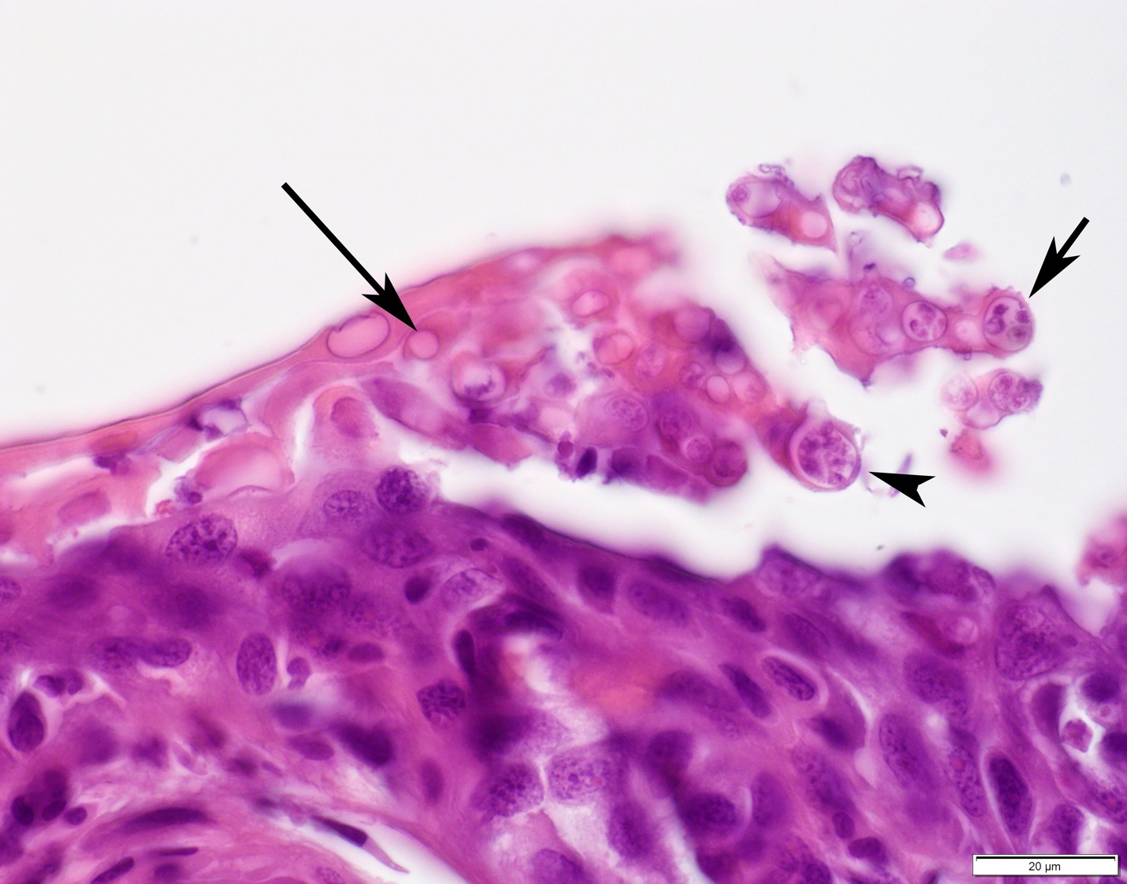

Figure S2 (B):

**Figure S2.** Images of histological samples. Stained with hematoxylin and eosin, 1000X magnification. **(A)** *Bd*-infected skin from a specimen of *Arthroleptis poecilonotus* collected in Cameroon (CAS250011). The epidermis and stratum corneum are severely thickened, hyperplastic, and hyperkeratotic. Numerous organisms consistent with *Bd* at various stages of maturation are present in the keratinized epithelium. These include empty thalli (long arrow), zoosporangia filled with multiple zoospores (short arrow), and a zoosporangium with a discharge papilla (arrowhead). **(B)** Normal skin from a specimen of *Xenopus longipes* collected in Cameroon (CAS253704). The epidermis and stratum corneum (keratinized layer) are uniformly thin.