**Supplementary Information**

# Advances and perspectives on perylenequinone biosynthesis

Huaxiang Deng1,2*, Xinxin Liang2, Jinbing Liu3, Xiaohui Zheng4, Tai-Ping Fan5, Yujie Cai2*

1 Center for Synthetic Biochemistry, Shenzhen Institute of Synthetic Biology, Shenzhen Institute of Advanced Technology, Chinese Academy of Sciences, Shenzhen 518055, China

2 The Key Laboratory of Industrial Biotechnology, Ministry of Education, School of

Biotechnology, Jiangnan University, 1800 Lihu Road, Wuxi, Jiangsu 214122, China

3 School of Marine and Bioengineering, Yancheng Institute of Technology, Yancheng, Jiangsu, 224051, China

4 College of Life Sciences, Northwest University, Xi’an, Shanxi 710069, China

5 Department of Pharmacology, University of Cambridge, Tennis Court Road Cambridge CB2 1PD, United Kingdom

*Corresponding author: yjcai@jiangnan.edu.cn (Yujie Cai); denghxiang@163.com (Huaxiang Deng)

**Contents**

**Figure S1.** The basic core structure of perylenequinones.

**Figure S2.** Structures of Phaeosphaerins A-F.

**Figure S3.** Structures of Calphostin, Cladochromes, Phleichrome, Cercosporin, Elsinochrome, and Hypocrellin.

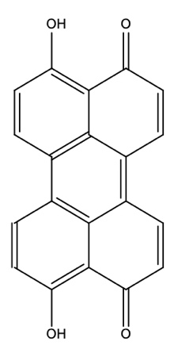**Figure S1.** The basic core structure of perylenequinones.

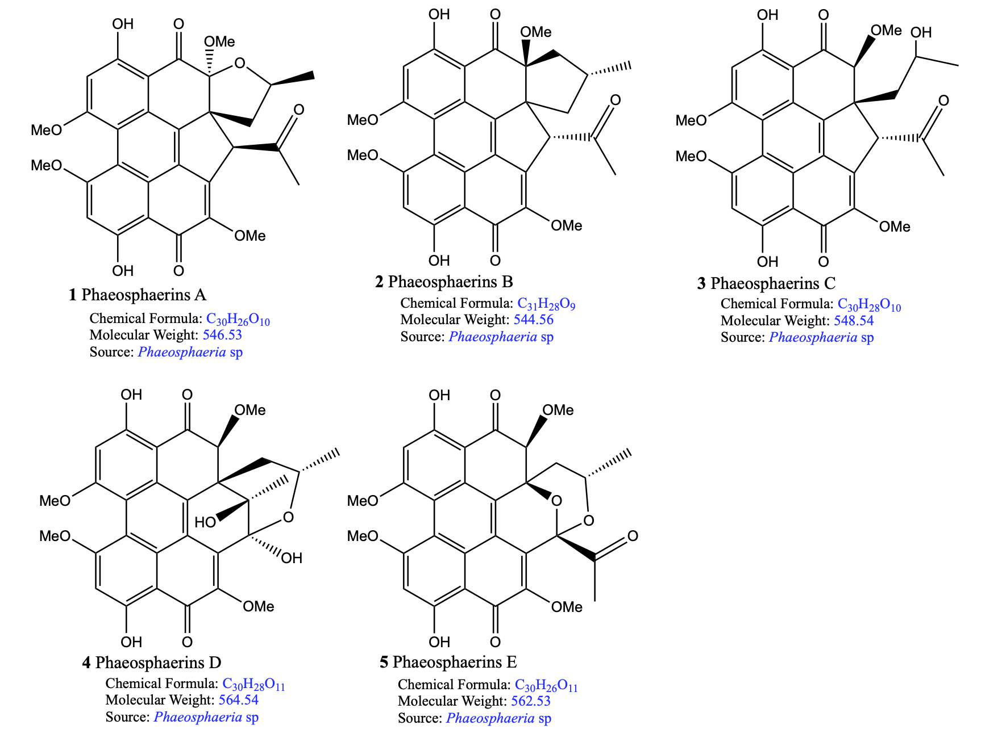

**Figure S2.** Structures of Phaeosphaerins A-F.

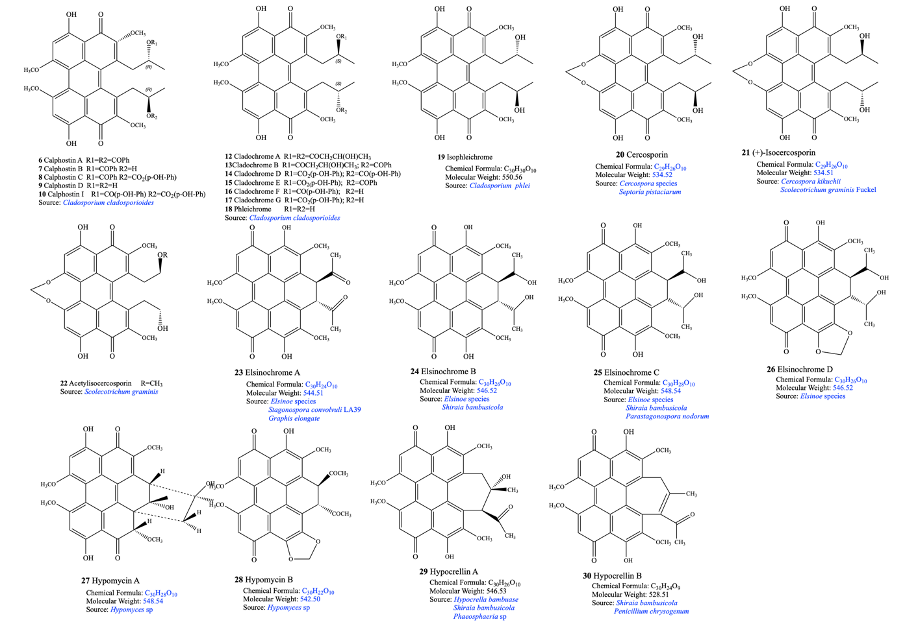**Figure S3.** Structures of Calphostin, Cladochromes, Phleichrome, Cercosporin, Elsinochrome, and Hypocrellin.