Supplementary Material

Supplementary Movies
SI Movie 1. Photographs of plant growth.
SI Movie 2. Automatic selection of leaf area.

Supplementary Figures
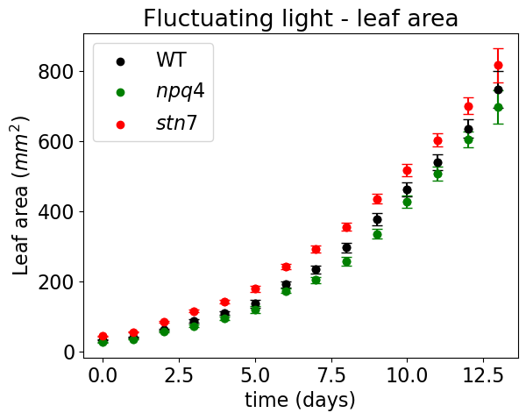
SI Figure 1. Leaf area of WT, npq4 and stn7 plants grown under fluctuating light (see Fig. 1 of manuscript for the fluctuations).

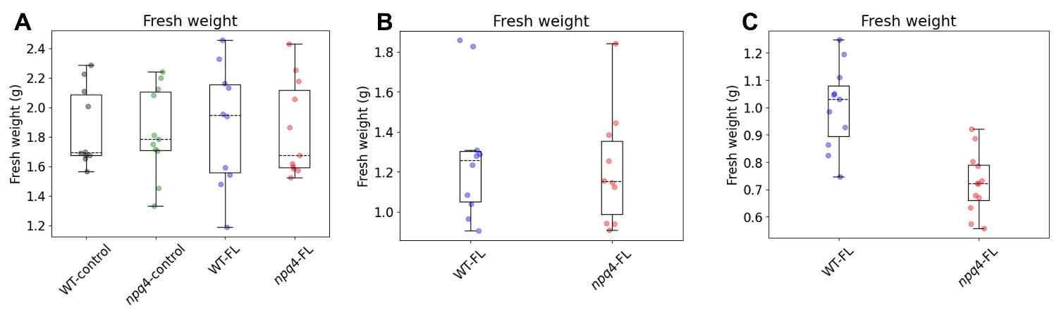
SI Figure 2. Comparison of fresh weight of WT and npq4 plants grown under 125 µmol photons m⁻² s⁻¹ continuous light (control) and or 1h HL/ 0.5h LL fluctuating light (FL) (A), 1 min HL/ 5 min LL (B), 5 min HL/ 5 min LL (C).

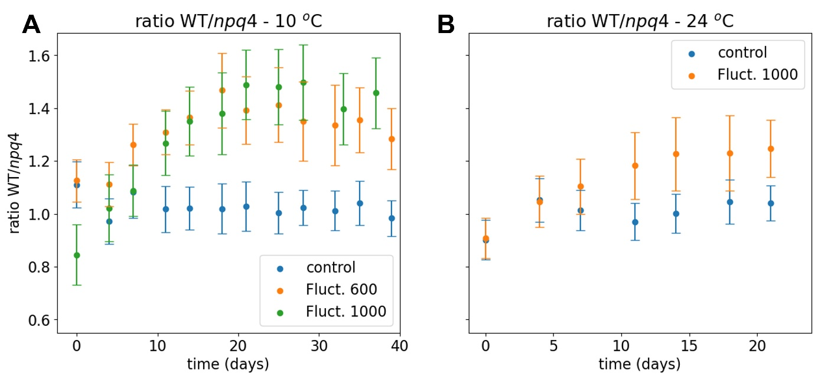
SI Figure 3. Ratio of leaf area for WT vs npq4 plants grown under fluctuating light: 5 min HL (600 µmol photons m⁻² s⁻¹)/ 5 min LL and 5 min HL (1000 µmol photons m⁻² s⁻¹)/ 5 min LL at 10 ºC (A), and 5 min HL (1000 µmol photons m⁻² s⁻¹)/ 5 min LL at 24 ºC (B).

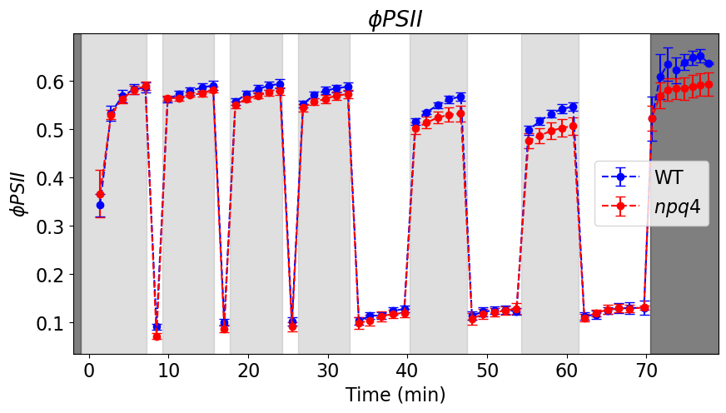
SI Figure 4. PSII operating efficiency for WT and npq4 plants under fluctuating light: three cycles of approximately 5 min. LL (white)/ 1 min. HL (grey), followed by three cycles of 5 min. LL (white)/ 5 min. HL (grey). Note that in the dark grey area (darkness) it is technically speaking not the PSII operating efficiency. SE is shown, n=3.

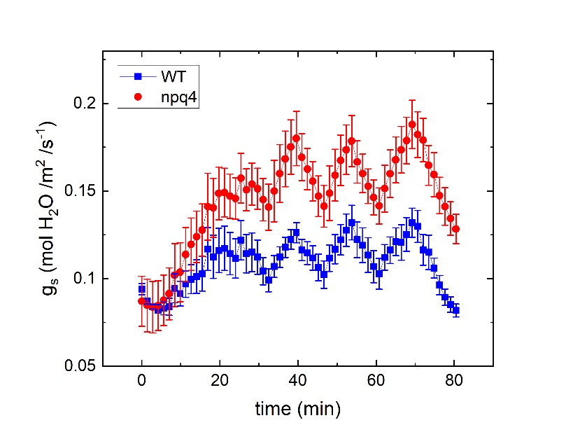
SI Figure 5. Stomatal conductance of WT and npq4 plants under fluctuating light: : three cycles of approximately 5 min. LL/ 1 min. HL, followed by three cycles of 5 min. LL/ 5 min. SE is shown, n=3.

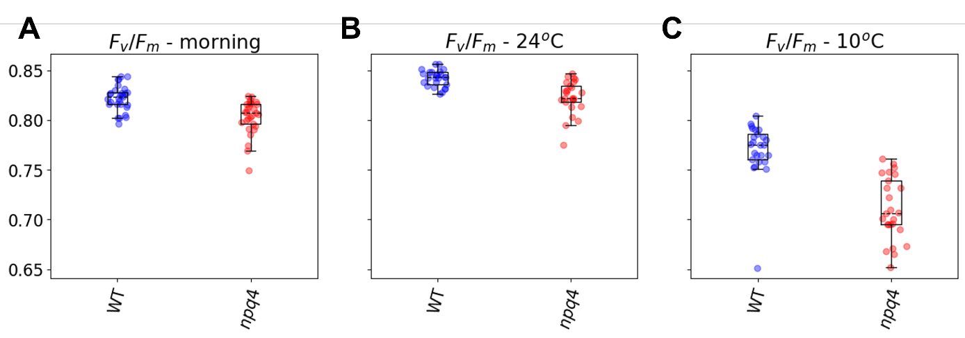
SI Figure 6. Fv/Fm values of WT and npq4 plants exposed for 7 days to 5 min. HL/ 5 min. LL during the photoperiod of 8h. A. measurement in the morning, before the start of the photoperiod, 24 ºC growth temperature. B. Measurements after 5h of exposure to fluctuating light followed by 30 min. dark adaptation, 24 ºC growth temperature. C. Measurements after 5h of exposure to fluctuating light followed by 30 min. dark adaptation, 10 ºC growth temperature. WT and npq4 plants have significantly different values, One-way ANOVA, p<0.05, n ≥ 25.

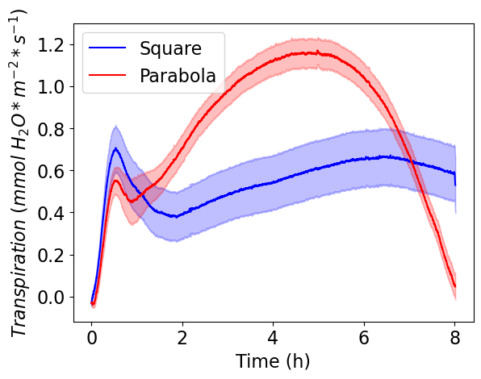
SI Figure 7. Transpiration rate of WT plants grown and measured under square and parabolic light.

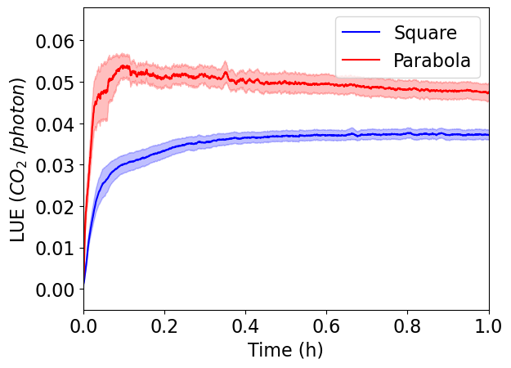
SI Figure 8. Zoom in of light-use efficiency (LUE) curve for plants tested under square wave and parabolic light.

