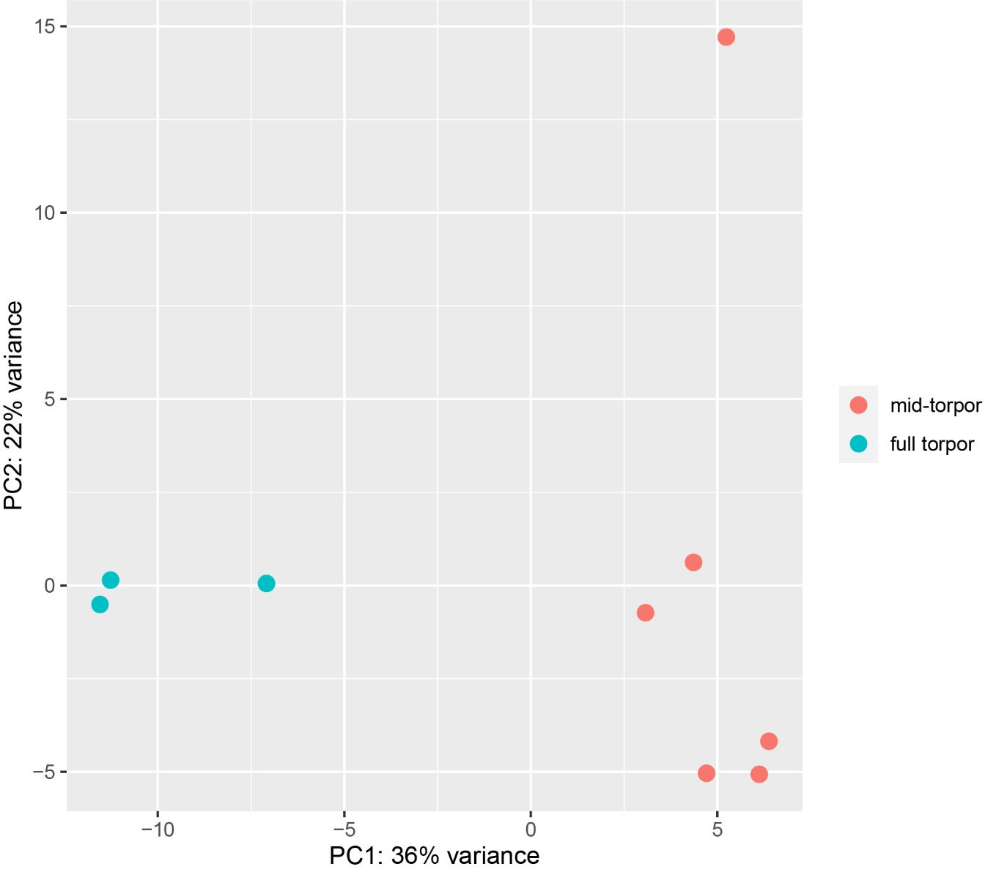
Supplementary Fig. 1: Principal component analysis of normalized expression profiles in Endoicomonas symbionts of Botrylloides leachi.

Supplementary Fig. 2- SEED features distribution in Pie chart of Endozoicomonas along torpor stage. Total of 947 reads count that are divided into 27 categories (in parentheses- numbers of reads/category)

