***Supporting Information for***

**Differential response of chlorophyll-a concentrations to explosive volcanism in the western South Pacific**

Joo-Eun Yoon1*, David King2, Jack Longman3,4, Shane J. Cronin5

1Centre for Climate Repair at Cambridge, Department of Applied Mathematics and Theoretical Physics, University of Cambridge, Cambridge, United Kingdom

2Downing College, University of Cambridge, Cambridge, United Kingdom

3Marine Isotope Geochemistry, Institute for Chemistry and Biology of the Marine Environment (ICBM), University of Oldenburg, Oldenburg, Germany

4Department of Geography and Environmental Sciences, Northumbria University, Newcastle upon Tyne, United Kingdom

5School of Environment, The University of Auckland, Auckland, New Zealand

*Correspondence to Joo-Eun Yoon ([jey28@cam.ac.uk](mailto:jey28@cam.ac.uk))

**Contents of this file**

**Tables S1 to S3**

**Figures S1 to S8**

**Table S1.** Volcanic eruptions with a volcanic explosivity index of 3 or higher in the western SPO over the study period (https://volcano.si.edu/).

|  |  |  |
| --- | --- | --- |
| Volcano name | Date | Max VEI |
| Hunga | 15 Jan., 2022 | 5 |
| Unnamed | 6–8 Aug., 2019 | 3 |
| Ulawun | 26 Jun., 2019 | 4 |
| Tinakula | 21 Oct., 2017 | 3 |
| Ambae | 13 Oct., 2017 – 30 Oct., 2018 | 3 |
| Manam | 31 Jul., 2015 | 4 |
| Rabaul | 29 Aug., 2014 | 3 |
| Karkar | 29 Jan. – 15 Mar., 2013 | 3 |
| Manam | 12 Feb., 2013 | 3 |
| Karkar | 1 Feb., 2012 | 3 |
| Rabaul | 7 Oct., 2006 | 4 |
| Manam | 28 Jan., 2005 | 4 |

**Table S2.** Bulk rock and glass analyses from Hunga 2022 eruption material.

|  |  |  |  |  |  |  |  |  |  |  |  |  |  |
| --- | --- | --- | --- | --- | --- | --- | --- | --- | --- | --- | --- | --- | --- |
|  | **SiO2** | **TiO2** | **Al2O3** | **Fe2O3** | **MnO** | **MgO** | **CaO** | **Na2O** | **K2O** | **SO3** | **P2O5** | **LOI** | **SUM** |
|  | wt% | wt% | wt% | wt% | wt% | wt% | wt% | wt% | wt% | wt% | wt% | wt% | wt% |
| **Bulk XRF analysis of ash (collected after a little bit of rainfall, but not completely saturated – Nukualofa, Tongatapu, Tonga)** |  |  |  |  |  |  |  |  |  |  |  |  |  |
| HT9 – bulk | 55.62 | 0.54 | 14.95 | 10.62 | 0.18 | 4.03 | 9.03 | 2.80 | 0.55 | <0.01 | 0.09 | 1.53 | 99.92 |
| **XRF analysis of bulk pumice separated from the ash, de-ionised water washed, picked – sampled from Fu’amotu airport, Tongatapu, Tonga** |  |  |  |  |  |  |  |  |  |  |  |  |
| HT1 – powdered pumice | 56.92 | 0.56 | 15.33 | 10.83 | 0.18 | 3.89 | 9.17 | 2.03 | 0.52 | <0.01 | 0.10 | 0.39 | 99.92 |
|  | **SiO2** | **Al2O3** | **TiO2** | **MnO** | **FeO** | **MgO** | **CaO** | **Na2O** | **K2O** | **P2O5** | **SO3** | **K** |  |
|  | wt% | wt% | wt% | wt% | wt% | wt% | wt% | wt% | wt% | wt% | wt% | ppm |  |
| **Electron microprobe analysis of glass from Hunga eruption 2022** |  |  |  |  |  |  |  |  |  |  |  |  |  |
| Mean value (n=330) | 61.41 | 14.97 | 0.54 | 0.20 | 8.45 | 3.65 | 8.35 | 2.08 | 0.55 | 0.08 | 0.13 | 4572 |  |
| 1 Standard Deviation (1SD) | 3.97 | 0.92 | 0.05 | 0.02 | 0.70 | 0.84 | 0.58 | 0.24 | 0.09 | 0.02 | 0.08 | 729.5 |  |

**Table S3.** Data used for comparison from previous publication.

|  |  |  |  |  |  |  |  |  |  |  |
| --- | --- | --- | --- | --- | --- | --- | --- | --- | --- | --- |
|  |  | | SiO2 | | Fe2O3 | | Na2O | | K2O | |
|  |  | | wt% | | wt% | | wt% | | wt% | |
| **XRF analysis of bulk ash from Hunga eruption 2009 (Brenna et al., 2022)** | | | | | | | | | |
| Mean value (n=8, 1SD) | | 59.01 ± 0.1 | | 11.78 ± 0.06 | | 2.17 ± 0.09 | | 0.52 ± 0.01 | |
| **XRF analysis of bulk ash from Hunga eruption 2014–15 (Brenna et al., 2022)** | | | | | | | | | |
| Mean value (n=26, 1SD) | | 58.99 ± 0.1 | | 11.79 ± 0.05 | | 2.20 ± 0.08 | | 0.52 ± 0.01 | |
| **ICP-AES analysis of bulk ash from Ambae eruption 2017 (Moussallam et al., 2019)** | | | | | | | | | |
| Mean value (n=6, 1SD) | | 50.47 ± 1.41 | | 10.09 ± 0.18 | | 3.07 ± 0.33 | | 1.79 ± 0.07 | |
| **Electron Microprobe analysis of glass from Ambae eruption 2017 (Moussallam et al., 2019)** | | | | | | | | | |
| Mean value (n=89, 1SD) | | 52.13 ± 0.43 | | 10.55 ± 0.29 | | 3.57 ± 0.14 | | 2.33 ± 0.11 | |
| **Electron Microprobe analysis of glass from Ambae eruption 2018 (Moussallam et al., 2019)** | | | | | | | | | |
| Mean value (n=22, 1SD) | | 51.77 ± 0.28 | | 10.46 ± 0.31 | | 3.53 ± 0.11 | | 2.22 ± 0.11 | |
| **XRF analysis of bulk ash from Hunga eruption 2022 (Whiteside et al., 2023)** | | | | | | | | | |
| Mean value (n=9, 1SD) | | 54.78 ± 1.01 | | 10.42 ± 0.14 | | 2.31 ± 0.14 | | 0.47 ± 0.04 | |
| **Electron Microprobe analysis of glass from Rabaul eruption 2006 (Bernard and Bouvet de Maisonneuve, 2020)** | | | | | | | | | |
| Mean value (n=22, 1SD) | | 64.45 ± 2.30 | | 6.17 ± 1.21 | | 4.76 ± 0.68 | | 3.18 ± 0.36 | |

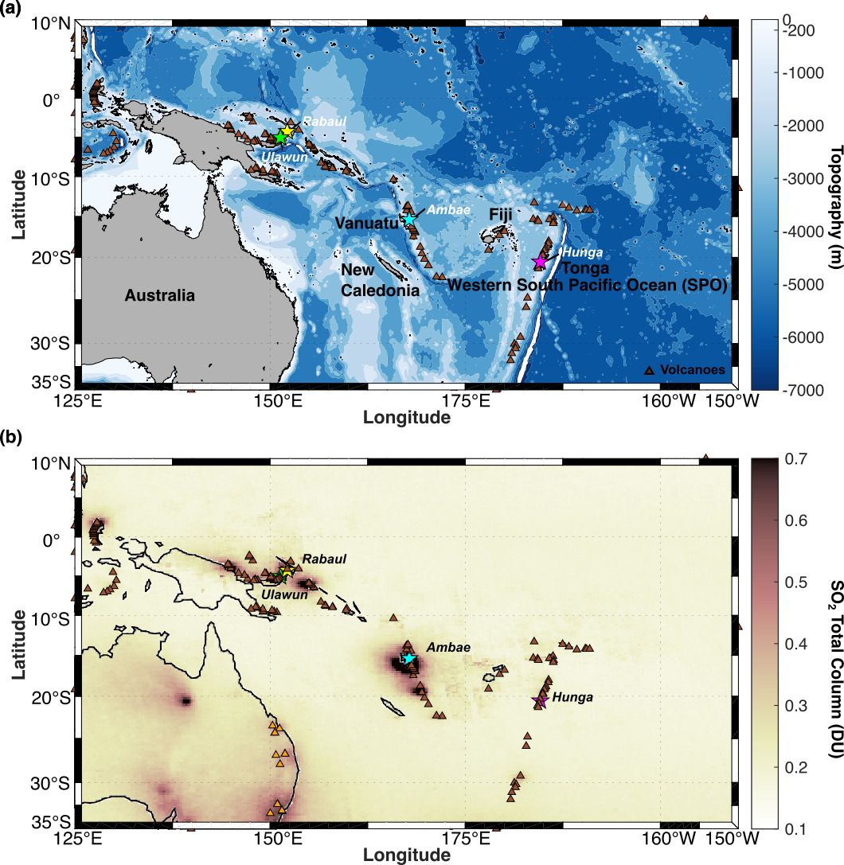

**Figure S1.** (a) A map of the western SPO with volcanoes, highlighted. Contours indicate bathymetry derived from the ETOPO2. (b) OMI-derived mean SO2 total column amounts in the western SPO averaged over last 19 years (2004–2022). Brown triangle markers indicate the volcanoes and orange triangle markers indicate the coal-plants.

**Figure S2.** The number of pixels (0.25° x 0.25° grid) with SO2 values that exceed 99.9th percentile (0.931 DU).

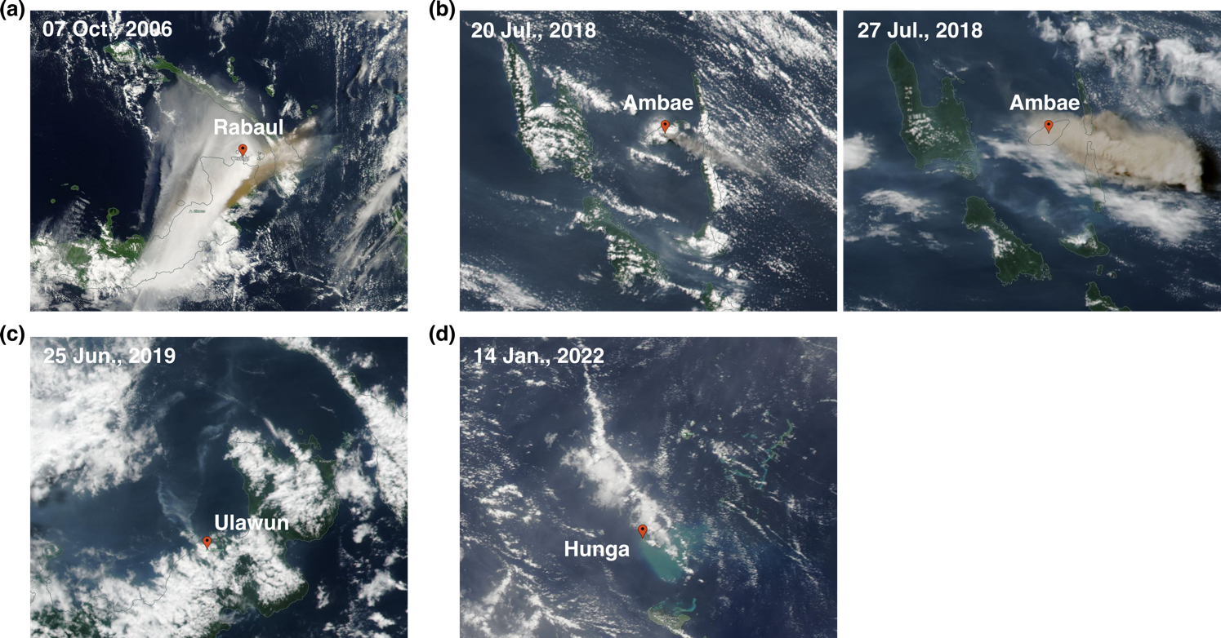

**Figure S3.** True color images on (a) 7 October 2006, (b) 20 and 27 July 2018, (c) 25 June 2019, and (d) 14 January 2022.

**Figure S4.** The spatial distribution of daily SO2 total column over the period of (a) 7⎼13 October, 2006, (b) 20 July ⎼ 4 August, 2018, (c) 26 June ⎼ 4 July, 2019, and (d) 15⎼20 January, 2022, with surface wind (at 925 hPa).

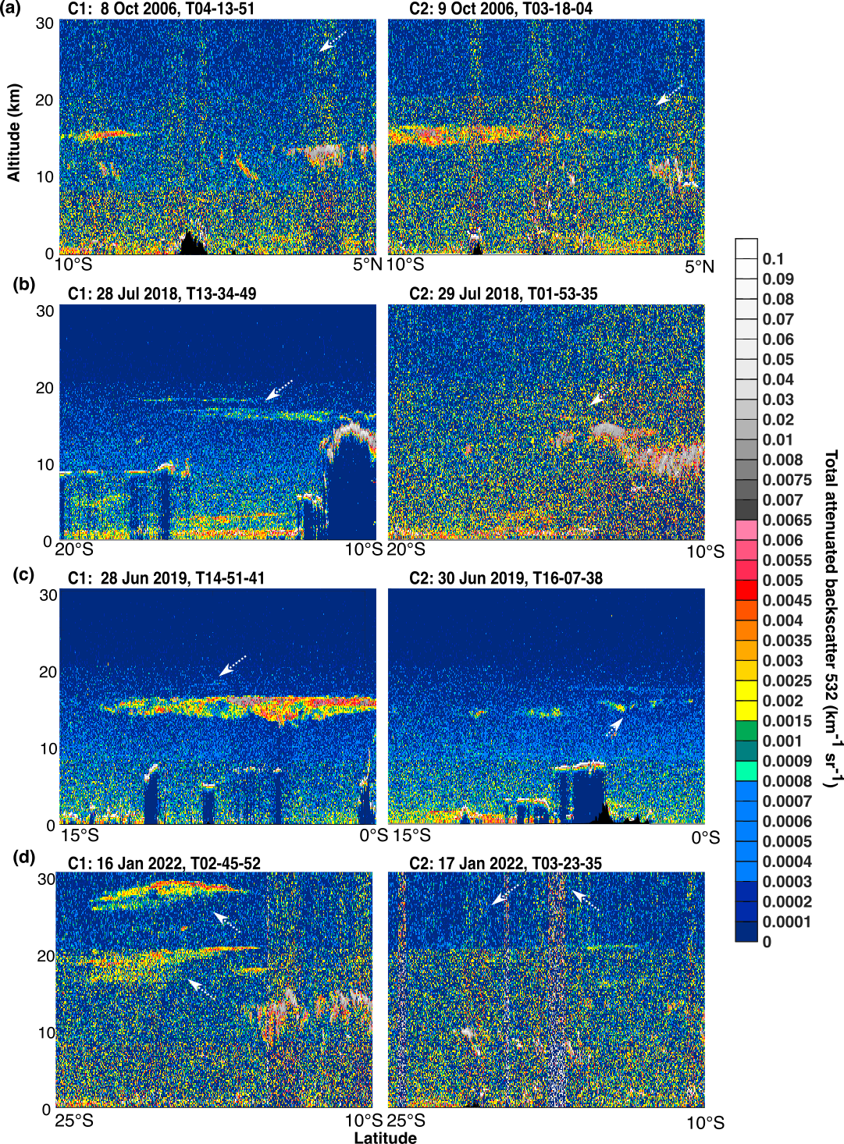

**Figure S5.** The vertical distribution of CALIPSO-derived total attenuated backscattering coefficients in (a) 2006 (C1: 8 October, C2: 9 October), (b) 2018 (C1: 28 July, C2: 29 July), (c) 2019 (C1: 28 June, C2: 30 June), and (d) 2022 (C1: 16 January, C2: 17 January) along the orbits shown in Figure 3A. Arrows indicate the presence of volcanic ash plumes.

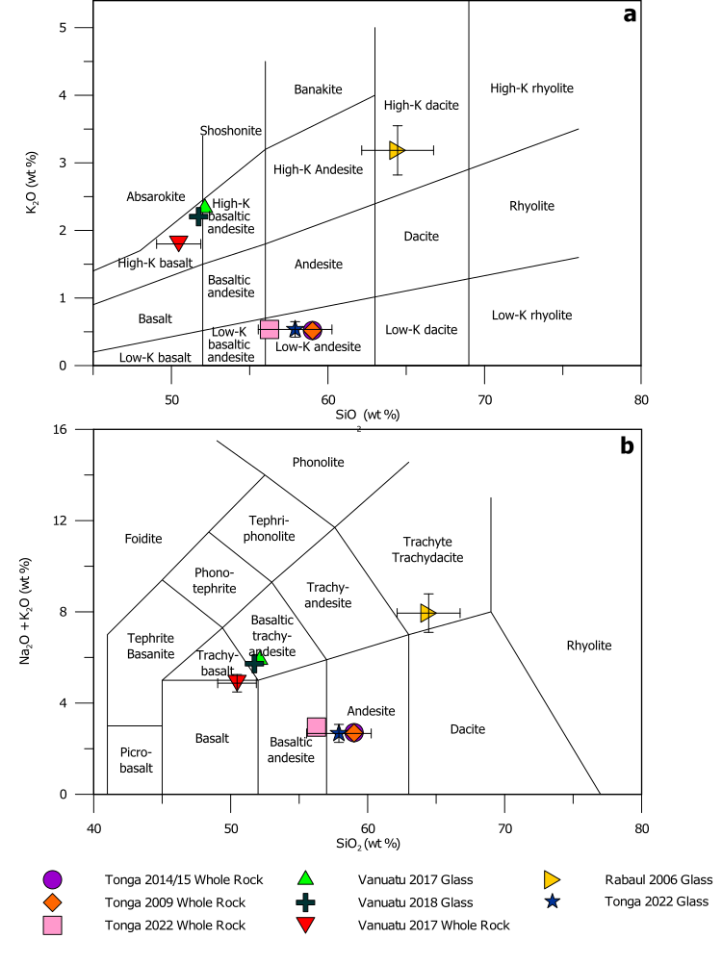

**Figure S6.** Classification of volcanic ash samples discussed here according to (a) silicon-potassium content (Ewart, 1982) and to (b) total alkali-silica content (Bas et al., 1986). Data from the eruption of Hunga in 2022 are from this work. Data from the eruptions in Tonga from 2009 and 2014/2015 are from Brenna et al. (2022), with data on the Vanuatu eruptions from Moussallam et al. (2019), and data for the Rabaul eruption in 2006 from Bernard and Bouvet de Maisonneuve (2020).

**Figure S7.** Fe2O3 content (wt%) in selected volcanic ash samples from the western SPO. Error bars (1 SD) are presented when larger than symbol size. Data from the eruption of Hunga in 2022 are from this work and where highlighted from Whiteside et al. (2023). Data from the eruptions in Tonga from 2009 and 2014/2015 are from Brenna et al. (2022), with data on the Vanuatu eruptions from Moussallam et al. (2019) and for the Rabaul 2006 eruption from Bernard and Bouvet de Maisonneuve (2020).

**Figure S8.** (a) The spatial distribution of 5 day-mean surface zonal current anomalies in the waters surrounded by Vanuatu, New Caledonia, and Fiji (difference of surface zonal current between 2022 and climatological value of 2004 to 2021). The arrows indicate the 5 day-mean current for 1⎼5, 6⎼10, 11⎼15, 16⎼20, 21⎼25, and 26⎼30 of January 2022, respectively. (b) Area-averaged timeseries of surface precipitation rate in the waters surrounded by Vanuatu, New Caledonia, and Fiji (blue box shown in Figure 2D). Red markers indicate the precipitation rate in 2022 and grey markers indicate the climatological mean precipitation rate and 1SD over the period of 2004 to 2021, respectively. (c) Area-averaged timeseries of MLD (blue box shown in Figure 2D). Red markers indicate the MLD in 2022. Grey and cyan markers indicate the climatological mean MLD and 1SD over the period of 2004 to 2021 and 2020 to 2021, respectively.

**References**

Bas, M.J.L., Maitre, R.W.L., Streckeisen, A., Zanettin, B. (1986). A Chemical Classification of Volcanic Rocks Based on the Total Alkali-Silica Diagram. *J. Petrol.* 27:3, 745-750. 10.1093/petrology/27.3.745

Bernard, O., Bouvet de Maisonneuve, C. (2020). Controls on eruption style at Rabaul, Papua New Guinea – Insights from microlites, porosity and permeability measurements. *J. Volcanol. Geotherm. Res.* 406, 107068. <https://doi.org/10.1016/j.jvolgeores.2020.107068>

Brenna, M., Cronin, S., Smith, I., Pontesilli, A., Tost, M., Barker, S., et al. (2022). Post-caldera volcanism reveals shallow priming of an intra-ocean arc andesitic caldera: Hunga volcano, Tonga, SW Pacific. *Lithos* 412-413. 10.1016/j.lithos.2022.106614

Ewart, A. (1982). The mineralogy and petrology of Tertiary-Recent orogenic volcanic rocks: With special reference to the andesitic-basaltic compositional range, in: Thorpe, R.S. (Ed.), Andesites: Orogenic Andesites and Related Rocks. Wiley, Chichester, pp. 25-95.

Moussallam, Y., Rose-Koga, E.F., Koga, K.T., Médard, E., Bani, P., Devidal, J.-L., et al. (2019). Fast ascent rate during the 2017–2018 Plinian eruption of Ambae (Aoba) volcano: a petrological investigation. *Contrib. Mineral. Petrol.* 174:11, 90. 10.1007/s00410-019-1625-z

Whiteside, A., Dupouy, C., Singh, A., Bani, P., Tan, J., Frouin, R. (2023). Impact of ashes from the 2022 Tonga volcanic eruption on satellite ocean color signatures. *Front. Mar. Sci.* 9. 10.3389/fmars.2022.1028022