**Supplemental Material**

**Supplemental Table**

**Table S1.** The 98 NOAA tide gauges used in the study, including the high tide flooding threshold, 40-year MSL trend and tidal datum epoch.

|  |  |  |  |  |  |  |  |  |
| --- | --- | --- | --- | --- | --- | --- | --- | --- |
| **Region** | **Station Number** | **Station Name** | **Lat** | **Lon** | **Minor Flood Threshold MHHW (m)** | **MSL Trend (mm/yr)** | **MSL 95% CI (mm.yr)** | **Epoch** |
| **Pacific Islands** | 1611400 | Nawiliwili, HI | 21.954 | -159.356 | 0.30 | 1.79 | 0.93 | 1983-2001 |
| 1612340 | Honolulu, HI | 21.307 | -157.867 | 0.30 | 1.65 | 0.99 | 1983-2001 |
| 1612480 | Mokuoloe, HI | 21.433 | -157.790 | 0.31 | 2.14 | 1.00 | 1983-2001 |
| 1615680 | Kahului, HI | 20.895 | -156.477 | 0.31 | 2.05 | 1.03 | 1983-2001 |
| 1617433 | Kawaihae, HI | 20.037 | -155.829 | 0.31 | 4.29 | 2.22 | 1983-2001 |
| 1617760 | Hilo, HI | 19.730 | -155.056 | 0.31 | 2.28 | 0.90 | 1983-2001 |
| 1619910 | Midway Island | 28.212 | -177.360 | 0.30 | 3.76 | 0.82 | 1983-2001 |
| 1630000 | Apra Harbor, Guam | 13.439 | 144.654 | 0.31 | 3.37 | 4.36 | 1983-2001 |
| 1770000 | Pago Pago, American Samoa | -14.280 | -170.690 | 0.31 | 3.99 | 2.64 | 2011-2016 |
| 1820000 | Kwajalein, Marshall Islands | 8.732 | 167.736 | 0.33 | 3.51 | 1.79 | 1983-2001 |
| 1890000 | Wake Island | 19.290 | 166.618 | 0.31 | 2.30 | 0.98 | 1983-2001 |
| **Northeast** | 8413320 | Bar Harbor, ME | 44.392 | -68.205 | 0.64 | 2.66 | 0.45 | 1983-2001 |
| 8418150 | Portland, ME | 43.657 | -70.247 | 0.62 | 2.41 | 0.63 | 1983-2001 |
| 8443970 | Boston, MA | 42.355 | -71.053 | 0.63 | 4.31 | 0.57 | 1983-2001 |
| 8447930 | Woods Hole, MA | 41.523 | -70.672 | 0.53 | 4.22 | 0.55 | 1983-2001 |
| 8449130 | Nantucket Island, MA | 41.285 | -70.097 | 0.54 | 4.38 | 0.52 | 1983-2001 |
| 8452660 | Newport, RI | 41.505 | -71.327 | 0.55 | 3.86 | 0.54 | 1983-2001 |
| 8454000 | Providence, RI | 41.807 | -71.401 | 0.56 | 3.84 | 0.58 | 1983-2001 |
| 8461490 | New London, CT | 41.361 | -72.090 | 0.54 | 4.49 | 0.58 | 1983-2001 |
| 8467150 | Bridgeport, CT | 41.173 | -73.182 | 0.59 | 3.72 | 0.60 | 1983-2001 |
| 8510560 | Montauk, NY | 41.048 | -71.960 | 0.53 | 5.08 | 0.54 | 1983-2001 |
| 8516945 | Kings Point, NY | 40.810 | -73.765 | 0.60 | 2.76 | 0.68 | 1983-2001 |
| **Mid Atlantic** | 8518750 | The Battery, NY | 40.701 | -74.014 | 0.56 | 4.31 | 0.66 | 1983-2001 |
| 8519483 | Bergen Point, NY | 40.637 | -74.142 | 0.57 | 4.44 | 0.74 | 1983-2001 |
| 8531680 | Sandy Hook, NJ | 40.467 | -74.009 | 0.56 | 5.27 | 0.64 | 1983-2001 |
| 8534720 | Atlantic City, NJ | 39.355 | -74.418 | 0.56 | 5.02 | 0.71 | 1983-2001 |
| 8536110 | Cape May, NJ | 38.968 | -74.960 | 0.57 | 5.59 | 0.63 | 1983-2001 |
| 8545240 | Philadelphia, PA | 39.933 | -75.142 | 0.58 | 5.19 | 0.95 | 1983-2001 |
| 8551910 | Reedy Point, DE | 39.558 | -75.573 | 0.57 | 4.29 | 0.75 | 1983-2001 |
| 8557380 | Lewes, DE | 38.782 | -75.120 | 0.56 | 4.96 | 0.69 | 1983-2001 |
| 8571892 | Cambridge, MD | 38.573 | -76.068 | 0.52 | 5.05 | 0.63 | 1983-2001 |
| 8573364 | Tolchester Beach, MD | 39.213 | -76.245 | 0.52 | 4.73 | 1.18 | 1983-2001 |
| 8574680 | Baltimore, MD | 39.267 | -76.578 | 0.52 | 4.48 | 0.66 | 1983-2001 |
| 8575512 | Annapolis, MD | 38.983 | -76.482 | 0.52 | 5.00 | 0.74 | 1983-2001 |
| 8577330 | Solomons Island, MD | 38.317 | -76.452 | 0.52 | 5.92 | 0.66 | 1983-2001 |
| 8594900 | Washington, DC | 38.873 | -77.022 | 0.54 | 4.91 | 1.08 | 1983-2001 |
| 8631044 | Wachapreague, VA | 37.608 | -75.686 | 0.56 | 5.48 | 0.75 | 1983-2001 |
| 8632200 | Kiptopeke, VA | 37.165 | -75.988 | 0.54 | 4.43 | 0.69 | 1983-2001 |
| 8635750 | Lewisetta, VA | 37.996 | -76.464 | 0.52 | 6.41 | 0.75 | 1983-2001 |
| 8636580 | Windmill Point, VA | 37.616 | -76.290 | 0.52 | 7.35 | 1.15 | 1983-2001 |
| 8638610 | Sewells Point, VA | 36.947 | -76.330 | 0.53 | 6.12 | 0.82 | 1983-2001 |
| **Southeast** | 8651370 | Duck, NC | 36.183 | -75.747 | 0.54 | 4.78 | 0.71 | 1983-2001 |
| 8652587 | Oregon Inlet Marina, NC | 35.795 | -75.548 | 0.51 | 6.25 | 1.59 | 1983-2001 |
| 8656483 | Beaufort, NC | 34.720 | -76.670 | 0.54 | 4.26 | 0.69 | 1983-2001 |
| 8658120 | Wilmington, NC | 34.227 | -77.953 | 0.56 | 4.00 | 1.08 | 1983-2001 |
| 8661070 | Springmaid Pier, SC | 33.655 | -78.918 | 0.57 | 2.71 | 0.87 | 1983-2001 |
| 8665530 | Charleston, SC | 32.782 | -79.925 | 0.57 | 4.34 | 0.84 | 1983-2001 |
| 8670870 | Fort Pulaski, GA | 32.033 | -80.902 | 0.59 | 4.33 | 0.87 | 1983-2001 |
| 8720030 | Fernandina Beach, FL | 30.672 | -81.465 | 0.58 | 3.01 | 0.94 | 1983-2001 |
| 8720218 | Mayport, FL | 30.397 | -81.430 | 0.56 | 4.34 | 0.94 | 1983-2001 |
| 8721604 | Port Canaveral, FL | 28.416 | -80.593 | 0.55 | 5.65 | 1.80 | 1983-2001 |
| 8723214 | Virginia Key, FL | 25.731 | -80.162 | 0.53 | 3.55 | 0.78 | 1983-2001 |
| **Gulf Coast** | 8723970 | Vaca Key, FL | 24.712 | -81.105 | 0.51 | 4.43 | 0.56 | 1983-2001 |
| 8724580 | Key West, FL | 24.556 | -81.808 | 0.52 | 3.47 | 0.65 | 1983-2001 |
| 8725110 | Naples, FL | 26.132 | -81.808 | 0.53 | 4.21 | 0.60 | 1984-2001 |
| 8725520 | Fort Myers, FL | 26.648 | -81.871 | 0.52 | 3.73 | 0.77 | 1983-2001 |
| 8726520 | St. Petersburg, FL | 27.761 | -82.627 | 0.53 | 3.67 | 0.55 | 1983-2001 |
| 8726724 | Clearwater, FL | 27.978 | -82.832 | 0.53 | 4.38 | 0.75 | 1983-2001 |
| 8727520 | Cedar Key, FL | 29.135 | -83.032 | 0.55 | 4.10 | 0.69 | 1983-2001 |
| 8728690 | Apalachicola, FL | 29.727 | -84.982 | 0.52 | 3.43 | 0.87 | 1983-2001 |
| 8729108 | Panama City, FL | 30.152 | -85.667 | 0.52 | 3.56 | 0.67 | 1983-2001 |
| 8729210 | Panama City Beach, FL | 30.213 | -85.878 | 0.52 | 4.53 | 1.08 | 1983-2001 |
| 8729840 | Pensacola, FL | 30.404 | -87.211 | 0.52 | 4.24 | 0.77 | 1983-2001 |
| 8735180 | Dauphin Island, AL | 30.250 | -88.075 | 0.51 | 4.57 | 0.83 | 1983-2001 |
| 8747437 | Bay Waveland, MS | 30.326 | -89.326 | 0.52 | 4.99 | 0.84 | 1983-2001 |
| 8761724 | Grand Isle, LA | 29.263 | -89.957 | 0.51 | 7.97 | 0.80 | 2007-2011 |
| 8770570 | Sabine Pass, TX | 29.728 | -93.870 | 0.52 | 6.19 | 1.45 | 1983-2001 |
| 8770613 | Morgans Point, TX | 29.682 | -94.985 | 0.52 | 3.79 | 1.69 | 1983-2001 |
| 8771013 | Eagle Point, TX | 29.480 | -94.918 | 0.51 | 14.17 | 1.68 | 1983-2001 |
| 8771450 | Galveston Pier 21, TX | 29.310 | -94.793 | 0.52 | 6.81 | 1.04 | 1997-2001 |
| 8774770 | Rockport, TX | 28.022 | -97.047 | 0.50 | 8.79 | 0.92 | 2002-2006 |
| 8775870 | Corpus Cristi, TX | 27.580 | -97.217 | 0.52 | 5.11 | 1.06 | 1983-2001 |
| 8779770 | Port Isabel, TX | 26.060 | -97.215 | 0.52 | 5.79 | 0.76 | 1983-2001 |
| **West Coast** | 9410170 | San Diego, CA | 32.714 | -117.174 | 0.57 | 2.26 | 1.16 | 1983-2001 |
| 9410230 | La Jolla, CA | 32.867 | -117.258 | 0.56 | 1.57 | 1.26 | 1983-2001 |
| 9410660 | Los Angeles, CA | 33.720 | -118.272 | 0.57 | 1.60 | 1.02 | 1983-2001 |
| 9410840 | Santa Monica, CA | 34.008 | -118.500 | 0.57 | 1.66 | 1.14 | 1984-2001 |
| 9412110 | Port San Luis, CA | 35.177 | -120.760 | 0.56 | 1.00 | 0.99 | 1983-2001 |
| 9413450 | Monterey, CA | 36.605 | -121.888 | 0.57 | 1.21 | 1.00 | 1983-2001 |
| 9414290 | San Francisco, CA | 37.807 | -122.465 | 0.57 | 1.39 | 1.22 | 1983-2001 |
| 9414750 | Alameda, CA | 37.772 | -122.298 | 0.58 | 0.63 | 1.33 | 1983-2001 |
| 9415020 | Point Reyes, CA | 37.996 | -122.977 | 0.57 | 1.78 | 1.01 | 1983-2001 |
| 9415144 | Port Chicago, CA | 38.056 | -122.040 | 0.56 | 1.57 | 1.64 | 1983-2001 |
| 9416841 | Arena Cove, CA | 38.913 | -123.708 | 0.57 | 0.89 | 1.11 | 1983-2001 |
| 9418767 | Humboldt Bay, CA | 40.767 | -124.217 | 0.58 | 4.90 | 0.97 | 1983-2001 |
| 9431647 | Port Orford, CA | 42.739 | -124.498 | 0.59 | 0.39 | 1.18 | 1983-2001 |
| 9432780 | Charleston, OR | 43.345 | -124.322 | 0.59 | 0.90 | 1.00 | 1983-2001 |
| 9435380 | South Beach, OR | 44.625 | -124.043 | 0.60 | 1.96 | 1.02 | 1983-2001 |
| 9440910 | Toke Point,WA | 46.707 | -123.967 | 0.61 | -0.21 | 1.03 | 1983-2001 |
| 9444090 | Port Angeles, WA | 48.125 | -123.440 | 0.59 | 0.18 | 0.95 | 1983-2001 |
| 9444900 | Port Townsend, WA | 48.112 | -122.758 | 0.60 | 1.51 | 0.89 | 1983-2001 |
| 9447130 | Seattle, WA | 47.603 | -122.339 | 0.64 | 1.81 | 0.90 | 1983-2001 |
| 9449424 | Cherry Point, WA | 48.863 | -122.758 | 0.61 | -0.05 | 0.89 | 1983-2001 |
| 9449880 | Friday Harbor, WA | 48.547 | -123.010 | 0.59 | 1.17 | 0.90 | 1983-2001 |
| **Caribbean** | 9751401 | Lime Tree Bay, VI | 17.695 | -64.754 | 0.51 | 2.95 | 0.69 | 1984-2001 |
| 9751639 | Charlotte Amalie, VI | 18.336 | -64.920 | 0.51 | 2.24 | 0.76 | 1983-2001 |
| 9755371 | San Juan, PR | 18.459 | -66.116 | 0.52 | 2.42 | 0.68 | 1983-2001 |
| 9759110 | Magueyes Island, PR | 17.970 | -67.046 | 0.51 | 2.52 | 0.63 | 1983-2001 |

**Supplemental Figures**

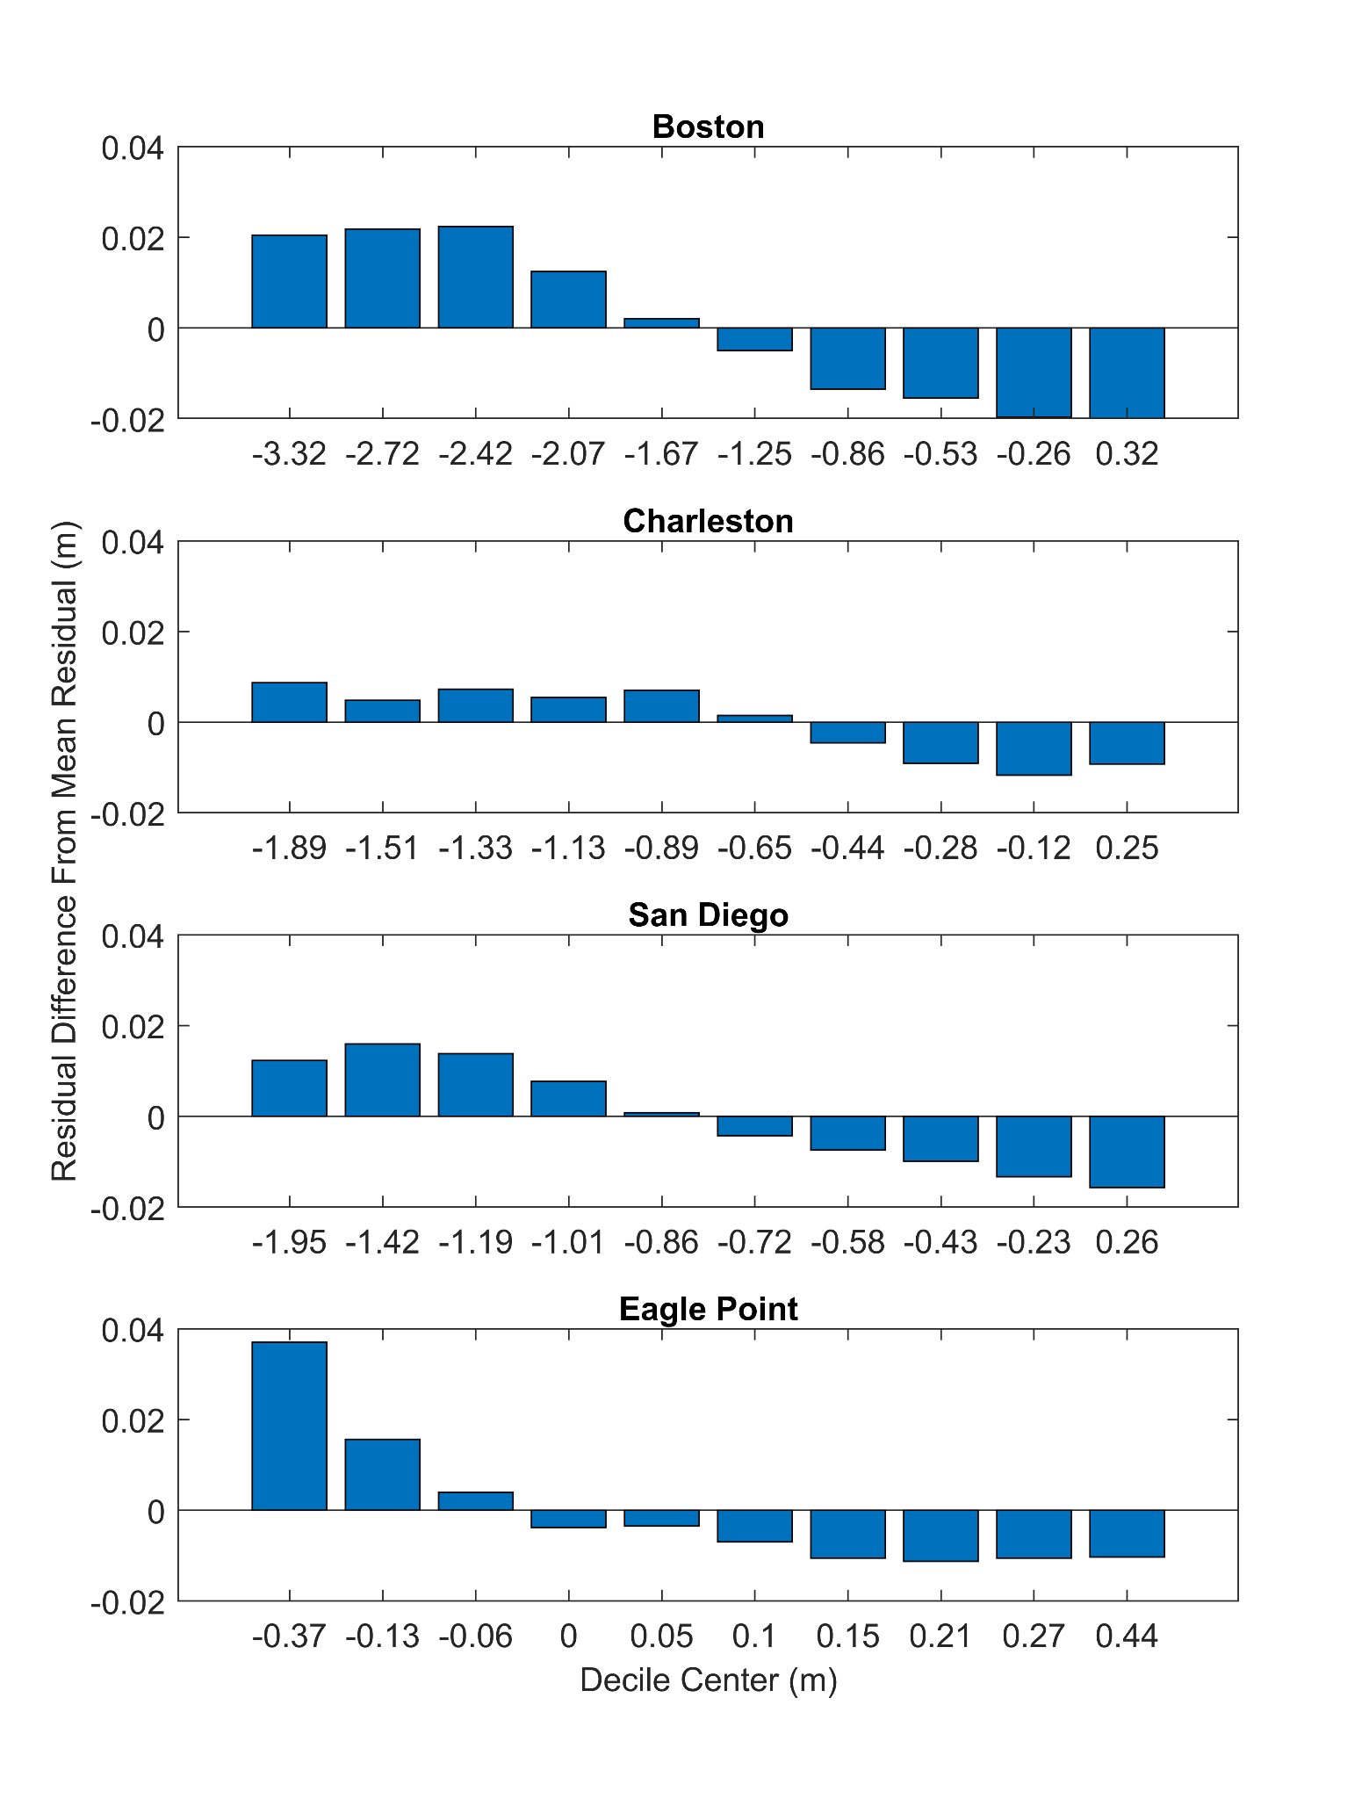

**Figure S1.** The difference between the mean non-tidal residual of the entire data record and the mean non-tidal residual for each decile of the tide elevation for each of the four example gauge locations. Note the substantial differences in mean residual at low and high tide, which requires accounting for the dependence on tidal elevation when developing the HTF prediction model.

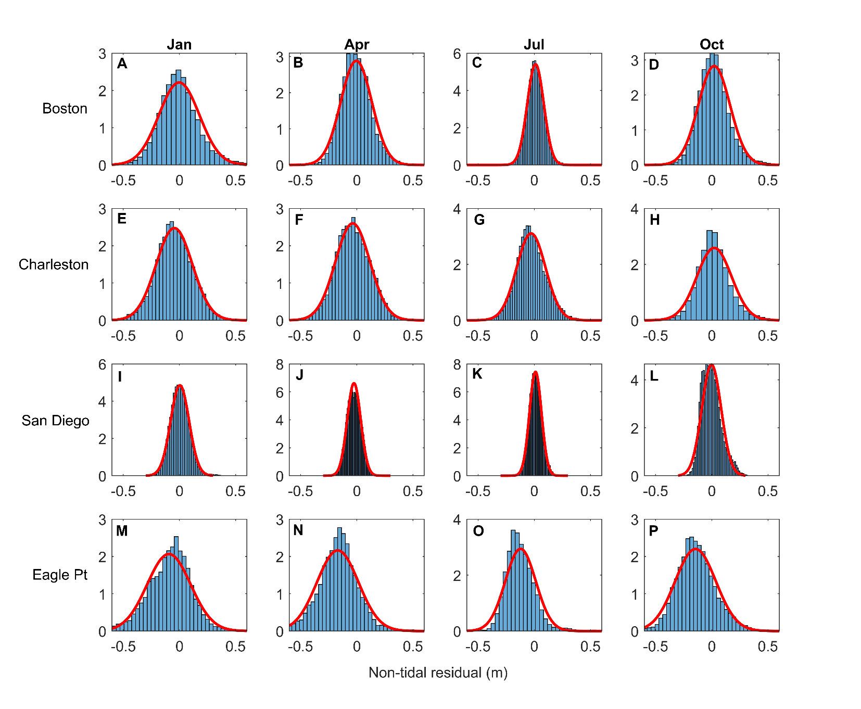

**Figure S2.** Examples of observed probability density functions (blue bars) and the normal fit (red curve) for all months of January, April, July and October over the 1997 – 2019 period for the four tide gauges at Boston, MA (A – D), Charleston, SC (E – H), San Diego, CA (I – L) and Eagle Point, TX (M – P).