Supplementary Material

# Supplementary materials caption

**Figure S1** | Funnel plot of the analysis for OS of 4 RCT(A) and 5 retrospective studies after the sensitivity analysis(B).

**Figure S2** | Egger’s plot of the analysis for OS of 4 RCTs(A) and 5 retrospective studies after the sensitivity analysis(B).

**Figure S3** | Egger’s tests for publication bias for BCRFS of 9 retrospective studies.

**Figure S4** | Begg’s and Egger’s tests for publication bias for OS of 4 RCT(A) and 5 retrospective studies after the sensitivity analysis(B) and for BCRFS of 9 retrospective studies(C).

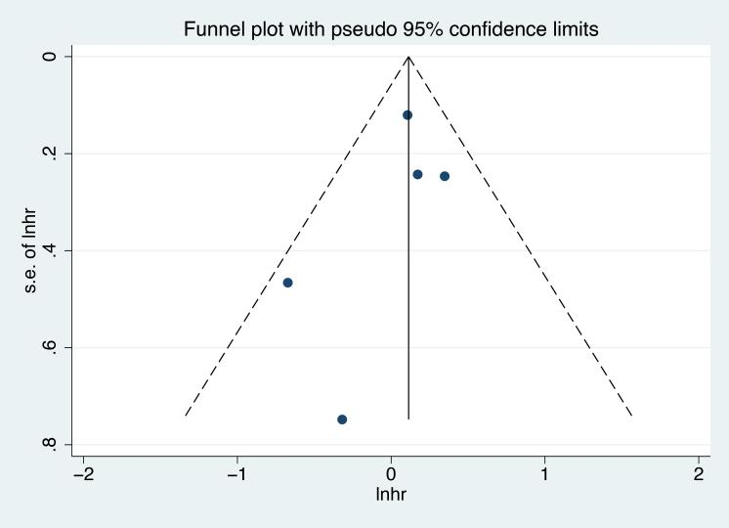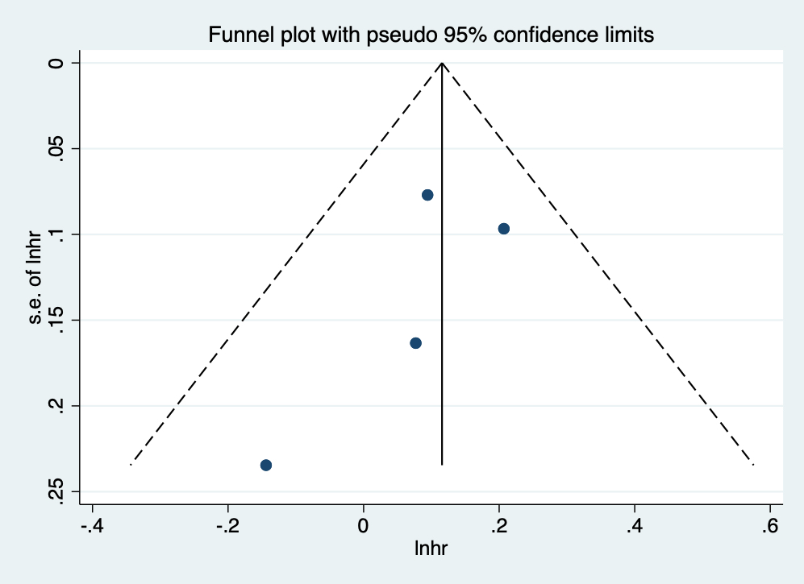A B

Figure S1| Funnel plot of the analysis for OS of 4 RCT(A) and 6 retrospective studies after the sensitivity analysis(B).

A B

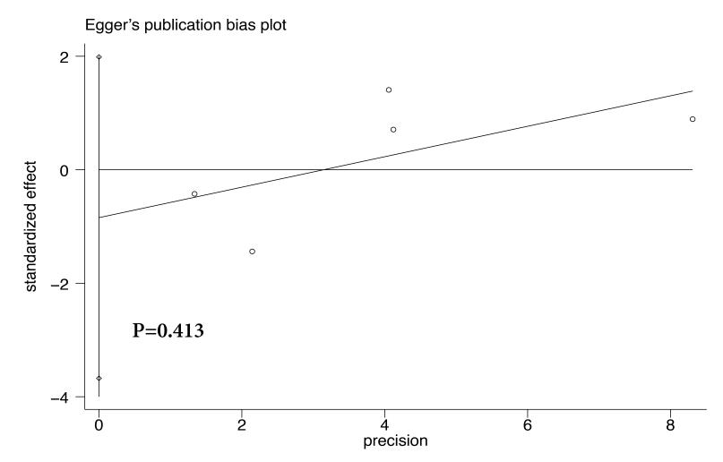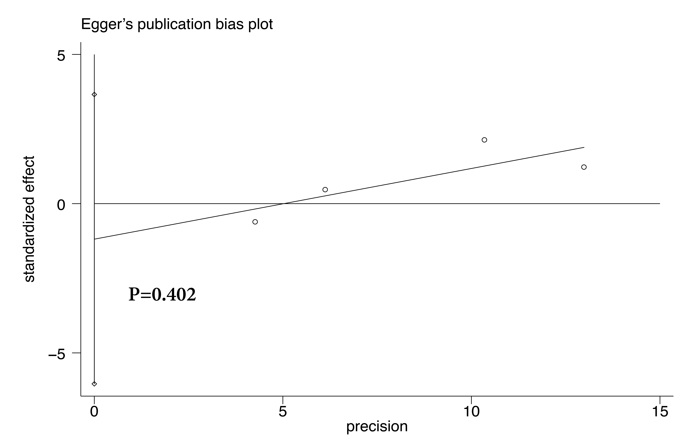

**Figure S2** | Egger’s plot of the analysis for OS of 4 RCTs(A) and 5 retrospective studies after the sensitivity analysis(B).

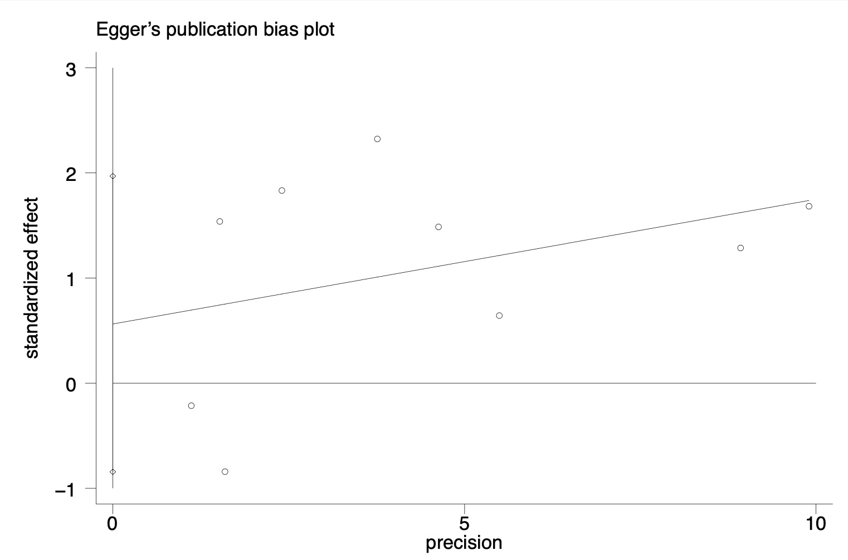

**Figure S3** | Egger’s tests for publication bias for BCRFS of 9 retrospective studies.

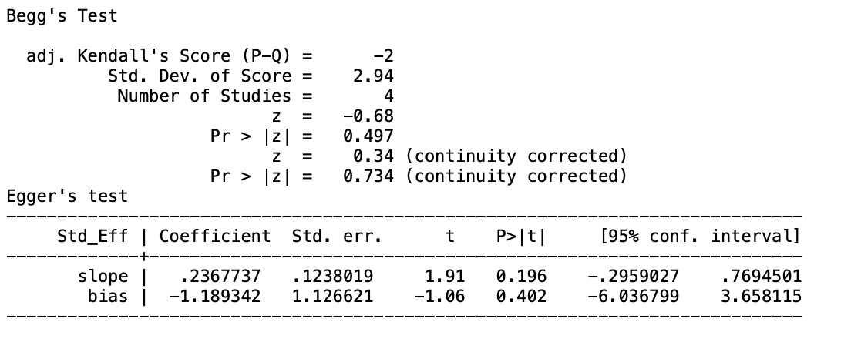**A**

**B**

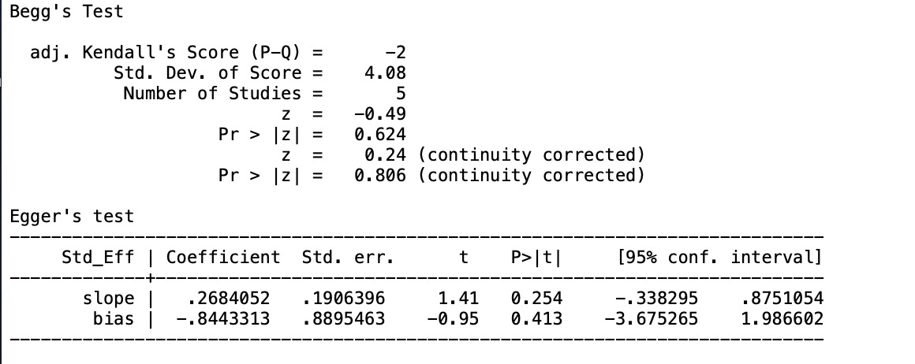

**C**

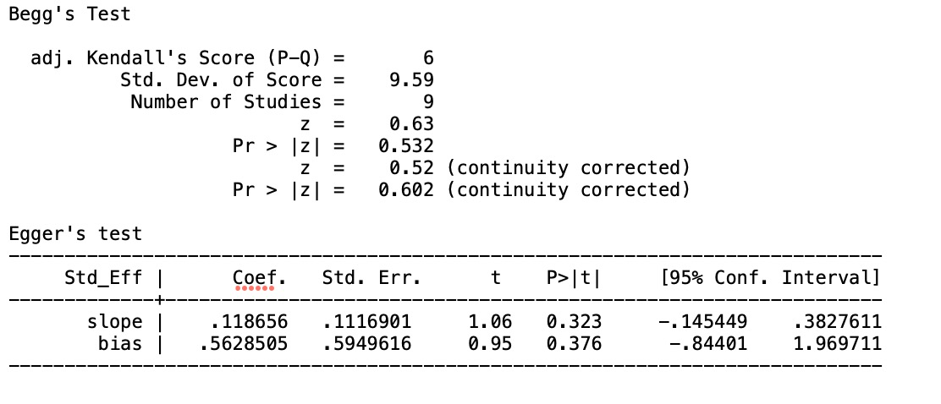

**Figure S4** | Begg’s and Egger’s tests for publication bias for OS of 4 RCT(A) and 5 retrospective studies after the sensitivity analysis(B) and for BCRFS of 9 retrospective studies(C).

