# SUPPLEMENTAL TABLES AND FIGURES

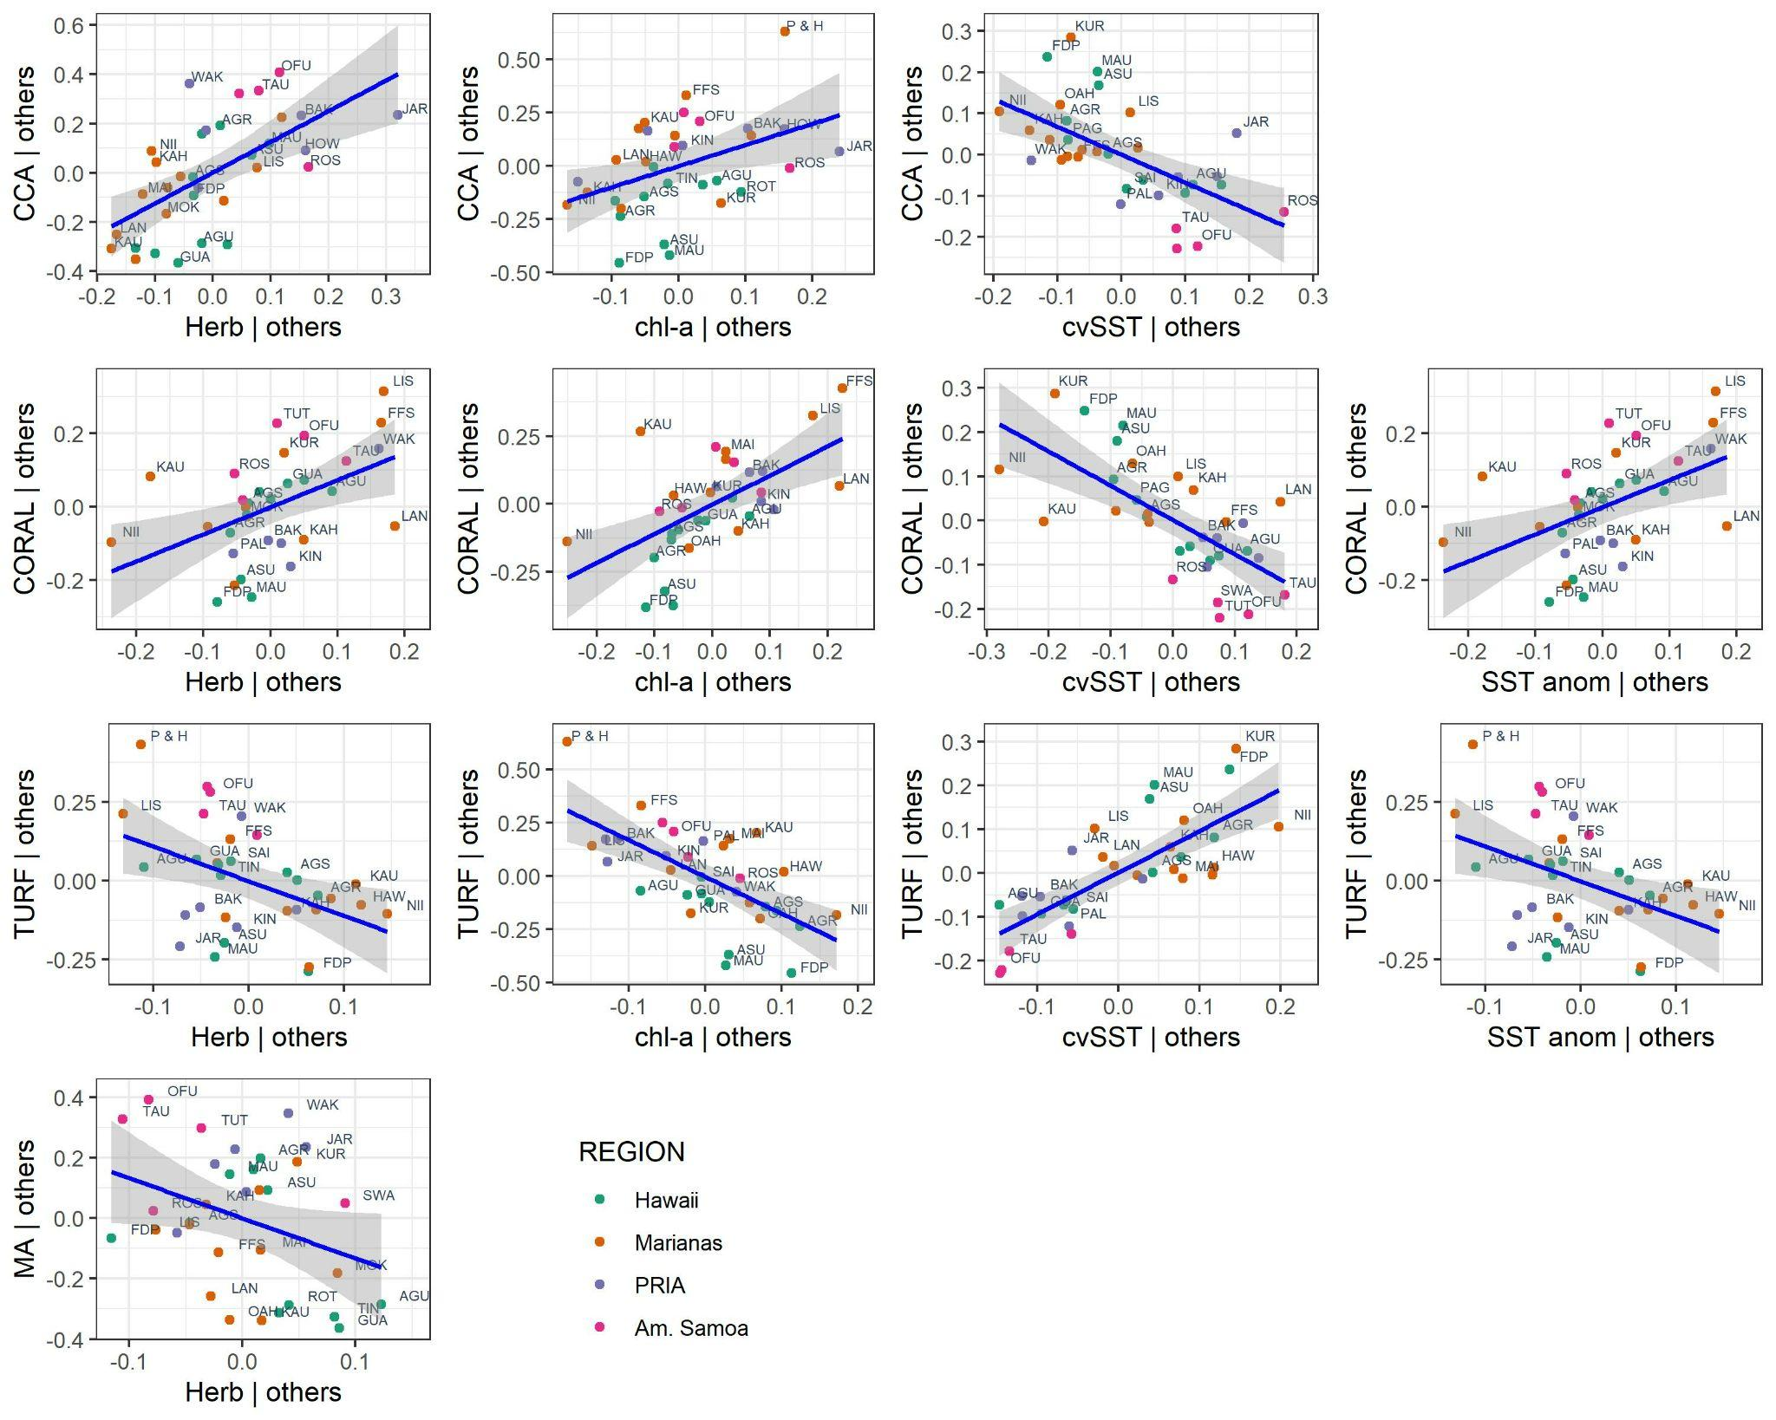

**Figure S1.**  Added variable plots for each of the significant environmental variables identified in the benthic cover beta regression models. Linear trend line (blue) and CI (gray) shown.

**Table S1**. Islands surveyed by region. Three letter island code, number of benthic survey sites (N), habitation status, and human population density (humans/reef area [hectare]) provided. Wake Island is not part of any archipelago but was grouped with the Line Islands as the Pacific Remote Island Area (PRIA). *Islands pooled due to small sample size per island.

|  |  |  |  |  |  |
| --- | --- | --- | --- | --- | --- |
| **Region** | **Island** | **Island Code** | **N** | **Habitation** | **Pop. Density** |
| Marianas | Agrihan | AGR | 26 | Uninhabited | 0 |
| Alamagan, Guguan, and Sarigan* | AGS | 117 | Uninhabited | 0 |
| Aguijan | AGU | 27 | Uninhabited | 0 |
| Asuncion | ASU | 31 | Uninhabited | 0 |
| Farallon de Pajaros | FDP | 28 | Uninhabited | 0 |
| Guam | GUA | 97 | Inhabited | 32.6 |
| Maug | MAU | 65 | Uninhabited | 0 |
| Pagan | PAG | 59 | Uninhabited | 0 |
| Rota | ROT | 41 | Inhabited | 43.26 |
| Saipan | SAI | 58 | Inhabited | 16.26 |
| Tinian | TIN | 38 | Inhabited | 2.22 |
| Hawaii | Hawaii | HAW | 120 | Inhabited | 12.68 |
| Kahoolawe | KAH | 30 | Uninhabited | 0 |
| Kauai | KAU | 37 | Inhabited | 3.69 |
| Lanai | LAN | 45 | Inhabited | 1.03 |
| Maui | MAI | 70 | Inhabited | 19.91 |
| Molokai | MOK | 60 | Inhabited | 0.68 |
| Niihau | NII | 24 | Inhabited | 0.03 |
| Oahu | OAH | 84 | Inhabited | 55.85 |
| French Frigate Shoal | FFS | 73 | Uninhabited | 0 |
| Kure | KUR | 58 | Uninhabited | 0 |
| Lisianski | LIS | 56 | Uninhabited | 0 |
| Pearl and Hermes | P&H | 75 | Uninhabited | 0 |
| PRIA | Baker | BAK | 23 | Uninhabited | 0 |
| Howland | HOW | 22 | Uninhabited | 0 |
| Jarvis | JAR | 67 | Uninhabited | 0 |
| Kingman | KIN | 68 | Uninhabited | 0 |
| Palmyra | PAL | 86 | Uninhabited | 0.01 |
| Wake | WAK | 81 | Inhabited | 0.36 |
| Am. Samoa | Ofu & Olosega* | OFU | 38 | Inhabited | 0.63 |
| Rose | ROS | 33 | Uninhabited | 0 |
| Swains | SWA | 22 | Uninhabited | 0.06 |
| Tau | TAU | 38 | Inhabited | 0.87 |
| Tutuila | TUT | 101 | Inhabited | 16.38 |

**Table S2**. Results from evaluating 2-factor ANCOVA assumptions of homogeneity of regression slopes (ANOVA interaction term between Latitude and the ANCOVA factors of Region and Remote), normality, and homogeneity of slope.

|  |  |  |  |
| --- | --- | --- | --- |
|  | **P values** | | |
| **Benthic Cover** | **ANOVA intxn term** | **Shapiro-Wilk test** | **Levene's test** |
| Coral | 0.244 | 0.251 | 0.176 |
| Macroalgae | 0.006 | 0.449 | 0.635 |
| Reef Builder | 0.223 | 0.823 | 0.110 |
| Fleshy Algae | 0.519 | 0.867 | 0.042 |

**Table S3**. The 14 explanatory variables considered for db-RDA, including their data sources. Chl-*a* = chlorophyll-a. DHW = degree heating weeks. * denotes variables excluded to alleviate collinearity due to │*r*│> 0.6. As the resolution of the SST and DHW satellite metrics was 5km, a 10km buffer was selected from which to extract all satellite data around each island to provide a greater number of data points from which to calculate island-scale averages.

|  |  |  |  |  |
| --- | --- | --- | --- | --- |
| **Variable** | | | **Trans-**  **formation** | **Data Source** |
|
| Latitude | *Lat | Decimal degrees latitude | -- |  |
| Productivity | chl-a | Long-term mean chl-a (mg m-3) | log10 | [noaa_snpp_chl-a_monthly_750m](https://oceanwatch.pifsc.noaa.gov/erddap/griddap/noaa_snpp_chla_monthly_750m.html) |
| *SDchl-*a* | SD, monthly chl-a (mg m-3) |  | noaa_snpp_chl-a_monthly_750m |
| CVchl-*a* | CV, monthly chl-a | sqrt | noaa_snpp_chl-a_monthly_750m |
| Past SST | *SST | Long-term mean of monthly SST (°C) | sqrt | [CRW_sst_v3_1_monthly](https://oceanwatch.pifsc.noaa.gov/erddap/griddap/CRW_sst_v3_1_monthly.html) |
| *SDSST | SD, monthly SST (°C) | log10 | CRW_sst_v3_1_monthly |
| CVSST | CV, monthly SST | log10 | CRW_sst_v3_1_monthly |
| *MMM | Max Monthly Mean Climatology (°C) | log10 | CRW_sst_v3_1_monthly |
| SST_anom | Mean of high-frequency (i.e., daily) SST anomaly (°C) | -- | [CRW_sst_anom_v1_0](https://oceanwatch.pifsc.noaa.gov/erddap/griddap/CRW_sst_anom_v1_0.html) |
| Heat stress | *MaxSST_anom | Max, daily SST anomaly (°C) | sqrt | CRW_sst_anom_v1_0 |
| MaxSST | Max, monthly SST (°C) | sqrt | CRW_sst_v3_1_monthly |
| DHW>8 | Freq. of DHW >8 | log10 | [CRW_dhw_v1_0](https://oceanwatch.pifsc.noaa.gov/erddap/griddap/CRW_dhw_v1_0.html) |
| Humans | PopDen | No. of Humans/reef area (ha) | log10 | U.S. Census & [Pacific Islands Benthic Habitat Mapping Center](https://www.soest.hawaii.edu/pibhmc/cms/) |
| Grazing pressure | Herb | Herbivore biomass (g m-3) | log10 | NCRMP |
|  | | | | |

**Table S4.** Data for explanatory variables retained in distance based redundancy (db-RDA) models for each island. Data were transformed as described in Table S2 prior to analysis.

|  |  |  |  |  |  |  |  |  |  |
| --- | --- | --- | --- | --- | --- | --- | --- | --- | --- |
| **Region** | **Island Code** | **Pop Den** | **chl-*a*** | **CVchl-*a*** | **MaxSST** | **CVSST** | **SST anom** | **DHW>8** | **Herb** |
| Marianas | AGR | 0 | 0.047 | 7.3 | 30.61 | 4.58 | 0.49 | 0.04 | 24.6 |
| AGS | 0 | 0.045 | 15.3 | 30.22 | 2.87 | 0.56 | 0.02 | 7.5 |
| AGU | 0 | 0.044 | 10.7 | 30.49 | 3.72 | 0.56 | 0.05 | 14.3 |
| ASU | 0 | 0.047 | 8.8 | 30.48 | 5.18 | 0.39 | 0.02 | 20.3 |
| FDP | 0 | 0.047 | 10.1 | 30.63 | 5.96 | 0.36 | 0.04 | 14.5 |
| GUA | 32.6 | 0.036 | 10.9 | 30.07 | 2.62 | 0.62 | 0.02 | 6 |
| MAU | 0 | 0.047 | 9.6 | 30.56 | 5.49 | 0.35 | 0.03 | 23.4 |
| PAG | 0 | 0.05 | 8.8 | 30.51 | 4.2 | 0.51 | 0.03 | 22.2 |
| ROT | 43.3 | 0.035 | 9.6 | 30.15 | 2.75 | 0.61 | 0.02 | 7.2 |
| SAI | 16.3 | 0.054 | 11.8 | 30.21 | 2.98 | 0.55 | 0.02 | 7.1 |
| TIN | 2.2 | 0.045 | 13.5 | 30.19 | 2.91 | 0.54 | 0.02 | 6.9 |
| Hawaii | HAW | 0 | 0.245 | 6.2 | 28.32 | 6.18 | 0.46 | 0.02 | 13.3 |
| KAH | 12.7 | 0.118 | 4.4 | 28.49 | 4.15 | 0.28 | 0.05 | 16.6 |
| KAU | 0 | 0.077 | 10 | 28.84 | 4.4 | 0.35 | 0.04 | 18.5 |
| LAN | 3.7 | 0.19 | 9.1 | 28.18 | 4.88 | 0.34 | 0 | 8.1 |
| MAI | 0 | 0.082 | 18.1 | 28.4 | 12.29 | 0.76 | 0.02 | 24.6 |
| MOK | 1 | 0.132 | 6.6 | 28.71 | 4.51 | 0.28 | 0.04 | 9.7 |
| NII | 0 | 0.124 | 4.3 | 28.99 | 8.79 | 0.78 | 0.03 | 14.2 |
| OAH | 19.9 | 0.197 | 7 | 28.27 | 4.4 | 0.22 | 0.04 | 14.3 |
| FFS | 0.7 | 0.191 | 27 | 28.18 | 4.5 | 0.21 | 0.03 | 12 |
| KUR | 0 | 0.07 | 7.8 | 28.5 | 5.06 | 0.39 | 0 | 20.6 |
| LIS | 55.9 | 0.091 | 5.6 | 28.08 | 4.59 | 0.21 | 0 | 8.2 |
| PHR | 0 | 0.435 | 10.7 | 28.37 | 11.28 | 0.84 | 0.03 | 9.6 |
| PRIA | BAK | 0 | 0.206 | 19.1 | 30.48 | 3.51 | 0.07 | 0.09 | 31.9 |
| HOW | 0 | 0.208 | 18.8 | 30.44 | 3.44 | 0.06 | 0.08 | 23.2 |
| JAR | 0 | 0.233 | 10.7 | 30.51 | 4.57 | -0.02 | 0.12 | 34.8 |
| KIN | 0 | 0.141 | 21.6 | 29.71 | 2.45 | 0.04 | 0 | 16.3 |
| PAL | 0 | 0.166 | 28.2 | 29.72 | 2.48 | 0.03 | 0 | 27.8 |
| WAK | 0.4 | 0.041 | 7 | 30.04 | 4.37 | 0.74 | 0 | 31.2 |
| American Samoa | OFU | 0.6 | 0.066 | 15 | 30.13 | 2.3 | 0.56 | 0.03 | 35.5 |
| ROS | 0 | 0.041 | 23.7 | 30.12 | 2.42 | 0.59 | 0.01 | 14.8 |
| SWA | 0.1 | 0.054 | 20 | 30.38 | 1.81 | 0.4 | 0 | 16.6 |
| TAU | 0.9 | 0.052 | 23 | 30.14 | 2.34 | 0.55 | 0.03 | 30.3 |
| TUT | 16.4 | 0.072 | 16.3 | 30.05 | 2.37 | 0.58 | 0.03 | 28.5 |

**Table S5.** Beta regression models for four benthic cover components. Pseudo R2 values are provided for the model. Significant explanatory variables shown in bold. Outliers removed per benthic group: CCA - Swains; Coral - Jarvis, Pearl and Hermes; Turf - Swains; Macroalgae - Pearl and Hermes.

|  |  |  |  |  |  |
| --- | --- | --- | --- | --- | --- |
| **a) CCA** | **Estimate** | **Std. Error** | **z value** | **Pr(>|z|)** | **Psuedo R2** |
| (Intercept) | -0.966 | 0.077 | -12.57 | <0.001 | 0.54 |
| **chl-a** | 0.326 | 0.107 | 3.06 | **0.002** |  |
| SST anom | 0.176 | 0.102 | 1.74 | 0.083 |  |
| **CVSST** | -0.421 | 0.101 | -4.16 | **<0.001** |  |
| **Herbivore biomass** | 0.343 | 0.078 | 4.38 | **<0.001** |  |
| **b) Coral** | |  |  |  |  |
| (Intercept) | -0.55 | 0.069 | -8.07 | <0.001 | 0.49 |
| **chl-a** | 0.44 | 0.115 | 3.83 | **<0.001** |  |
| **SST anom** | 0.33 | 0.111 | 2.98 | **0.003** |  |
| **CVSST** | -0.42 | 0.088 | -4.82 | **<0.001** |  |
| **Herbivore biomass** | 0.15 | 0.07 | 2.21 | **0.027** |  |
| **c) Turf** | |  |  |  |  |
| (Intercept) | 1.053 | 0.063 | 16.77 | <0.001 | 0.68 |
| **chl-a** | -0.464 | 0.088 | -5.28 | **<0.001** |  |
| **SST anom** | -0.233 | 0.082 | -2.83 | **0.005** |  |
| **CVSST** | 0.529 | 0.085 | 6.25 | **<0.001** |  |
| **Herbivore biomass** | -0.338 | 0.064 | -5.32 | **<0.001** |  |
| **d) Macroalgae** | |  |  |  |  |
| (Intercept) | -1.763 | 0.08 | -22.01 | <0.001 | 0.34 |
| chl-a | -0.114 | 0.126 | -0.9 | 0.366 |  |
| SST anom | 0.222 | 0.121 | 1.84 | 0.066 |  |
| CVSST | 0.06 | 0.095 | 0.64 | 0.525 |  |
| **Herbivore biomass** | -0.164 | 0.077 | -2.14 | **0.033** |  |

**Table S6.** Mean Kd490 (m-1) data for each island extracted for the same spatial and temporal extent as the other remotely senses explanatory variable. NOAA ERDDAP Data source: esa-cci-kd-monthly-v6-0.

|  |  |  |  |
| --- | --- | --- | --- |
| **Region** | **Island Code** | **Kd490** | **SE** |
| Marianas | AGR | 0.028 | 0.0002 |
| AGU | 0.028 | 0.0002 |
| AGS | 0.027 | 0.0002 |
| ASU | 0.028 | 0.0002 |
| FDP | 0.028 | 0.0002 |
| GUA | 0.031 | 0.0004 |
| MAU | 0.028 | 0.0002 |
| PAG | 0.028 | 0.0002 |
| ROT | 0.028 | 0.0002 |
| SAI | 0.035 | 0.0006 |
| TIN | 0.031 | 0.0003 |
| Hawaii | HAW | 0.034 | 0.0004 |
| KAH | 0.032 | 0.0003 |
| KAU | 0.039 | 0.0006 |
| LAN | 0.034 | 0.0004 |
| MAI | 0.036 | 0.0005 |
| MOK | 0.040 | 0.0009 |
| NII | 0.035 | 0.0004 |
| OAH | 0.040 | 0.0007 |
| FFS | 0.078 | 0.0008 |
| KUR | 0.060 | 0.0014 |
| LIS | 0.088 | 0.0018 |
| P & H | 0.107 | 0.0017 |
| PRIA | BAK | 0.039 | 0.0005 |
| HOW | 0.039 | 0.0004 |
| JAR | 0.041 | 0.0004 |
| KIN | 0.040 | 0.0006 |
| PAL | 0.049 | 0.0015 |
| WAK | 0.029 | 0.0003 |
| American Samoa | OFU | 0.028 | 0.0002 |
| ROS | 0.034 | 0.0009 |
| SWA | 0.027 | 0.0001 |
| TAU | 0.028 | 0.0002 |
| TUT | 0.031 | 0.0003 |