Supplementary Material

## Supplementary Figures and Tables

## Supplementary Figures

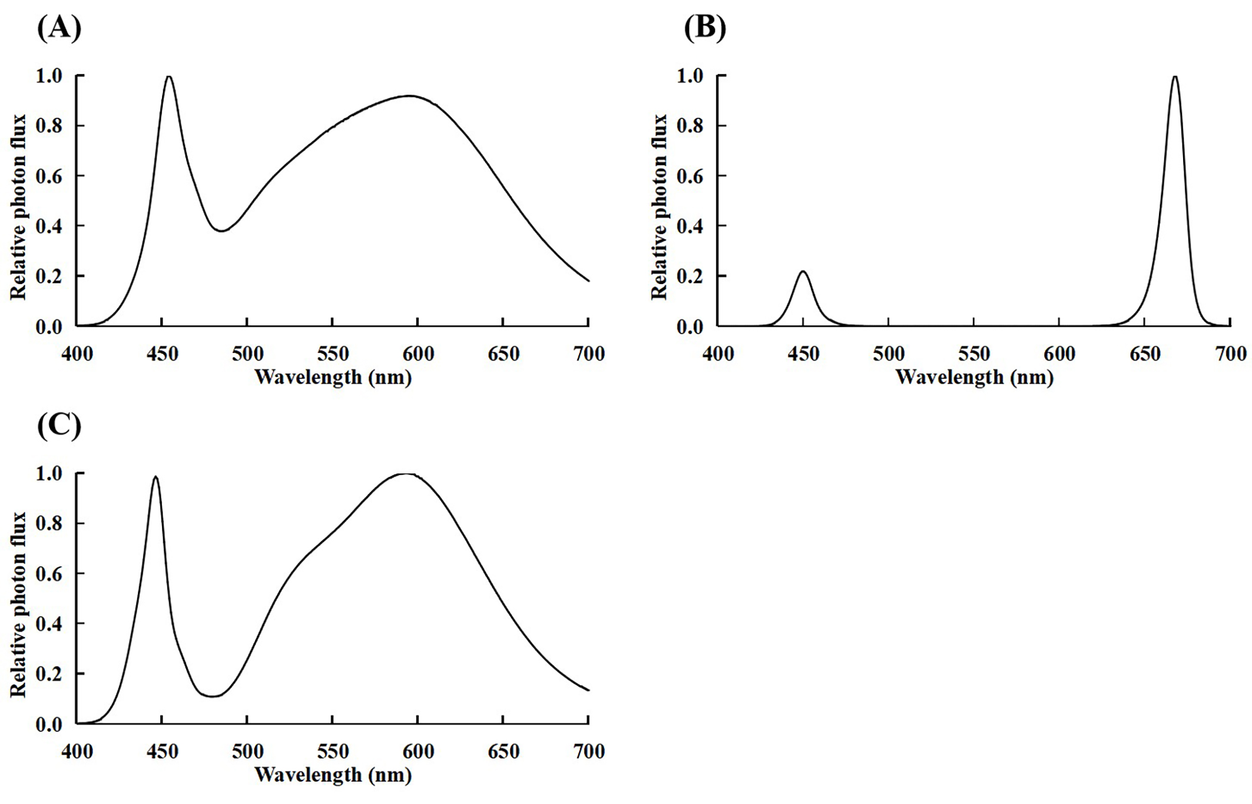**Supplementary Figure 1. Spectral photon flux distributions of (A) white lamps (LDL40S-N19/21) until 24 days after sowing (DAS), (B) red and blue (red:blue = 9:1) LED lamps (CIVILIGHT) from 24–35 DAS, and (C) white LED lamps (customized lamp) after 35 DAS.** The maximum value of photon flux was converted to 1.0.

## Supplementary Figure 2. The total dry weight of a ‘Micro-Tom’ plant from 36 to 84 days after sowing (DAS) in different photosynthetic photon flux density (PPFD) treatments in a preliminary experiment (A) and present experiment (B).

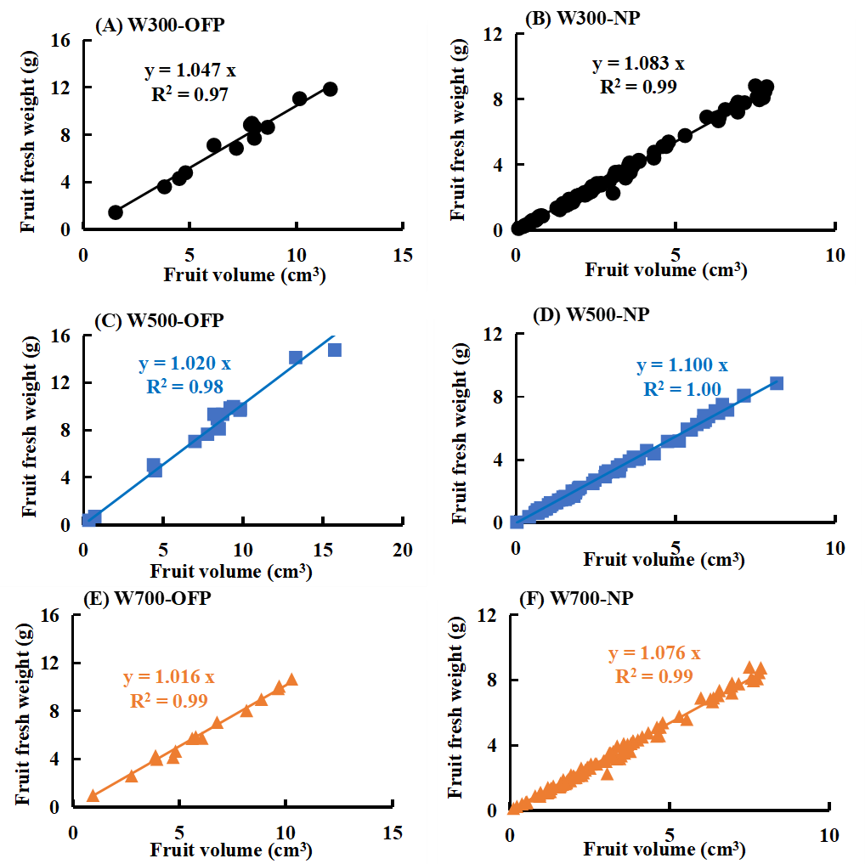

**Supplementary Figure 3. The relationships between individual fruit fresh weight and volume of one-fruit plants (A) and plants without fruit pruning (B) in W300, of one-fruit plants (C) and plants without fruit pruning (D) in W500, and one-fruit plants (E) and plants without fruit pruning (F) in W700.** There were 15–16 fruits of one-fruit plants, and 77–104 fruits of plants without fruit pruning sampled in each PPFD treatment.

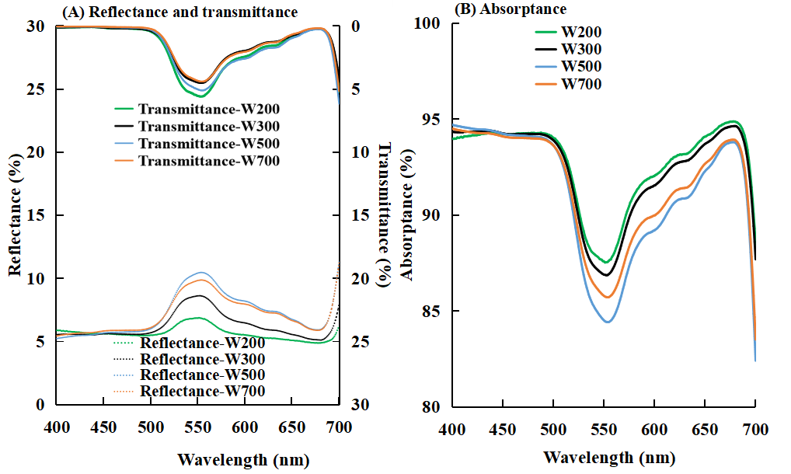

**Supplementary Figure 4. Effects of PPFD on the spectra of reflectance and transmittance (A) and absorptance (B) of leaves in ‘Micro-Tom’ 82 DAS.** The range of measured light spectrum was 400–700 nm. W200, W300, W500, and W700 denote 200, 300, 500, and 700 µmol m−2 s−1 PPFD, respectively. Each value represents the average of the values of four NPs.

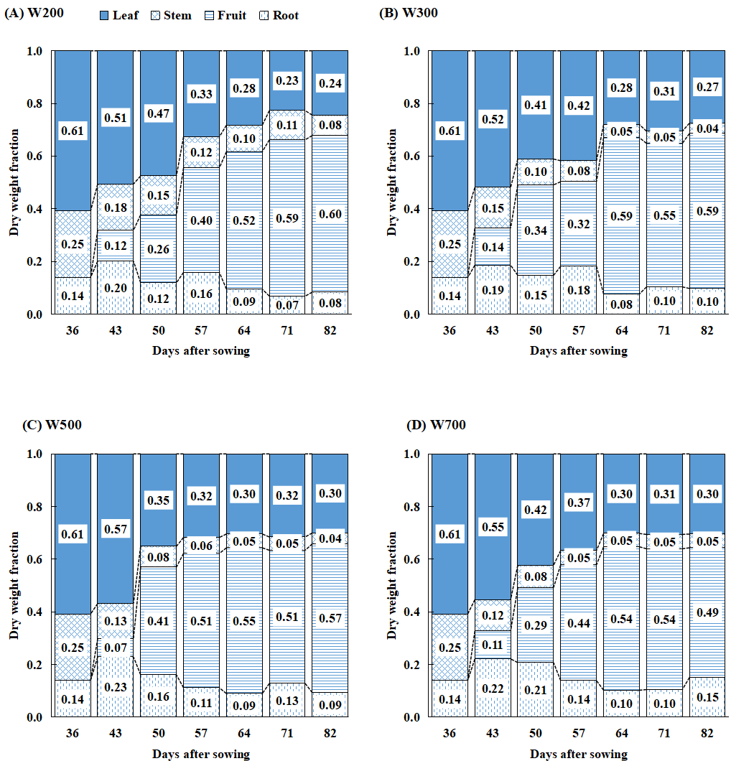

**Supplementary Figure 5. Fractions of dry mass partitioned to each organ in W200 (A), W300 (B), W500 (C), and W700 (D) treatments in ‘Micro-Tom’ 36, 43, 50, 57, 64, 71, and 82 days after sowing (DAS).** Each value represents the mean of three or four values. All sampled plants are NPs.



**Supplementary Figure 6. The relation between fruit age and dry matter content of one-fruit plants in W300, W500, and W700 treatments.** There were 11–15 fruits sampled in each PPFD treatment. Curves represent the 4th-degree (or 3rd-degree) polynomial function used to fit the data in the three treatments (Equation 6). Goodness of fit of fitted curves are shown in the box. SSE, R2, adjusted R2, and RMSE represent the sum of squares due to error, coefficient of determination, degree-of-freedom adjusted coefficient of determination, and root mean squared error, respectively.

## Supplementary Tables

**Supplementary Table 1. Goodness of fit of the fitted total dry weight curves related to Equation 4 in the present study.** The SSE, R2, adjusted R2, and RMSE represent the sum of squares due to error, coefficient of determination, degree-of-freedom adjusted coefficient of determination, and root mean squared error, respectively.

|  |  |  |  |  |
| --- | --- | --- | --- | --- |
| Treatment | SSE | R2 | Adjusted R2 | RMSE |
| W200 | 2.1 | 0.97 | 0.96 | 0.64 |
| W300 | 2.6 | 0.97 | 0.96 | 0.72 |
| W500 | 3.9 | 0.96 | 0.94 | 0.99 |
| W700 | 5.1 | 0.96 | 0.95 | 1.13 |

**Supplementary Table 2. Effects of PPFD on parameters of fruit biomass radiation-use efficiency (FBRUE) component analyses.** The results are shown in Fig. 6. Abbreviations within the table are as follows: FBRUE, fruit biomass radiation-use efficiency, g mol−1; RUE, radiation use efficiency, g mol−1; Ffruits, fraction of dry mass partitioned to fruits, g g–1; IPPFD, integrated PPFD received by the plant until 82 DAS, mol; W, total dry weight, g; Wfruit, fruit dry weight, g; PPFDT, difference between the PPFDs at the top and bottom of the plant (mol m− 2 s− 1); and average PLA, average projected leaf area, m2. All sampled plants were treated with NPs. All values except FBRUE, RUE, and IPPFD represent the mean ± standard error. Different letters indicate significant differences at *p* < 0.05 (*n* = 3−4) among PPFD treatments with Tukey−Kramer’s test.

|  |  |  |  |  |  |  |  |  |
| --- | --- | --- | --- | --- | --- | --- | --- | --- |
| **Treatment** | **FBRUE**  **(g mol−1)** | **RUE**  **(g mol−1)** | **Ffruits**  **(g g–1)** | **IPPFD**  **(mol)** | **W**  **(g)** | **Wfruit**  **(g)** | **PPFDT**  **(mol m−2 s−1)** | **Average PLA**  **(m2)** |
| W200 | 0.59 | 1.00 | 0.59 ± 0.06 a | 11.0 | 10.97 ± 0.46 b | 6.53 ± 0.70 c | 192.2 ± 0.5 d | 180.7 ± 11.2 a |
| W300 | 0.61 | 1.04 | 0.59 ± 0.03 a | 10.5 | 10.90 ± 1.78 b | 6.41 ± 1.05 c | 297.0 ± 0.6 c | 119.5 ± 3.4 b |
| W500 | 0.48 | 0.85 | 0.57 ± 0.02 a | 15.8 | 13.41 ± 1.10 ab | 7.58 ± 0.56 b | 495.4 ± 1.13 b | 117.2 ± 3.7 b |
| W700 | 0.38 | 0.78 | 0.49 ± 0.03 b | 23.1 | 18.00 ± 0.89 a | 8.86 ± 0.83 a | 693.6 ± 1.7 a | 117.2 ± 3.6 b |

**Supplementary Table 3. Effects of fruit pruning on** **volume, fresh and dry weights, and dry matter content 42 days after anthesis (DAA) in W300, W500, and W700 treatments.** Each value represents the mean ± standard error.

|  |  |  |  |  |  |  |
| --- | --- | --- | --- | --- | --- | --- |
| **Treatment** | **PPFD**  **(μmol m–2 s–1)** | **Pruning treatment** | **Fruit age (DAA)** | **Fruit volume**  **(cm3)** | **Single fruit fresh weight (g/fruit)** | **Single fruit dry weight (g/fruit)** |
| W300 | 300 | One-fruit plants | 42 | 8.76 ± 0.95 | 9.54 ± 0.85 | 0.98 ± 0.11 |
| Plants with one fruit per truss | 9.78 ± 0.36 | 10.59 ± 0.39 | 1.00 ± 0.04 |
| W500 | 500 | One-fruit plants | 42 | 9.14 ± 0.78 | 9.59 ± 0.86 | 1.12 ± 0.05 |
| Plants with one fruit per truss | 7.93 ± 1.38 | 8.63 ± 1.60 | 1.00 ± 0.14 |
| W700 | 700 | One-fruit plants | 42 | 8.55 ± 0.83 | 8.64 ± 0.97 | 1.30 ± 0.13 |
| Plants with one fruit per truss | 8.72 ± 1.21 | 8.59 ± 1.37 | 1.09 ± 0.17 |

**Supplementary Table 4. List of abbreviations and symbols.**

|  |  |  |
| --- | --- | --- |
| **Abbreviation or symbol** | **Full name or description** | **Unit** |
| DAS | Days after sowing | days |
| DLI | Daily light integral | mol m–2 d–1 |
| EC | Electrical conductivity | dS m–1 |
| FBRUE | Fruit biomass radiation-use efficiency | g mol−1 |
| Ffruits | Fraction of dry mass portioned to fruits | - |
| *IDMCfruit(x)* | Dry matter content of individual fruits at *x* days after anthesis (DAA) | - |
| *IGRfruit* | Growth rate of individual fruit | g d–1 |
| IPPFD | Integrated PPFD | mol |
| *IWmax* | Maximum dry weight of individual fruit | g |
| *k* | Growth rate coefficient | **-** |
| LA | Leaf area | cm2 |
| PFAL | Plant factory with artificial light | **-** |
| *PLA(t)* | Projected leaf area of the plant on day *t* | m2 |
| Pmax | Maximum net photosynthetic rate | µmol m−2 s−1 |
| Pn | Net photosynthetic rate | µmol m−2 s−1 |
| PPFD | Photosynthetic photon flux density | µmol m−2 s−1 |
| *PPFD(t)* | PPFD at the bottom of the canopy on day *t* | mol m–2 s–1 |
| *PPFDT* | PPFD at the top of the canopy | mol m–2 s–1 |
| RUE | Radiation-use efficiency | g mol−1 |
| Sfruit-sink | Fruit sink strength | g d−1 |
| SLA | Specific leaf area | cm2 g−1 |
| Ssource | Source strength | g d−1 |
| W | Total dry weight | g |
| *Wfruits* | Fruit dry weight | g |
| *x* | Fruit age | DAA |
| *xm* | Fruit age at the maximum growth rate | DAA |
| ϕ | Photosynthetic quantum yield | mmol CO2 / mol photon |