Supplementary Material

# Supplementary Figures and Tables

The supplementary material contains additional information on numerical simulations of the 2 L, 100 L and 500 L perfusion bioreactors.

## Reactor setup

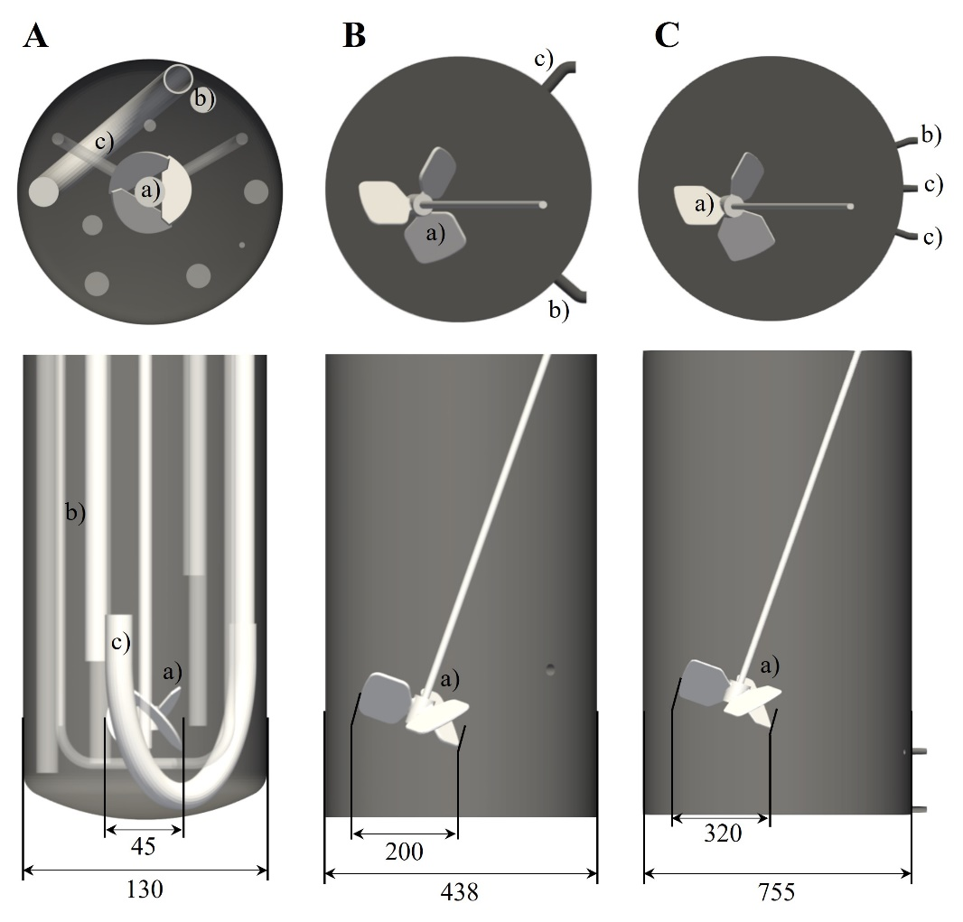

**Supplementary Figure 1 |** Geometry of the 2 L laboratory bioreactor (A), 100L pilot scale (B) and 500L pilot scale bioreactor (C). Dimensioning is given in mm. Depicted sizes do not match real proportions between reactor scales but are scaled to the same size. The letters a), b) and c) indicate impeller, retentate pipe (reactor inlet) and perfusion feed (reactor outlet) respectively. In case of the 500L bioreactor the perfusion feed flow was distributed to two tubes.

## Grid study

To ensure grid independence a grid study was performed for each reactor scale. Grid independence was reached for the power number as well for the kinetic energy for a number of points along the domain edge of LX=250 for the 2 L reactor scale. This value corresponds to 25.2 million grid points. For 100 L LX=200 was sufficient, corresponding to 13.7 million grid points, whereas grid independence was reached for LX=200 in case of the 500 L pilot scale reactor, which is equivalent to 14.5 million grid points.



Supplementary Figure 2 | Grid independence study for 2 L, 100 L and 500 L perfusion bioreactor in terms of power number and kinetic energy. Mean values of the time averaged profile are depicted by the black dots and the error bars indicate the fluctuations over time.

## Streamlines in the 2L lab scale perfusion bioreactor

To obtain a better picture from the flow field within the 2L perfusion bioreactor, supplementary figure 3 and 4 show streamlines depicted in the manuscript in figure 4 and 5 from a different angle.

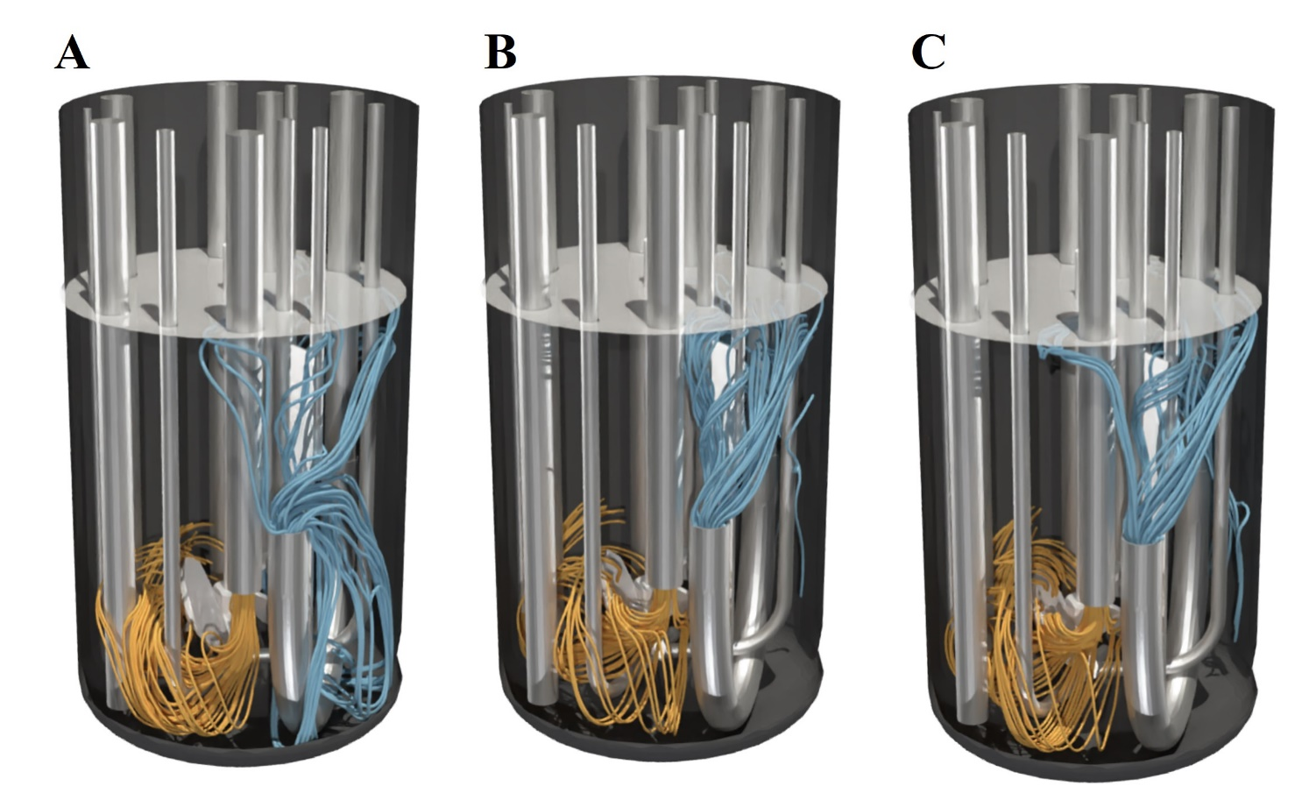

**Supplementary Figure 3** | Streamlines in 2 L bioreactor of setup I from a different angle at several power inputs (A) 10 W/m³, (B) 27 W/m³ and (C) 58 W/m³. Streamlines calculated forwards in orange as inflow and streamlines calculated backwards in blue as outflow. The surface color indicates the topology of the vortex.

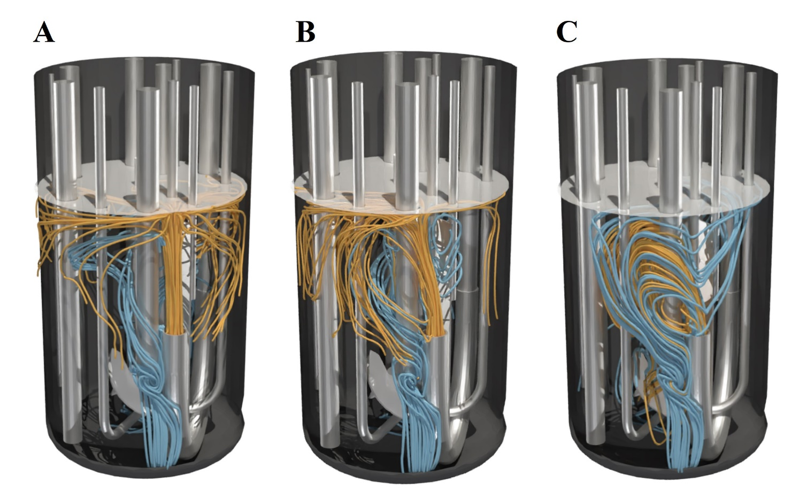

**Supplementary Figure 4** | Streamlines in 2 L bioreactor of setup II from a different angle at several power inputs (A) 10 W/m³, (B) 27 W/m³ and (C) 58 W/m³. Streamlines calculated forwards in orange as inflow and streamlines calculated backwards in blue as outflow. The surface color indicates the topology of the vortex.