Supplementary Material
A.  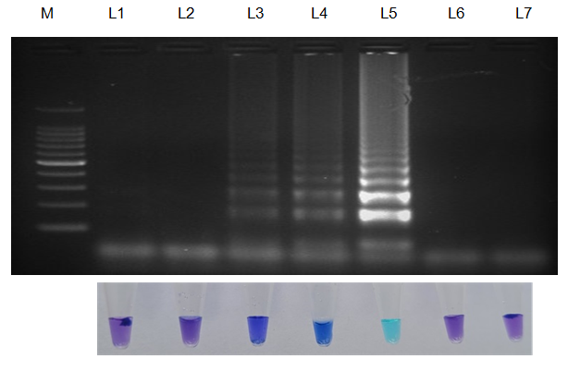 | B.  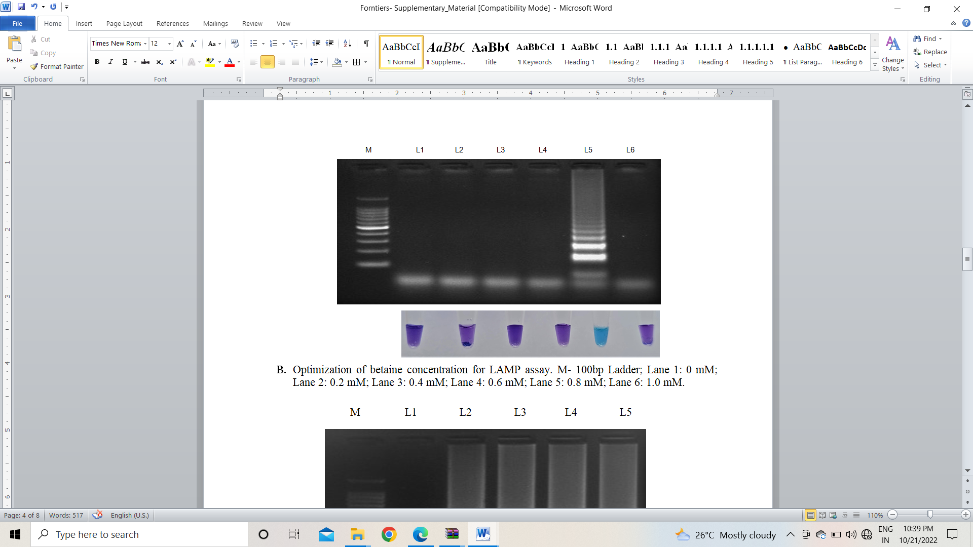
C.  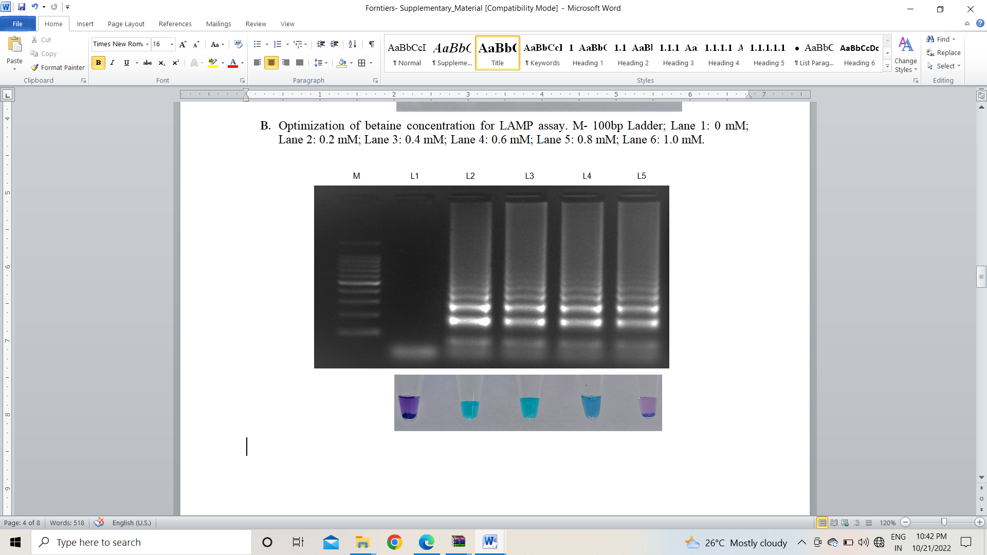 | D.  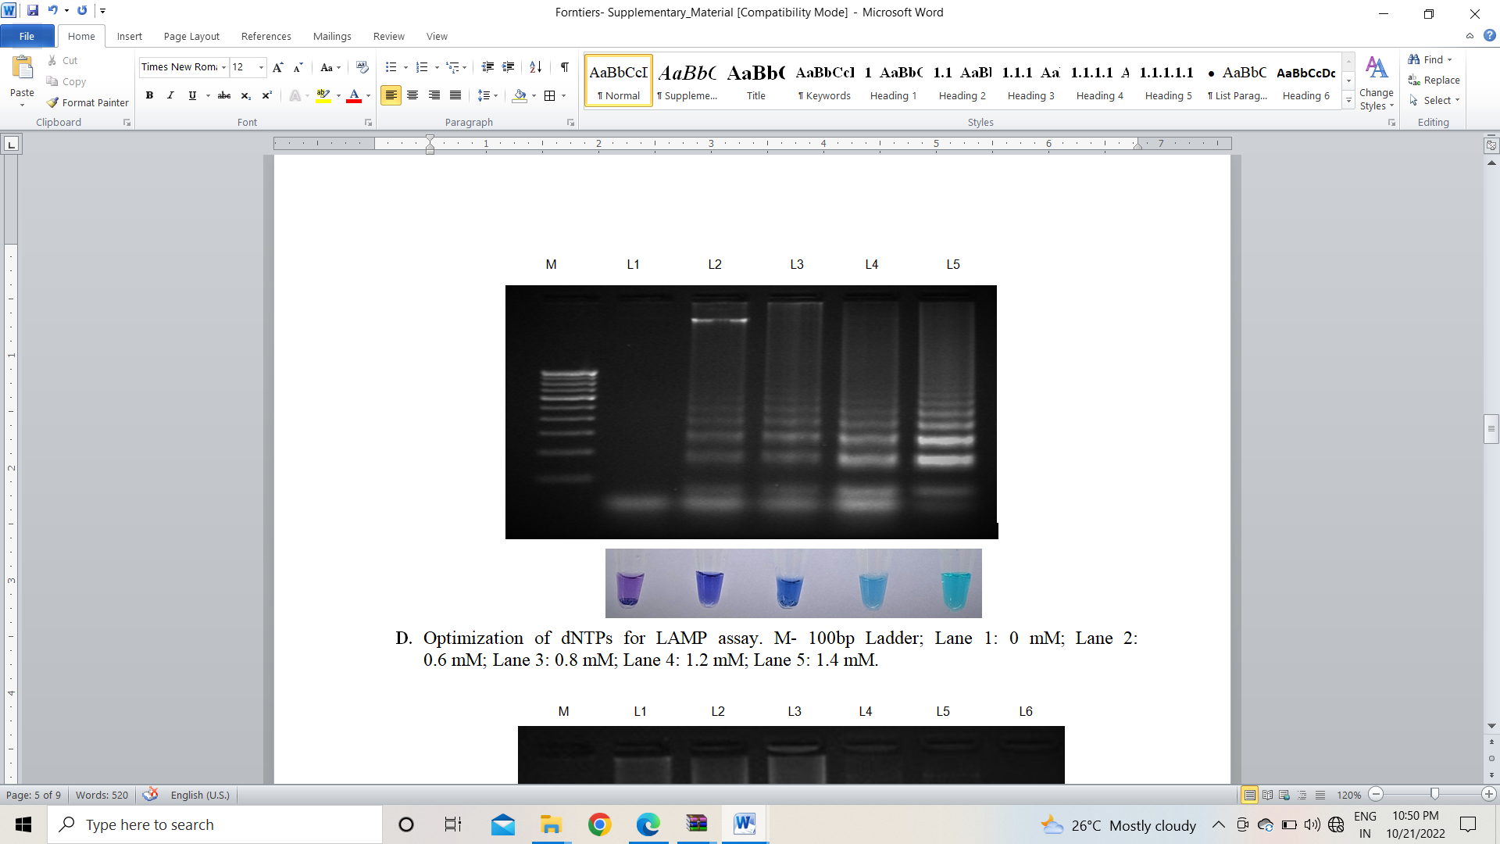
E.
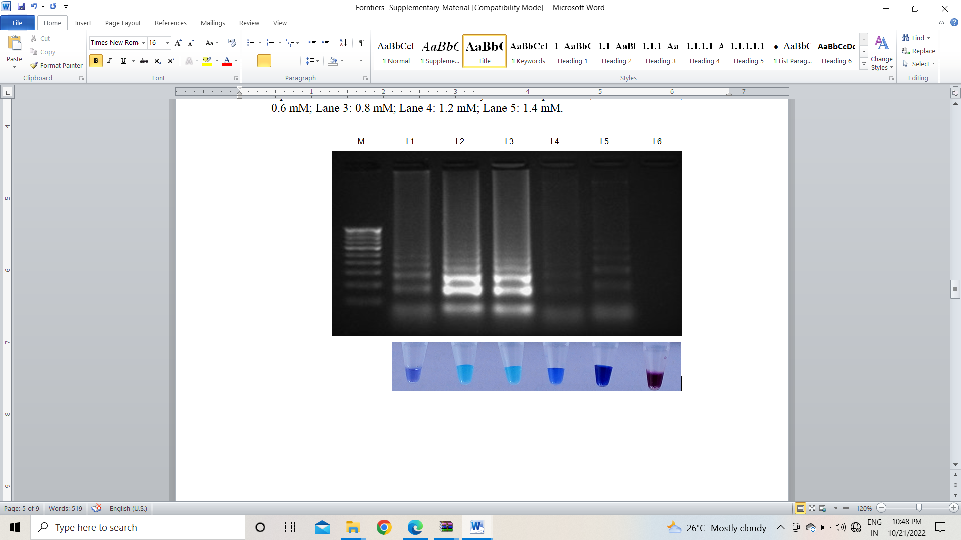
Figure S1: Optimization of LAMP assay components. Bright sky blue colour represents positive reaction while the violet colour indicates the negative reaction. Total DNA isolated from fungi were used as the template. Upper panel in the figure shows agarose gel electrophoresis results whereas lower panel shows reaction tubes for colorimetric detection. M- 100bp Ladder A. MgSO₄ concentration Lane 1-7: 0mM, 2mM, 4mM, 6mM, 8mM, 10mM, Nuclease free water(Control). B. Betaine concentration Lane 1-6: 0 mM, 0.2 mM, 0.4 mM, 0.6 mM, 0.8 mM, 1.0 mM. C. Bst DNA Polymerase Lane 1-5: 0U, 2U, 4U, 6U, 8U D. dNTPs concentration Lane 1-5: 0 mM, 0.6 mM, 0.8 mM, 1.2 mM, 1.4 mM. E. HNB dyes Lane 1-5: 80 µM, 100 µM, 120 µM, 148 µM, 300 µM.

A.  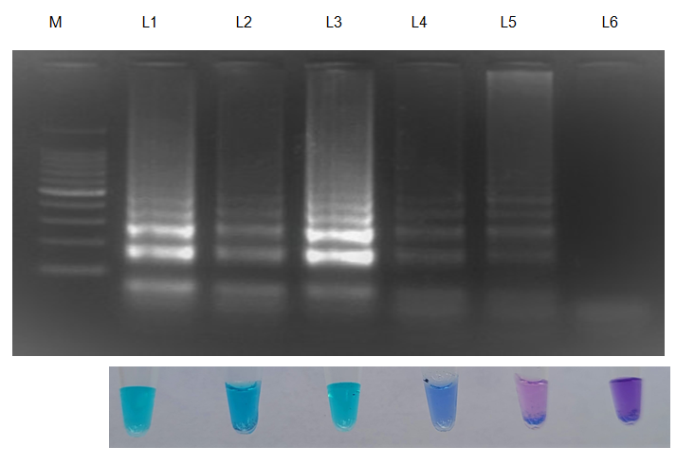 | B.  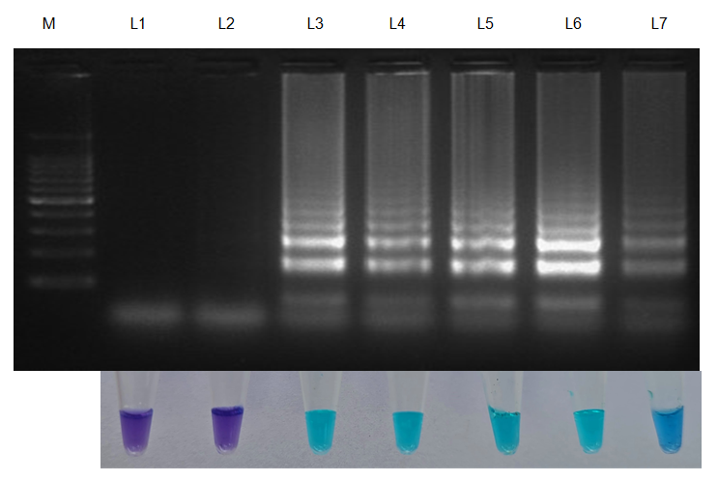
Figure S2: Optimization of LAMP conditions. Bright sky blue colour represents positive reaction while the violet colour indicates the negative reaction. Total DNA isolated from fungi was used as the template. Upper panel in the figure shows agarose gel electrophoresis results whereas lower panel shows reaction tubes for colorimetric detection. M- 100bp Ladder;
A. Reaction temperature Lane 1-6: 56 °C, 60 °C, 65 °C, 69 °C, 70 °C, Nuclease free water (Control)
B. Reaction time Lane 1-7: 10 min, 20 min, 30 min, 60 min, 90 min, 120 min, 150 min.

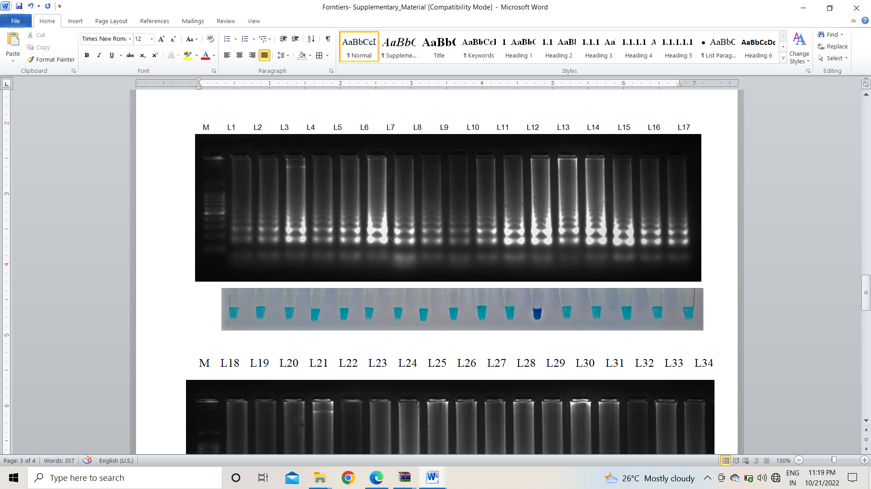
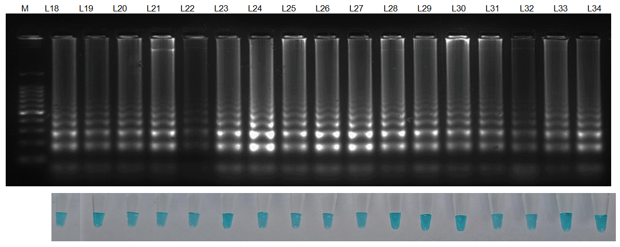
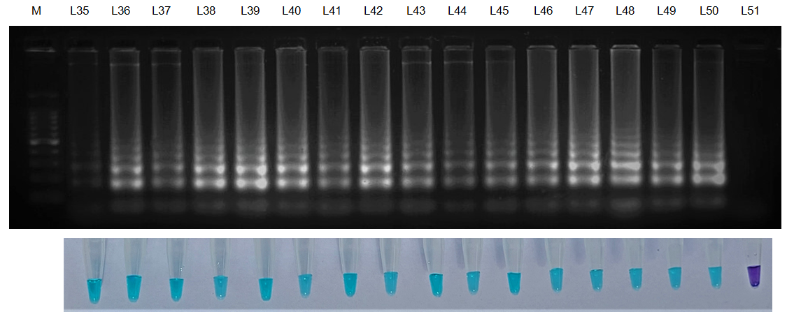
Figure S3: Validation of LAMP assay with different isolates of S. oryzae. Bright sky blue colour represents positive reaction while the violet colour indicates the negative reaction. Total DNA isolated from fungi was used as the template. Upper panel in the figure shows agarose gel electrophoresis results whereas lower panel shows reaction tubes for colorimetric detection.
M- 100bp Ladder; Lane 1-50: Sarocladium oryzae study isolates 1-50; Lane 51: Nuclease free water (Control).
Table S1: Genebank accession number of ITS region of S. oryzae

S. No. | Isolate code | Location | Accession no.
1. | So 1 | Coimbatore | OM841519
2. | So 2 | Thirukovilur | OK018129
3. | So 3 | Vasanthakrishnapuram | OK018130
4. | So 4 | Coimbatore | OK031107
5 | So 5 | Chidambaram | OK032120
6. | So 6 | Emappur | OK018133
7. | So 7 | Thiruvannamalai | OK018137
8. | So 8 | Kondathur | OM841478
9. | So 9 | Coimbatore | OM812089
10. | So 10 | Thiruvennainallur | OM841481
11. | So 11 | Mayiladuthurai | OM343181
12. | So 12 | Kallakurichi | ON084817
13. | So 13 | Sathyamangalam | OP099854
14. | So 14 | Someshwarapuram | OM343185
15. | So 15 | Thirupazhanam | OM841483
16. | So 16 | Sirkazhi | OM841484
17. | So 17 | - Papanasam | OM841485
18. | So 18 | - Puduchatiram | OM919528
19. | So 19 | - Saliyantoppu | OM841489
20. | So 20 | - Tanjore | OM991946
21. | So 21 | - Vadakurangaduthurai | OM841491
22. | So 22 | - Pudhur, S | OM841497
23. | So 23 | - Ganapathiagaram | OM841499
24. | So 24 | - Rayampettai,Tanjore | OM892668
25. | So 25 | - Aduthurai | OM919508
26. | So 26 | - Athukudi | ON008305
27. | So 27 | - Sivapuri, CDM | OM992220
28. | So 28 | Kallanai,Tanjore | OM919515
29. | So 29 | - Govindhanallucheri | OM919516
30. | So 30 | - Thiruvidaimaruthur | ON112283
31. | So 31 | - Chellapatty, Madurai | OM919518
32. | So 32 | - Bhavanisagar | ON112364
33. | So 33 | - Dindugal | ON008316
34. | So 34 | - Kodikulam, Madurai | ON112988
35. | So 35 | - Samayapuram | ON115184
36. | So 36 | - Perambalur | ON115188
37. | So 37 | - Palaiyur, Thiruvarur | ON115189
38. | So 38 | - Purathakudi | ON008436
39. | So 39 | - Aduthurai | ON115190
40. | So 40 | - Perugamani, Trichy | ON115191
41. | So 41 | - Kumaramangalam | ON115203
42. | So 42 | - Perugamani | ON009020
43. | So 43 | - Orayur | ON009071
44. | So 44 | - Vayalur | ON115207
45. | So 45 | - Yethapur, Salem | ON115213
46. | So 46 | - K. Sathanoor | ON115234
47. | So 47 | - Maruthandakurichi | OP099852
48. | So 48 | - Mochakottapalayam | ON009255
49. | So 49 | - Melur, Madurai | OP377086
50. | So 50 | - Kulithalai | OP377796

Table S2: Additional details of designed LAMP primers in this study.
Primer name | Molecular Weight | Extinction Coefficient | µg/OD at 260 nm | Run Length (bp) | Primer Dimer | Secondary Structure | Binding site | Id ¹  (%)
SoT-F3 | 6148.1 | 188.4 | 32.6 | 3 | No | Moderate | 444-463 | 100
SoT -B3 | 6175.1 | 203.6 | 30.3 | 4 | No | Very Weak | 624-643 | 100
SoT -FIP | 12347.1 | 380.4 | 32.5 | 3 | No | Moderate | 483-517 | 100
SoT -BIP | 12675.4 | 396.8 | 31.9 | 4 | No | Weak | 574-600 | 100
SoT- LF | 6817.5 | 227.1 | 30.0 | 3 | No | None | 484-505 | 100
SoT- LB | 5764.8 | 174.3 | 33.1 | 2 | No | Strong | 576-594 | 100
¹ Percentage identity of primer sequence compared to S. oryzae genomes available in GenBank using BLAST.

