[Supplementary Materials for]
Estimating fractional cover of saltmarsh vegetation species in coastal wetlands in the Yellow River Delta, China using ensemble learning model
Zhanpeng Wang^{1,2}, Yinghai Ke^{1*}, Dan Lu², Zhaojun Zhuo¹, Qingqing Zhou¹, Yue Han¹, Peiyu Sun¹, Zhaoning Gong¹, Demin Zhou¹

¹College of Resource Environment and Tourism, Capital Normal University, Beijing, 100048, China;
²School of Resource and Environmental Sciences, Wuhan University, Wuhan , 430079, China

Corresponding Author: Yinghai Ke, Ph. D, yke@cnu.edu.cn

Contents of this file
Figure S1

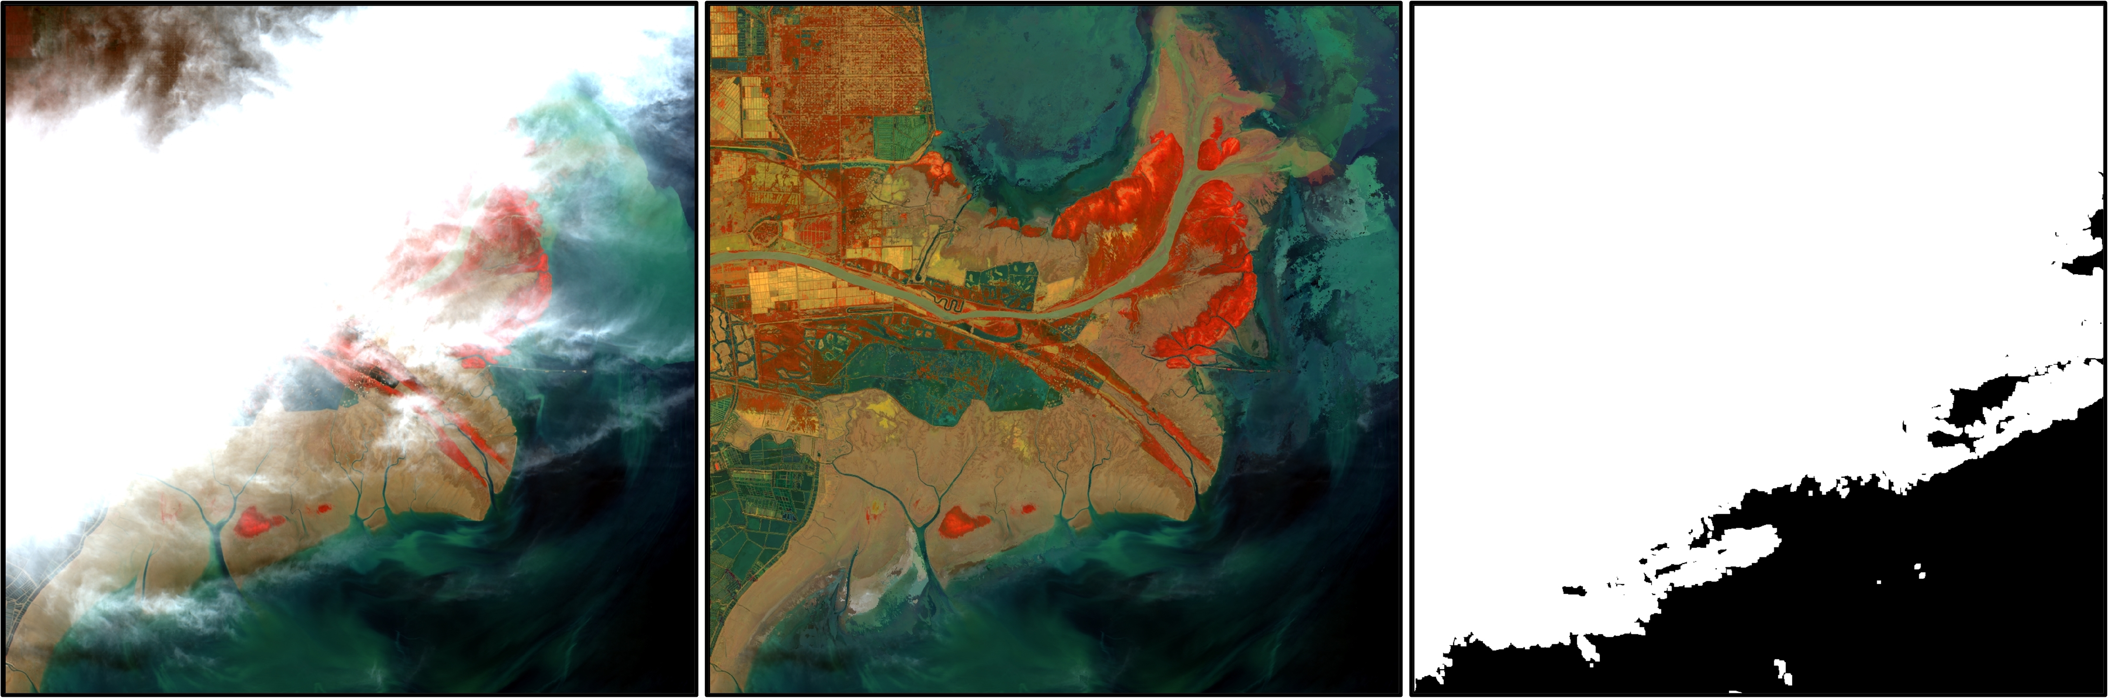
- (B) (C)
Figure S1. (A) Original Landsat 8 OLI image and (B) cloud removal image in standard false color composition, and (C) the cloud mask image obtained by Landsat quality assessment band in October 8, 2020.

