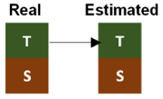
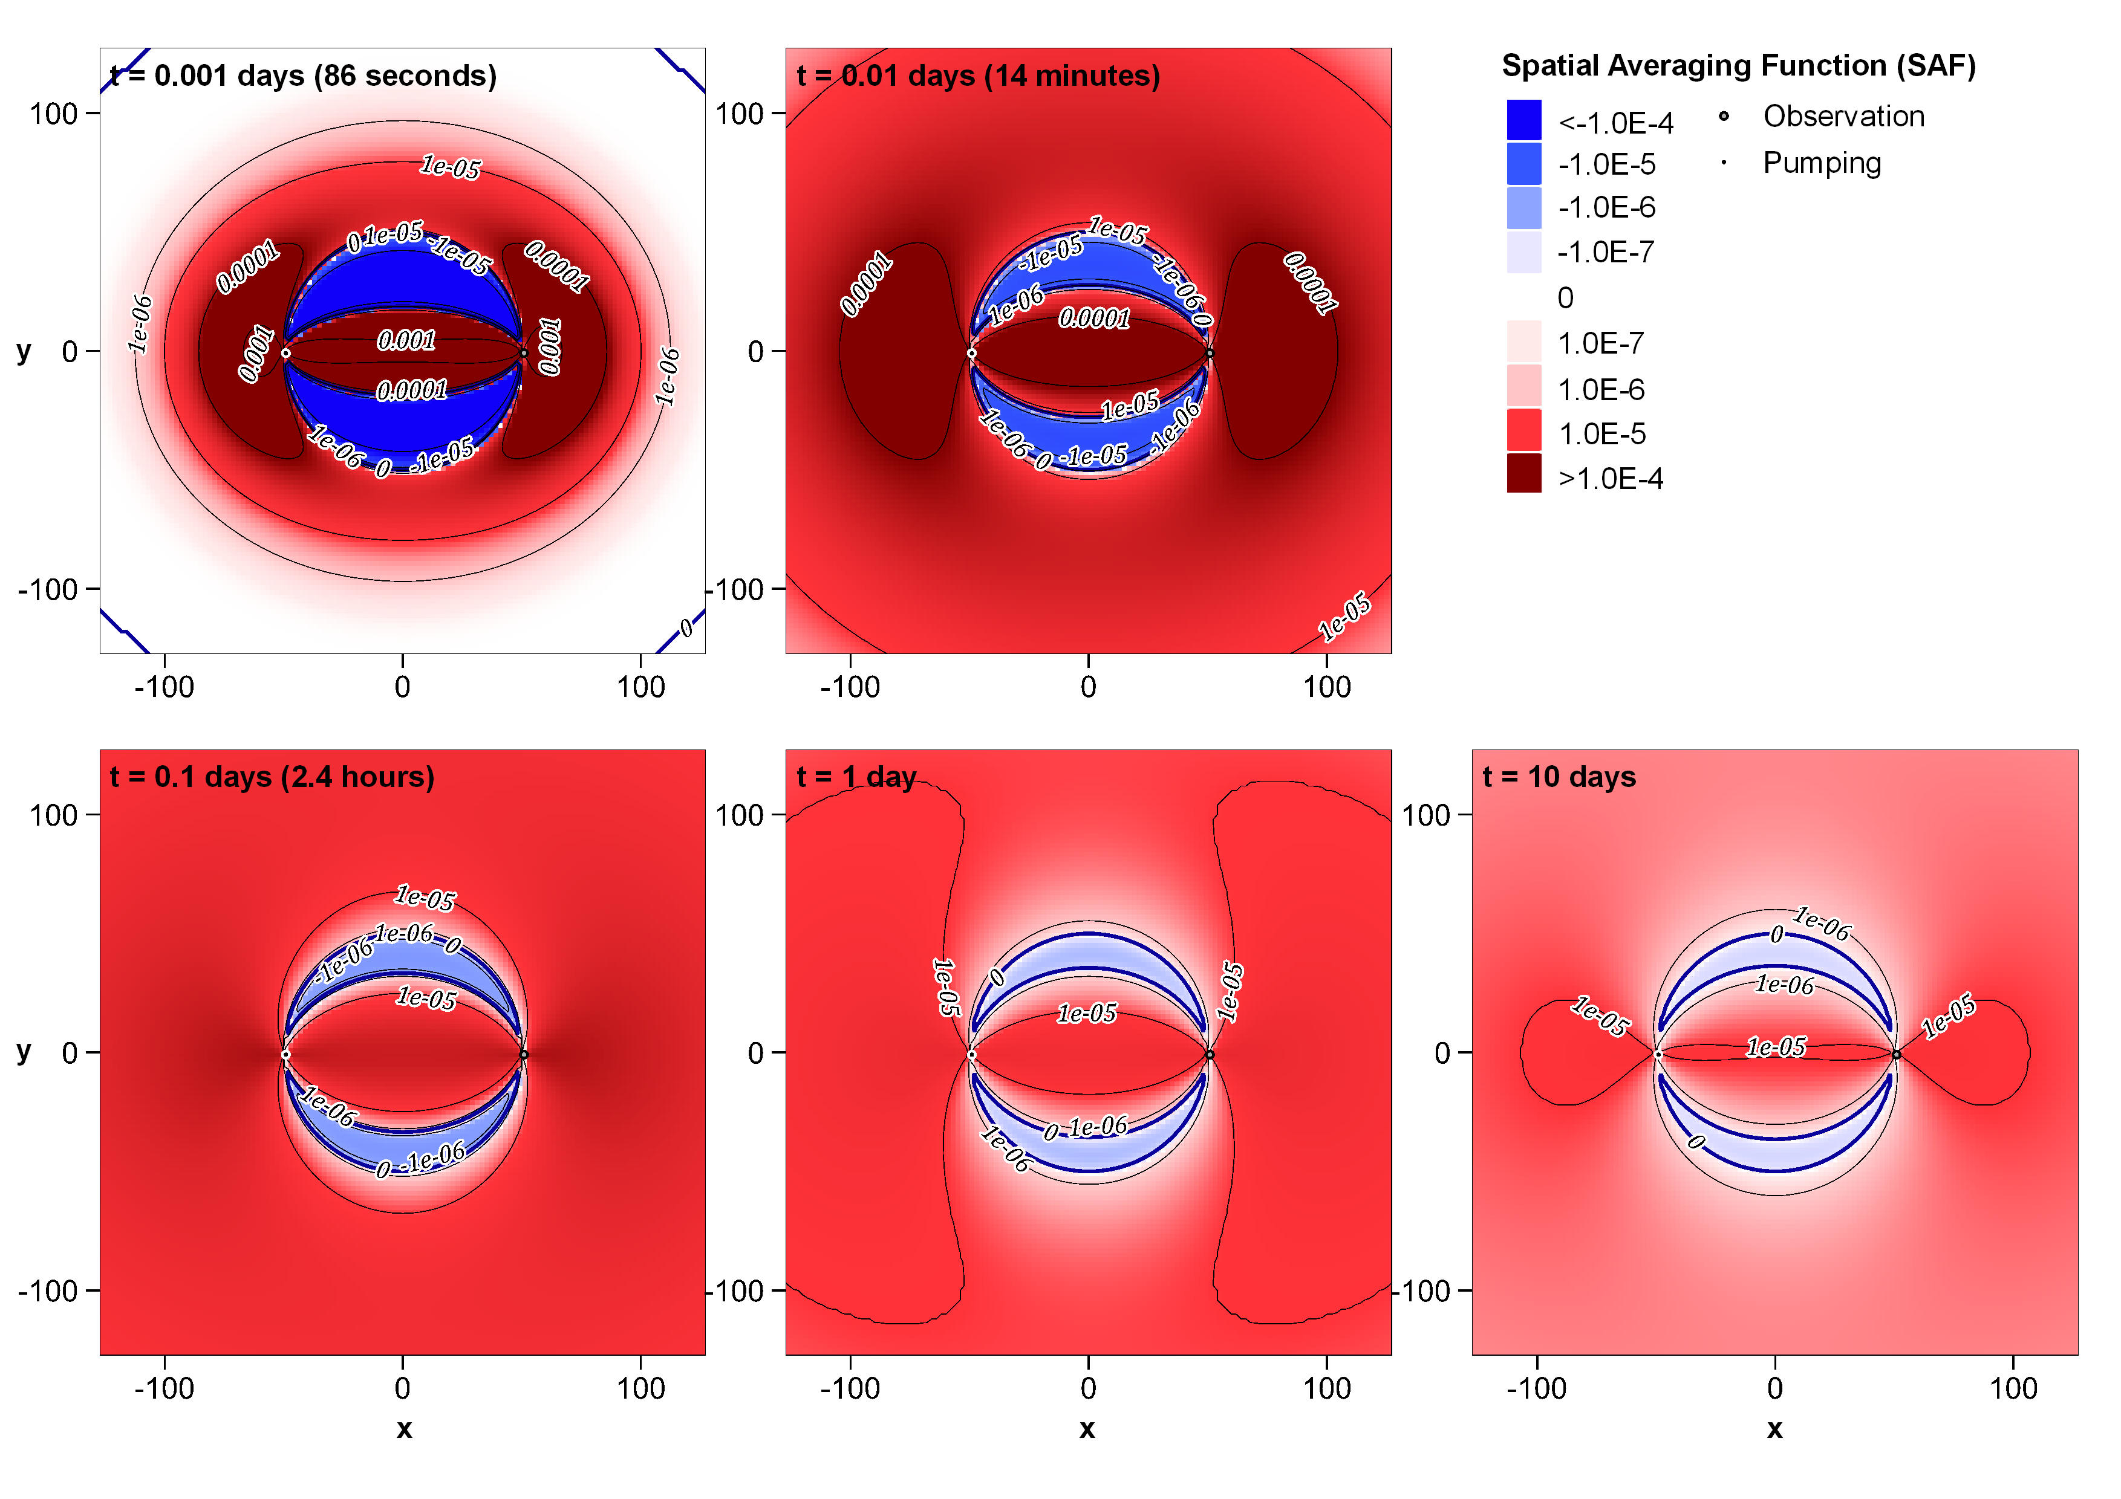
Figure A 1. R'_{T-T} for separated wells at five different times. (log colouring/contour intervals)
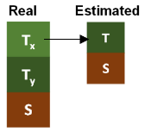
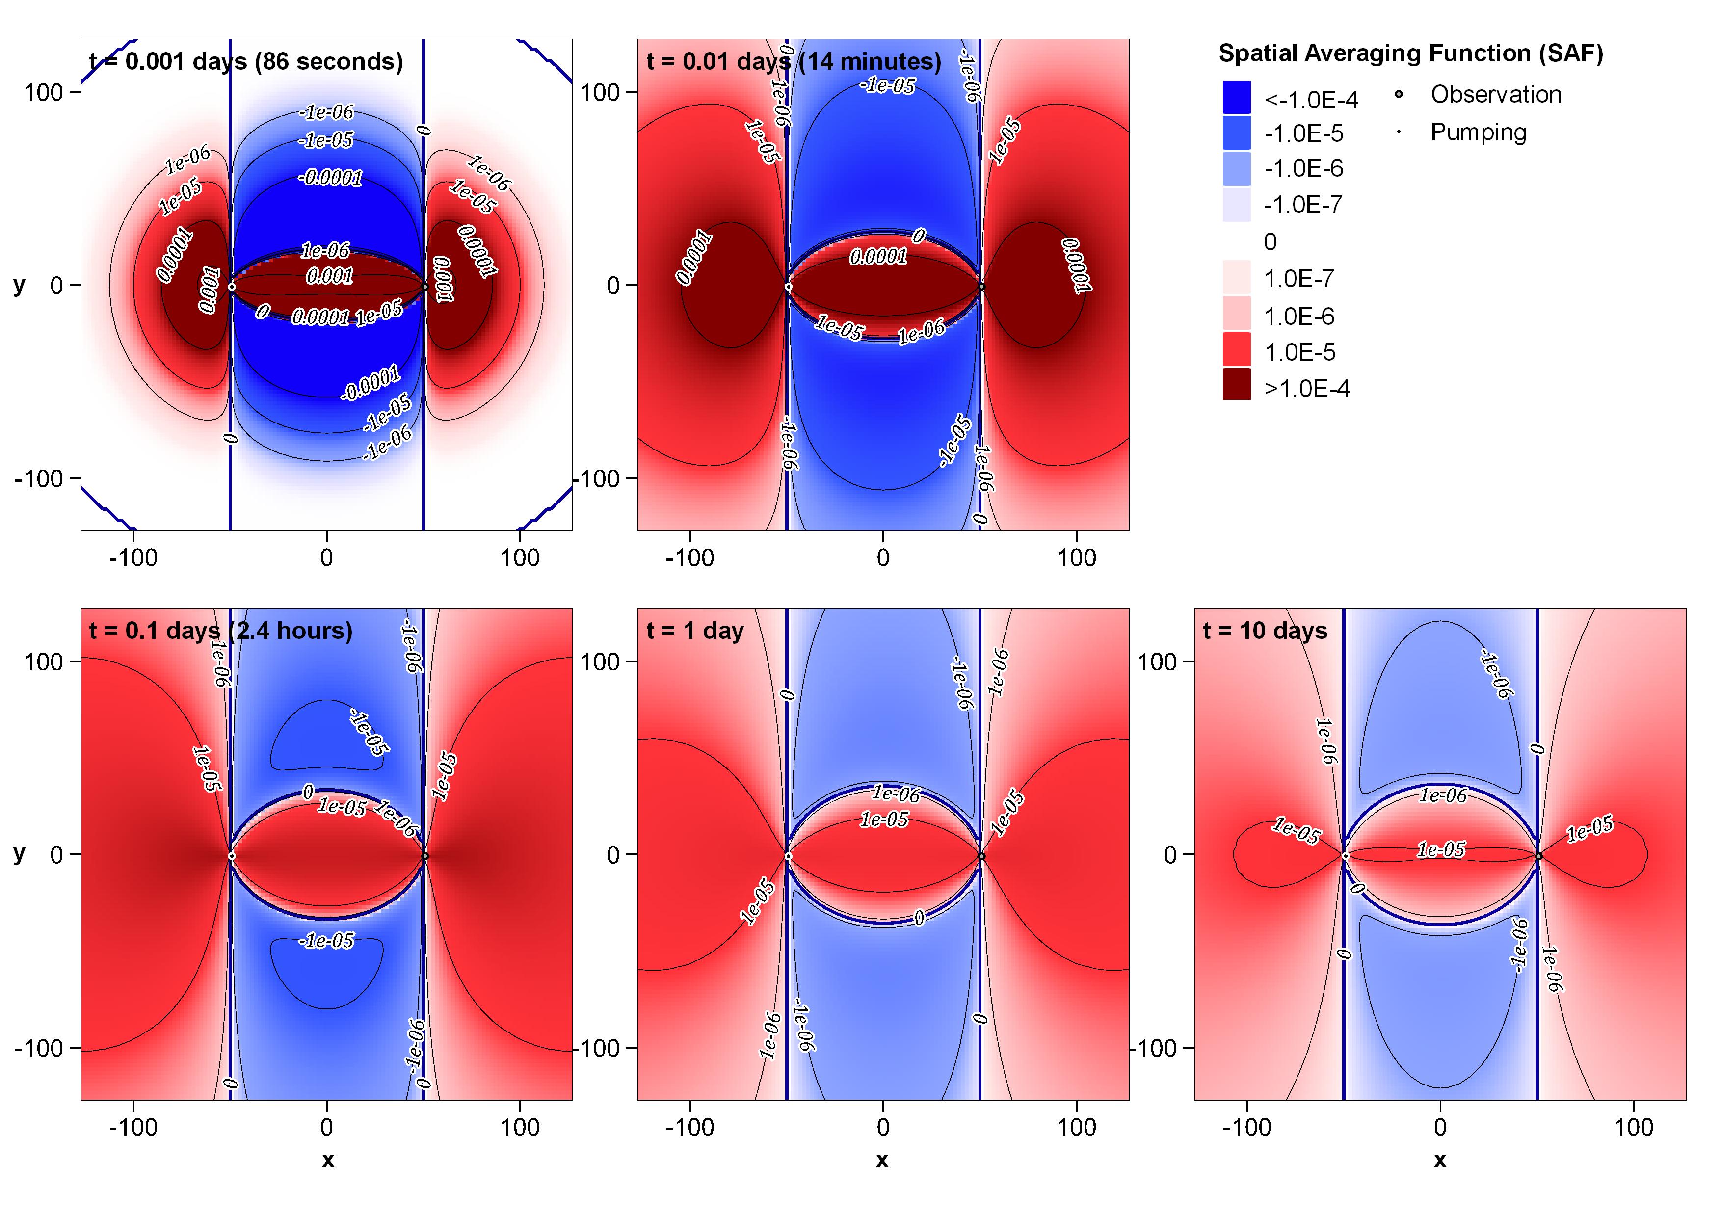
Figure A 2. R'_{T-Tx} for separated wells at five different times. (log colouring/contour intervals)
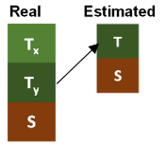
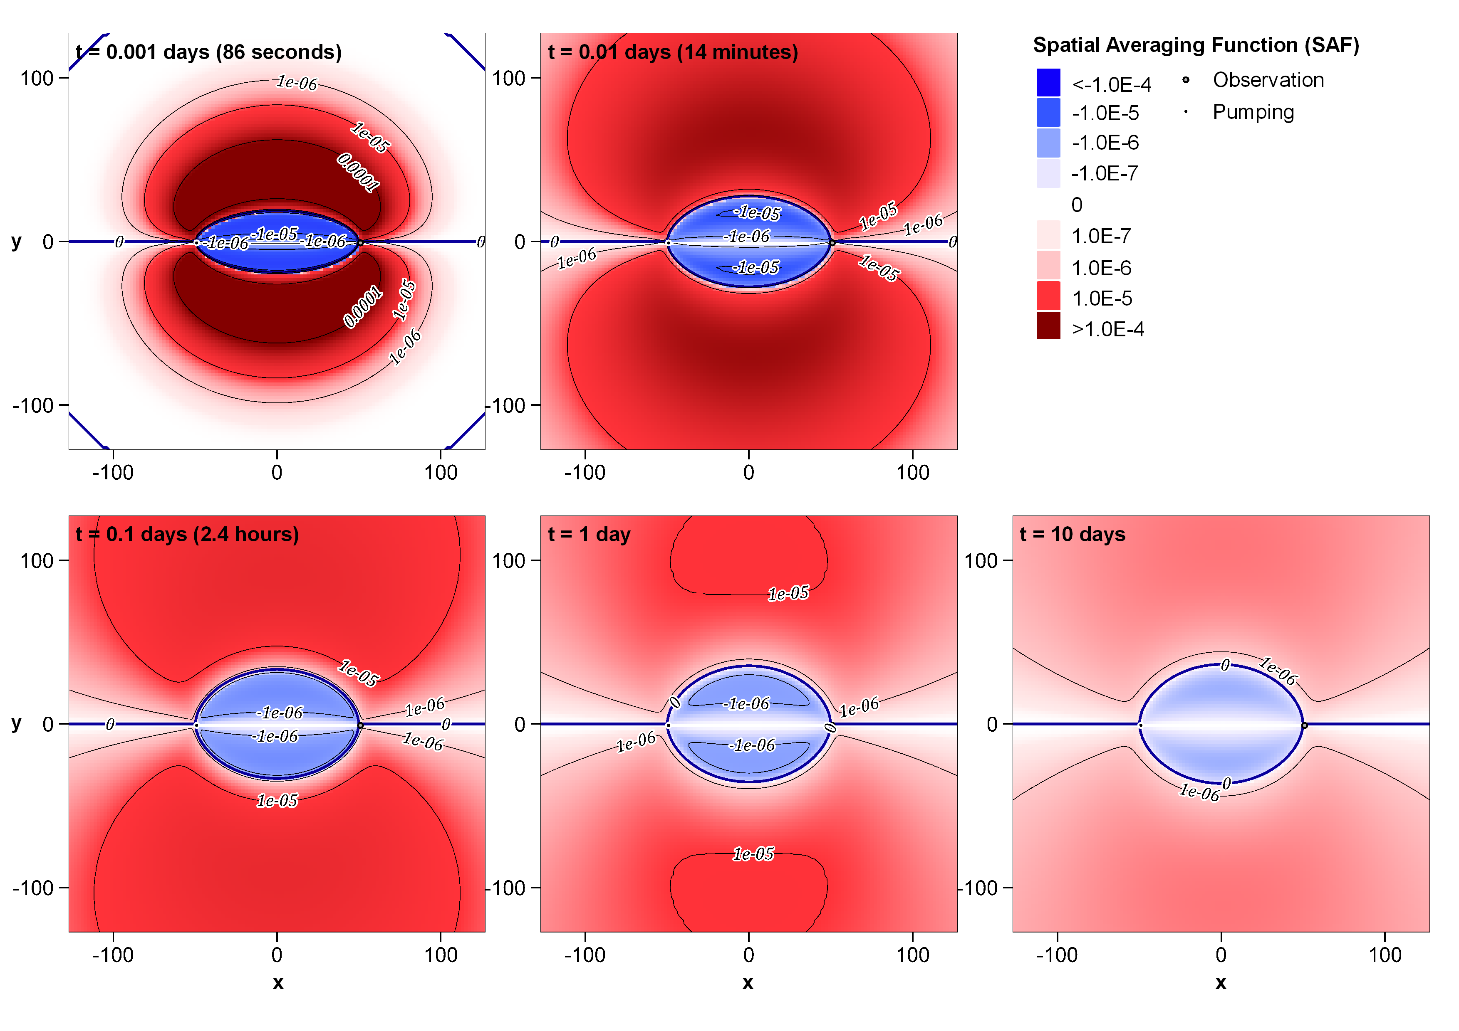
Figure A 3. R'_{T-Ty} for separated wells at five different times. (log colouring/contour intervals)
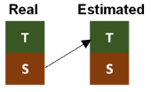
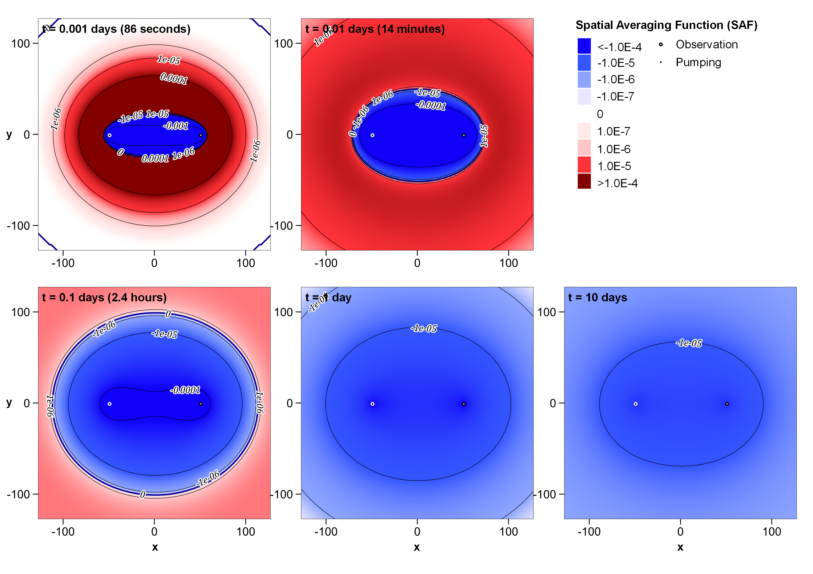
Figure A 4. R'_{T-S} for separated wells at five different times. (log colouring/contour intervals)
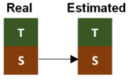
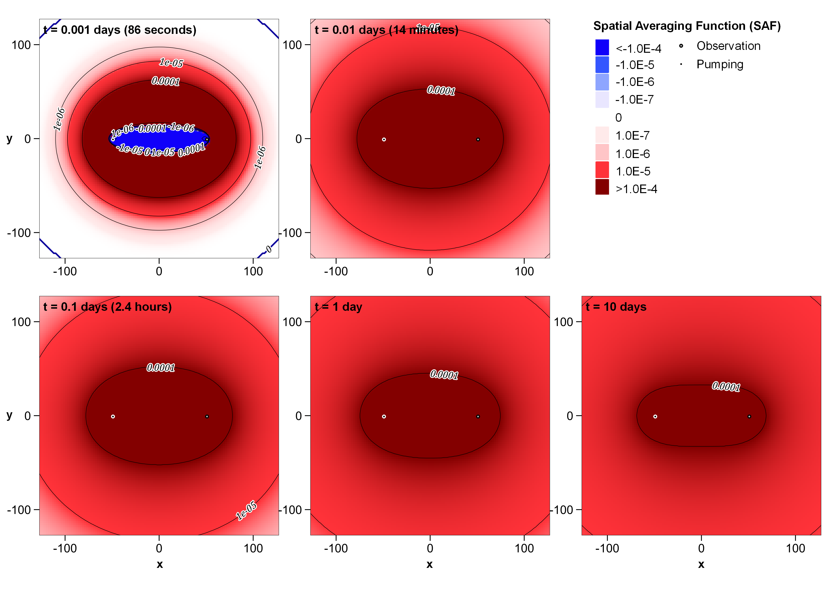
Figure A 5. R'_{S-S} for separated wells at five different times. (log colouring/contour intervals)
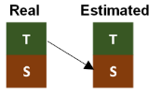
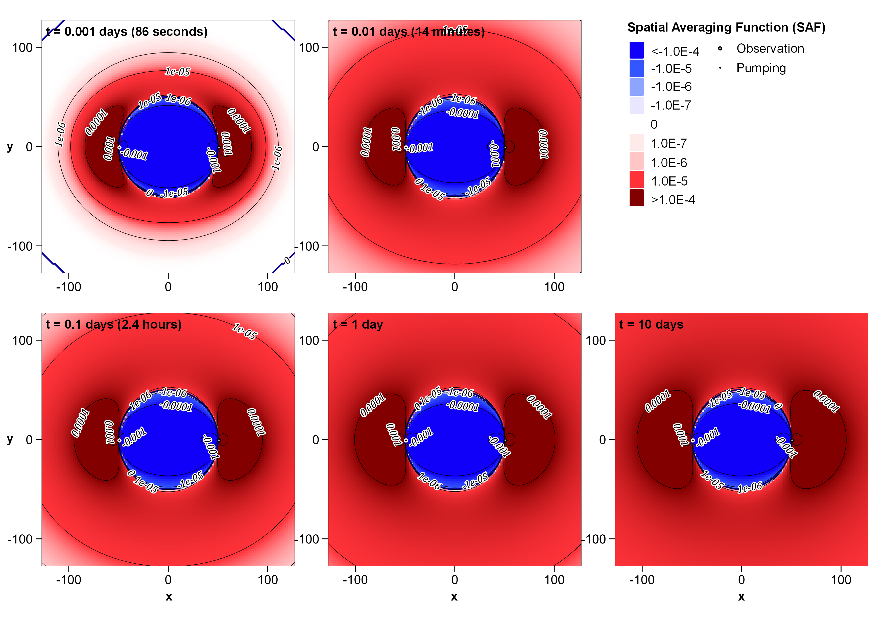
Figure A 6. R'_{S-T} for separated wells at five different times. (log colouring/contour intervals)
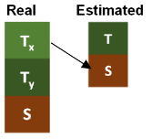
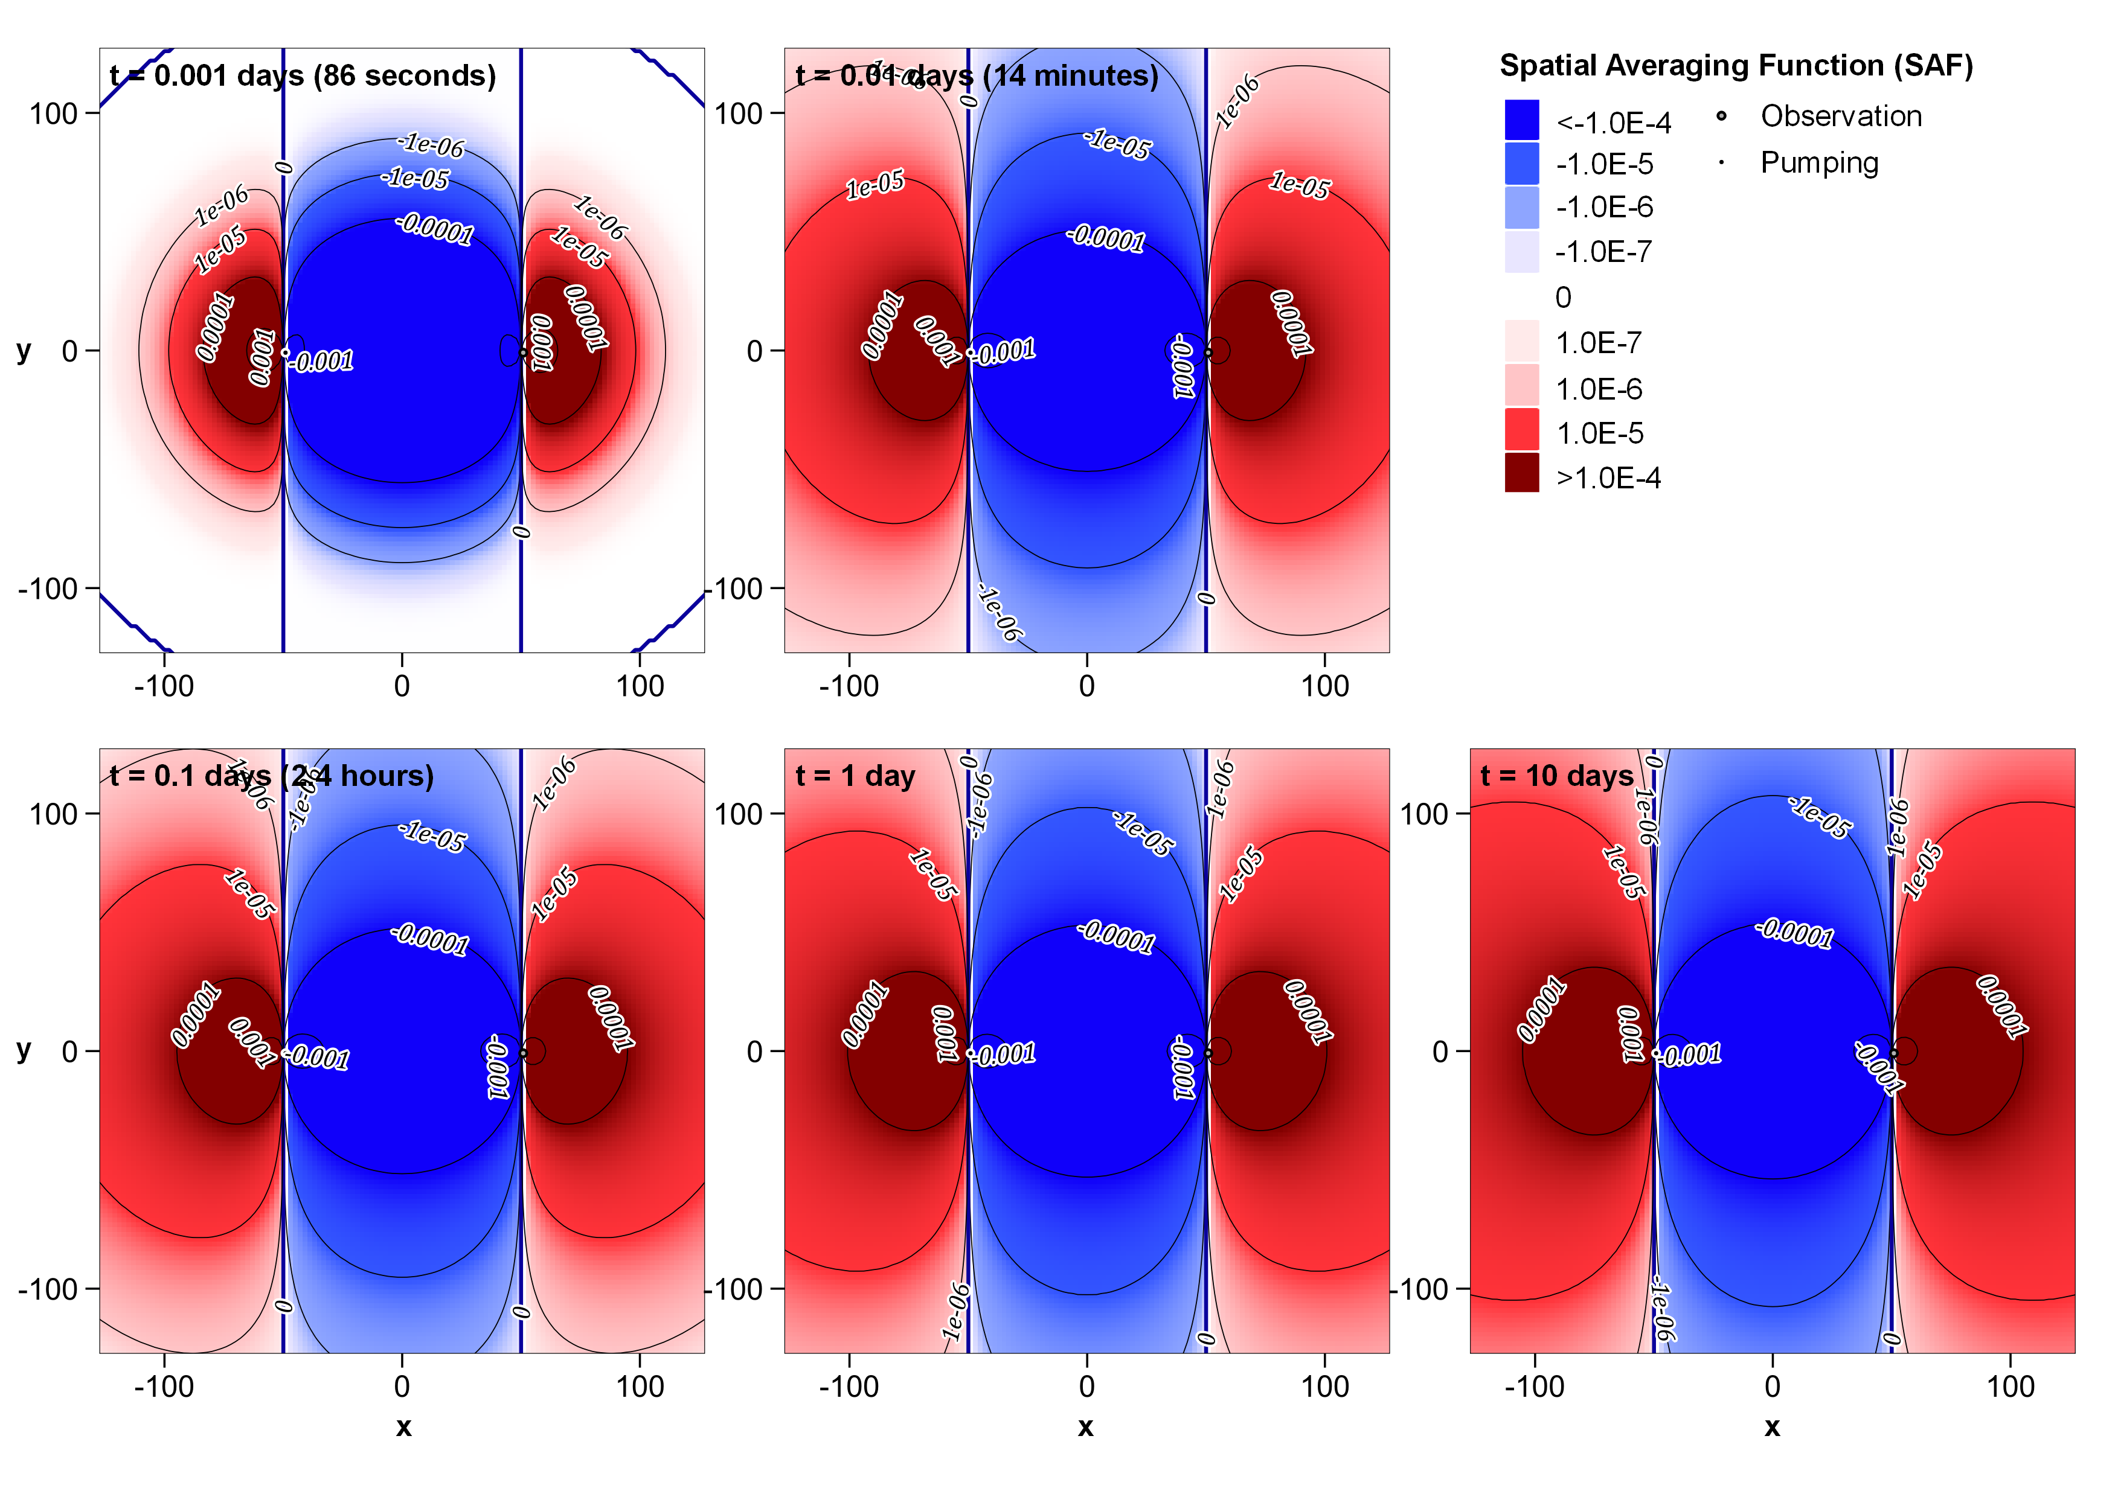
Figure A 7. R'_{S-Tx} for separated wells at five different times. (log colouring/contour intervals)
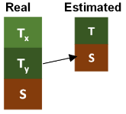
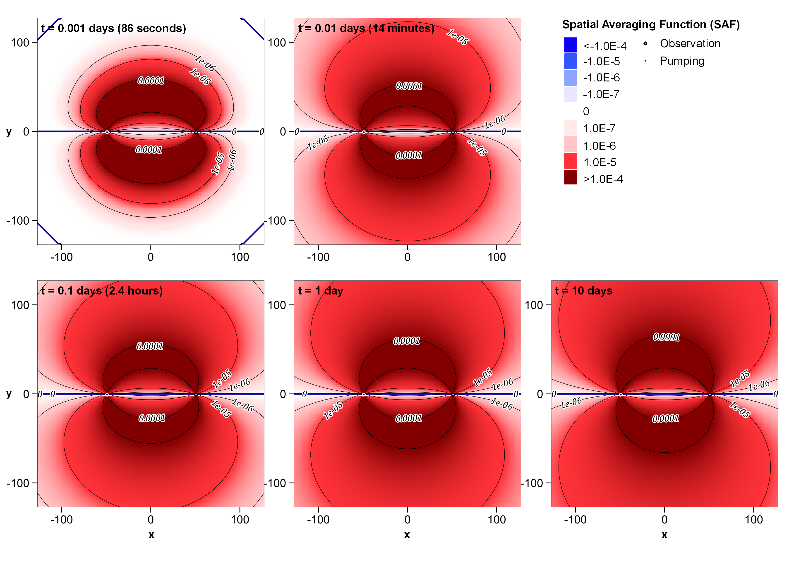
Figure A 8. R'_{S-Ty} for separated wells at five different times. (log colouring/contour intervals)
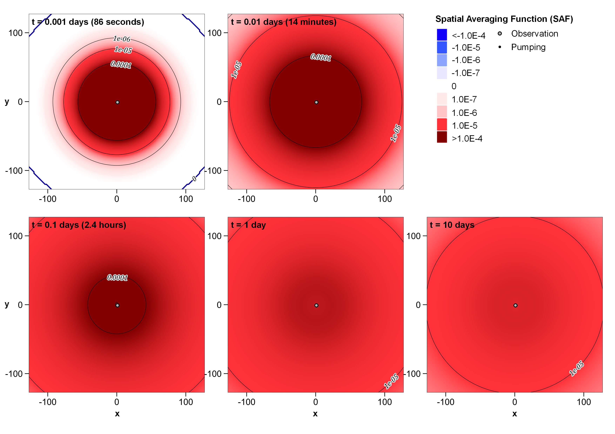
Figure A 9. R'_{T-T} for near-coincident wells at five different times. (log colouring/contour intervals)
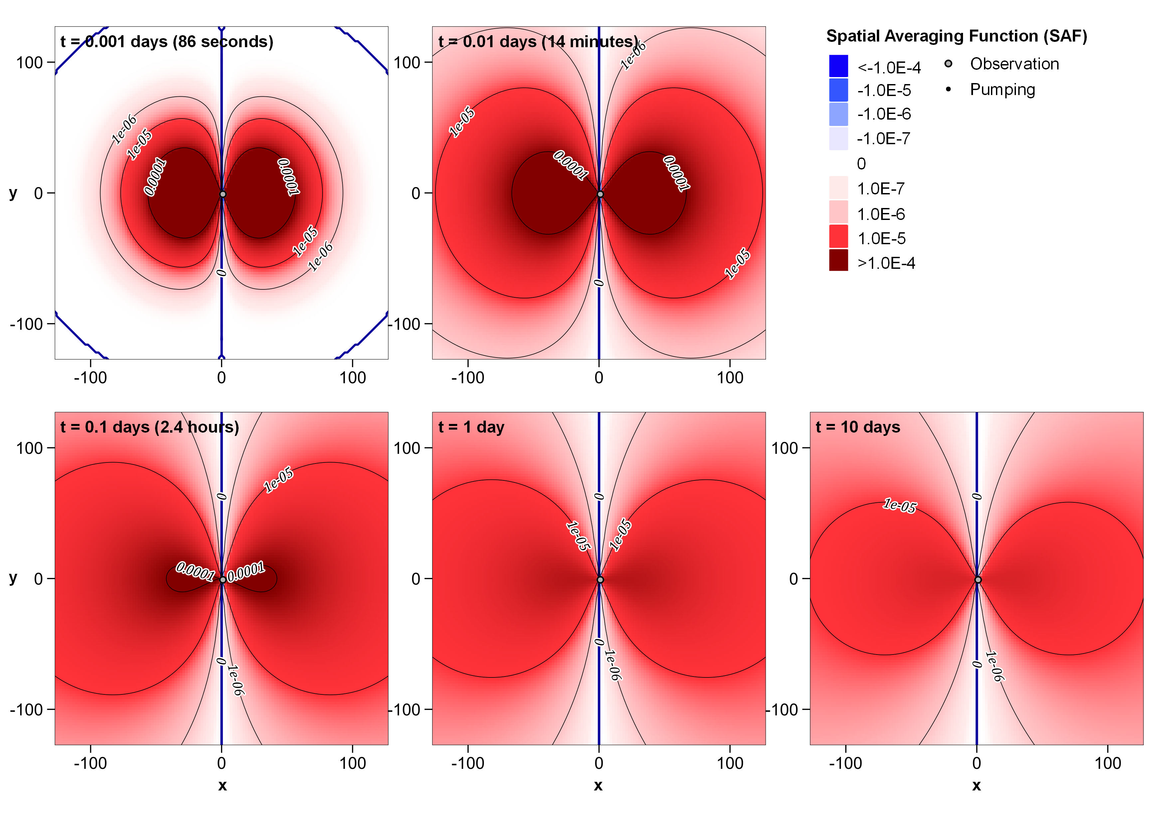
Figure A 10. R'_{T-Tx} for near-coincident wells at five different times. (log colouring/contour intervals)
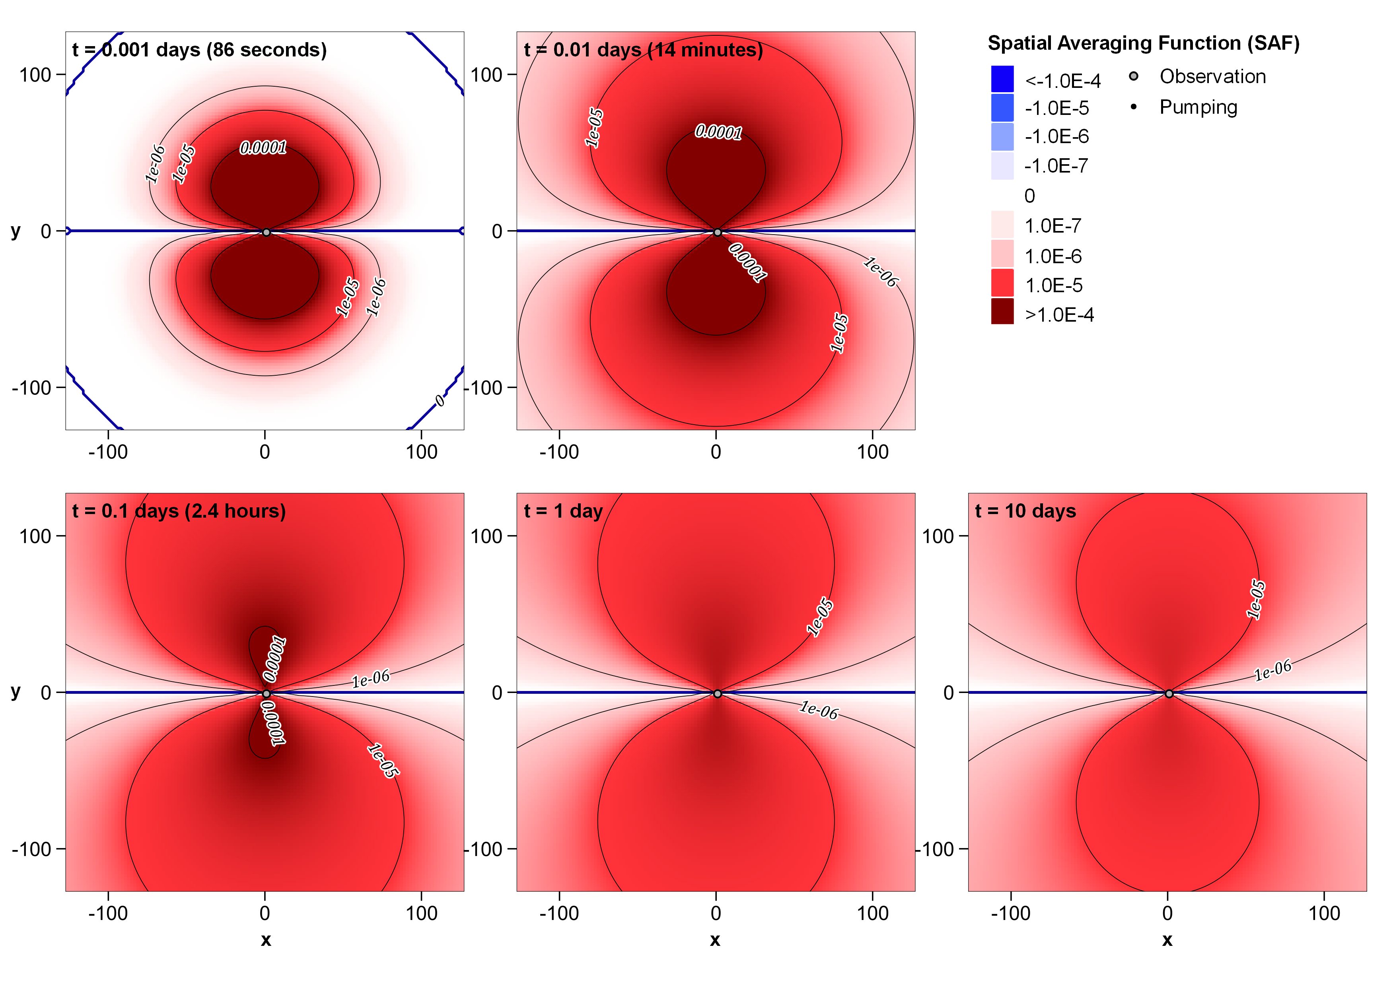
Figure A 11. R'_{T-Ty} for near-coincident wells at five different times. (log colouring/contour intervals)
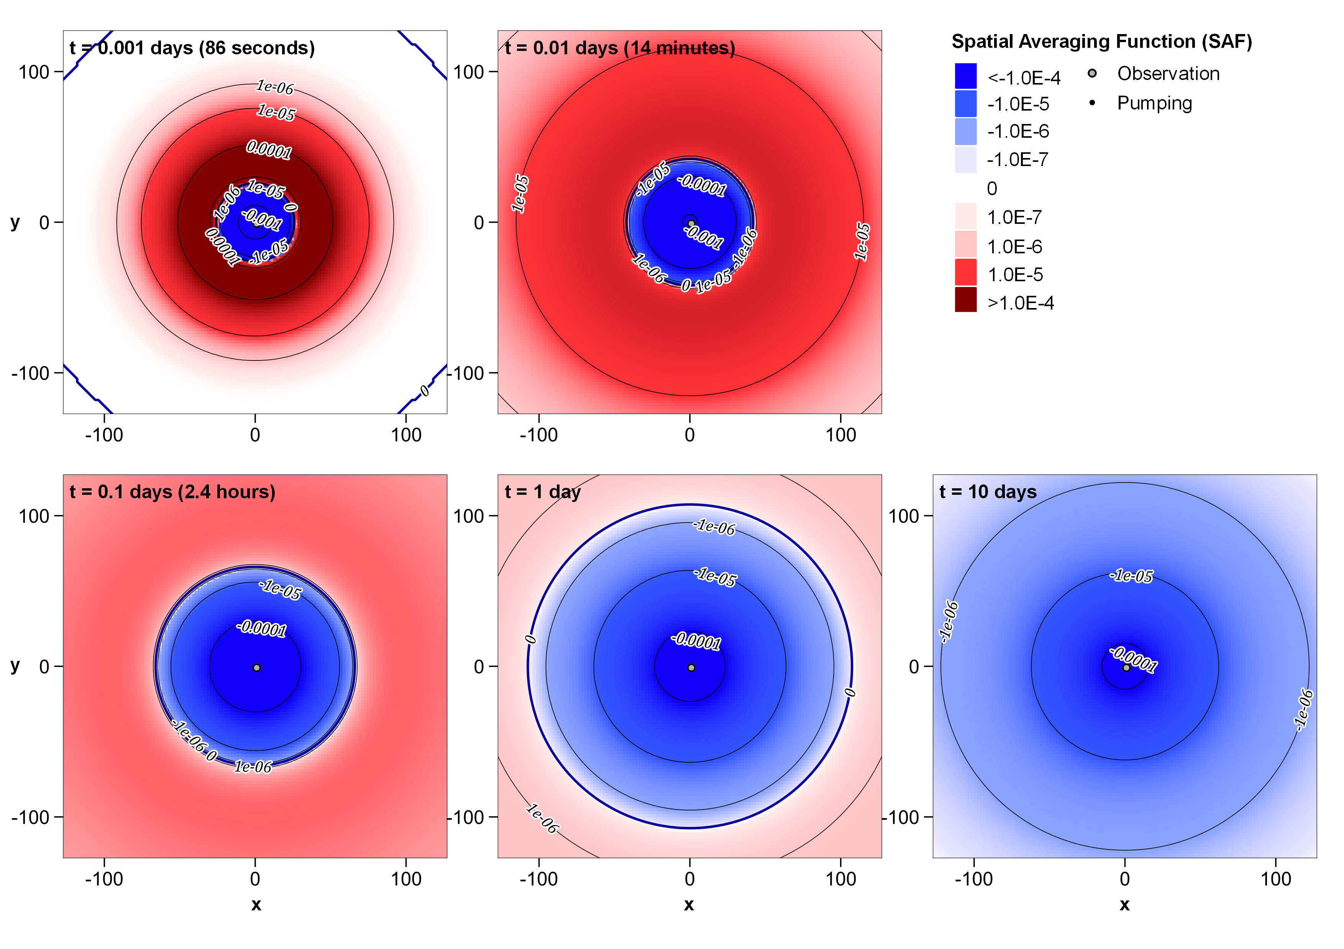
Figure A 12. R'_{T-S} for separated wells at five different times. (log colouring/contour intervals)

