Supplementary Material.

# Supplementary Figures

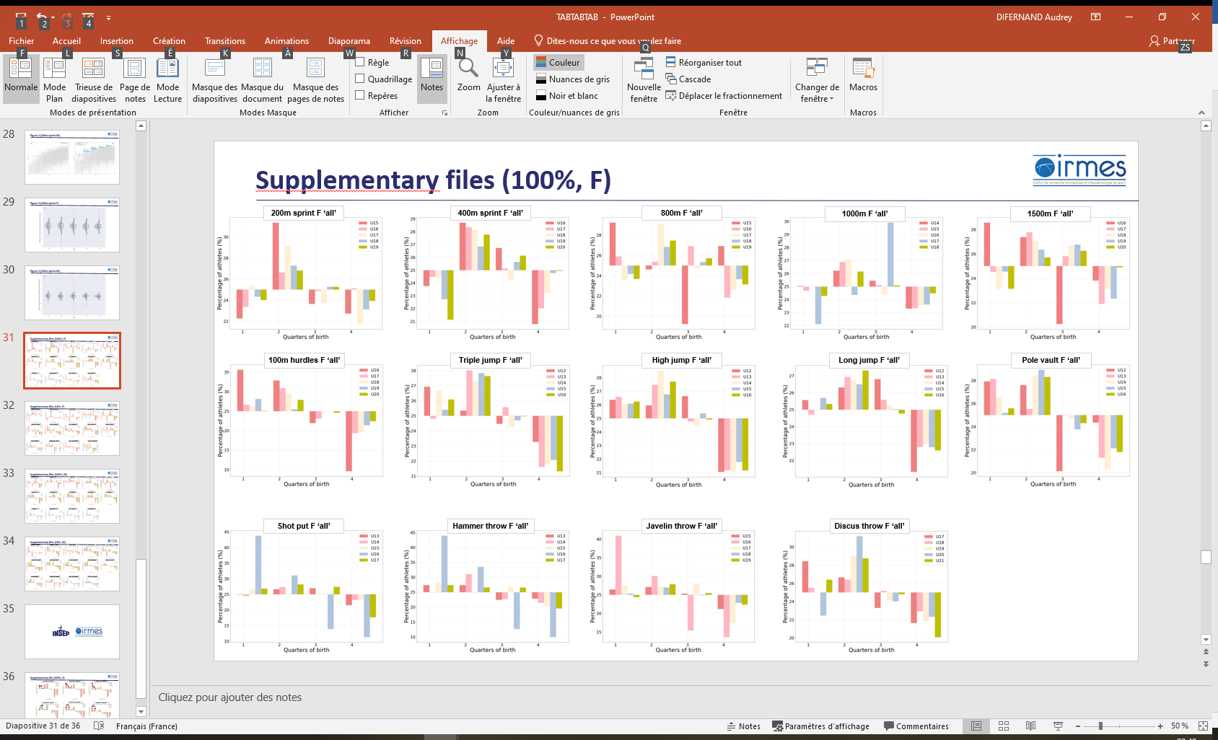

**Supplementary Figure 1A.** Birth quarters distribution according to age categories for ‘all’ female events.

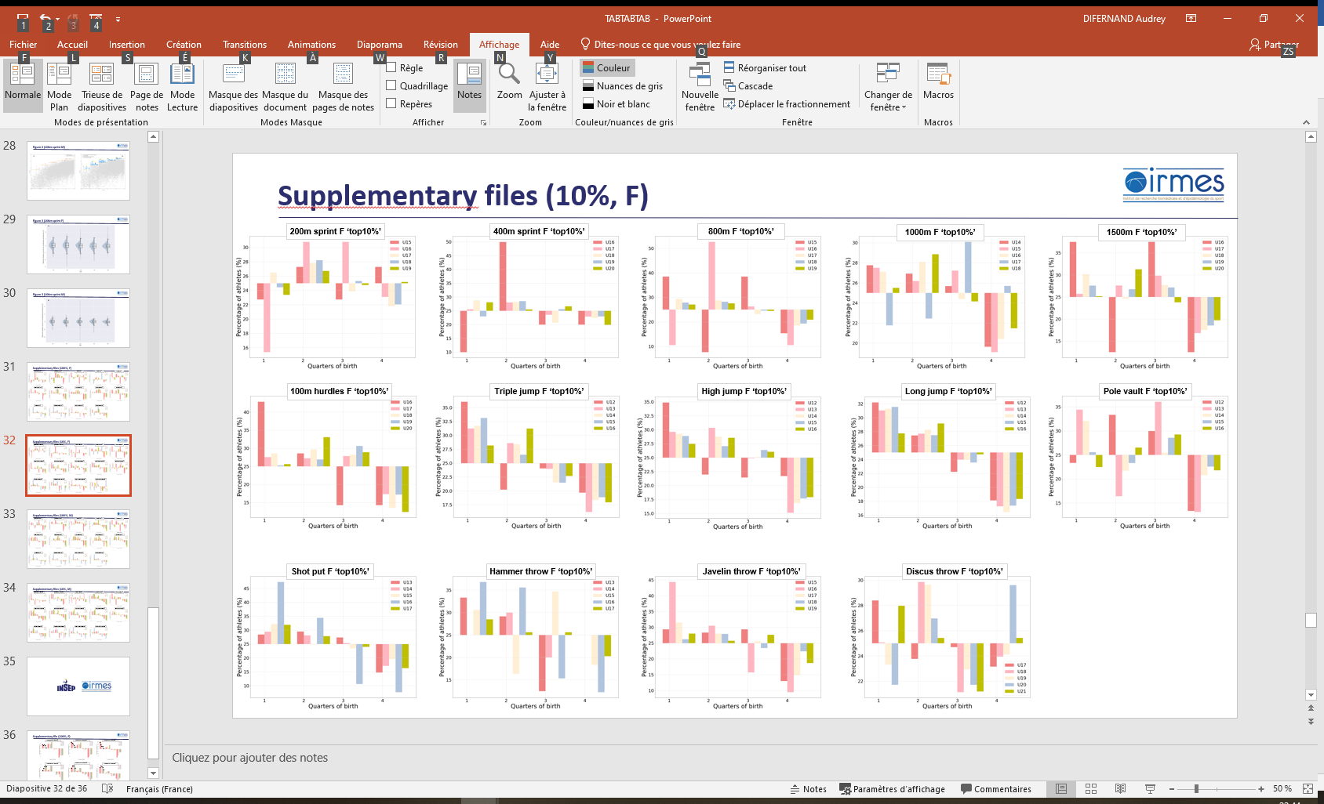

**Supplementary Figure 1B.** Birth quarters distribution according to age categories for ‘Top10%’ female events.

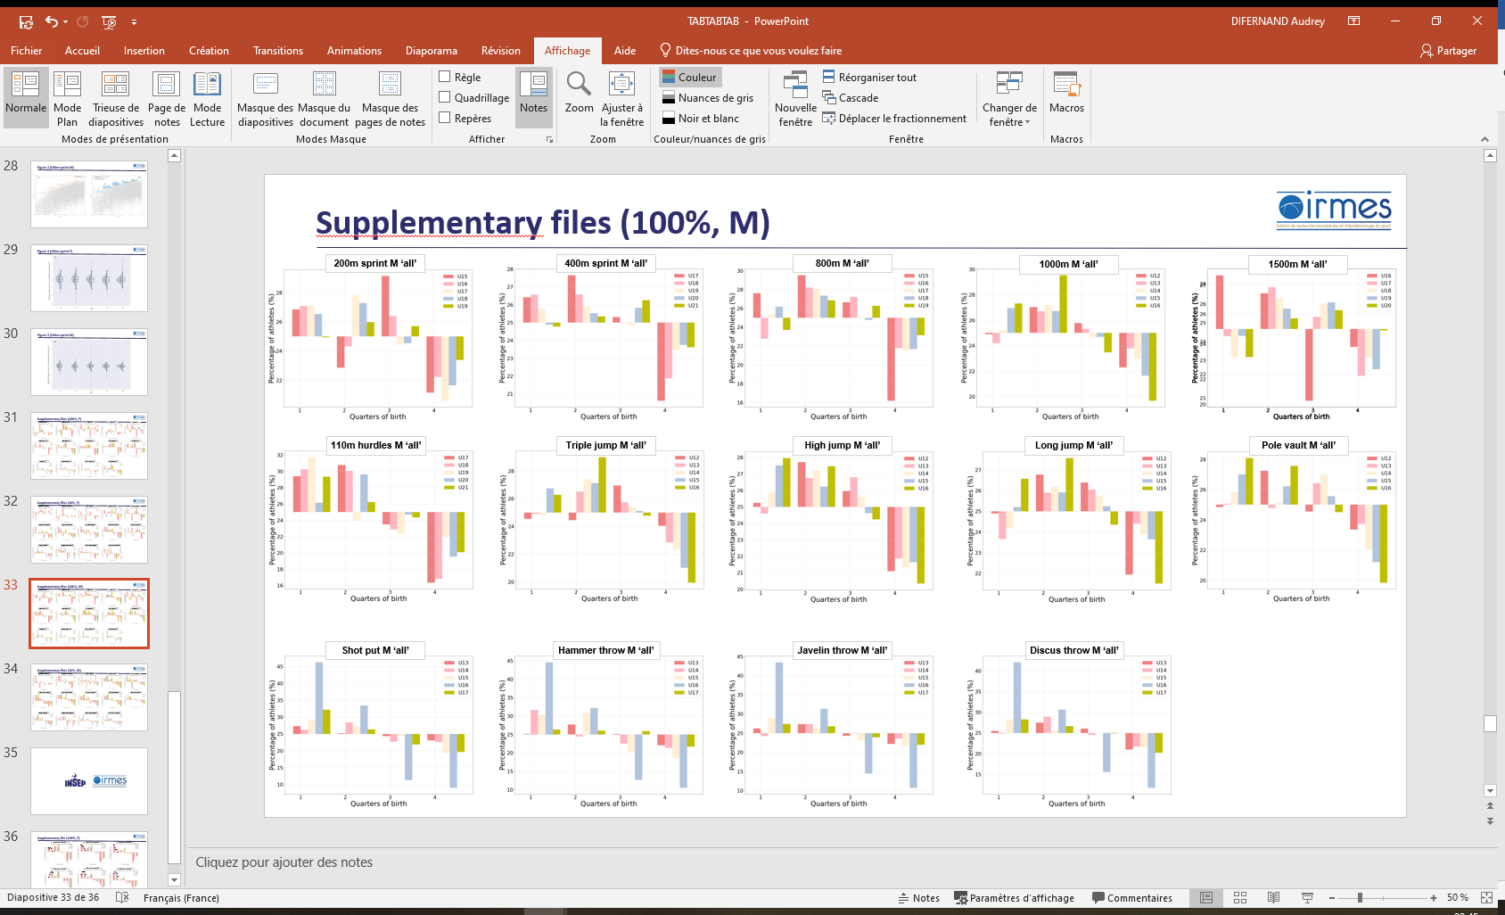

**Supplementary Figure 2A.** Birth quarters distribution according to age categories for ‘all’ male events.

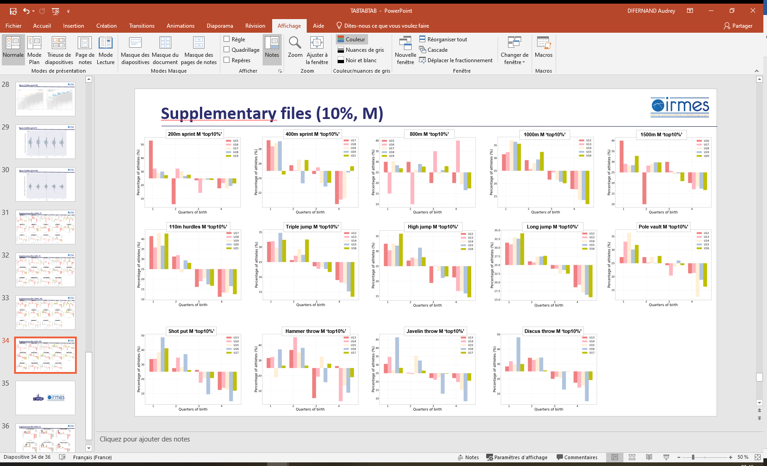

**Supplementary Figure 2B.** Birth quarters distribution according to age categories for ‘Top10%’ male events.