**Supplemantary informations**

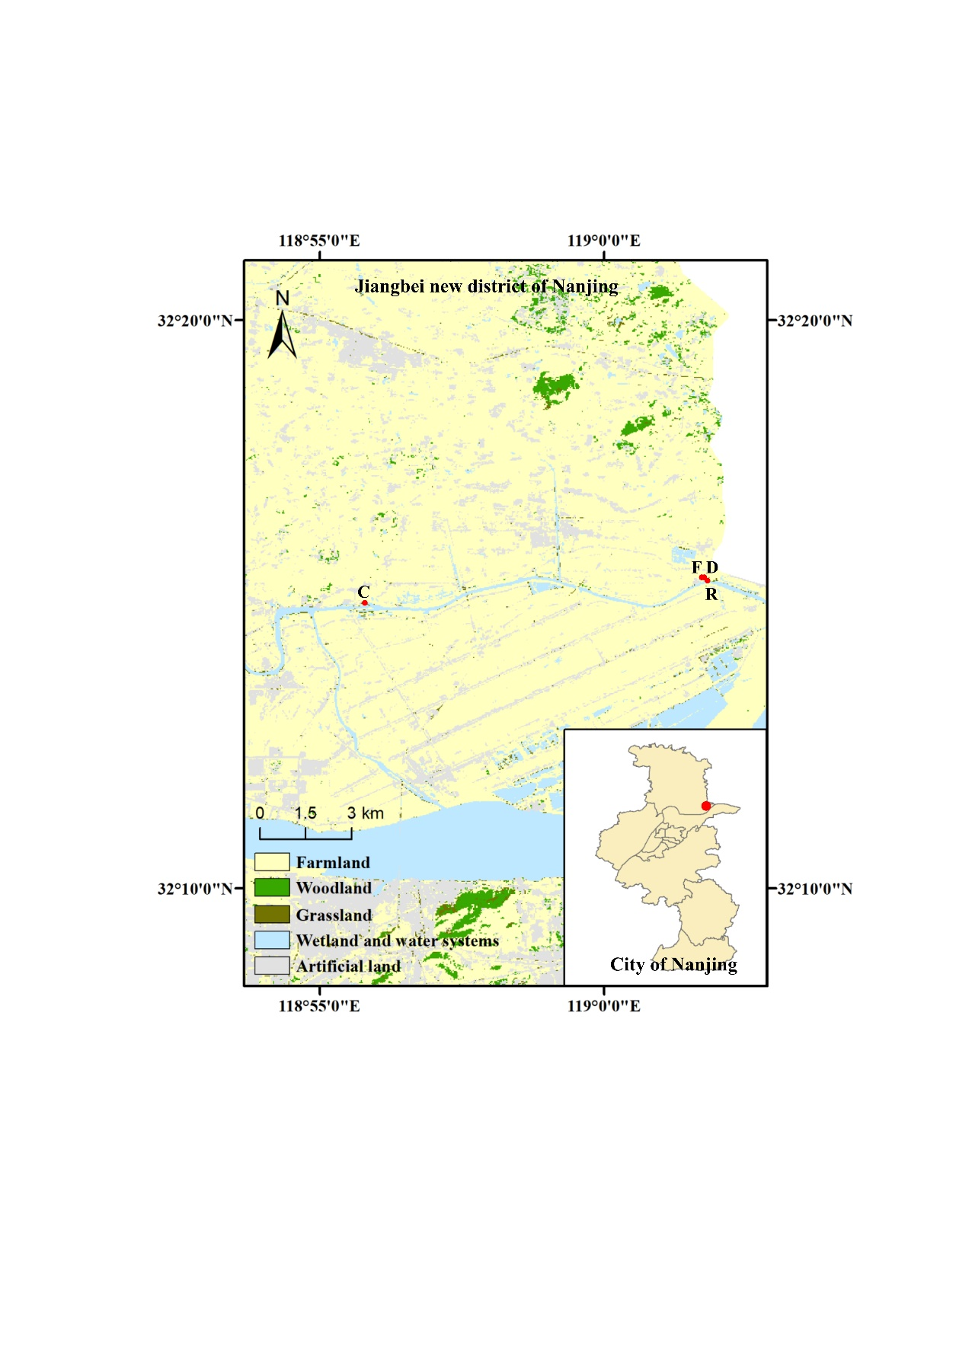

**Figure S1:** Overview of sampling sites, the land use data in the figure are from the Global 30m Land-Cover Product V1.0 for 2020 (Zhang et al., 2022).

**Table S1**: Longitude and latitude coordinates of sampling sites

|  |  |  |
| --- | --- | --- |
| Sampling sites | Sample point type | Longitude and latitude |
| Chu River riparian | Urban River | 32.258N 119.034E |
| Hongshan Gate | Urban River | 32.247N 118.927E |
| Fish pondinterchange | Aquaculture pond | 32.257N 119.035E |
| Zero-interchange fish pond | Aquaculture pond | 32.258N 119.035E |

**S1.1** Field campaign, **sample collection and experimental design**

**S1.1.1** **Field observation**

In the field campaign (May 2020 to late April 2021), greenhouse gas (GHG) data of CO2, CH4, and N2O were evaluated in situ at the water-air interface using cylindrical floating chambers (diameter: 26 cm; height: 8cm, volume: 4.25 Lit). The sampling sites were chosen close to the shore (shallow depth of 1.2 m) and then 3 static floating chambers are lined up parallelly, and the distance between each chamber is about 2 m. The GHG sampling time for the Fish pondinterchange (Pint) is at 9:00 a.m., and for Chu River riparian (CRR) is at 10:00 a.m for each collection. Seven gas samples were collected at 5 min intervals over the period of 45-minute enclosure by using 30 mL plastic syringes equipped with three-way stopcocks. After that samples were injected into pre-evacuated airtight gas sampling vials followed by gas chromatography (GC; Agilent Technologies 7890B, USA) analysis in the lab. At the end of each sampling date, all the vials were sent back to the laboratory for the determination of CO2, CH4, and N2O concentrations in the individual samples (Guerin et al., 2006).

**S1.1.2** **Microcosm incubation setup**

In order to undertake a microcosm incubation experiment (aerobic condition) on the process of surface water interchange, sediments were collected from the surface (0–15 cm) of four studied sites after a year of field observations. Before the experiment, sediment samples from 3 sites were collected for elemental analysis (Vario MACRO cube, German), see Table S2. Hongshan Gate sediment has low carbon content than CRR, and it is located upstream of the CRR, thus it was chosen as a contrast sediment site for CRR. A zero-exchange aquaculture pond near the Pint was chosen as a contrast sediment site of Pint. At the same time, the overlying water from the Pint sample site was also collected, and the concentrations of total phosphorus (TP) and total nitrogen (TN) of fish-pond-overlying water were measured (Wen et al., 2019). All collected sediments were kept for a natural drying and then plants were removed and sieved at 2 mm.

For the microcosm experiment, the four different types of treated sediments were individually mixed with three different types of water: i) deionized water (U), ii) fish-pond-overlay water (N), and iii) artificial water (A). Artificial water has the same N/P ratio as fish-pond-overlay water, and only ammonium chloride (NH4Cl; 1.80×10-3g∙L-1) and potassium dihydrogen phosphate (KH2PO4;1.72×10-3g∙L-1) are used in it. For every single sample, 80g of sediments were covered with 125mm of liquids in a vitreous bottle of GL-45. Both water and gas samples were taken on days 1, 8, 15, 22, 29, 36, 43, and 50 of the incubation. Samples were pre-incubated for 3 days before the experiment to get off dissolved oxygen (DO). To imitate the actual environment of the Chu River downstream and to encourage the emissions of organic matter, the incubator's temperature was set at 20°C. The concentrations of dissolved organic carbon (DOC), dissolved inorganic carbon (DIC), and TN were measured by adopting the catalytic oxidation method (SHIMADZU TOC-LCSN, Japan) while the concentrations of TP, ammonia nitrogen (NH4+-N), nitrate nitrogen (NO3—N) and SUVA254 were measured by spectrophotometry (Hach DR6000, USA). Before analysis, water samples were filtered through a 0.45 µm needle filter membrane. To maintain a steady weight of each sample, they were weighed after collecting water samples each time and adding deionized water to reach a confirmed weight. Additionally, extracted sediment before-and-after the whole incubation experiment and used the method of cauterization to ascertain the content of OM in the sediment (KSL1200X-UL, China).

**Table S2:** Longitude and latitude coordinates of sampling sites

|  |  |  |
| --- | --- | --- |
| Sample sites | C content  (mg∙kg-1) | N content  (mg∙kg-1) |
| Chu River Riparian | 1.53∙104 | 2.00∙102 |
| Fish pondinterchange | 2.38∙104 | 2.59∙102 |
| Hongshan Gate | 1.24∙104 | 2.01∙102 |

**S1.1.3 Calculations of GHG emissions**

The emission rates (F) of GHG (mmol·m-2·day-1) of each site are calculated by adopting the following equation (Higgins et al., 2014):

$F=\frac{∆c}{∆t}∙\frac{h∙p}{R∙T}∙{10}^{-3}∙60∙24$**(Eq. S1)**

Where ∆c/∆t denotes the slope of the gases in the floating chamber with time during samplings, h (m) is the height of the chamber, p (pa) is the partial pressure of the atmosphere, R is the gas constant (8.3143), T (K) is the s the air temperature

In the microcosm incubation experiment, one gas sample was taken before each time of experiment and sealed the bottles, and after 12 hours of the experiment another gas sample was taken, and the concentration difference was used for the calculation of GHG emissions. The accumulative emissions (E) of three GHG (μmol·10-1) during the microcosm incubation experiment are calculated through the following equation:

$E=\frac{∆c}{∆t}∙\frac{T_{0}}{T_{1}}∙22.4$**(Eq. S2)**

Where ∆c/∆t denotes the slope of concentration difference and time, To is the standard temperature (273.15K), T1 (K)is the temperature of the experimental environment, and 22.4 is the standard volume constant.

**S1.1.4** **Fluorescence PARAFAC analysis**

SUVA254 of water samples should be less than 0.3 if the filtered samples were used to identify the fluorescence excitation-emission matrix (EEMs). A Cary eclipse fluorescence spectrometer (Agilent Cary Eclipse Fluorescence Spectrophotometer, USA) was used to collect fluorescence EEM data in 5 nm steps across the excitation and emission ranges of 200-450 and 250-600 nm respectively. Inner filter correction, blank subtraction, and Raman normalization were carried out using Domflour (version 1.7) and MATLAB (Version 2018b, MathWorks, USA). To provide potential fluorophores for DOM fingerprinting, reshaped EEMs were submitted to PARAFAC analysis. Additionally, FI, FrI, HIX, and BIX are estimated by adopting Broder et al., (2017) method.

**S1.1.5** **Calculation of methanogenic pathway**

A methane high-precision carbon isotope analyzer (Picarro G2201-I, USA) with an upper limit of 1000 ppm for CO2 and CH4 was used to measure the stable isotopes in the collected samples of CO2 and CH4. In general, two processes—i) dismutation of acetate (acetotrophic methanogenesis) and ii) reduction of CO2 (hydrogenotrophic methanogenesis) were frequently adopted which led to the formation of CH4 from benthic sediments. The chemical equation for both processes is given below:

CH3COO-(aq)+H+(aq)→CO2(aq)+CH4(aq) **(Eq. S3)**

4H2(aq)+CO2(aq)→2H2O(aq)+CH4(aq) **(Eq.S4)**

The equations related to isotopes are as follows. $δ‰=\left(\frac{R_{sample}}{R_{standard}}-1\right)×{10}^{3}$ 
 **(Eq.S5)**

Where h denotes the deviation of the actual sample from the standard sample, Rsample denotes the abundance ratio of 13C/12C in the sample to be measured, and Rstandard denotes the abundance ratio of 13C/12C in the standard sample.

The isotopic fractionation factor (αc) was used to measure the main methanogenic mode occurring in the sediment, and the fractionation factor (αc) was calculated by adopting Holler and Thomus method.

$α_{c}=\frac{δ^{13}C_{{CO}_{2}}+1000}{δ^{13}C_{{CH}_{4}}+1000}$**(Eq. S6)**

Where δ represents the deviation of CO2 from CH4 in thousand when αc<1.055, the methanogenic mode is dominated by acetic acid methanogenesis, and when αc>1.055 the methanogenic mode is dominated by H2 reduction of CO2 (Whiticar et al., 1986).

**Table S3:** Accumulative emissions of different treatments in microcosm incubation.

|  |  |  |  |  |
| --- | --- | --- | --- | --- |
| Treatments | Sediment | CH4 (μmol∙L-1) | CO2 (μmol∙L-1) | N2O (μmol∙L-1) |
| Deionized water | Chu River Riparian | 0.51 | 1494.14 | 4.39 |
| Hongshan Gate | 0.32 | 1684.40 | 0.38 |
| Fish pondinterchange | 2.16 | 1571.80 | 3.26 |
| Zero-interchange fish pond | 5.41 | 3889.22 | 22.00 |
| Fish-pond-overlying water | Chu River Riparian | 0.23 | 1536.63 | 3.28 |
| Hongshan Gate | 0.14 | 1771.69 | 1.75 |
| Fish pondinterchange | 1.21 | 3069.27 | 4.25 |
| Zero-interchange fish pond | 7.01 | 4943.33 | 28.04 |
| Artificial water | Chu River Riparian | 0.63 | 1101.17 | 10.36 |
| Hongshan Gate | 0.25 | 1196.99 | 0.71 |
| Fish pondinterchange | 4.67 | 2948.52 | 6.86 |
| Zero-interchange fish pond | 13.98 | 4893.77 | 37.95 |

**Table S4:** Methane production pathways over treatments

|  |  |  |  |
| --- | --- | --- | --- |
| Treatments | Sediment | αc | Methanogenic pathways |
| Deionized water | Chu River Riparian | 2.87 | HM |
| Hongshan Gate | 3.01 | HM |
| Fish pondinterchange | 3.23 | HM |
| Zero-interchange fish pond | 3.76 | HM |
| Fish-pond-overlying water | Chu River Riparian | 3.37 | HM |
| Hongshan Gate | 3.56 | HM |
| Fish pondinterchange | 3.82 | HM |
| Zero-interchange fish pond | 3.51 | HM |
| Artificial water | Chu River Riparian | 2.84 | HM |
| Hongshan Gate | 3.78 | HM |
| Fish pondinterchange | 5.29 | HM |
| Zero-interchange fish pond | 8.06 | HM |

Note: HM stands for hydrogenotrophic methanogenesis

**Table S5:** Changes in sediment organic matter content before and after incubation for different treatments.

|  |  |  |  |  |
| --- | --- | --- | --- | --- |
| Sediment | Organic matter content before incubation (mg∙kg-1) | Treatments | Organic matter content after incubation (mg∙kg-1) | Consumption rate of organic matter (%) |
| Chu River Riparian | 7.63∙102 | Deionized water | 4.77∙102 | 37.42 |
| Fish-pond-overlying water | 4.84∙102 | 36.61 |
| Artificial water | 5.09∙102 | 33.23 |
| Hongshan Gate | 4.41∙102 | Deionized water | 3.82∙102 | 13.59 |
| Fish-pond-overlying water | 3.98∙102 | 9.65 |
| Artificial water | 3.97∙102 | 9.81 |
| Fish pondinterchange | 7.38∙102 | Deionized water | 4.24∙102 | 42.54 |
| Fish-pond-overlying water | 4.38∙102 | 40.65 |
| Artificial water | 4.42∙102 | 40.11 |
| Zero-interchange fish pond | 8.11∙102 | Deionized water | 4.43∙102 | 45.49 |
| Fish-pond-overlying water | 4.58∙102 | 43.57 |
| Artificial water | 5.06∙102 | 37.60 |

**Table S6:** Fluorescence indices over incubation treatments

|  |  |  |  |  |  |  |
| --- | --- | --- | --- | --- | --- | --- |
| Sediment | Treatments | FluI | FrI | BIX | HIX | SUVA254 |
| Chu River Riparian | Deionized water | 2.098 | 0.763 | 0.799 | 0.846 | 0.070 |
| Fish-pond-overlying water | 2.180 | 0.775 | 0.817 | 0.851 | 0.120 |
| Artificial water | 2.286 | 0.767 | 0.806 | 0.852 | 0.081 |
| Hongshan Gate | Deionized water | 3.007 | 0.770 | 0.817 | 0.849 | 0.062 |
| Fish-pond-overlying water | 2.237 | 0.777 | 0.823 | 0.879 | 0.119 |
| Artificial water | 2.188 | 0.786 | 0.831 | 0.842 | 0.062 |
| Fish pondinterchange | Deionized water | 2.186 | 0.765 | 0.806 | 0.864 | 0.071 |
| Fish-pond-overlying water | 2.389 | 0.789 | 0.839 | 0.872 | 0.102 |
| Artificial water | 2.214 | 0.772 | 0.814 | 0.871 | 0.090 |
| Zero-interchange fish pond | Deionized water | 2.295 | 0.779 | 0.826 | 0.863 | 0.128 |
| Fish-pond-overlying water | 2.228 | 0.795 | 0.842 | 0.861 | 0.156 |
| Artificial water | 2.199 | 0.770 | 0.814 | 0.883 | 0.110 |