Supplementary Information – Lu et al.

Appendix 1. Description of Model Subroutines

The submodels of ManHam are described in detail in Lu et al. (2022). Here we just mention the important aspects of each submodel.

*Tree Growth*

Each tree is assigned an initial tree diameter at breast height, dbh. The code iterates over all trees and computes their growth in yearly increments in a way is similar to earlier models developed for describing woody plant growth in agent-based simulations (e. g., Botkin et al. 1972). The ‘field of neighborhood’ model (Berger and Hildenbrandt 2002) is used to model competition between individual trees (see below). It imposes a decrease in growth rate for a tree depending on the proximity of neighbors. Canopy extent of each tree is an allometric function of the dbh of a tree.

The growth model is the same for the two vegetation types except for the growth rate coefficient *G*, which is *Gnative* = 267 and *Ginvader* = 400. Parameter *G* relates growth rate in volume of the tree to leaf area and is used to scale the relative early growth rates of trees of different species (Moore 1989, Botkin 1993). When biocontrol was assumed to occur in the model, it is assumed to reduce the growth rate of the invader by about 80%, to *Ginvader* = 80.

*Field of neighborhood method for calculating effects of neighbors*

The 'field of neighborhood' (FON)is used to calculate the effects of all neighbors of a particular tree on that tree’s growth. The annual growth increment is reduced by the fraction, *r_fon*, where *r_fon* is given by

*r_fon* = 1 - 2\**FS_ave*

*FS_ave* is calculated as follows. First, let *r2* be the radius of the subject tree, is converted here from centimeters dbh to radius in meters;

*r2 = dbh*/200 (meters).

There is a zone from an inner radius, *KR*,

*KR = c1*r2c2*,

where parameters *c1* and *c2* are given in Lu et al. (2022) to an outer radius, *NR_max*, given by

*NR_max*  = *c1*\*(140/200)c2,

within which existing neighbors can have an effect on the subject tree. Assume that the radius of a given neighbor is, in meters,

*r1 = dbhneighbor*/200.

The distance, *di*, of each given neighbor, *i*, of the subject tree, and *r1* and *KR*, are sent to the function *fon(di, r1, KR)* to compute the degree of overlap and thus the potential shading effect from that neighboring tree. Every neighboring tree that is wholly within the inner radius *KR* is assumed to have full influence on the subject tree. For neighboring trees outside of *KR*, but within *NR_max*, the influence decays as the expression $F=0.1^{(di-KR)/r1},$ which is computed within function *fon(di, r1, KR)*. This is done for each tree, so that the effect *fon(di, r1, KR)* of each neighboring tree is added sequentially to determine the

*FS_sum = FS_sum + fon(di, r1, KR)*

to arrive at a summation over all the neighboring trees. Then the average over the area zone of influence is computed;

*FS_ave* = *FS_sum*/(*pi*KR*2)

where the denominator *pi*KR*2 accounts for the size of the subject tree; the larger the size, the less influence of the neighbors on its growth. It is finally assumed that if *r_fon* < 0.5, the growth increment, *DNC*, is set to zero.

*Litterfall and its accumulation*

The leaf litterfall and accumulation of both the invader and native trees are simulated, but only that of the invader is used in the simulations. The parameters are estimated for melaleuca based on Van et al. (2002). The computer code kept track of how much leaf litter from each tree falls annually in a particular 1 x 1 m cell and sums these for all trees part of whose canopy covers that cell for each species separately. To do this, the spatial extent of the canopy of each tree is first determined. The cumulative leaf litter depth of the invader is calculated using an equation for decomposition; a fraction, *decomp*, of litter on the ground decomposes each year.

*Reproduction*

In calculating annual reproduction, a seedling production probability constant, *bratei* (*i* = *invasive* or *native*), is assigned, which is greater for the invader than for the native species. In the iteration over all trees greater than a certain age, set arbitrarily at 20 years here, the code specifies that each tree can produce an upper limit of *Nseedling,limit* viable seedlings each year, with each seedling having the probability, *brate*, to survive. In each iteration over the these *Nseedling,limit* ‘chances’, a uniform random number between 0 and 1 is selected, where survival occurs if *rand < bratei*. Therefore, each mature tree can produce anywhere from zero up to *Nseedling,limit* seedlings each year. The low value of *Nseedling,limit* used here (see Table A1) takes into account the very low survivorship of seedlings.

*Seedling dispersal and litter suppression of seedlings*

These are described in the main text.

*Mortality*

Three types of tree mortality are included; size-dependent mortality, mortality due to poor growth rate, and density-dependent mortality. These are (1) size-dependent mortality, (2) mortality due to poor growth rate, and (3) mortality due to density dependence, where the mortality due to density dependence (spatial crowding) declines with size of tree. The total mortality rate is the sum of these. Biocontrol is assumed to affect only the invader. Insect herbivores were not simulated explicitly; a constant effect level of herbivory on each invasive tree was assumed. For our model we assumed reductions of growth rate of 80% from *Ginvader* = 400 to *Ginvader* = 80 and of reproduction of 90%, from *brateinvader* = 0.7 to 0.07.

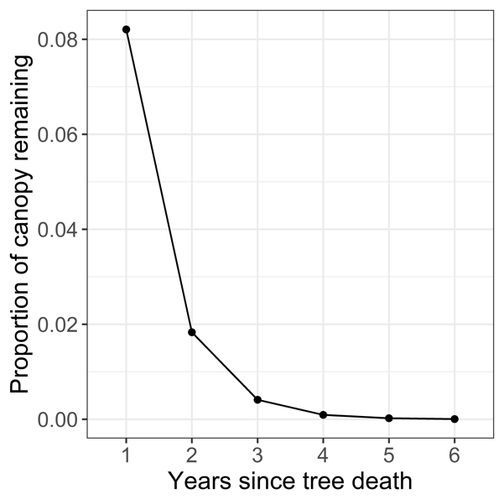*Standing dead*

Figure A1.1 Visual representation of the standing dead multiplier. The exponential decay function determines the proportion of canopy remaining as function of time since tree death.

Table A1. Parameter values for reproduction, seedling dispersal and litter suppression of seedlings.

|  |  |  |  |
| --- | --- | --- | --- |
| Parameter | Definition | Value | Units |
| *brateinvader* | Parameter for seedling establishment | 0.7 | dim’less |
| *bratenative* | “ | 0.25 | “ |
| *Nseedling,limit* | Upper limit on number of viable seedlings from a single tree | Variable, 1 to 15 | number |
| *c3,invader* | Parameter related to dispersal | 0.15 | m-1 |
| *c3,native* | " | 0.5 | “ |
| *slitter,invasive on invader* | Parameter related to seedling suppression, of invader | 1 | kg-1 |
| *slitter,invasive on native* | Parameter related to seedling suppression, of native | Variable, 1 to 200 | “ |

Appendix 2. Results for competition of invader and native species

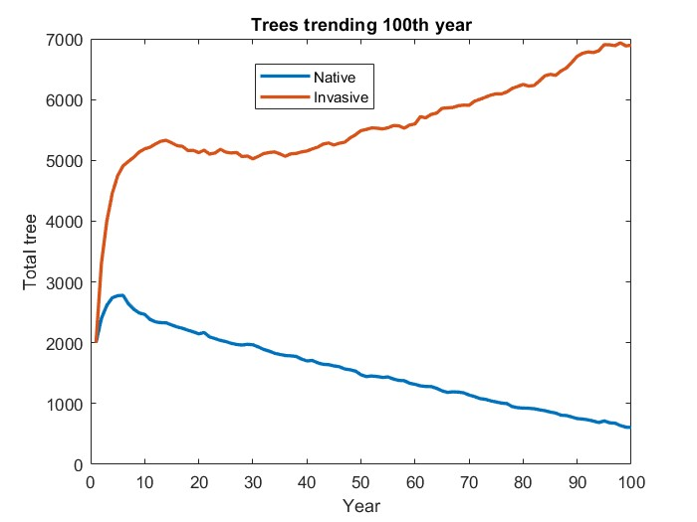

Figure A2.1. Trajectories of native and invasive trees in the absence of biocontrol. The parameters are *c3* = 0.20, *slitter* = 0, and random number initiator 39. This is an example of the general result that even without litter suppression of native seedlings, the invasive species dominates the native species.

(A)

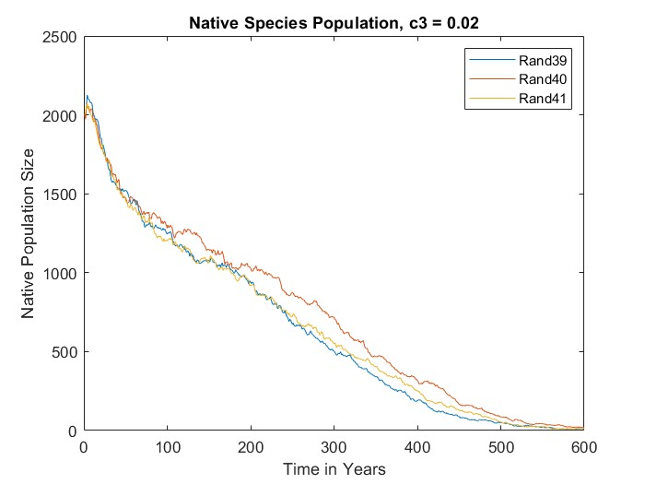

(B)

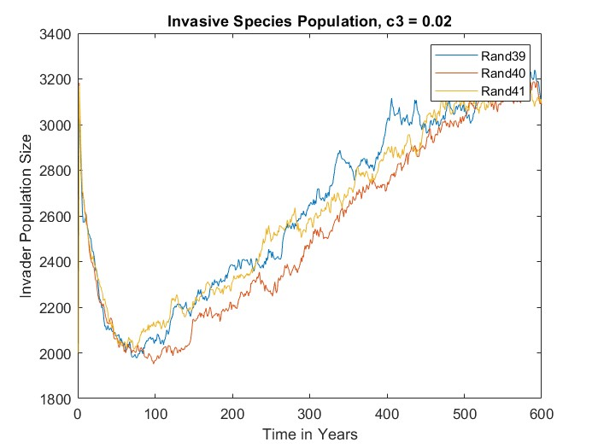

Figure A2.2. Temporal trajectories of native and invader trees following the start of invasion from a plot divided in half to natives and invaders (Figure 1.) Parameters *c3* = 0.02, *slitter* = 14, three values of random number initiator. (A) Native tree species, (B) Invasive species.

(A)

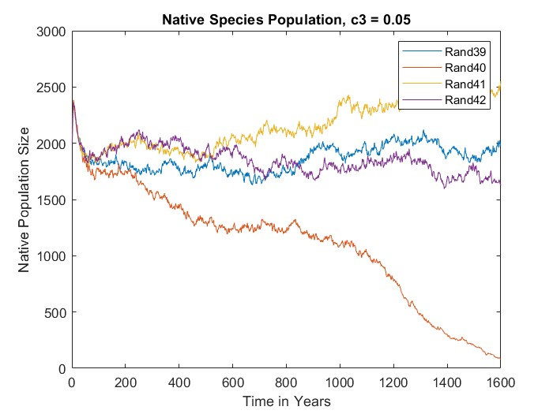

(B)

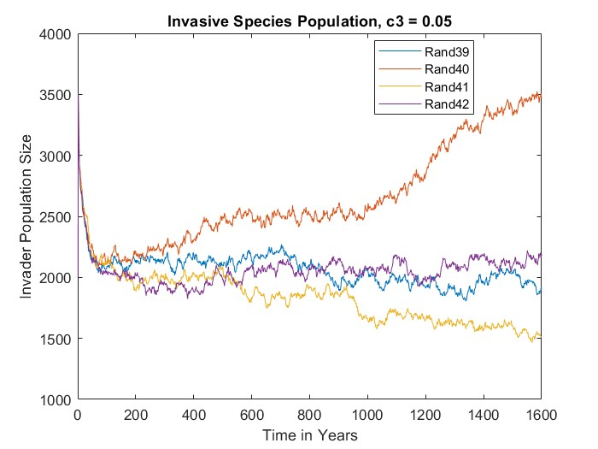

Figure A2.3. Temporal trajectories of native and invader trees following the start of invasion from a plot divided in half to natives and invaders (Figure 1.) Parameters *c3* = 0.05, *slitter* = 14, three values of random number initiator. (A) Native tree species, (B) Invasive species.

(A)

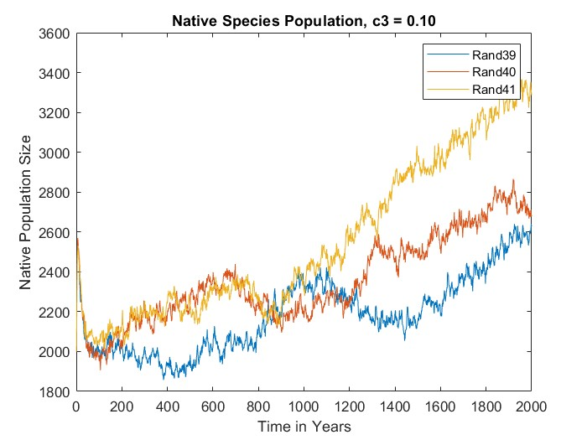

(B)

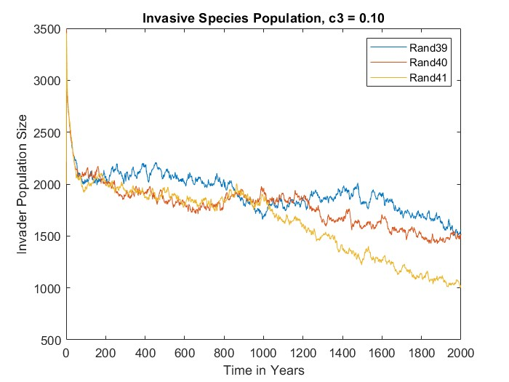

Figure A2.4. Temporal trajectories of native and invader trees following the start of invasion from a plot divided in half to natives and invaders (Figure 1.) Parameters *c3* = 0.10, *slitter* = 14, three values of random number initiator. (A) Native tree species, (B) Invasive species.

(A)

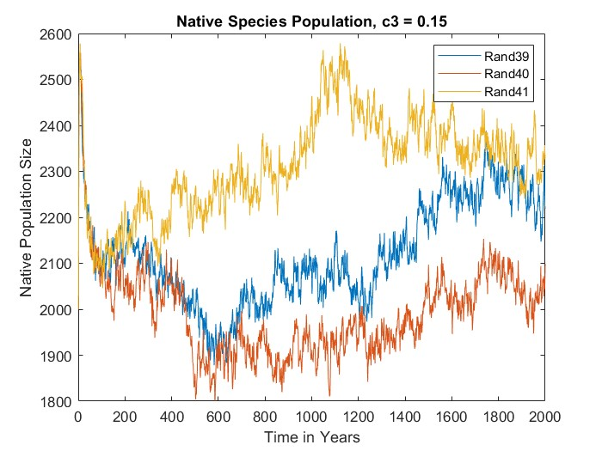

(B)

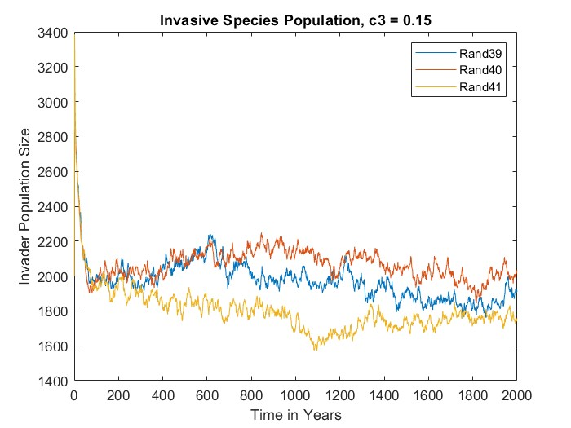

Figure A2.5. Temporal trajectories of native and invader trees following the start of invasion from a plot divided in half to natives and invaders (Figure 1.) Parameters *c3* = 0.15, *slitter* = 14, three values of random number initiator. (A) Native tree species, (B) Invasive species.

(A)

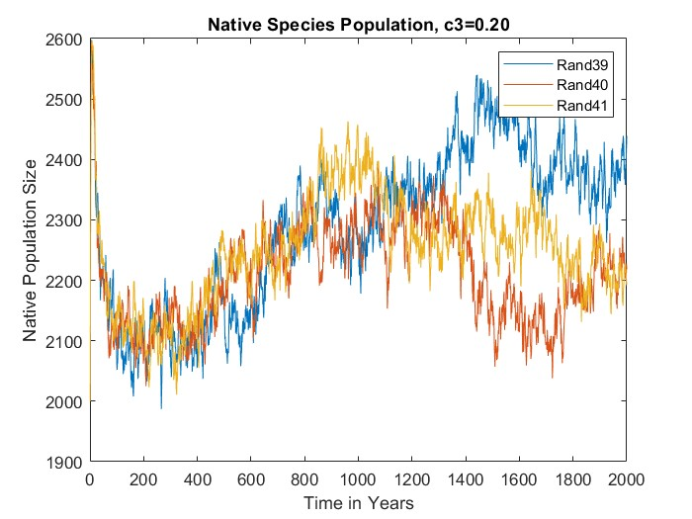

(B)

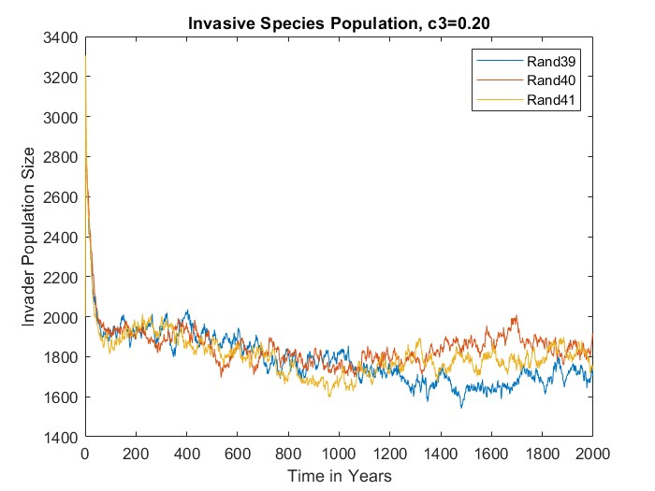

Figure A2.6. Temporal trajectories of native and invader trees following the start of invasion from a plot divided in half to natives and invaders (Figure 1.) Parameters *c3* = 0.20, *slitter* = 14, three values of random number initiator. (A) Native tree species, (B) Invasive species.

(B)

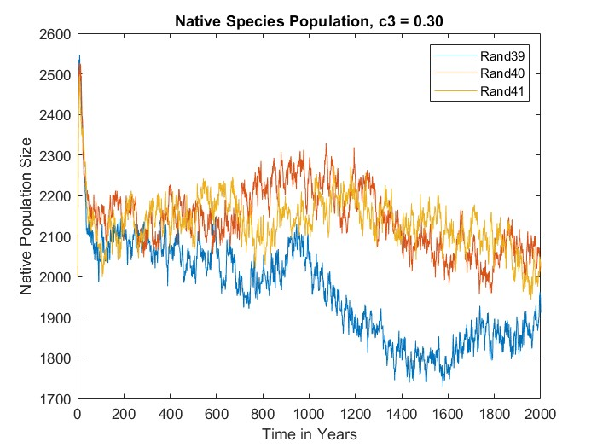

(B)

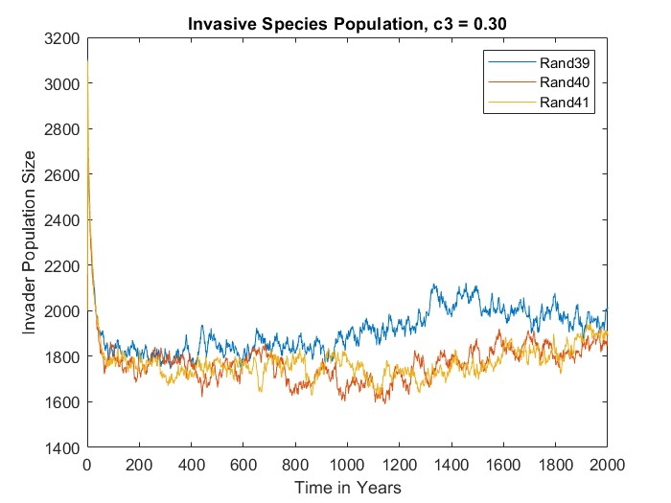

Figure A2.7. Temporal trajectories of native and invader trees following the start of invasion from a plot divided in half to natives and invaders (Figure 1.) Parameters *c3* = 0.30, *slitter* = 14, three values of random number initiator. (A) Native tree species, (B) Invasive species.

(A)

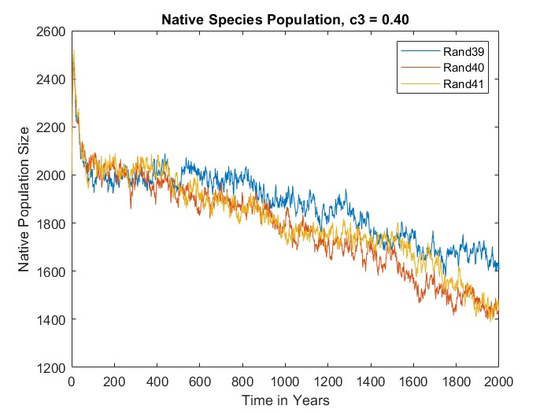

(B)

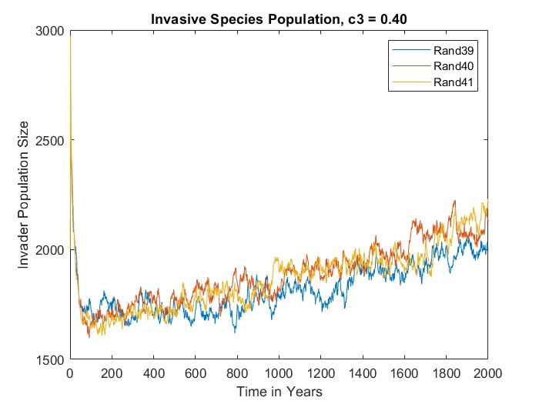

Figure A2.8. Temporal trajectories of native and invader trees following the start of invasion from a plot divided in half to natives and invaders (Figure 1.) Parameters *c3* = 0.40, *slitter* = 14, three values of random number initiator. (A) Native tree species, (B) Invasive species.

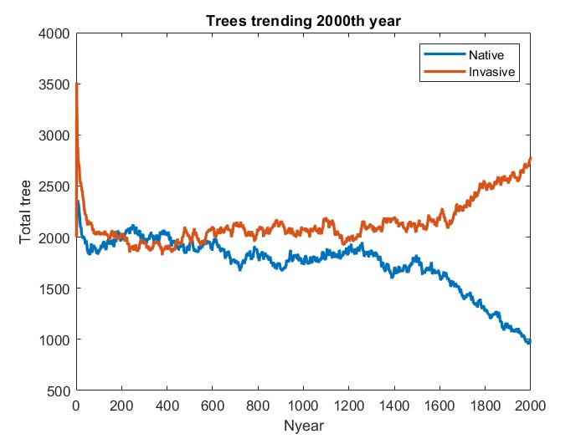

Figure A2.9. Temporal trajectories of native and invader trees following the start of invasion from a plot divided in half to natives and invaders (Figure 1 (L) *c3* = 0.05, with random number initiator 43.

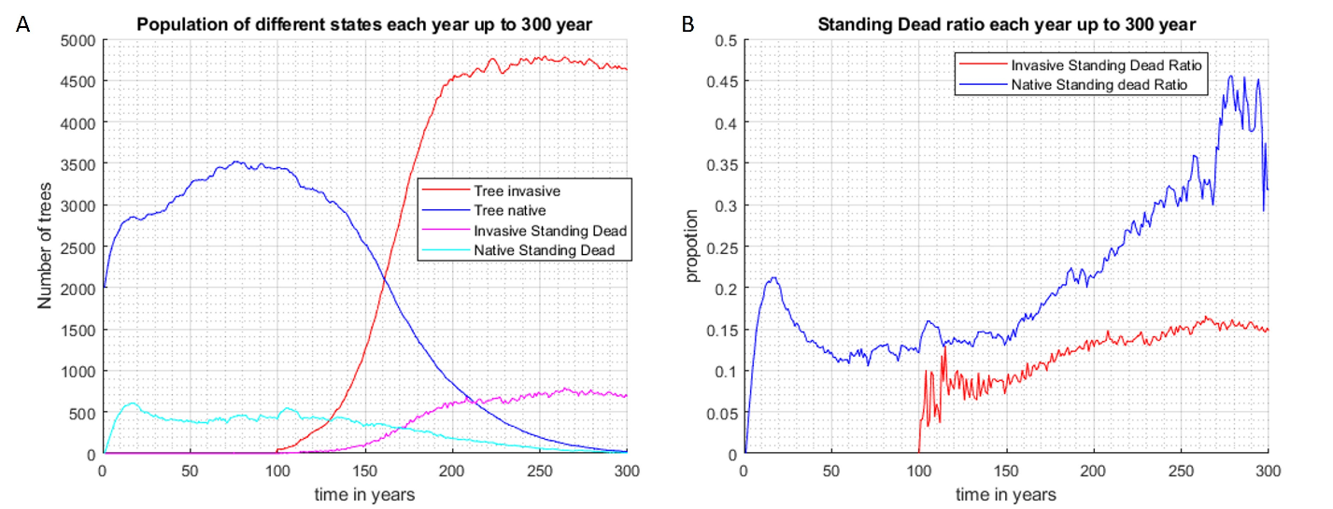

Figure A2.10. Pre-run without biocontrol

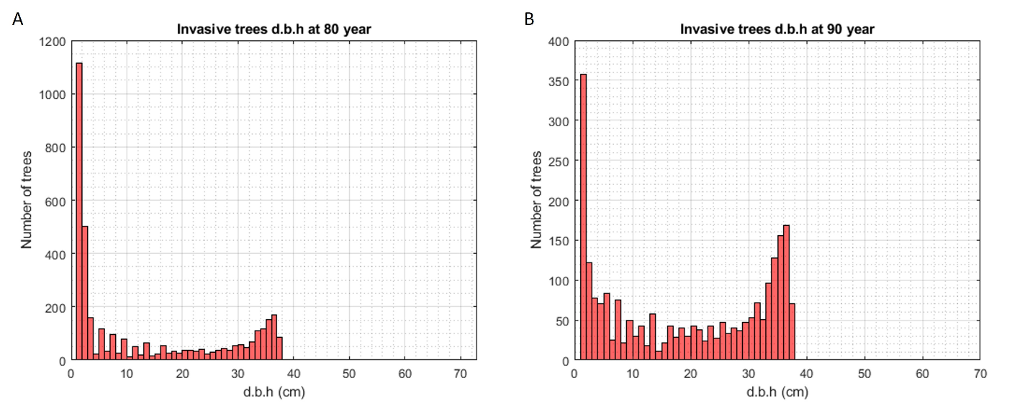

Figure A2.11. Scenario 2, the stem dbh. of invaders before and after application of biocontrol