Supplementary Material

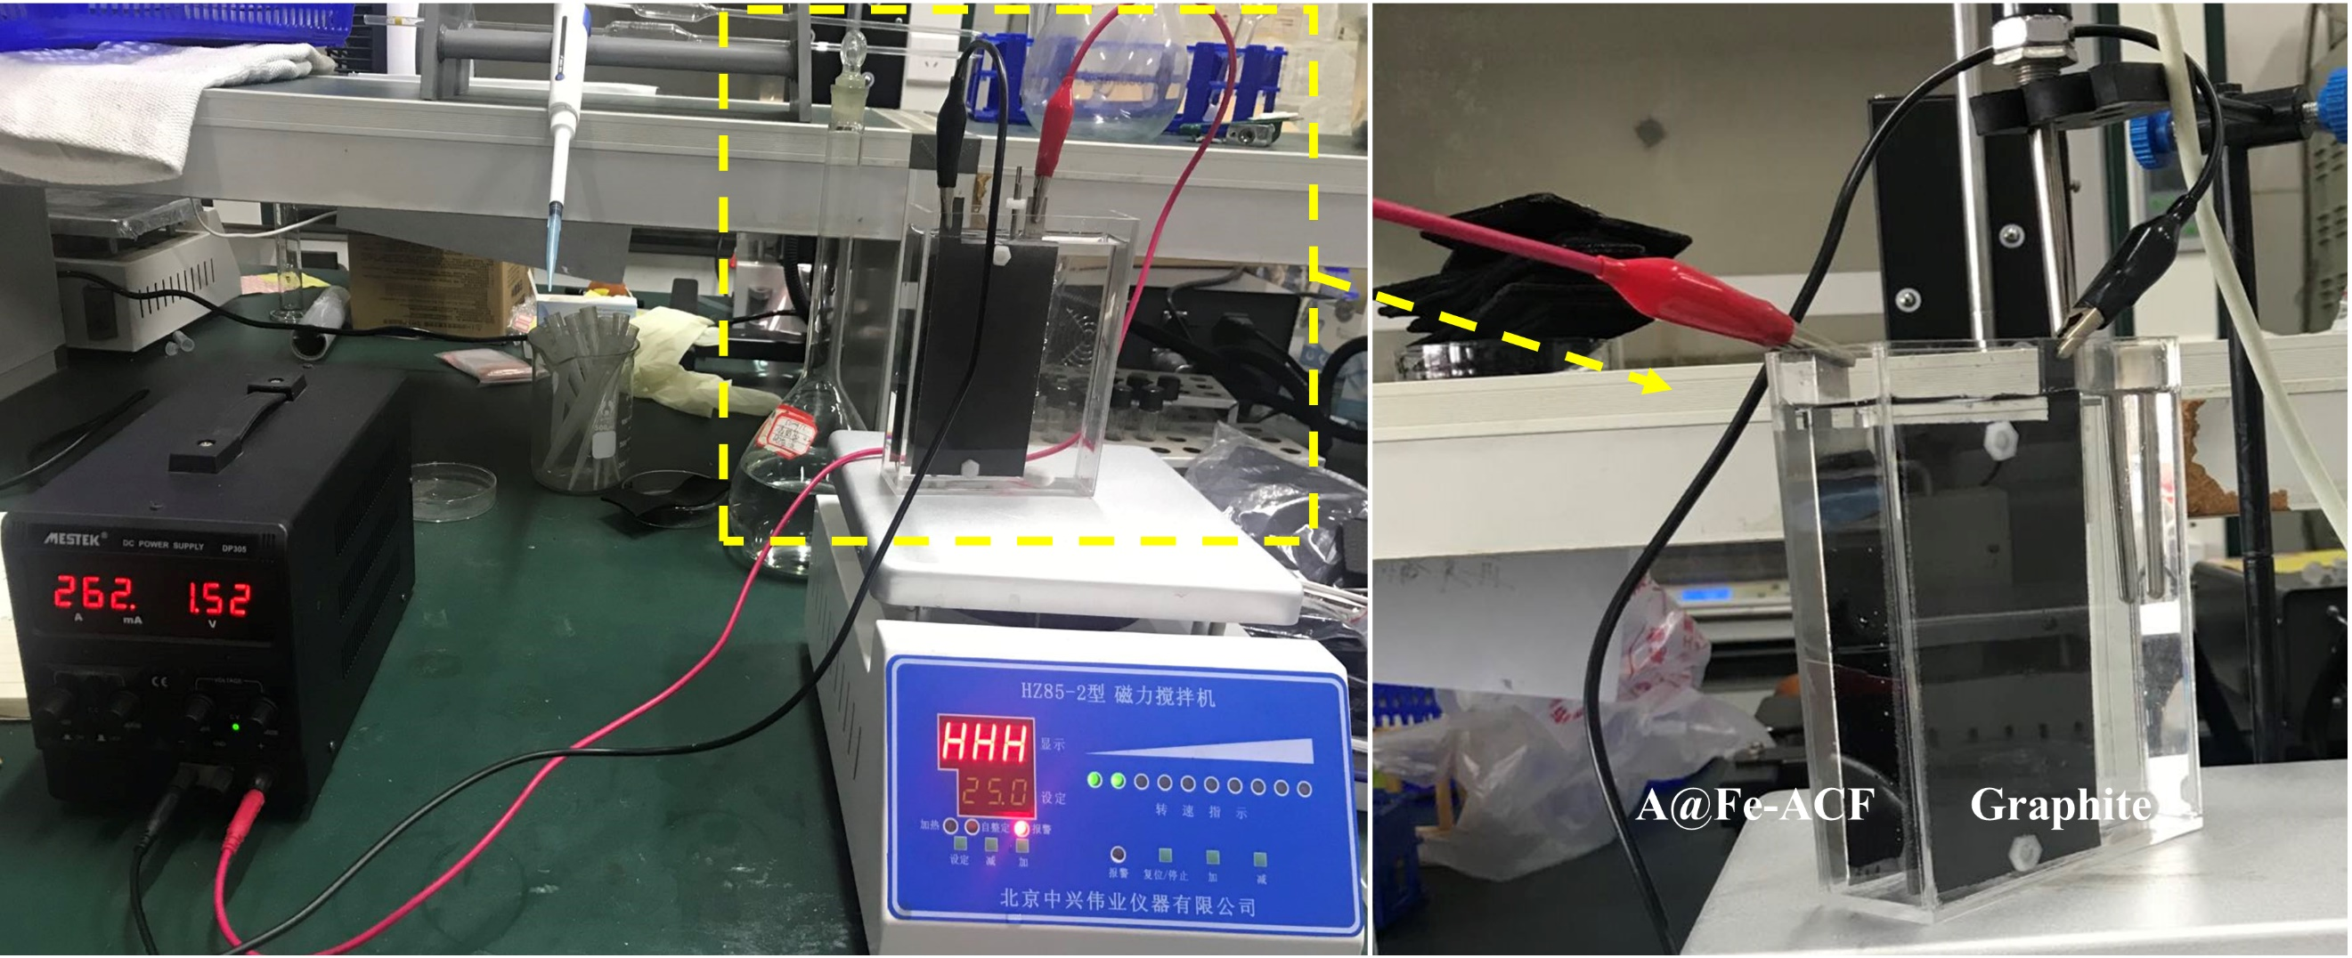

**Fig. S1.** in-situ equipment in the capacitive deionization experiment.



**Fig. S2.** The effect of calcination temperature on CDI performance: (a) removal of TP. (b) removal of TF. (c) The effect of Fe loading concentration on the CDI performance.



**Fig. S3.** EIS curves of different prepared electrodes (amplitude voltage 5 mV, and the data was collected between the frequency range 0.01 Hz–10 kHz).



**Fig. S4.** The interference of different anions on A@Fe-ACF-400 adsorption capacity (small letters indicate the difference in removal efficiency for different coexisting ion concentrations).

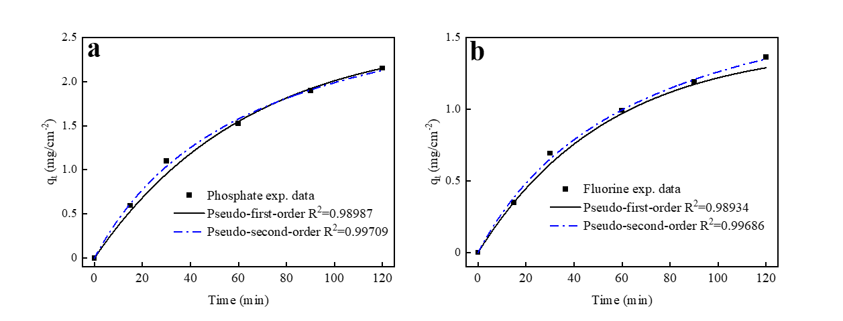

**Fig. S5.** Kinetic results simulated by pseudo-first order and pseudo-second order kinetics: (a) phosphate. (b) fluoride.