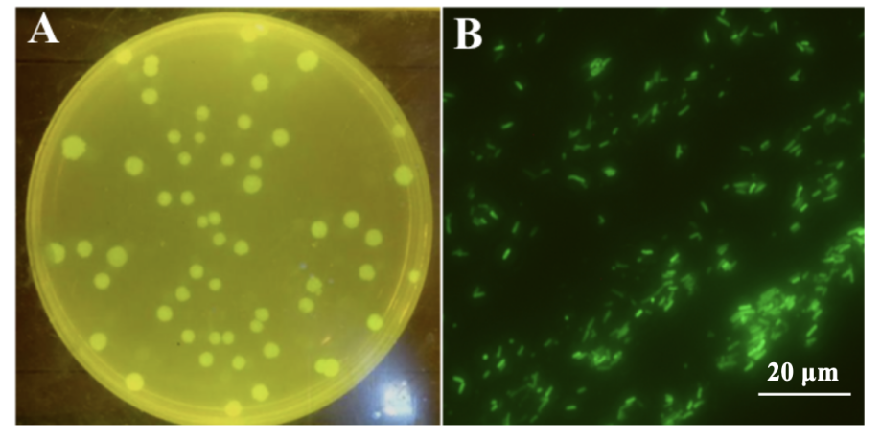

**Fig. S2** Fluorescence microscopy analysis. (A) *Pal*::GFP aerosol colonies on nutrient agar (NA) plates. (B) *Pal*:: GFP cell on cucumber diseased leaves.