Supplementary Material

  - Review on Niche Modeling
One of the earliest models for ecological competition is the Lotka-Volterra equation, where species 1 with abundance $N_{1}$ competes with species 2 with abundance $N_{2}$ for the same renewable resource $K$. The abundances then change with time according to
$$\begin{aligned}\frac{dN_{1}}{dt}=μ_{1}N_{1}\left(1-\frac{αN_{1}+βN_{2}}{K}\right),\#\left(S1\right)\end{aligned}$$
$$\begin{aligned}\frac{dN_{2}}{dt}=μ_{2}N_{2}\left(1-\frac{αN_{1}+βN_{2}}{K}\right),\#\left(S2\right)\end{aligned}$$
where $μ_{1}$ and $μ_{2}$ are the net reproductive rates of species 1 and 2 respectively, $α$ and $β$ are constants that determine the equilibrium abundances of species 1 and 2 if they were alone in the ecosystem.
One way to disrupt this ecosystem would be to introduce a third species into the model, to write
$$\begin{aligned}\frac{dN_{i}}{dt}=μ_{i}N_{i}\left(1-\frac{αN_{1}+βN_{2}+γN_{3}}{K}\right).\#\left(S3\right)\end{aligned}$$
Here we have assumed that there is only one resource, and the invasive species needs to share it with the two native species. This assumption aside, there are problems with using such models. First, in the absence of the third species, we end up almost always with an equilibrium situation where all individuals are from species 1 or species 2 [1, 2]. For arbitrary $K$, the dominant species is 1 if $μ_{1}>μ_{2}$, or 2 if $μ_{2}>μ_{1}$. There is a special case where the two species can coexist, and that is when $K=αN_{1}^{*}+βN_{2}^{*}$. Here, $N_{1}^{*}$ and $N_{2}^{*}$ are the equilibrium abundances of species 1 and 2 respectively. This special case turns out to be important later when we introduce the model of interacting niches. Second, when we introduce the third species, we still end up almost always with an equilibrium situation where all individuals are from the same species. Where biodiversity is concerned, there would be no difference before or after introducing the third species.
    - Ecological Perspective on Niches
In order to allow species to co-exist in the equilibrium, we need to introduce more than one resource, say $K_{1},…,K_{m},…,K_{M}$. If we then write down Lotka-Volterra equations for each of the resource, we will end up with an equilibrium with $M$ species, with abundances ${\left\{N_{m}^{*}\right\}}_{m=1}^{M}$ determined by ${\left\{K_{m}\right\}}_{m=1}^{M}$ [3-6]. Therefore, if we now introduce a new species to the ecosystem, there can only two outcomes: (1) the invasion fails, and the new species disappears completely, or (2) the invasive species displaces the old species as the species that is sustained by $K_{m}$. The entropy $S$ may change, because the new species have a different equilibrium abundance compared to the old species, but there will be no cascading effects on the other abundances. Therefore, to even start discussing biological invasion (or human migration), we must introduce models in which the resources themselves also interact. This is the idea of a niche.
In 1917, Grinnell was the first to propose such a concept [7], which is a subset of the environment containing the habitat conditions that allow the individuals of a species to survive and reproduce. Since then, his notion of a niche has come to be known as the Grinnellian niche. Later in 1927, Elton proposed a slightly different concept of a niche [8]. A Eltonian niche is primarily defined by the functional role of a species inside a community, mainly according to consumed resources (bionomic variables, e.g. nutrients, ecosystem, …). 30 years later, Hutchinson described his ideas on what a niche should be, and provided the first mathematical description of the ecological niche [8], referred to now as the Hutchinsonian niche. Hutchinson distinguished between the fundamental niche, which is the largest possible habitat a given species can persist within, based on biotic resources the species need to consume, and abiotic factors limiting its spread, when there is no competition; and the realized niche, which is the actual habitat of the species, when it is forced to compete with other species for space and biotic resources. which later became the two cornerstones in the niche theory framework.
In his 1973 book [9], May explained why ecological niches emerge. To do so, May considered $M$ species inhabiting a resource continuum $K(x)$ in one dimension (although the idea can be easily extended to higher dimensions). For species $i$, let us denote its (time-independent) resource utilization function as $f_{i}(x)$. The population $N_{i}\left(t\right)$ of species $i$ would then evolve in time as
$$\begin{aligned}\frac{dN_{i}\left(t\right)}{dt}=N_{i}\left(t\right)\left[k_{i}-\sum_{j=1}^{M}{α_{ij}N_{j}\left(t\right)}\right],\#\left(S4\right)\end{aligned}$$
where $k_{i}=∫K\left(x\right)f_{i}\left(x\right) dx$ is the maximum growth rate of species $i$ (if it is alone in the ecosystem), and $α_{ij}=∫f_{i}\left(x\right)f_{j}\left(x\right)dx$ is the competition coefficient between species $i$ and $j$, as a result of niche overlap between the two species (shown schematically in Figure S1). Equation (S4) can be solved by going to the basis $\{{\tilde{N}}_{l}(t)\}$ formed by the eigenvectors of the matrix $α_{ij}$. In this basis,
$$\begin{aligned}{\tilde{N}}_{l}\left(t\right)=\sum_{i=1}^{m}{ω_{li}N_{i}\left(t\right)},\#\left(S5\right)\end{aligned}$$
$$\begin{aligned}{\tilde{f}}_{l}\left(x\right)=\sum_{i=1}^{m}{ω_{li}f_{i}\left(x\right)},\#\left(S6\right)\end{aligned}$$
$$\begin{aligned}k_{l}=∫K\left(x\right){\tilde{f}}_{l}\left(x\right) dx,\#\left(S7\right)\end{aligned}$$
$$\begin{aligned}\frac{d{\tilde{N}}_{l}\left(t\right)}{dt}={\tilde{N}}_{l}\left(t\right)\left[k_{l}-λ_{l}{\tilde{N}}_{l}(t)\right].\#\left(S8\right)\end{aligned}$$

Supplementary Figure S1: A schematic figure demonstrating niche overlap in May’s model. The x-axis denotes the position of the habitat, and on the $x$-axis we show the spatial distributions of the populations of different species. In this figure, the populations are shown as three normal distributions, indicating where different species are dominant. Neighboring distributions are $d$ apart (center to center), and all of them have the same standard deviation $w$. The ratio $w/d$ can therefore be used to measure the overlap between neighboring niches.

To understand what this general solution implies, let us make several assumptions. First, let us assume that the utilization function is a Gaussian,
$$\begin{aligned}f_{i}\left(x\right)=C_{i}\exp\left[-\frac{{\left(x-μ_{i}\right)}^{2}}{2w_{i}^{2}}\right],\#\left(S9\right)\end{aligned}$$
where $C_{i}$ is a constant, and $w_{i}$ is the width of $f_{i}(x)$. The competition coefficient is then
$$\begin{aligned}α_{ij}=C_{i}C_{j}\int_{-∞}^{∞}{\exp\left[-\frac{{\left(x-μ_{i}\right)}^{2}}{2w_{i}^{2}}-\frac{{\left(x-μ_{j}\right)}^{2}}{2w_{j}^{2}}\right]dx}=C_{ij}\exp\left[-\frac{d_{ij}^{2}}{2\left(w_{i}^{2}+w_{j}^{2}\right)}\right],\#\left(S10\right)\end{aligned}$$
where we can choose $μ_{i}=0$ and $μ_{j}=d_{ij}$ (the distance between the centers of the two distributions) without loss of generality. If we then assume that the $M$ species are equally spaced with separation $d$, and the utilization functions have the same spread $w_{i}=w_{j}=w$, then we can write $α=\exp{[-d^{2}/4w^{2}]}$. The niche overlap is then determined by a single metric $d/w$. For small values of $d/w$, the niche overlap is significant, whereas for $d/w≫1$, we have nearly zero niche overlap.

In the former case ($d/w<1$), the smallest eigenvalue $λ_{\text{min} }$of $α_{ij}$ approaches zero faster than any power of $d/w$, and the ecosystem is unstable. In the latter case ($d/w≫1$), $λ_{\text{min} }$ becomes increasingly tiny, but not exactly zero, and thus the ecosystem remains stable. May demonstrated therefore that an ecosystem will evolve towards a state of zero niche overlap, even in the presence of environmental noise. In the 2001 edition of his book, May reviewed previous works between 1959 and 1976, and demonstrated that the empirical results reported in Hutchinson [10], Simpson [11], Terborgh [12], Diamond [13], Beaver [14], Heatwoles and Davis [15], Whittakers [16], and Curtis [17] can be explained by his niche interaction theory.

    - Evolutionary Perspective on Niches

In Supplementary Section II, we focused on the ecological perspective on niches, and how competing in overlapping niches eventually lead to them becoming isolated. However, there is also an evolutionary perspective on niches and their formation. This was first discussed by Conrad Waddington in his 1969 paper [18], who described the many ways in which animals choose and modify the conditions of their environments throughout their lives, a phenomenon that he later called “the exploitive system”. Later ecologists then referred to the body of ideas outlined by Waddington as niche construction theory (NCT), which was popularized by Richard Lewontin in the 1970s and 1980s. In Lewontin’s series of articles on adaptation, he pointed out that organisms do not passively adapt through selection to pre-existing conditions, but actively construct important components of their niches [19]. In 1988, Oxford biologist John Odling-Smee coined the term “niche construction”, and was also the first to make the argument that “niche construction” and “ecological inheritance” should be recognized as evolutionary processes [20]. Since then, over the next few decades, niche construction as a research field has blossomed, culminating in many empirical and theoretical studies.

In a nutshell, the standard evolutionary theory (SET) can be written as
$$\begin{aligned}\frac{dO}{dt}=f\left(O,E\right),\#\left(S11\right)\end{aligned}$$
$$\begin{aligned}\frac{dE}{dt}=g\left(E\right),\#\left(S12\right)\end{aligned}$$
where $O$ and $E$ are the states of the organism and environment respectively. In the above SET equations, we assume that the organism has no part to play in the evolution of its environment. In this sense, SET oversimplified the role of organisms in their respective environments, because many organisms were found to affect their environments in various ways to alleviate the pressures of natural selection. Lewontin then suggested the natural extension of the SET equations, by replacing Equation (S12) with
$$\begin{aligned}\frac{dE}{dt}=g\left(O,E\right),\#\left(S13\right)\end{aligned}$$
so that the state of the environment now depends on the state of the organism as well [19]. The perspective embodied in Equation (S13) is also referred to as niche construction.

Following the work of Odling-Smee et al. [21], who described the ecological and evolutionary impacts niche construction has on ecosystems, and how it triggers ecological and evolutionary feedbacks to leave detectable ecological signatures, Matthews et al. proposed an operational framework [22] to evaluate comparative and experimental evidence for the evolutionary consequences of niche construction, further suggesting research that can improve our understanding of ecological and evolutionary dynamics. More recently, Matthews et al. found experimentally feedback between the ecosystem modifying activities of adult fish, and the fitness relationships among juveniles in a subsequent generation [23]. These are just a few testaments that niche formations are ubiquitous and indispensable in understanding how ecological systems behave and evolve.

In the NCT perspective, offspring thus inherit not only the genes but also the environment modified by their parents. In particular, younger advocates of NCT, such as Laland, Feldman, and many others helped to popularize the idea, develop the mathematical framework of NCT, and used it to explain many ecological and human social phenomena with great success. In particular, Laland’s model for niche construction [24, 25] assumes an isolated population of randomly mating, diploid individuals, defined at two diallelic loci, $E$ (with alleles $E$ and $e$) and $A$ (with alleles $A$ and $a$). In each generation $t$, one can write out the frequencies of gametes ($x_{i}$, $i=1,..,4$ of gametes $EA$, $Ea$, $eA$, and $ea$), and frequencies for $E$ and $A$ in terms of $p=x_{1}+x_{2}$, and $q={x_{}}_{1}+x_{3}$, respectively. Also, the resource $R$ in generation $t$ can be written as $R_{t}=λ_{1}R_{t-1}\left(1-γp_{t}\right)+λ_{2}p_{t}+λ_{3}$, where $λ_{1}$, $λ_{2}$, and $λ_{3}$ determine the extents of independent depletion, niche construction, and independent renewal, respectively. $γ$ is a coefficient that determines if there is negative niche construction, which refers to niche construction activities that reduce the fitness of the population, i.e., individuals become less able to consume the resource. In this model, $λ_{2}$ and $γ$ are the two variables that take the effects of niche construction into consideration.

Next, we can construct the genotype fitness table shown in Table 1, in which the fitness for loci $E$ and $A$ can be rigorously defined in terms of niche-independent and niche-dependent components for $AA$, $Aa$, $aa$, $EE$, $Ee$, and $ee$. Using the fitness table, we can write down the gametic recursion relations
$\begin{aligned}Wx_{1}^{'}=\left[x_{1}\left(x_{1}w_{11}+x_{2}w_{21}+x_{3}w_{12}+x_{4}w_{22}\right)\right]-rw_{22}D,\#\left(S14\right) \end{aligned}$
$$\begin{aligned}Wx_{2}^{'}=\left[x_{2}\left(x_{1}w_{21}+x_{2}w_{31}+x_{3}w_{22}+x_{4}w_{32}\right)\right]+rw_{22}D,\#\left(S15\right) \end{aligned}$$
$$\begin{aligned}Wx_{3}^{'}=\left[x_{3}\left(x_{1}w_{12}+x_{2}w_{22}+x_{3}w_{13}+x_{4}w_{23}\right)\right]+rw_{22}D,\#\left(S16\right) \end{aligned}$$
$$\begin{aligned}Wx_{4}^{'}=\left[x_{4}\left(x_{1}w_{22}+x_{2}w_{32}+x_{3}w_{23}+x_{4}w_{33}\right)\right]-rw_{22}D,\#\left(S17\right) \end{aligned}$$
where $w_{ij}$ denotes elements in the fitness table, $r$ is the recombination rate, $D=x_{1}x_{4}-x_{2}x_{3}$ is the linkage disequilibrium between the loci, and
$$\begin{aligned}W=\left[x_{1}\left(x_{1}w_{11}+x_{2}w_{21}+x_{3}w_{12}+x_{4}w_{22}\right)\right]+ \\ \left[x_{2}\left(x_{1}w_{21}+x_{2}w_{31}+x_{3}w_{22}+x_{4}w_{32}\right)\right]+ \\ \left[x_{3}\left(x_{1}w_{12}+x_{2}w_{22}+x_{3}w_{13}+x_{4}w_{23}\right)\right]+ \\ \left[x_{4}\left(x_{1}w_{22}+x_{2}w_{32}+x_{3}w_{23}+x_{4}w_{33}\right)\right].\#\left(18\right)\end{aligned}$$
In Equations (S14) to (S17), $x_{1}^{'}$, $x_{2}^{'}$, $x_{3}^{'}$, and $x_{4}^{'}$ are the gamete frequencies in the next generation. To find the equilibrium gamete frequencies $x_{1}^{*}$, $x_{2}^{*}$, $x_{3}^{*}$, and $x_{4}^{*}$, we simply let $x_{i}=x_{i}^{'}=x_{i}^{*}$ in the above equations, and solve for $x_{1}^{*}$, $x_{2}^{*}$, $x_{3}^{*}$, and $x_{4}^{*}$.

Supplementary Table 1: Genotypic fitness table used to evaluate the gametic recursion relations. In this table, the entry in row $i$ and column $j$ is written as $w_{ij}$. Additionally, positive values of $ϵ$ represent cases where an increase in the amount of resources results in increased fitness of genotypes containing alleles $A$, while negative values of $ϵ$ represent cases where an increase in $R$ favors alleles $a$. The fixed components $α_{i}$ and $β_{j}$ represent selection forces from the environment that are independent of niche construction.
Locus | $$EE$$ | $$Ee$$ | $$ee$$
$$AA$$ | $$α_{1}α_{2}+ϵR$$ | $$α_{2}+ϵR$$ | $$β_{1}α_{2}+ϵR$$
$$Aa$$ | $$α_{1}+ϵ\sqrt{R(1-R)}$$ | $$1+ϵ\sqrt{R(1-R)}$$ | $$β_{1}+ϵ\sqrt{R(1-R)}$$
$$aa$$ | $$α_{1}β_{2}+ϵ(1-R)$$ | $$β_{2}+ϵ(1-R)$$ | $${β_{1}}_{ }β_{2}+ϵ(1-R)$$

With this model, we can incorporate both abiotic environmental components, biotic populations, and their ecological interactions into an evolutionary framework, to simulate scenarios with no external selection, or with external selection involving only the $A$, or $E$ locus. Unlike the SET, this NCT approach can be applied to both population–community level ecology, as well as ecosystem-level ecology, making it possible to reconcile these two ecological subdisciplines. Using this NCT approach, Laland et al. [24, 25], and later Creanza and Feldman [26] as well as Silver and Di Paolo [27], found that when niche construction is present, genes or phenotypes that are deleterious under SET can remain in the population at a significant level. In these same papers, they also found that niche construction can create or eliminate equilibria (new NCT equilibria not found in SET, or the disappearance of SET equilibria under niche construction), affect evolutionary rates, cause evolutionary time lags, generate momentum and inertia, autocatalytic effects, catastrophic responses to selection, and cyclical dynamics. Lehmann [28], also van Dyken and Wade [29] argued that the above findings can explain the evolution of cooperation. Furthermore, Kylafis and Loreau [30], along with Krakauer et al. [31] argue that the ability of NCT to regulate environmental states allows some organisms to persist in otherwise inhospitable conditions, thus facilitating range expansion.

    - Niche Modeling in Culture

Following the success of their evolutionary model of niche construction for ecosystems, Laland et al. [32] realized that the NCT perspective can be extended to a triple inheritance framework that includes genes, ecologies, and cultures, and their interactions. Laland et al. proposed to use such a framework to model gene-cultural coevolution, which is important for understanding phenomena such as human global dispersal, migration, language evolution, behavioral modernity and sociality, the advent of agriculture, and the evolution of human and domesticate diseases, to name just a few. In their paper [33], Laland et al. treated the second allele $E=\{E,e\}$ as a culturally-transmitted trait (along the lines of the meme concept proposed by Richard Dawkins [34-37]), as opposed to $A=\{A,a\}$, which is a genetic allele. We will review this theory of cultural niche construction, before listing some of its successful applications.

To begin, we construct the fitness table of individuals with gametes $AAE$, $AAe$, $AaE$, $Aae$, $aaE$, and $aae$, with frequencies $x_{1}$, $x_{2}$, $x_{3}$, $x_{4}$, $x_{5}$, and $x_{6}$ respectively. We assume that the cultural trait $E$ is responsible for cultural niche construction (i.e., individuals with cultural trait $e$ cannot). Therefore, the contribution of the cultural niche to the fitness function is proportional to the frequency $x=x_{1}+x_{3}+x_{5}$, the sum of frequencies of gametes where $E$ appear. Since $E$ is not genetic, its transmission rates must therefore be specified independently. These rates are set to $b_{3}$ for $E×E$ (both parents with cultural trait $E$), $b_{2}$ for $E×e$ (the first parent with cultural trait $E$), $b_{1}$ for $e×E$ (the second parent with cultural trait $E$), and $b_{0}$ for $e×e$ (no parents with cultural trait $E$). When Laland et al. analyzed the model, they found that the results are the same as their genetic model, when there is no external selection $α_{1}=α_{2}=η_{1}=η_{2}=1$. When there is external selection at genetic allele $A$ only, cultural selection for $A$ is stronger than natural selection. Conversely, when there is external selection at cultural ‘allele’ $E$ only, we have the opposite result.

Using a cellular automaton model, Rendell et al. [38] explored local and global spatial effects of cultural niche construction on gene-culture coevolutionary dynamics. They found that after the cultural trait modified the local environment, the latter started selecting for a particular genetic trait, whose frequency increases. The frequency of the cultural trait responsible for niche construction also increases, not because it is selected by the local environment, but because it is present together with the genetic trait selected. Rendell et al. discovered that this genetic hitchhiking phenomenon occurs even when the inheritance of the genetic trait or cultural trait is costly. As the implications of the theory of cultural niche construction were elucidated through simulations, evidence to support it also emerged from field research. For example, Smith developed a classification scheme for niche-constructing activities [39], based on multiple field studies of small-scale North American human societies to produce food and raw materials from wild flora and fauna. He emphasized how the scheme distinguishes characteristics of wild taxa that make them likely targets for niche construction, as well as the proactive impact that humans have had on their own subsequent resource selection because of improved yields. Rowley-Conwy and Layton found that hunter-gatherers can also engage in niche construction, by proactively altering both the ecological stability and evolutionary dynamics of a wide variety of plants to increase their hunting success [40]. In particular, the niches constructed by hunter-gatherers made cereal and their games (sheep, goats, and cattle) boars so widespread that agricultural settlements based on them started emerging and expanding, to the detriment of hunter-gatherer communities. Taking an interdisciplinary approach, Gerbault et al. studied the most well-cited example of gene-culture coevolution, that of lactase persistence and dairy farming. By combining new genetic data, archaeological evidence, and simulation modeling, they explored how this co-evolutionary process took place [41]. Turning gene-culture coevolution on its head, Gintis argued that culture is not simply a by-product of genetic evolution, but an active ingredient that drives the overall evolution of humankind [42]. Specifically, Gintis claimed that altruism and norms emerged in societies because gene-culture coevolution selects for individuals with genetic predispositions for these prosocial and moral cultural traits. Last but not least, Ihara developed a mathematical model using gene-culture coevolution to explain why human communities can feel connected to each other, but discriminate against other human communities [43]. This is called discriminate sociality. In the model, the emergence and evolutionary stability of the two types of discriminate sociality are found to be promoted by the presence of cultural variation among individuals. Ihara went so far as to suggest that the capacity to discriminate in Homo sapiens helped us survived the Middle to Upper Paleolithic transition as a species, while the Neanderthals perished because they could not discriminate. A complete list of works conducted along this line can also be found in Kendal et al. [44]

    - Niche Modeling in Technology and Innovation

The idea of a niche also appeared independently in the technology and innovation literature, starting with the 1998 work by Kemp, Schot, and Hoogma [45], where they explain the difficulty for new products to establish themselves in an industrial ecosystem. Many factors contribute to this difficulty, none of which are individually forbidding. One of them is the availability of an initial niche that uses the new technology, which could eventually proliferate into a cascade of niches all using the new technology. They do not describe this process in mathematical terms but do give a list of processes constituting niche formation. These include: (1) coupling of expectations, i.e., the technology shows promise in multiple areas; (2) articulation, i.e., the new technology can be described in a way that everyone understands; and (3) social network formation, i.e., the creation of a network of actors with vested interests in the further development of the technology. As far we can tell, Kemp, Schot, and Hoogma are the first in the innovation literature to use the term niche formation. They were also not aware of niche theories introduced in the ecology and evolution literatures.

In 1999, Frenken, Saviotti, and Trommetter showed using two measures of diversity (statistical and structural), that the evolution of the technologies on aircrafts, helicopters, and motorcycles follows classic evolutionary patterns of specialization expected on the basis of May’s model of niche formation [46]. This is perhaps the first paper in the technology literature citing May’s work on niche formation. Inspired by the 1965 work by Campbell [47] and the 1982 work by McKelvey [48] applying evolutionary ideas to organizational and management theory, Luksha used NCT as his primary conceptual framework for understanding how organizations create and transform their niches, to create more opportunities within their environments [49]. No mathematical model was developed in this 2008 paper citing Lewontin’s 1983 work [19] and Odling-Smee, Laland, and Feldman’s 2003 work [50]. However, Luksha reviewed previous works to list the three most important processes used by organizations to construct niches: (1) to frame or seed a potential new construct; (2) to communicate the new construct to its future adherents; and (3) to facilitate learning of the new construct by these adherents. These are effectively the same processes mentioned by Frenken, Saviotti, and Trommetter.

To conclude, the ecological perspective on niche construction was first introduced during the 1970s, before an evolutionary perspective emerged in the 1990s. In particular, the evolutionary NCT found applications on cultural problems and the field of technology and innovation in the 2000s, with re-interpretations of the processes and mechanisms in the respective areas.

    - Phase Portraits of Nonlinear Oscillation Phase
As we can see from Supplementary Figure S2(a), (b), (d), (f), (h), (i), (j), $\left(K_{1}\left(t\right), K_{2}\left(t\right)\right)$, $(N_{1}\left(t\right),N_{2}(t))$, $\left(N_{2}\left(t\right), N_{6}\left(t\right)\right)$, $(K_{1}\left(t\right),N_{2}(t))$, $(K_{2}\left(t\right),N_{1}\left(t\right))$, $(K_{2}\left(t\right),N_{2}\left(t\right))$, and $\left(K_{2}\left(t\right),N_{6}\left(t\right)\right)$ tend towards their respective limit cycles, whereas from Supplementary Figure S2(e), we see that $K_{1}(t)$ and $N_{1}(t)$ are in phase, while $N_{6}(t)$ tends towards a constant independent of $K_{1}(t)$ and $N_{1}(t)$. The stable limit cycle behaviour seen here suggests that there must be a Hopf bifurcation (which occurs when a fixed point becomes unstable, leading to the appearance of stable or unstable limit cycles) or saddle-node bifurcation (when a stable fixed point/limit cycle annihilates an unstable fixed point/limit cycle).
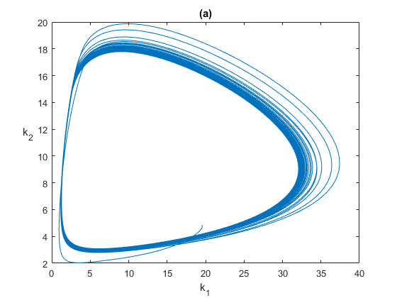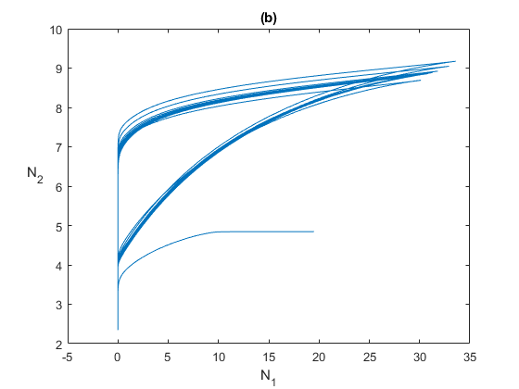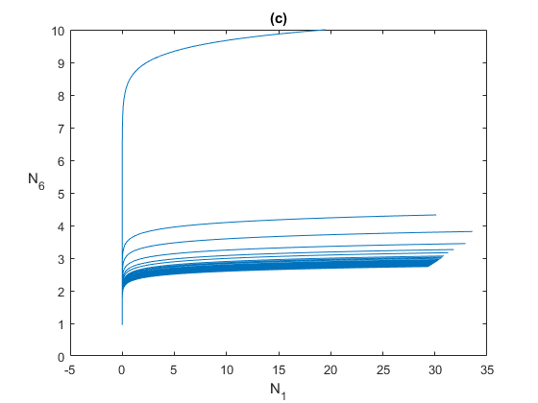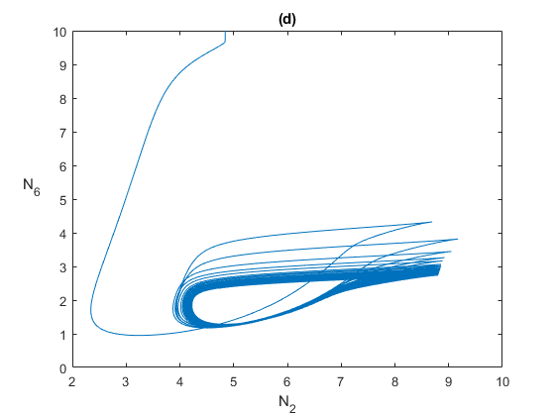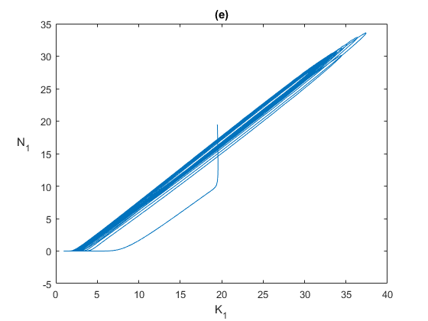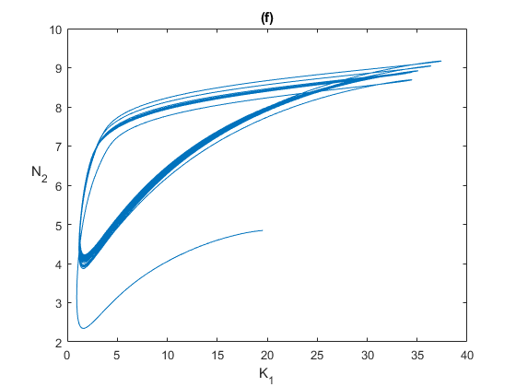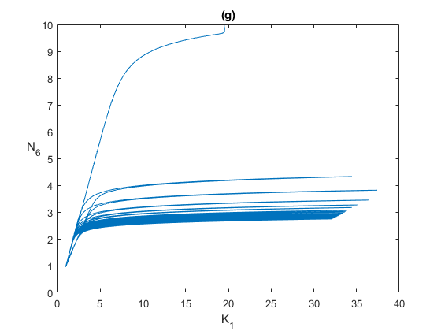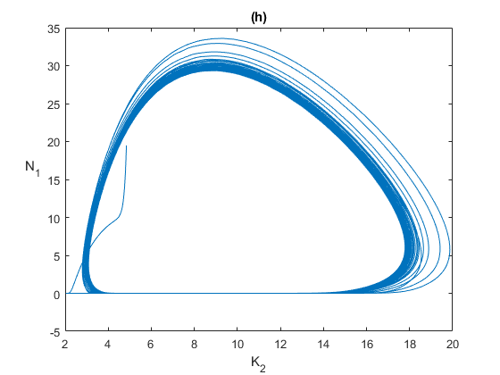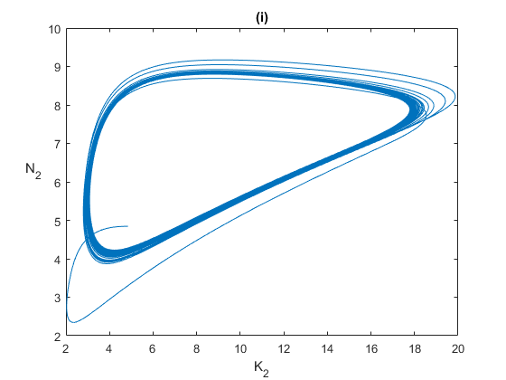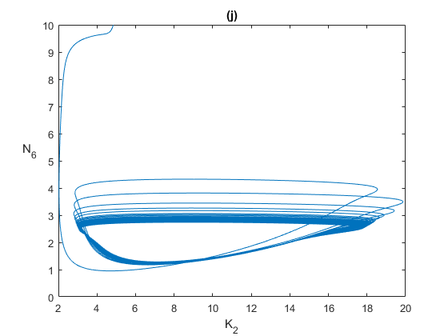
Supplementary Figure S2: Phase portraits of (a) $K_{1}$-$K_{2}$ (hub niche vs periphery niche), (b) $N_{1}$-$N_{2}$ (hub population vs periphery population), (c) $N_{1}$-$N_{6}$ (hub population vs invasive population), (d) $N_{2}$-$N_{6}$ (periphery population against invasive population), (e) $K_{1}$-$N_{1}$ (hub niche vs hub population), (f) $K_{1}$-$N_{2}$ (hub niche vs periphery population), (g) $K_{1}$-$N_{6}$ (hub niche vs invasive population), (h) $K_{2}$-$N_{1}$ periphery niche vs hub population), (i) $K_{2}$-$N_{2}$ (periphery niche vs periphery population), (j) $K_{2}$-$N_{6}$ (periphery niche vs invasive population), for $μ_{6}=1$ and $ϵ=0.7$.

References

1. Bomze IM. Lotka-Volterra equation and replicator dynamics: a two-dimensional classification. Biological cybernetics. 1983;48(3):201-11.
2. Bomze IM. Lotka-Volterra equation and replicator dynamics: new issues in classification. Biological cybernetics. 1995;72(5):447-53.
3. Smale S. On the differential equations of species in competition. Journal of Mathematical Biology. 1976;3(1):5-7.
4. Hirsch MW. Systems of differential equations that are competitive or cooperative II: Convergence almost everywhere. SIAM Journal on Mathematical Analysis. 1985;16(3):423-39.
5. Hirsch MW. Systems of differential equations which are competitive or cooperative: III. Competing species. Nonlinearity. 1988;1(1):51.
6. Hirsch MW. Systems of differential equations that are competitive or cooperative. IV: Structural stability in three-dimensional systems. SIAM journal on mathematical analysis. 1990;21(5):1225-34.
7. Grinnell J. The niche-relationships of the California Thrasher. The Auk. 1917;34(4):427-33.
8. Elton CS. Animal ecology: University of Chicago Press; 2001.
9. May RM. Stability and complexity in model ecosystems. Stability and Complexity in Model Ecosystems: Princeton university press; 2019.
10. Hutchinson GE. Homage to Santa Rosalia or why are there so many kinds of animals? The American Naturalist. 1959;93(870):145-59.
11. Simpson GG. Species density of North American recent mammals. Systematic zoology. 1964;13(2):57-73.
12. Terborgh J, Weske JS. Rediscovery of the Imperial Snipe in Peru. The Auk. 1972;89(3):497-505.
13. Diamond JM. Avifauna of the eastern highlands of New Guinea. 1972.
14. Beaver DL. Avian populations in herbicide treated brush fields. The Auk. 1976;93(3):543-53.
15. Heatwole H, Davis DM. Ecology of three sympatric species of parasitic insects of the genus Megarhyssa (Hymenoptera: Ichneumonidae). Ecology. 1965;46(1-2):140-50.
16. Whittaker RH, editor Evolution of diversity in plant communities. Brookhaven symposia in biology; 1969.
17. Curtis JT. The vegetation of Wisconsin: an ordination of plant communities: University of Wisconsin Pres; 1959.
18. Waddington CH. Paradigm for an evolutionary process. Biological Theory. 2008;3(3):258-66.
19. Lewontin RC. Gene, organism and environment. Evolution from molecules to men. 1983;273(285):975.
20. Odling-Smee FJ. Niche constructing phenotypes. The role of behavior in evolution. 1988:73-132.
21. Odling-Smee J, Erwin DH, Palkovacs EP, Feldman MW, Laland KN. Niche construction theory: a practical guide for ecologists. The Quarterly review of biology. 2013;88(1):3-28.
22. Matthews B, De Meester L, Jones CG, Ibelings BW, Bouma TJ, Nuutinen V, et al. Under niche construction: an operational bridge between ecology, evolution, and ecosystem science. Ecological Monographs. 2014;84(2):245-63.
23. Matthews B, Aebischer T, Sullam KE, Lundsgaard-Hansen B, Seehausen O. Experimental evidence of an eco-evolutionary feedback during adaptive divergence. Current Biology. 2016;26(4):483-9.
24. Laland KN, Odling-Smee FJ, Feldman MW. Evolutionary consequences of niche construction and their implications for ecology. Proceedings of the National Academy of Sciences. 1999;96(18):10242-7.
25. Laland KN, Odling‐Smee FJ, Feldman MW. The evolutionary consequences of niche construction: a theoretical investigation using two‐locus theory. Journal of evolutionary biology. 1996;9(3):293-316.
26. Creanza N, Feldman MW. Complexity in models of cultural niche construction with selection and homophily. Proceedings of the National Academy of Sciences. 2014;111(supplement_3):10830-7.
27. Silver M, Di Paolo E. Spatial effects favour the evolution of niche construction. Theoretical Population Biology. 2006;70(4):387-400.
28. Lehmann L. The adaptive dynamics of niche constructing traits in spatially subdivided populations: evolving posthumous extended phenotypes. Evolution: International Journal of Organic Evolution. 2008;62(3):549-66.
29. Van Dyken JD, Wade MJ. Origins of altruism diversity II: Runaway coevolution of altruistic strategies via “reciprocal niche construction”. Evolution: International Journal of Organic Evolution. 2012;66(8):2498-513.
30. Kylafis G, Loreau M. Ecological and evolutionary consequences of niche construction for its agent. Ecology letters. 2008;11(10):1072-81.
31. Krakauer DC, Page KM, Erwin DH. Diversity, dilemmas, and monopolies of niche construction. The American Naturalist. 2009;173(1):26-40.
32. Laland KN, Odling-Smee J, Feldman MW. Niche construction, biological evolution, and cultural change. Behavioral and brain sciences. 2000;23(1):131-46.
33. Laland KN, Odling‐Smee J, Feldman MW. Cultural niche construction and human evolution. Journal of evolutionary biology. 2001;14(1):22-33.
34. Aoki K. Theoretical and empirical aspects of gene–culture coevolution. Theoretical population biology. 2001;59(4):253-61.
35. Dawkins R, Davis N. The selfish gene: Macat Library; 2017.
36. Feldman MW, Cavalli-Sforza LL. Cultural and biological evolutionary processes, selection for a trait under complex transmission. Theoretical population biology. 1976;9(2):238-59.
37. Lumsden CJ, Wilson EO. Genes, mind, and culture-The coevolutionary process: World Scientific; 2005.
38. Rendell L, Fogarty L, Laland KN. Runaway cultural niche construction. Philosophical Transactions of the Royal Society B: Biological Sciences. 2011;366(1566):823-35.
39. Smith BD. General patterns of niche construction and the management of ‘wild’plant and animal resources by small-scale pre-industrial societies. Philosophical Transactions of the Royal Society B: Biological Sciences. 2011;366(1566):836-48.
40. Rowley-Conwy P, Layton R. Foraging and farming as niche construction: stable and unstable adaptations. Philosophical Transactions of the Royal Society B: Biological Sciences. 2011;366(1566):849-62.
41. Gerbault P, Liebert A, Itan Y, Powell A, Currat M, Burger J, et al. Evolution of lactase persistence: an example of human niche construction. Philosophical Transactions of the Royal Society B: Biological Sciences. 2011;366(1566):863-77.
42. Gintis H. Gene–culture coevolution and the nature of human sociality. Philosophical Transactions of the Royal Society B: Biological Sciences. 2011;366(1566):878-88.
43. Ihara Y. Evolution of culture-dependent discriminate sociality: a gene–culture coevolutionary model. Philosophical Transactions of the Royal Society B: Biological Sciences. 2011;366(1566):889-900.
44. Kendal J, Tehrani JJ, Odling-Smee J. Human niche construction in interdisciplinary focus. Philosophical Transactions of the Royal Society B: Biological Sciences. 2011;366(1566):785-92.
45. Kemp R, Schot J, Hoogma R. Regime shifts to sustainability through processes of niche formation: the approach of strategic niche management. Technology analysis & strategic management. 1998;10(2):175-98.
46. Frenken K, Saviotti PP, Trommetter M. Variety and niche creation in aircraft, helicopters, motorcycles and microcomputers. Research Policy. 1999;28(5):469-88.
47. Campbell DT. Variation and selective retention in socio-cultural evolution. Social change in developing area. 1965.
48. McKelvey B. Organizational systematics: Taxonomy, evolution, classification: Univ of California Press; 2022.
49. Luksha P. Niche construction: The process of opportunity creation in the environment. Strategic Entrepreneurship Journal. 2008;2(4):269-83.
50. Odling-Smee FJ, Laland KN, Feldman MW. Niche construction. Niche Construction: Princeton university press; 2013.

