Supplementary Material 1

The manufacturer of the Flame spectrometer (Ocean Insight; Any use of trade, firm, or product names is for descriptive purposes only and does not imply endorsement by the U.S. Government) promotes this model as having greater thermal stability than previous models (e.g. USB2000+). To quantify this performance we test the instrument’s calibration stability between 0 and 50˚C, a temperature range which should cover typical internal instrument conditions encountered in most deployments. The spectrometer was placed in an incubator (Panasonic MIR-254-PE) and spectra acquired from a Hg-Ar lamp coupled to the spectrometer with an optical fibre; the lamp was located outside of the incubator, to avoid any possible temperature effects on the lamp. Spectra were acquired ≈30 minutes after the incubator had reached each target temperature, to ensure time for the spectrometer to equilibrate to this temperature. Measurements were made at 5˚C increments within the range 0 - 50˚C.

We interrogate the change in line shape of two emission lines, located at 302.15 and 313.16 nm, both of which lie within typical fit windows for differential optical absorption spectroscopy retrievals of SO2. Both shifts in line peak centre and changes in line shape size (full width at half maximum) can occur with changing temperature, each affecting the calibration of the spectrometer, and thus any retrievals of SO2.

As can be seen from Supplementary Figure 1, the line shape of the Flame spectrometer remains almost identical across the temperature range 0 - 50˚C. The spectral resolution (defined as the full-width-at-half-maximum) remains at ≈0.6 nm throughout. There is a very small shift in line location (Supplementary Figure 2), indicating a slight shift in the calibration of the spectrometer; however, this shift is measured at just 0.003 nm/˚C across the range of temperatures here (using the 302.15 nm line, which exhibits the largest shift in this test). Platt and Stutz (2008) quoted typical commercial spectrometer shifts of 0.05 nm/˚C; therefore, our work indicates that the Flame spectrometer is substantially more stable to thermal changes than previous models (corroborating the manufacturer notes).

The most significant shift is found between 0 and 5˚C, with the colder temperature causing a notable (but still quite insignificant relative to other spectrometers) shift in the lines shape location. This suggests that at colder temperatures the spectrometer’s thermal stability may begin to deteriorate somewhat. However, even with lower ambient temperatures, it is likely that internally the instrument will not such lows, due to the continual generation of heat from the electronics.

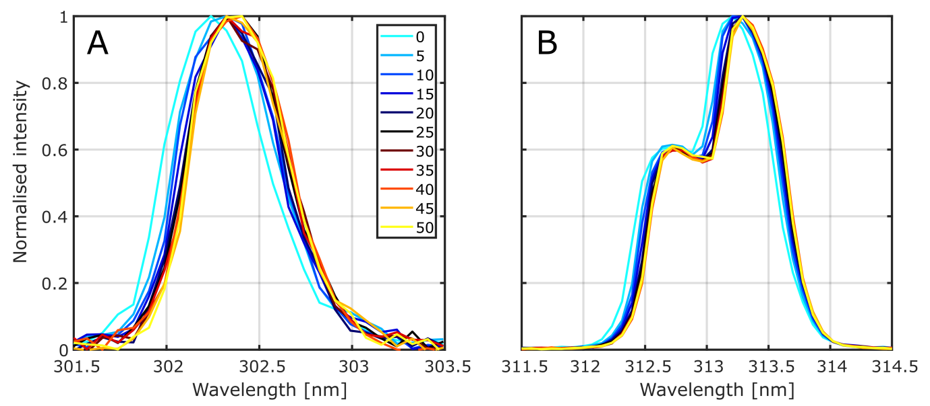

**Supplementary Figure 1.** Flame spectrometer line shapes for Hg-Ar lamp emission lines at A) 302.15 nm and B) 313.16 nm. Instrument stability across this temperature range is good, with the line shape (i.e., spectral resolution) remaining consistent throughout and only a small shift in line location – most notably at 0˚C.

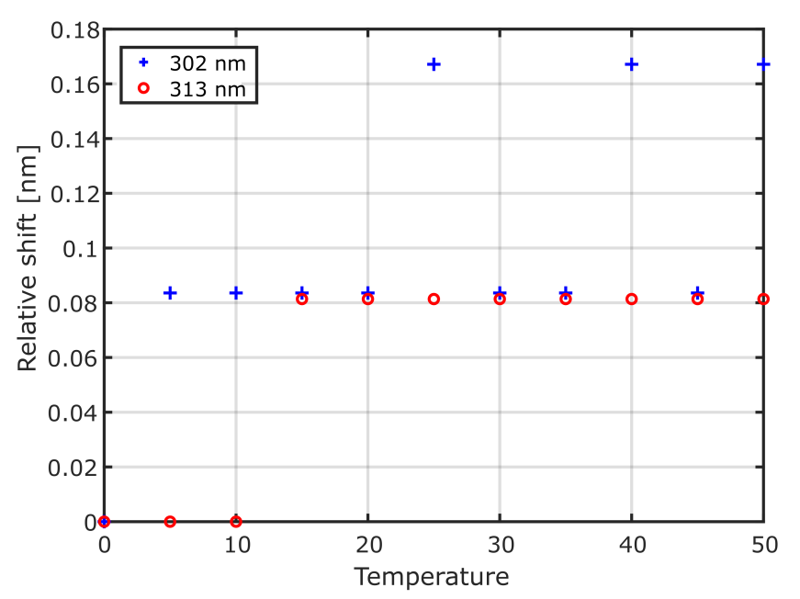

**Supplementary Figure 2.** Relative shift (relative to 0˚C) in line shape peak with changing temperature for emission lines at 302.15 and 313.16 nm. The span of shifts found here are across just 3 pixels of the Flame’s detector, hence the notable step changes.

Supplementary Material 2

We first isolated the horizontal component of plume speeds in the camera images, since this is the speed measured by the weather station, and likely to be the principal component of motion once the plume has exited the crater and cooled to ambient temperature. For cross-correlation, this was performed by using vertical plume cross-sections in the retrieval, as far downwind in the images as possible. For optical flow analysis we simply extracted only the horizontal displacement from the motion vectors for a defined down-wind region of interest. We took the median of region to be representative of the bulk plume speed, since the mean can be skewed by both sub-regions which are not detected to have moved (perhaps due to homogeneity in the plume) and also erroneously large plume speeds due to an inaccurate matching of feature movement. Nevertheless, mean and median plume speeds were typically within 10% of each other.

Exact plume motion azimuth was determined from the traverse data, by taking the center point from a Gaussian fit to the traverse and tracing this back to the source crater. This was used to correct the SO2 camera plume speeds for non-perpendicular viewing direction, i.e., plume velocities have a *cos*θ dependency, where θ is the angle between the image plane (perpendicular to viewing direction) and the plume motion azimuth. For the second sequence, this angular difference was 17˚, whilst in the first sequence it ranged between 13˚ and 25˚; this would result in non-corrected plume speed underestimations of 90-97%. Adjusted plume speeds were then scaled by 1.2, to account for the lofted plume as in Elias et al. (2018).