Appendix A: Sample Stimulus – A mock-up of the actual stimuli including some text from the HVI and sponsorship disclosure condition

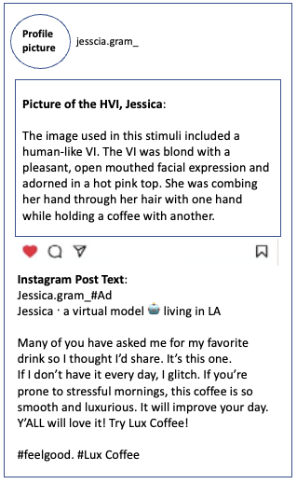

Sample Stimulus – A mock-up of the actual stimuli including some text from the AVI and sponsorship disclosure condition
