Supplementary Material

Table Supplementary 1. Low Phosphate Medium composition.
*Saline solution 10×, pH 7.2 | 100 ml/L
 | *Saline solution10X, pH 7.2, composition
 | NaCl | 46.8 g/L
 | KCl | 14.9 g/L
 | NH₄Cl | 10.7 g/L
 | (NH₄)₂SO₄ | 4.3 g/L
 | MgCl₂ | 10 ml/L
 | ZnSO₄ | 2.7 mg/L
 | Tris-base | 143.3 g/L
Glycerol | 5 ml/L
Thiamine (50 mg/ml) | 0.4 ml/L
Peptone 10% | 100 ml/L
CaCl₂ (100 mM) | 1 ml/L
Destillated water | 793.6 ml/L

Table Supplementary 2. Comparison of deprotonation constants and surface site concentrations between Microbacterium Be9 and other six bacterial species from different studies.
Species | pK1 | pK2 | pK3 | C₁ (×10⁻⁴ mol/g) | C₂ (×10⁻⁴ mol/g) | C₃ (×10⁻⁴ mol/g) | pH_{zpc} | Reference
Microbacterium sp. strain Be9 | 4.38 ± 0.67 | 6.07 ± 0.37 | 9.82 ± 0.12 | 0.45 ± 0.006 | 0.76 ± 0.015 | 1.19 ± 0.061 | 6.61 ± 0.07 | This study
Stenotrophomonas bentonitica | 4.97 ± 0.08 | 6.88 ± 0.02 | 9.43± 0.02 | 5.05 ± 0.31 | 10.78 ± 0.31 | 16.93 ± 1.45 | 5.7 | (Ruiz-fresneda et al., 2020)
Sporomusa sp. MT - 2.99 | 4.8 ± 0.06 | 6.68 ± 0.06 | 9.01 ± 0.08 | 5.3 ± 0.8 | 3.5 ±0.3 | 4.8 ± 0.5 | - | (Moll et al., 2014)
Bacillus licheniformis | 3.7 ± 0.2 | 5.5 ± 0.3 | 9.4 ± 0.3 | 0.59 ± 0.3 | 0.34 ± 4.9 | 0.50 ± 11.0 | - | (Yu et al., 2014)
Shewanella putrefaciens | 5.16 ± 0.04 | 7.22 ± 0.15 | 10.04 ±  0.67 | 0.32 ± 0.02 | 0.09 ± 0.01 | 0.38 ± 0.01 | - | (Haas et al., 2001)
Sphingomonas sp.  S15-S1 | 4.27 ± 0.45 | 7.03 ± 0.86 | 9.92 ± 0.32 | 4.91 ± 1.04 | 3.16 ± 0.56 | 9.24 ± 2.97 | 5.8 | (Merroun et al., 2011)
Bacillus sphaericus JG-7B | 4.37 ± 0.27 | 6.37 ± 0.31 | 9.95 ± 0.16 | 4.70 ± 0.55 | 2.19 ± 0.25 | 4.56 ± 0.77 | 5.5 | (Merroun et al., 2011)

Table Supplementary 3. U speciation (0.1 mM) in MC1 (MOPS+U), MC2 (MOPS+U+G2P) and MC3 (LPM + U) treatments, as predicted by Visual MINTEQ software 3.1 and PhreeqC software. ª aq, aqueous.

U Species | % of total concentration
 | MC1 | MC2 | MC3
UO₂²⁺ | 0.05 | 0.06 | 0.02
UO₂OH⁺ | 1.10 | 1.14 | 0.64
(UO₂)₂(OH)₂²⁺ | 0.17 | 0.20 | 0.09
(UO₂)₃(OH)⁵⁺ | 78.31 | 78.51 | 48.59
(UO₂)₂(OH)₃CO³⁻ | - | - | 24.25
(UO₂)₄(OH)⁷⁺ | 19.52 | 19.22 | 25.14
UO₂PO⁴⁻ | - | - | 0.38
UO₂HPO₄ | - | - | 0.07
UO₂CO₃ | - | - | 0.04
(UO₂)₃(OH)⁷⁻ | 0.05 | 0.05 | 0.12
(UO₂)₃(OH)₄²⁺ | 0.10 | 0.12 | 0.05
UO₂(OH)³⁻ | 0.03 | 0.03 | 0.06
UO₂(OH)₂ (aq)ª | 0.68 | 0.67 | 0.55

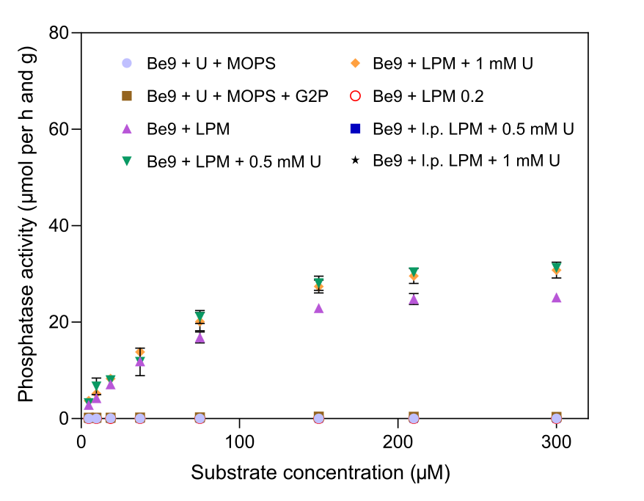
Figure Supplementary 1. Phosphatase activity (measured as µmol released per h and g at different substrate concentrations) of Be9 cells after incubation in the different conditions (MC1, MC2 and MC3). Peptone reduction (0.2 mg/L) is labelled as l.p. LPM (low-peptone LPM). Data are showed as the mean and error bars represent the standard error of at least three independent measurements.

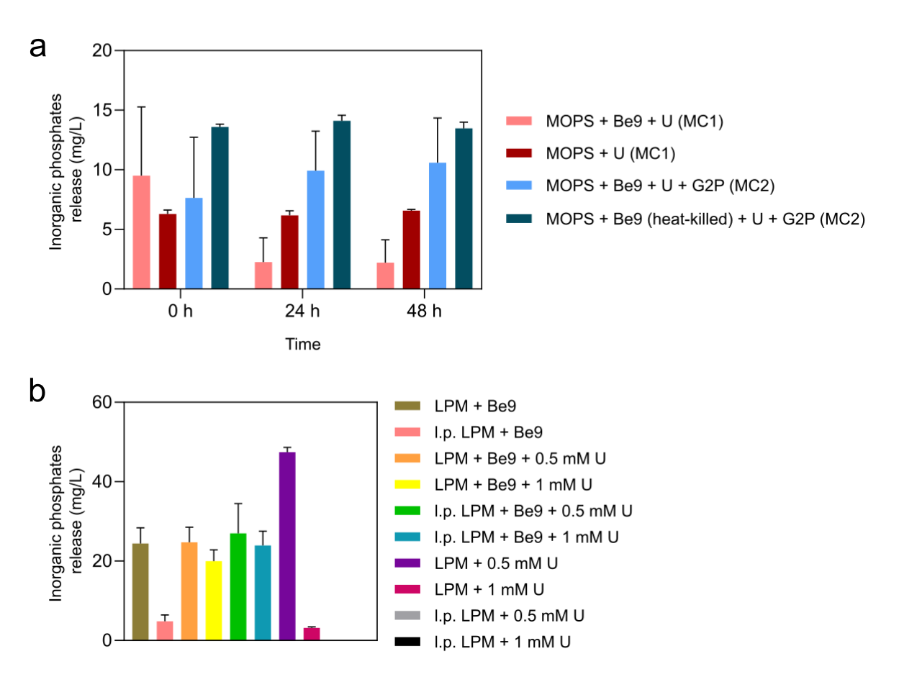
Figure Supplementary 2. Inorganic phosphates in solution (mg/L) detected during (A) MC1 and MC2 treatments incubation at different times (0, 24 and 48 h), and (B) MC3 treatment incubations at 48 h. Flasks without Be9 cells and heat-killed Be9 cells were used as control treatments. Data are showed as the mean ±SD of at least three independent measurements.

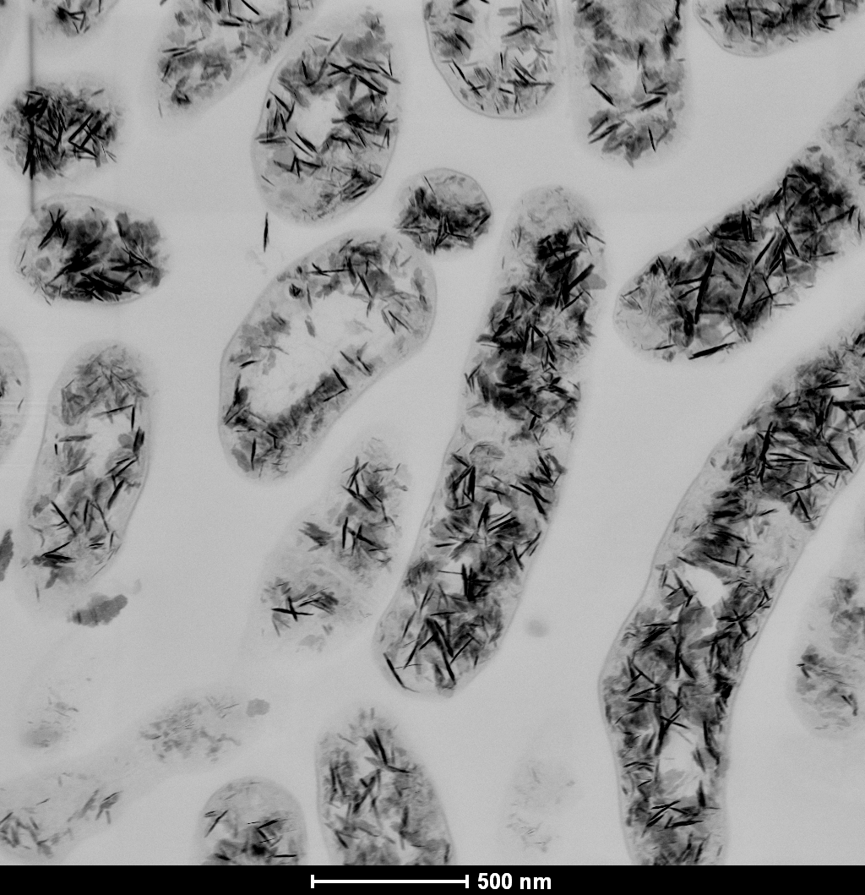
Figure Supplementary 3. HAADF-STEM image of a thin section of Microbacterium sp. Be9 cells recovered after their incubation in MOPS solution (5 mM) amended with U (0.1 mM). Intracellular U-precipitates are showed as condensed dark accumulations.

Table Supplementary 4. Cell viability and membrane potential of Be9 after 24 h and 48 h at different uranium concentrations. Data are showed as the mean and standard deviation is included as ± SD.
Conditions | Cell viability-24h |  | Cell viability-48h |  | Membrane potential-24h |  | Membrane potential-48h
 | Alive (%) | Dead (%) | Alive (%) | Dead (%) | Active (%) | Non active (%) | Active (%) | Non active (%)
0 mM U | 99.22 ± 0.22 | 0.78 ± 0.22 | 85.95 ± 0.26 | 14.05 ± 0.26 | 99.18 ± 0.07 | 0.82 ± 0.07 | 99.00 ± 0.00 | 1.00 ± 0.00
0.1 mM U | 100 ± 0.18 | 0.00 ± 0.18 | 18.42 ± 0.00 | 81.58 ± 0.00 | 97.10 ± 0.08 | 2.90 ± 0.08 | 0.00 ± 0.00 | 100 ± 0.00

Figure Supplementary 4. HAADF-STEM image of a thin section of Microbacterium sp. Be9 cells recovered after their incubation in MOPS solution (5 mM) amended with U (0.1 mM) and G2P (5 mM). Intracellular U-precipitates are showed as condensed dark accumulations.
Figure Supplementary 5. HAADF-STEM image of U-precipitates formed abiotically after their incubation (48 h) in LPM amended with U (1 mM). U-precipitates are showed as condensed dark aggregates and needle-like fibrils.

Figure Supplementary 6. HAADF-STEM image of a thin section of Microbacterium sp. Be9 cells recovered after their incubation during 48 h in LPM amended with U (1 mM). Extracellular U-precipitates are showed as condensed dark accumulations.
Figure Supplementary 7. HR-TEM images of (A) U (1 mM) amended abiotic low-peptone LPM sample, (B) U (0.1 mM) amended abiotic LPM sample, (C) U (1 Mm) amended abiotic LPM sample, and their respectively EDX analysis spectrum (D, E and F).

