(a) CN05
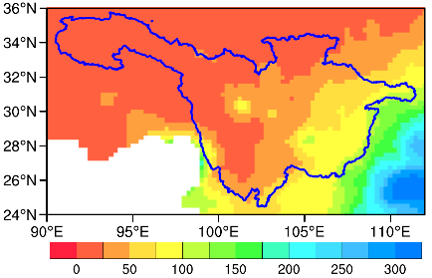
(b) Emanuel-BATS | (c) Tiedtke-Kain-BATS | (d) Kain-Fritsch-BATS
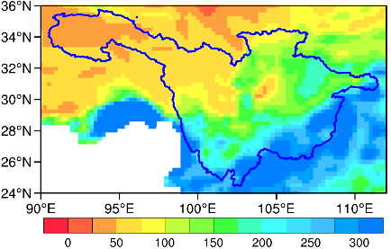 | 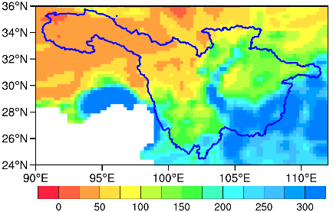 | 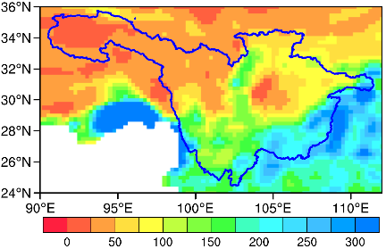
(e) Emanuel-CLM3.5 | (f) Tiedtke-Kain-CLM3.5 | (g) Kain-Fritsch-CLM3.5
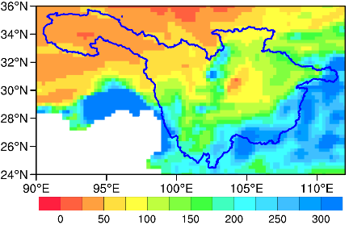 | 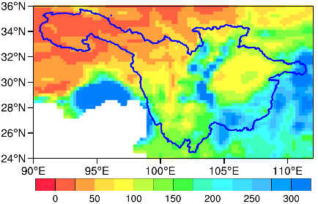 | 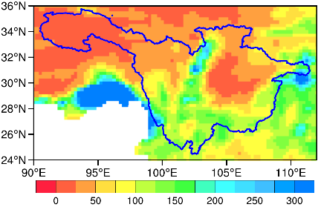
(h) Emanuel-CLM4.5 | (i) Tiedtke-Kain-CLM4.5 | (j) Kain-Fritsch-CLM4.5
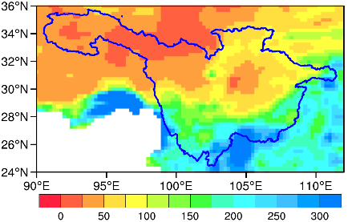 | 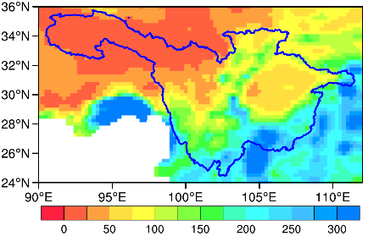 | 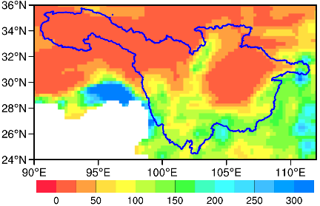
Figure S1. Spatial distribution of observed and simulated multi-year average winter total precipitation (unit: mm) for the current climate (1991-1993) over the UYRB. [a) CN05, b) Simulation of the combination scheme of Emanuel and BATS, c) Simulation of the combination scheme of Tiedtke-Kain and BATS, d Simulation of the combination scheme of Kain-Fritsch and BATS, e-g same as b-d but for CLM3.5, and h-j same as b-d but for CLM4.5.]

(a) CN05
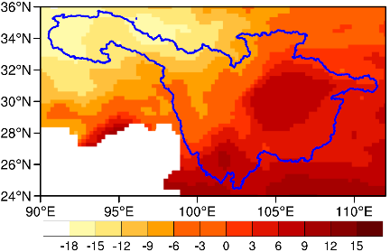
(b) Emanuel-BATS | (c) Tiedtke-Kain-BATS | (d) Kain-Fritsch-BATS
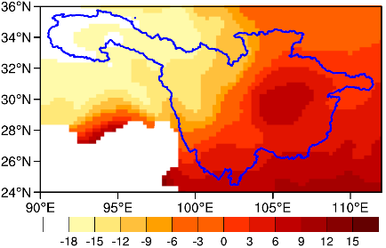 | 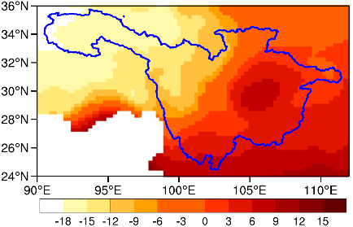 | 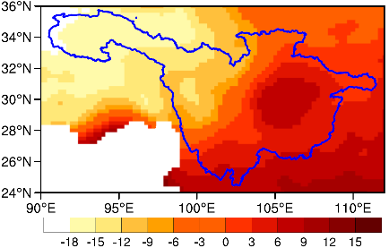
(e) Emanuel-CLM3.5 | (f) Tiedtke-Kain-CLM3.5 | (g) Kain-Fritsch-CLM3.5
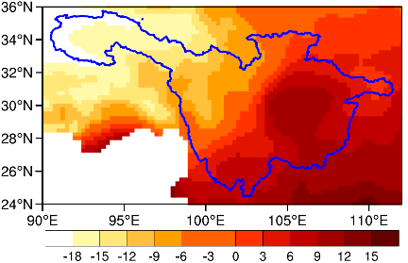 | 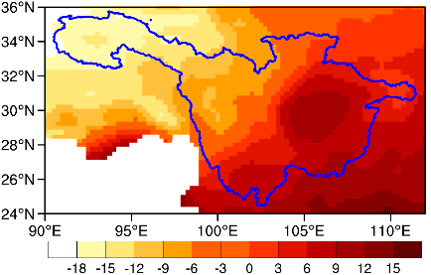 | 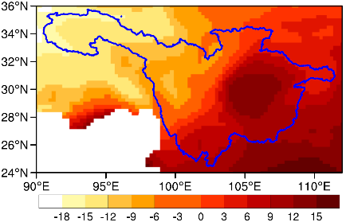
(h) Emanuel-CLM4.5 | (i)Tiedtke-Kain-CLM4.5 | (j) Kain-Fritsch-CLM4.5
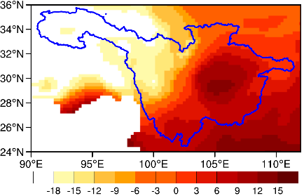 | 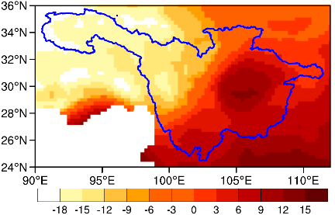 | 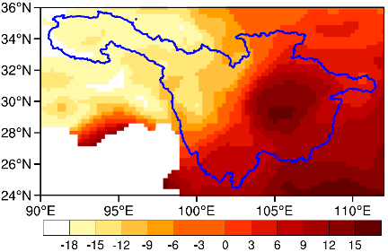
Figure S2. Spatial distribution of observed and simulated multi-year average winter average temperature (unit: °C) for the current climate (1991-1993) over the UYRB. [a) CN05, b) simulation of the combination scheme of Emanuel and BATS, c) simulation of the combination scheme of Tiedtke-Kain and BATS, d simulation of the combination scheme of Kain-Fritsch and BATS, e-g same as b-d but for CLM3.5, and h-j same as b-d but for CLM4.5.]
(a) summer Δwind at 850 hPa | (b) summer ΔT at 850 hPa | (c) summer Δshum at 850 hPa
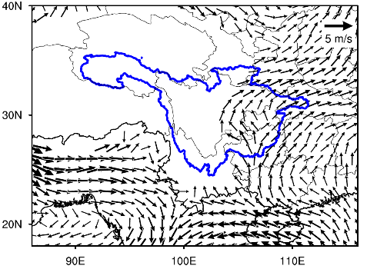 | 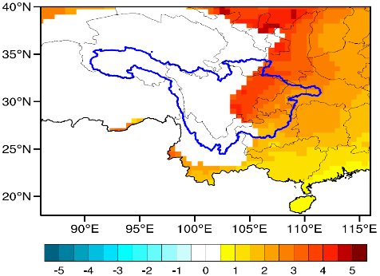 | 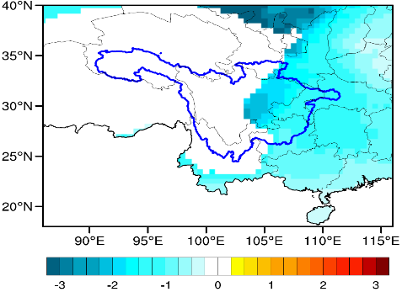
(d) summer Δwind at 500 hPa | (e) summer ΔT at 500 hPa | (f) summer Δshum at 500 hPa
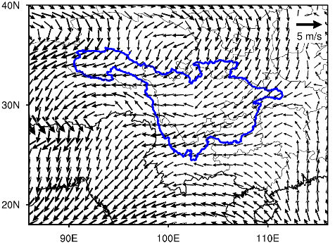 | 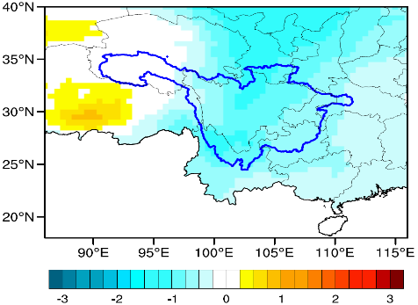 | 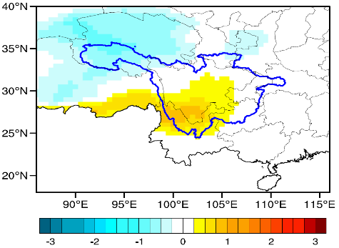
(g) winter Δwind at 850 hPa | (h) winter ΔT at 850 hPa | (i) winter Δshum at 850 hPa
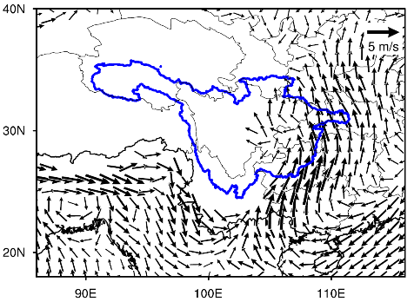 | 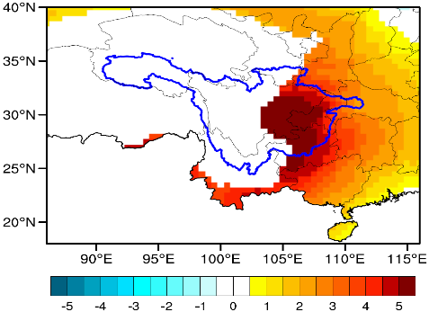 | 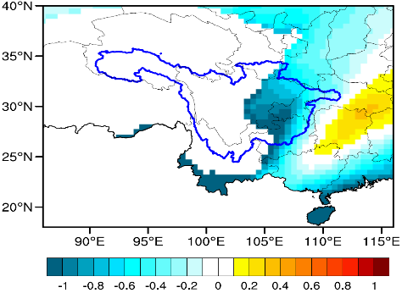
(j) winter Δwind at 500 hPa | (k) summer ΔT at 500 hPa | (l) winter Δshum at 500 hPa
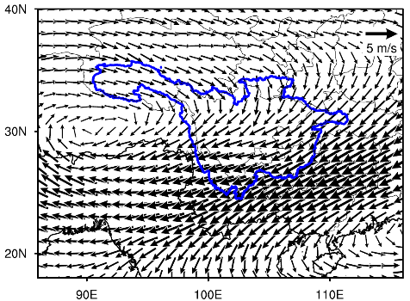 | 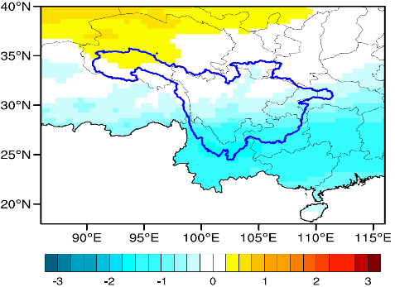 | 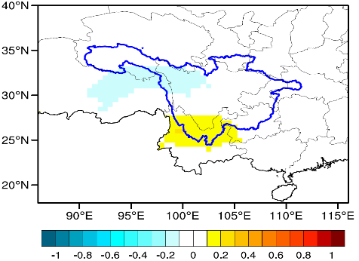
Figure S3. Difference in the wind field (m/s), temperature (°C) and specific humidity (g/kg) between CLM4.5 and BATS (defined as CLM4.5-BATS). [a) Difference in summer winds at 850 hPa; d) difference in summer winds at 500 hPa; g) difference in winter winds at 850 hPa; j) difference in winter winds at 850 hPa; b, e, h, k same as a, d, g, j but for temperature; and c, f, i, l same as a, d, g, j but for specific humidity.]

