Supplementary Information

Material properties of TiO₂
This is linked to Section 2 in the main manuscript. TiO₂ was used as the material for metasurface nanostructures. The optical properties of TiO₂ are shown in Fig. S1 [1].
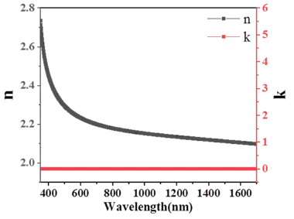
Figure S1. Refractive index of TiO₂.

Phase maps of metalens unit cells
This is linked to Section 2 in the main manuscript. The phase and transmission values of different diameters for 671 nm and 785 nm are plotted in Fig. S2 (a) and (b), respectively. The phase (blue curves) covered the full range from 0 to 2π. The transmission values (orange curves) were close to 1.
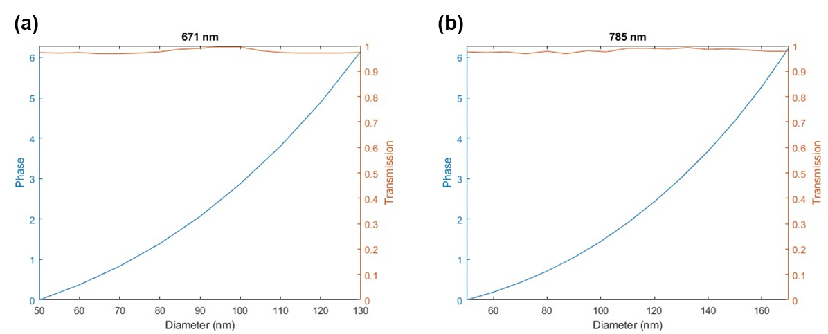
Figure S2. Phase maps of metalens unit cells for (a) 671 nm and (b) 785 nm. Phase (blue) is on the left axis and transmission (orange) is on the right axis.

Transmission properties of metasurfaces for excitation fiber
This is linked to Section 3a and 3b in the main manuscript. The transmission values at each layer of the interface are shown in Table S1 below.
Table S1: Transmission values at interfaces for 671 nm and 785 nm NBPF and off-axis metalens.
Interface | Transmission (671 nm) | Transmission (785 nm)
Substrate/Ag 1 Interface | 0.91 | 0.89
Ag 1/PMMA Interface | 0.78 | 0.77
PMMA/Ag 2 Interface | 0.77 | 0.76
Ag 2/Metalens Interface | 0.64 | 0.66
Metalens/Air Interface | 0.63 | 0.65

Propagation properties of metasurface for collection fiber
This is linked to Section 3c in the main manuscript. Fig. S3 shows the propagation properties of the metasurface for the collection arm at 11 wavelengths. It shows the achromatic broadband focusing capability that the focal length remains unchanged for the entire wavelength range 810 – 910 nm indicated by the white dashed line. The cross-sectional views of the electric field intensity distributions at the focal plane for each selected wavelength are shown in the right column, which is found to be maintained as well.
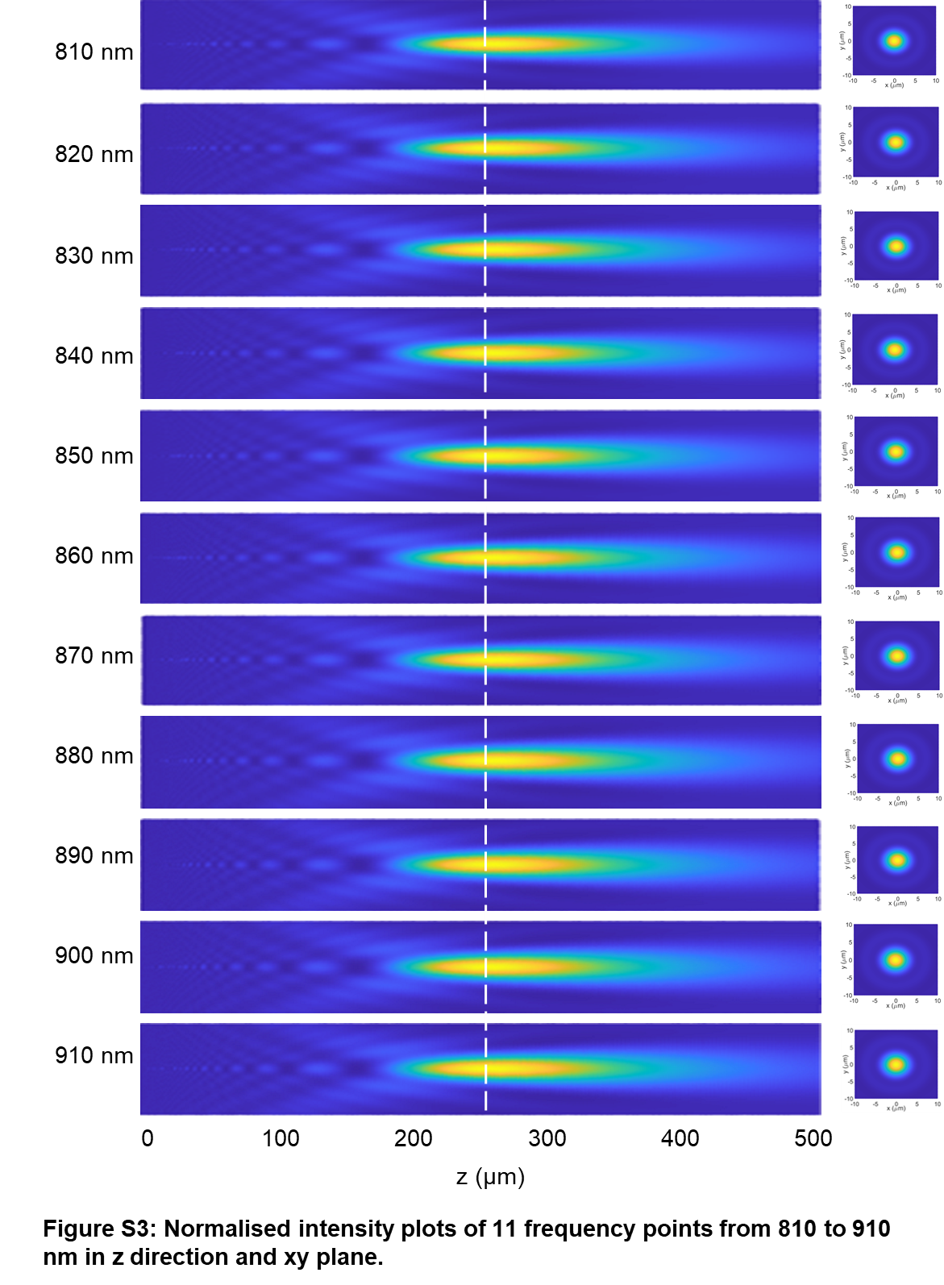
Figure S3: Normalized intensity plots of 11 frequency points from 810 to 910 nm in z-direction and x-y plane.

Properties of a single wavelength metalens at 860 nm
This is related to Section 3c in the main manuscript. Most metalenses are designed for single wavelength operation without optimizing the group dispersion, so they will suffer from chromatic aberration. Fig. S4 shows the optical performance of a single wavelength metalens design for the collection arm. Compared to the achromatic broadband metalens design that is shown in the main manuscript, the focal length is changed significantly from 810 nm to 910 nm, as shown in Fig. S4 (a) and (d). The cross-sectional distributions and line cuts of the focal spots at the designed focal length of 860 nm are also different, as shown in Fig. S3 (b) and (c), respectively.
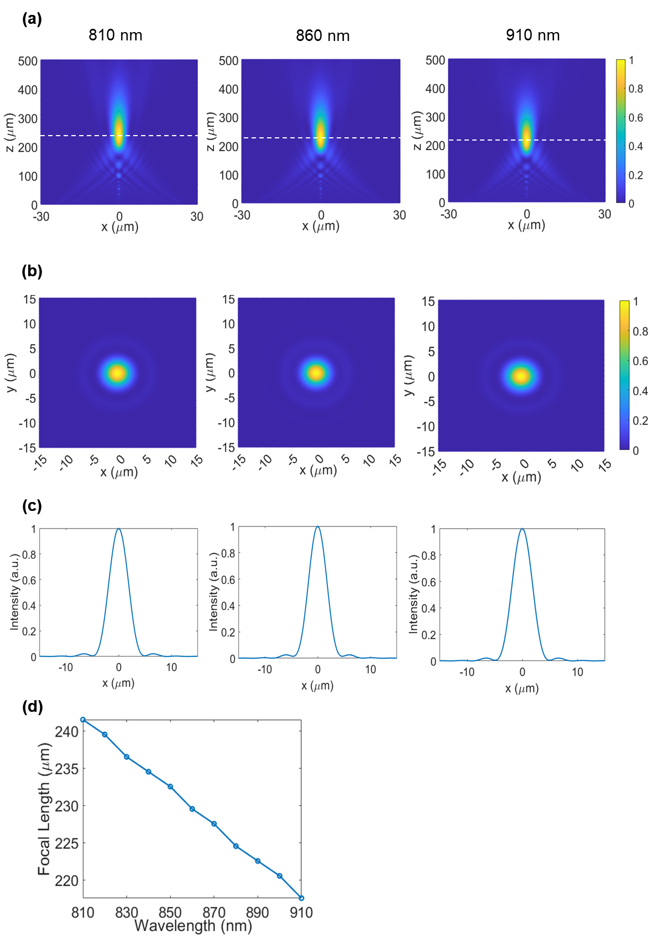
Figure S4: Normalized intensity plots of 860 nm single wavelength metalens. (a) Normalized intensity plot of the focal point profile of 860 nm on-axis single wavelength metalens in the x-z plane with λ = 810, 860, and 910 nm. (b) Normalized intensity plot of the focal point profile of 860 nm on-axis single wavelength metalens in the x-y plane with λ = 810, 860, and 910 nm. (c) Normalized intensity plot of the focal point profile of 860 nm on-axis single wavelength metalens along the x-axis with λ = 810, 860, and 910 nm. (d) Focal length vs wavelength plot for 860 nm on-axis single wavelength metalens across the wavelength range.
Reference:
1. Y. Wang, Q. Chen, W. Yang, Z. Ji, L. Jin, X. Ma, Q. Song, A. Boltasseva, J. Han, V. M. Shalaev, and S. Xiao, "High-efficiency broadband achromatic metalens for near-IR biological imaging window," Nat. Commun. 12, 5560 (2021).

