Supplementary Material
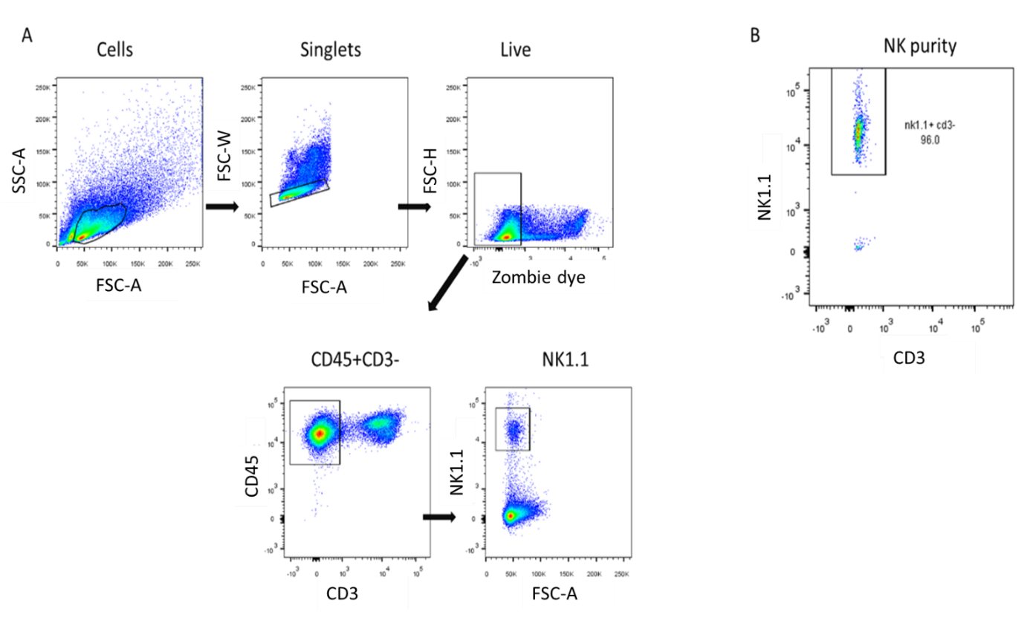

Supplementary Figure 1. Gating strategy for NK cell isolation by FACS and purity check. (A) Debris were gated out and viable single cells that were negative for CD3, and positive for CD45 and NK1.1, were isolated by FACS in sterile PBS. (B) The purity of the NK cells was checked by running a sample of the sorted cells on the flow cytometer.

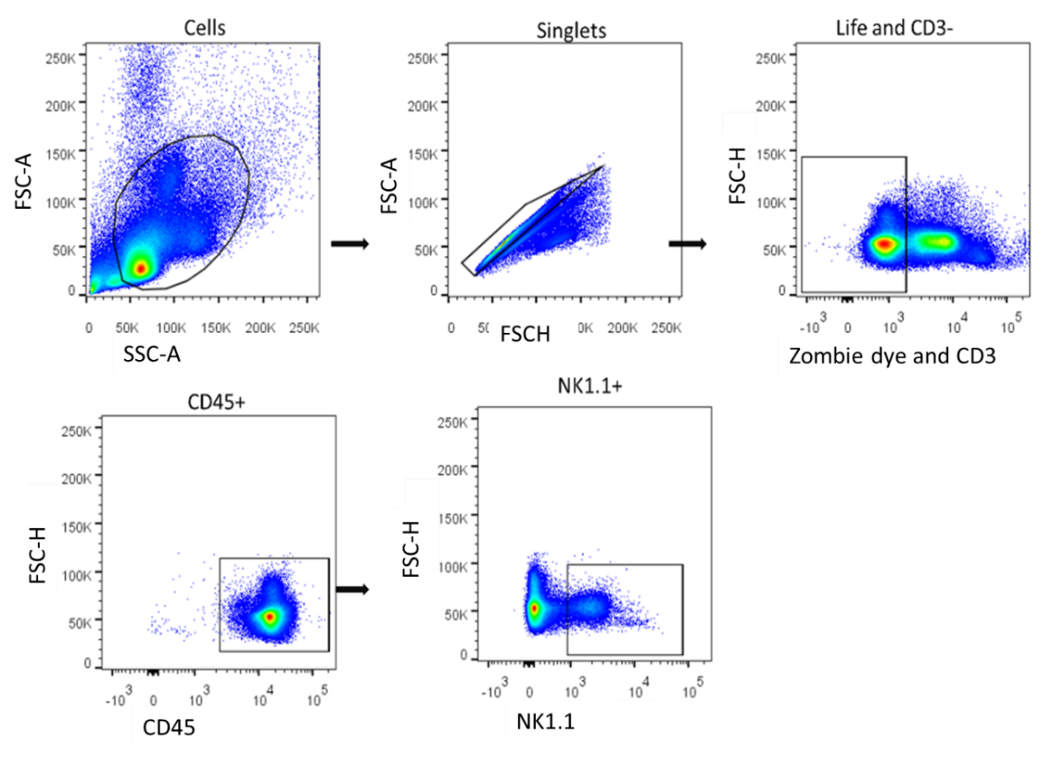

Supplementary Figure 2. Common gating strategy used for NK phenotyping by FACS. Debris were gated out and then viable single cells negative for CD3, and positive for CD45 and NK1.1 were gated.

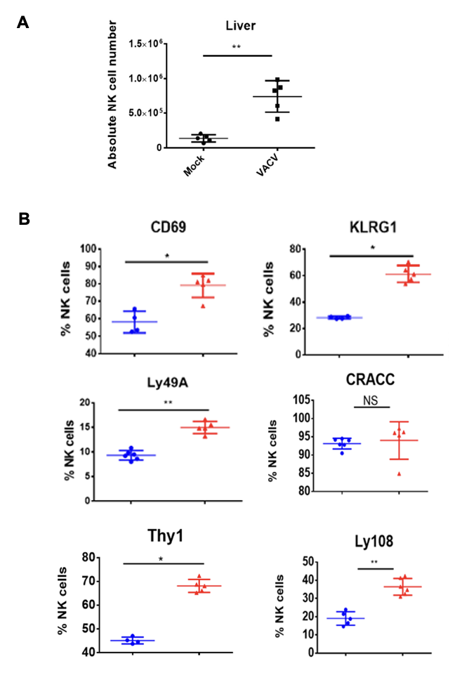
Supplementary Figure 3. C57BL/6 mice were mock-treated or infected i.n. with VACV and 6.5 d later (A) hepatic NK cells were counted, B) Protein expression on hepatic NK cells assessed by FACS from mock (blue) and VACV-infected mice (red). The percentage of NK cells expressing the indicated surface protein is shown. Error bars represent ± SD, statistical significance was assessed with a Mann-Whitney test (*p<0.05, ** p<0.01, ***p<0.001).

Tables

Antigen | Fluorochrome | Clone | Company cat. number
Fixable Viability Dye | Zombie violet |  | Biolegend #423113
CD3 | BV421 | 145-2C11 | Biolegend #100341
CD45 | BV650 | 30-F11 | Biolegend #103151
NK1.1 | APC-Cy7 | PK136 | Biolegend # 108724
CD16/CD32 |  | 2.4G2 | BD #553142
CD27 | APC | LG.3A10 | Biolegend # 124211
CD11b | FITC | M1/70 | Biolegend #101205
KLRG1 | BV510 | 2F1 | BD #740156
Thy-1.2 | PerCP | 30-H12 | Biolegend #105321
CD69 | PE | H1.2F3 | Biolegend #104507
Ly49C/I | FITC | 5E6 | BD # 553276
Ly49H | AF647 | 3D10 | BD #62207
CD107a | PE | 1D4B | Biolegend # 121611
Ly49A | FITC | YE1/48.10.6 | Biolegend 116805
Ly49F | APC | HBF-719 | Miltenyi Biotech 130-104-293
CD319 | PE | 4G2 | Biolegend#152005
Ly49D | FITC | 4E5 | BD #555313
Ly49G2 | APC | 4D11 | BD #555316
LY108 | PE | 330-AJ | Biolegend #134605
CD49b | FITC | HMα2 | Biolegend 103503
gp49B | PE | H1.1 | Biolegend 144904
CXCR6 | APC | SA051D1 | Biolegend #151104
Table 1. Antibodies used for Flow cytometry

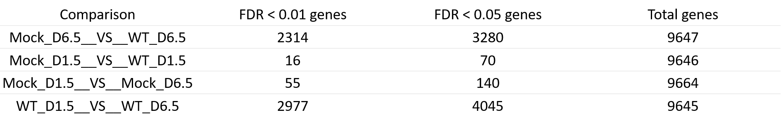

Table 2. Number of genes differentially expressed for the indicated pairwise comparisons during RNA-seq study of murine NK cells. Groups of B6 mice (n=4) were i.n. infected with WT VACV or vehicle control for 1.5 or 6.5 d.p.i.. Differential expression of transcripts was analysed following 4 pairwise comparisons, as indicated in the first column. The number of transcripts differentially expressed in a statistically significant manner is indicated in the second column (FDR<0.01) and in the third column (FDR<0.0.5). The total number of genes detected is indicated in the last column.

