Supplementary Material

# Supplementary Data

The following cell phones were used in our study (Model 1 – 15):

* Honor 10,
* Motorola Moto G5,
* Huawei P20 pro,
* iPhone 6s,
* iPhone 7,
* iPhone 8,
* LG G3,
* Huawei Y7,
* Xiaomi Mi 11 Lite 5G,
* Samsung Galaxy S7,
* Samsung Galaxy S8 lite,
* Samsung S5 Neo,
* Samsung S7 Edge,
* Samsung Galaxy S8 lite
* Samsung Galaxy S10.

PC configuration used for simulations: CPU AMD RYZEN 9 3950X; graphics card XFX Radeon RX 5700 XT Triple Dissipation 8G; motherboard ASUS ROG STRIX X570-E GAMING; RAM HyperX 64GB KIT DDR4 3200 MHz CL16 (2 sets together 128 GB); SSD Samsung 980 PRO 1TB. For all simulations the Magnetoquasistatic solver with Hexahedral mesh type (accuracy 1e-9 and at least 1.5x106 initial mesh cells) was used.

# Supplementary Figures

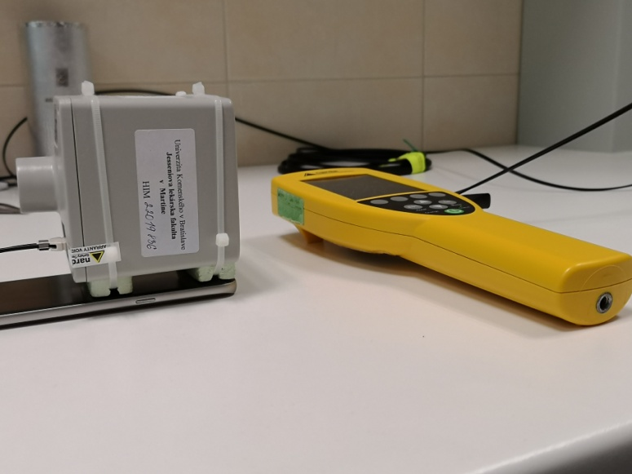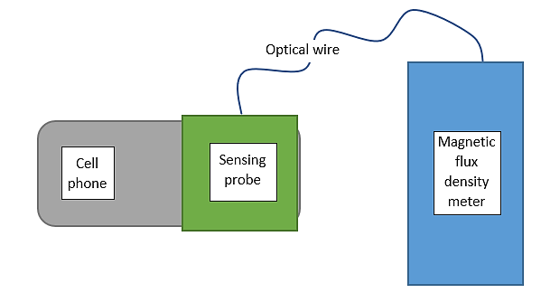

**Supplementary Figure 1:** LEFT panel: photo of the measurement setup (yellow Narda NBM550 connected to the sensing probe Narda EHP50D by an optical wire). RIGHT panel: schematic presentation of the measurement setup.

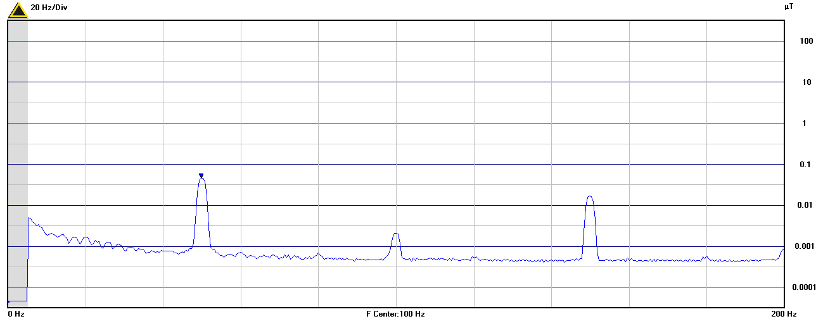

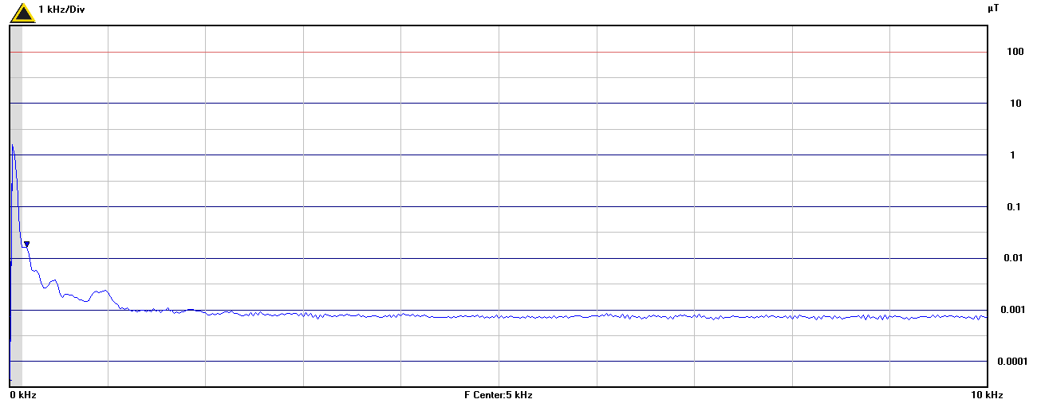

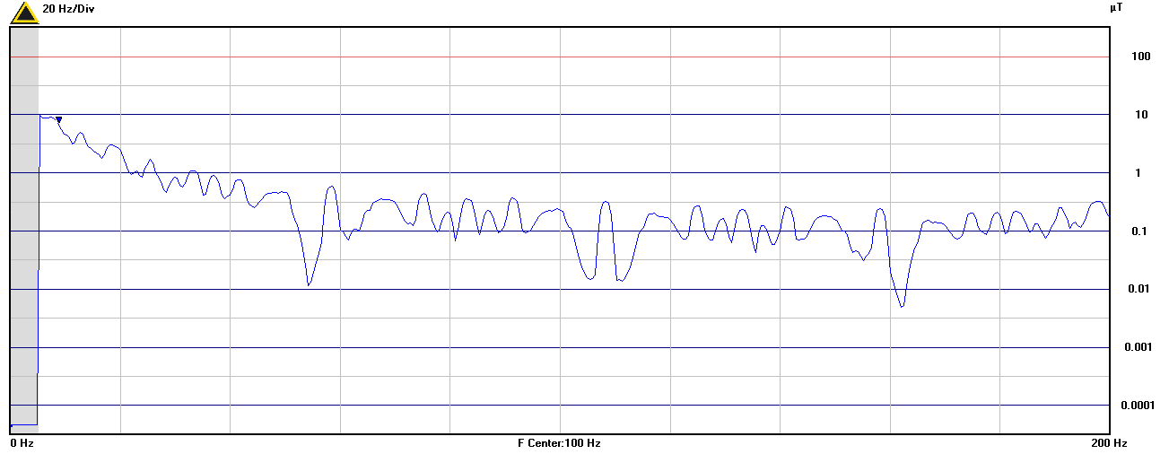

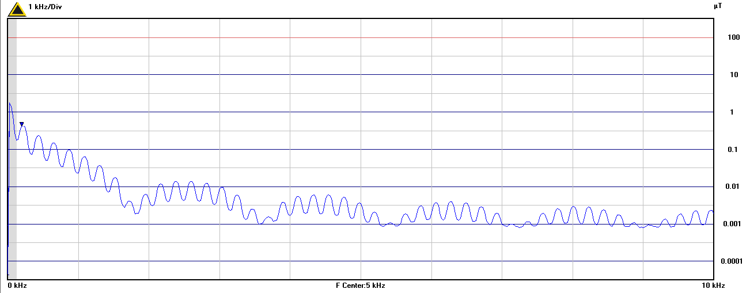

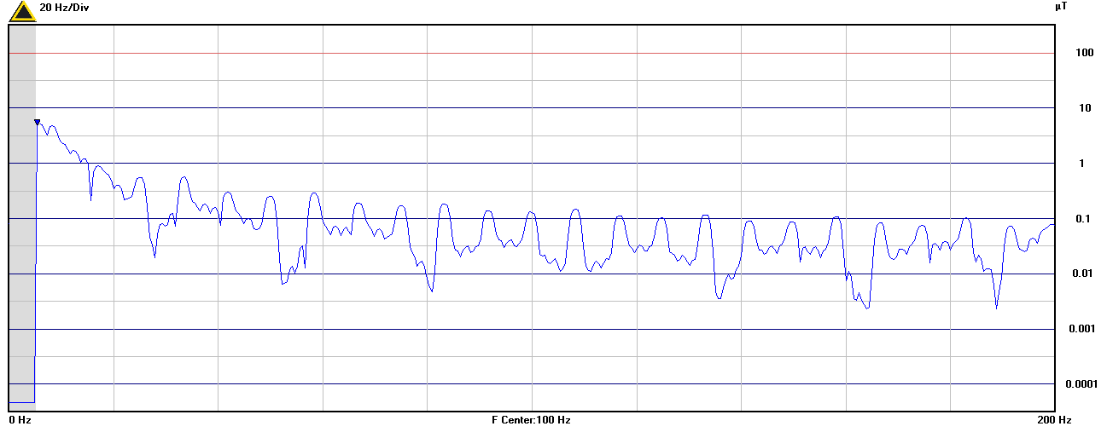

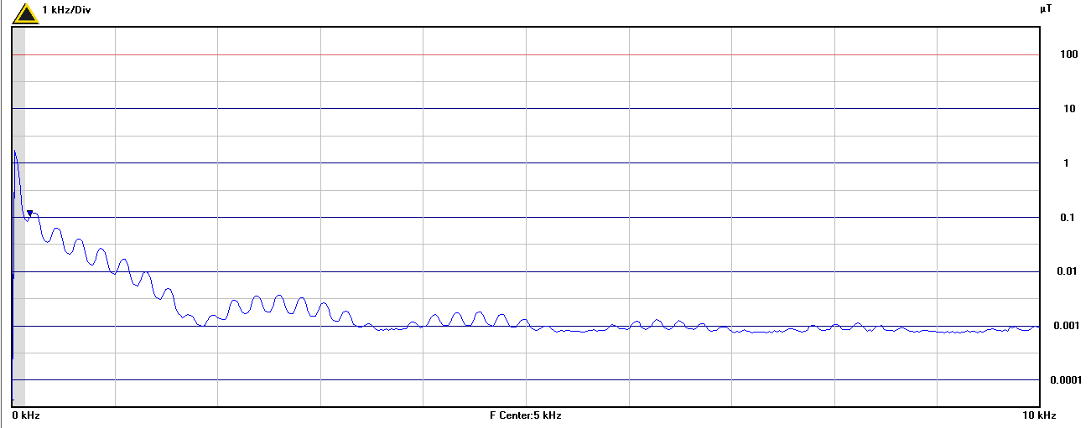

**Supplementary Figure 2.** Representative figures showing the frequency spectra of background MF in LF1, LF2, and spectra showing example measurements of 2G listening mode, front side LF1 and LF2 and 3G listening mode, front side LF1 and LF2 frequency bands using the Narda EHP50D.