**Supplementary Material**

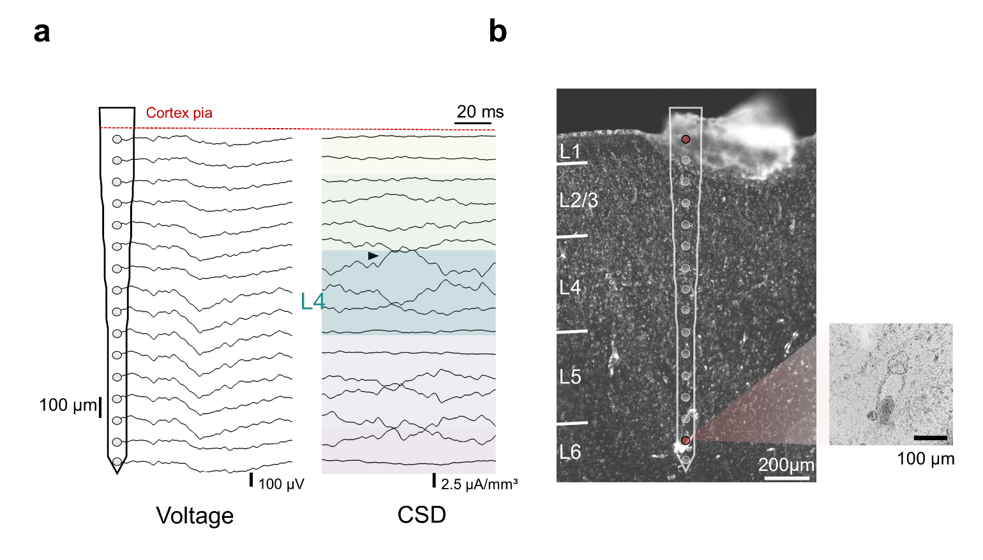

**Supplemental Figure 1. Electrophysiological and post-mortem implantation depth assessment.** a)Voltage traces and inverse current source density (iCSD) profile following an air puff onset to the animal’s contralateral forepaw. Black arrow indicates a current sink around 650 µm from the cortical surface. This initial sink, putative of thalamic input, is characteristic of upper layer 432. b) Histological verification of electrode location following electrolytic DC lesion of channels (red electrode-sites).

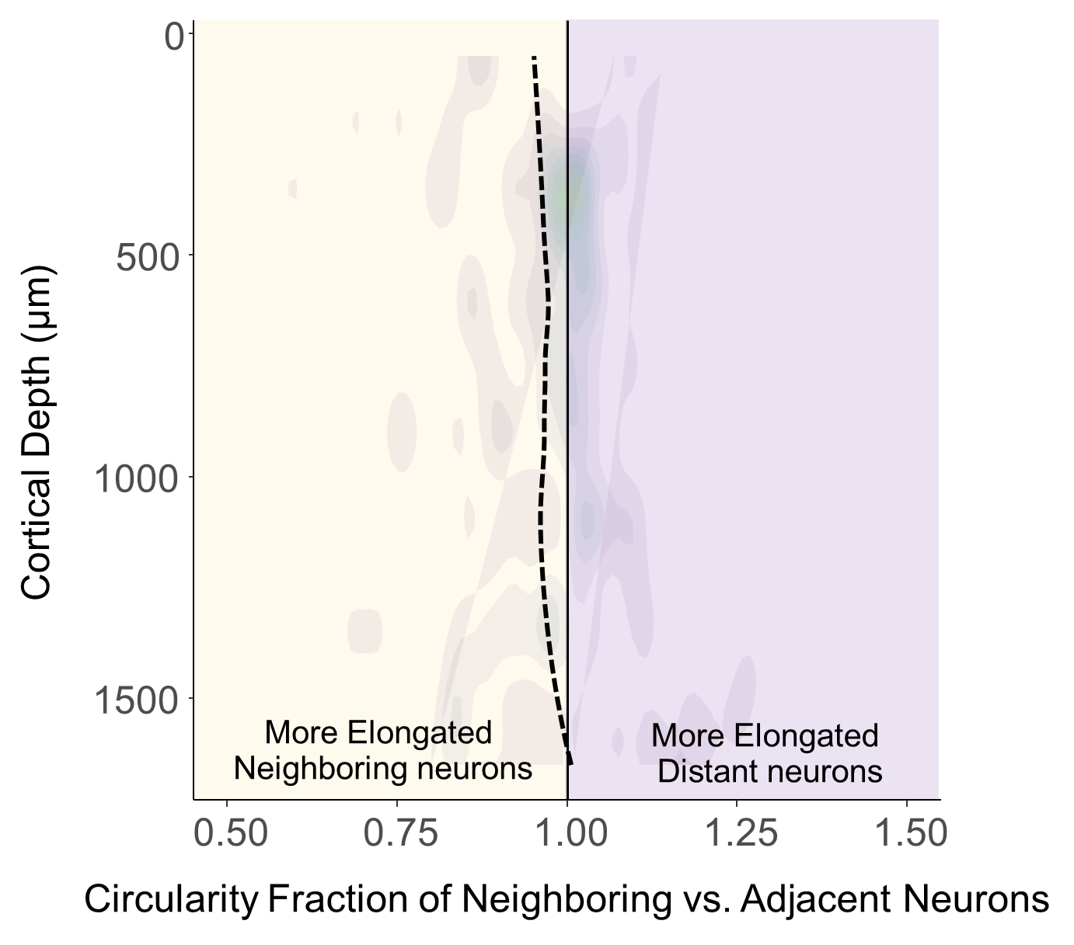

**Supplemental Figure 2. Neuronal circularity across cortical depth.** The circularity ratio of neighboring (100-200 µm from the electrode) and distant (400-500 µm from the electrode) neurons. Values below 1 indicate that neurons are more elongated than distant neurons. Dashed line represents a locally fitted polynomial regression of the means and shaded regions represent a locally weighted scatterplot (2D Kernel Density) of circularity values (N = 5).