Supplementary Material
This supplements the discussion in Section 3.1 in the manuscript. A mixture solution consisting of the two spatially overlapped quantum dots was analyzed, as illustrated in Fig. S1(a). The region of interest is indicated by the dashed lines and the reconstructed full-color image of this region is shown in Fig. S1(b). Spectral unmixing was performed on the obtained hyperspectral datacube of the mixture region. The spectrum at each pixel was analyzed. By performing spectral unmixing using the spectra in Fig. 3(b) in the manuscript as the endmember signatures, the spatial distributions of each quantum dot component in the mixture and their abundances at each pixel location can be calculated. Fig. S1(c) and (d) are the spectral unmixing results showing the spatial distribution of individual components of QD585 and QD705 in the mixture. Fig. S1(e) is the false-color representation of the mixture where the pixels with similar spectral features were assigned the same color. There are three regions identified with each having a distinct spectral feature, as shown in Fig. S1(f) – (h). The solid lines are the measured spectra of each region, and the dashed lines are the decomposed spectra of each quantum dot component. It is worth mentioning that there is no limit on how many fluorophores can be resolved at each pixel as long as their spectral features are different and can be distinguished using the hyperspectral system, in this case, it is 1 nm. It overcomes the challenge of crosstalk among fluorophores because the spectral unmixing takes into account the entire emission spectrum of each fluorophore instead of a single spectral band at the peak intensity.
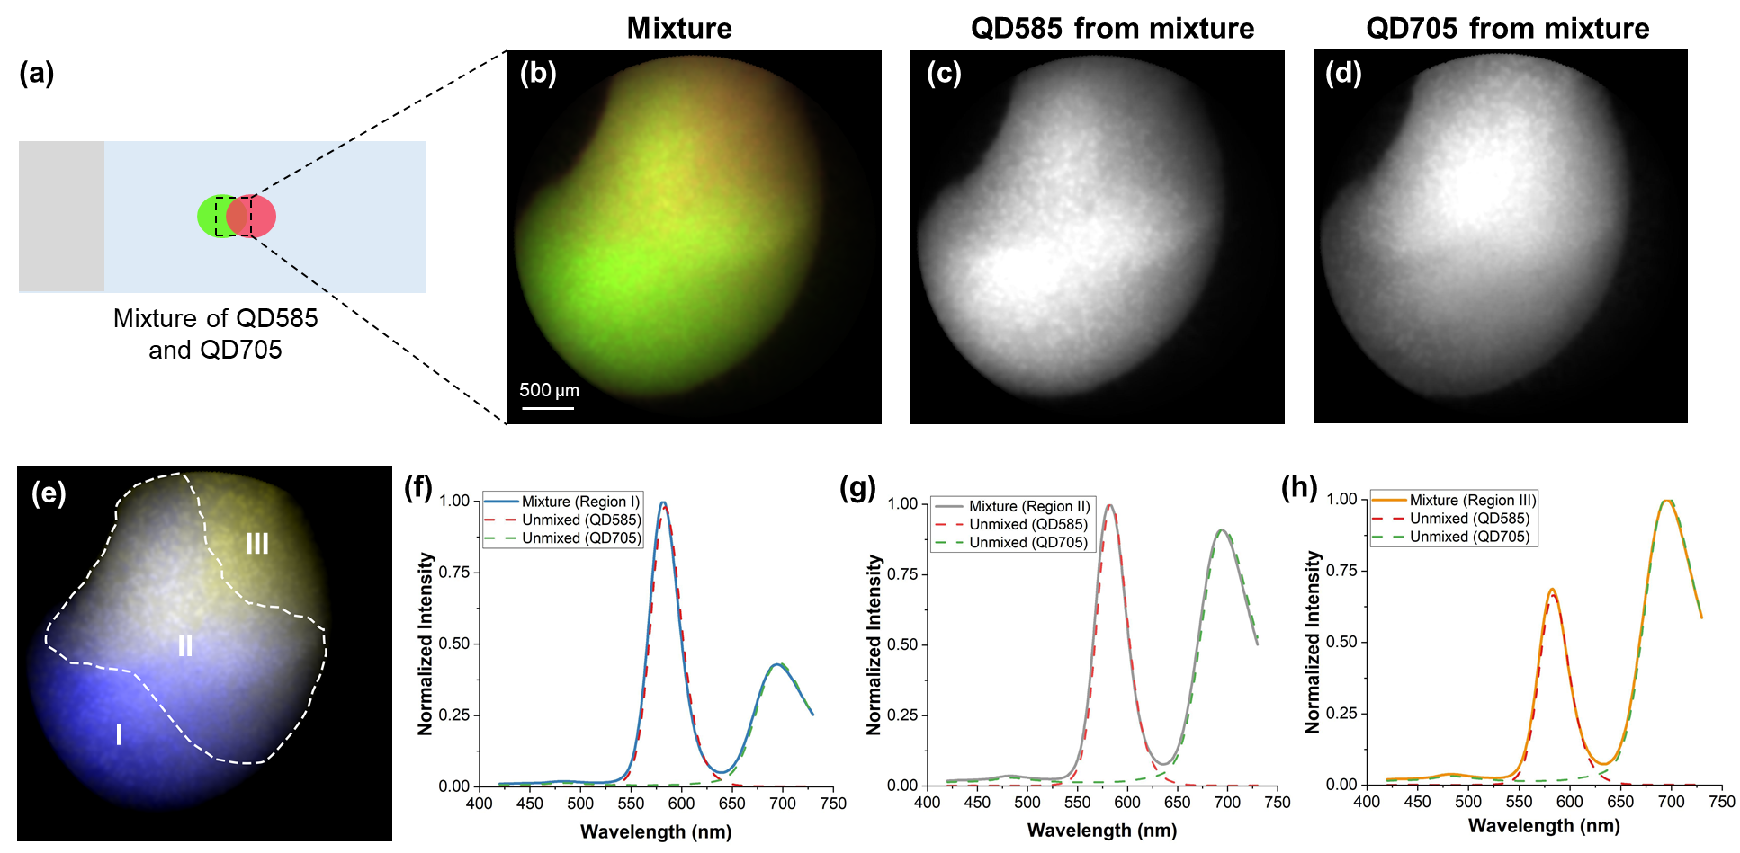
Figure S1. Hyperspectral endoscopy imaging of a mixture of quantum dots. (a) Illustration of a mixture of QD585 and QD705 samples. (b) Reconstructed full-color image of the overlapped region (dashed rectangle). (c) Grayscale image of spectrally unmixed QD585 component. (d) Grayscale image of spectrally unmixed QD705 component. (e) False-color image of the mixture showing the spectral angle mapper results of spectrally classified different regions. (f) – (h) Spectra of the mixture and decomposed individual components in region I, region II, and region III, respectively.

