**COVID-19 spike polypeptide vaccine reduces pathogenesis and viral infection in mouse model of SARS-CoV-2**

Running title: COVID-19 spike polypeptide vaccine

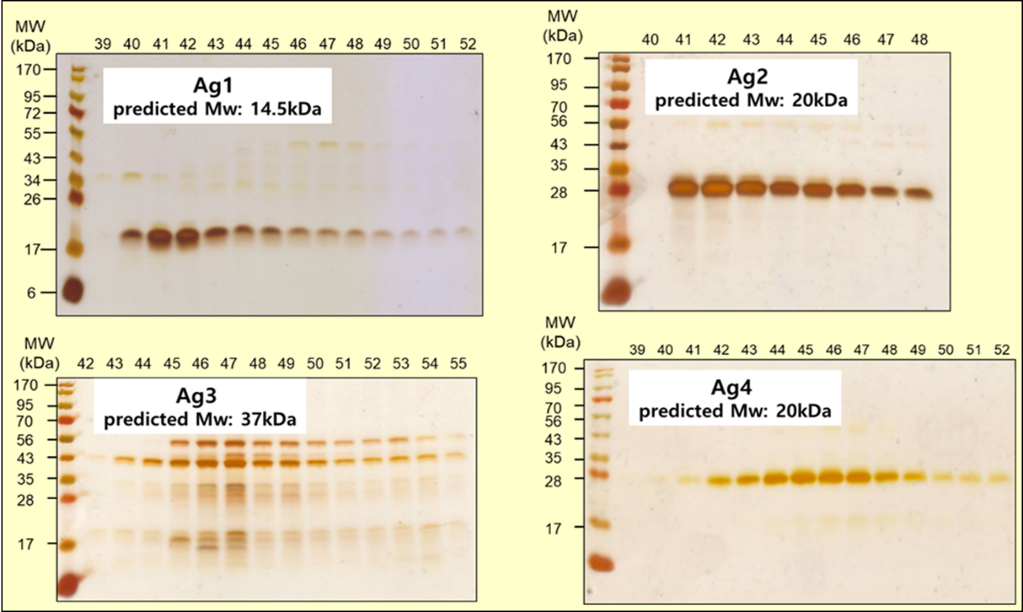

**Supplementary Figure 1.** 10% SDS-PAGE silver stained of the recombinant antigens were purified by two-steps, a mini-Talon and HPLC. HPLC fraction number was indicated at the top of each lane. An expected molecular weight of antigen was written in SDS-PAGE silver staining. The amino acid sequence of four antigens (Ag1 – Ag4) was shown in **Table 1**.

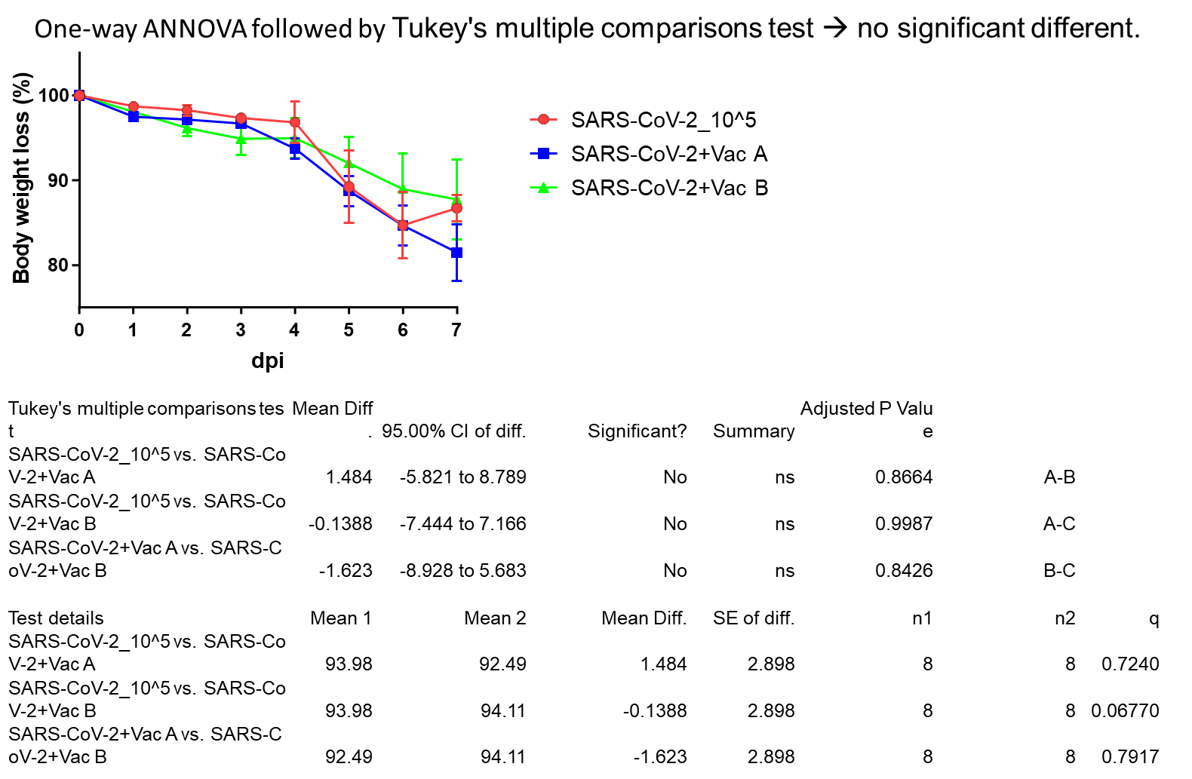

**Supplementary Figure 2.** Body weight loss percentage from day 0 up to day 7 post infection for the three groups of mice; vaccine-A, vaccine-B with SARS-CoV-2 infected group, and only SARS-CoV-2 infected group (each n=5), means with SD are presented and there was not significant among groups.

**Supplementary Figure 3.** Ratio of organ wight over body weight represent as percentage in liver, spleen, right and left kidneys, and lung of the three groups of mice; vaccine-A, vaccine-B with SARS-CoV-2 infected group, and only SARS-CoV-2 infected group (each n=5), means with SD are presented and there was not significant among groups.