Supplementary Material



**Supplementary Figure 1.** HPLC analysis of BH3 peptide.

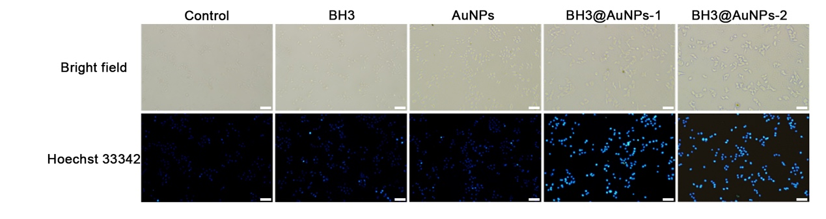

**Supplementary Figure 2**. Hoechst 33342 staining of A549 cells treated with different samples observed by fluorescence microscopy. (sacle bar: 100 μm)

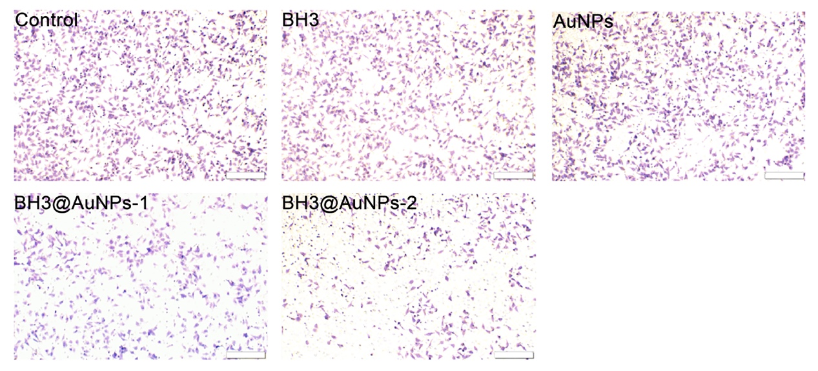

**Supplementary Figure 3.** Cell infiltration ability of A549 cells after 24 h incubation with different materials. (Sacle bar: 200 μm)

**Supplementary Table 1:** List of drug loading in different proportions.

|  |  |
| --- | --- |
| **BH3@AuNPs** | **Drug loading capacity (%)** |
| 400:1 | 63.90 |
| 500:1 | 65.72 |
| 600:1 | 66.76 |
| 800:1 | 73.38 |
| 1000:1 | 74.45 |
| 2000:1 | 63.21 |
| 4000:1 | 65.53 |
| 6000:1 | 63.13 |