Supplementary Material

# Supplementary Figures and Tables

## Supplementary Figures

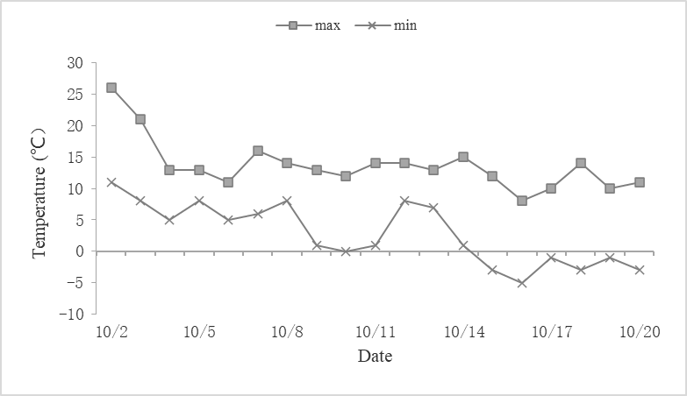

**Supplementary Figure 1** Maximum (max.) and minimum (min.) temperatures during the sampling period

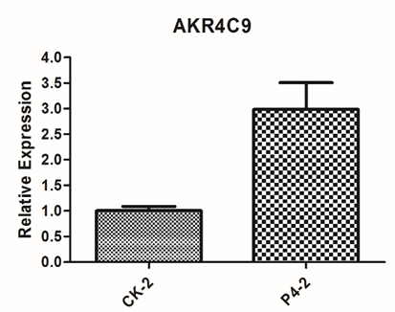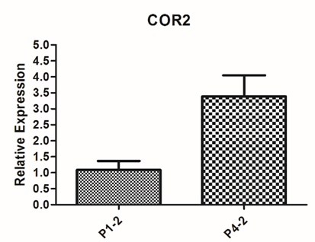

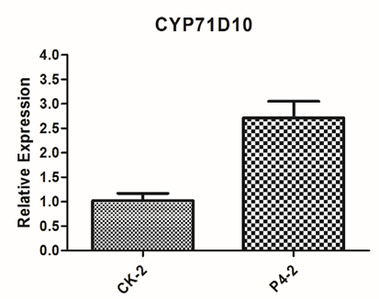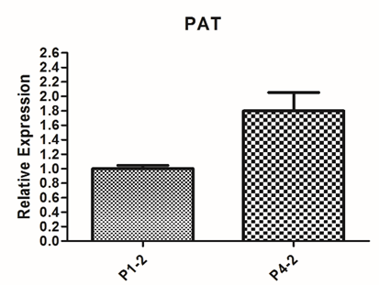

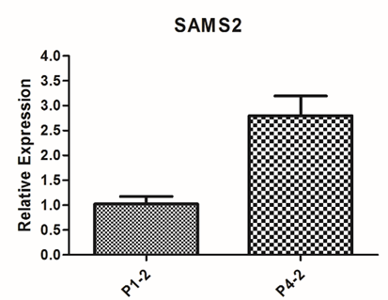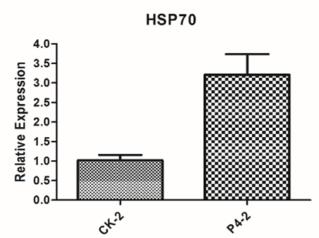

**Supplementary Figure 2** The qRT-PCR validation of differential gene expression levels

## Supplementary tables

**Supplementary Table 1** The genes and primers used for qRT-PCR analysis

|  |  |  |
| --- | --- | --- |
| Gene | Forward primers | Reverse primers |
| AKR4C9 | GGACACAGCGTGCTACCTAAGA | CACCATCCCAGAGTTCTTCAAT |
| COR2 | AGTAGTCCTCCCCTCCTCCA | GCTTCTCCAACAGATTTTTCCA |
| CYP71D10 | ACAAAACAAAGCACGCAAGGA | CGGACGATGTTTCGCTACCA |
| PAT | CCCCCGCAACGCATACAA | GGTAGAAACAGCCTCCCCAC |
| SAMS2 | ATGGCAGCAGAGACCTTCC | TCAGCATCAAGACCTACATCATC |
| HSP70 | GGCTGGAAAAGGTGAAGGAC | CAGGCACAGTTACGACAGC |
| AC101 | GTTCCGAGAGATTCCGTTGC | ATGCCAAGATAGACCCACCA |

**Supplementary Table 2** The major profile of expression of changed metabolites in different P treatments

|  |  |  |  |
| --- | --- | --- | --- |
| Class | Compounds | CK-vs-P1 | CK-vs-P4 |
| Amino acids and derivatives | L-Serine | 1.11 | 2.49 |
| N-Acetyl-L-phenylalanine | 0.67 | 1.10 |
| Flavonoids | 3,9-Dihydroxypterocarpan | 1.32 | 1.75 |
| Glycitein | 2.01 | 0.58 |
| Kaempferol | 2.28 | 0.96 |
| Eriodictyol | 13.21 | 0.24 |
| Afrormosin | 1.48 | 0.60 |
| 4'-Hydroxy-5,7-dimethoxyflavanone | 1.15 | 1.29 |
| Tricetin | 4.48 | 0.92 |
| 4,4'-dihydroxy-2,6-dimethoxydihydrochalcone | 3.43 | 0.89 |
| 5,7,4'-Trimethoxyflavone | 11.61 | 10.17 |
| 5,7-Dihydroxy-2'-methoxy-3',4'-methyleneoxydihydroisoflavone | 4.61 | 0.88 |
| 3,3',5-Trihydroxy-4',7-dimethoxyflavanone | 7.40 | 1.35 |
| Formononetin-7-O-glucoside (Ononin) | 1.30 | 0.80 |
| Chrysoeriol-7-O-(6''-malonyl)glucoside | 1.46 | 0.41 |
| Apigenin-6,8-di-C-glucoside (Vicenin-2) | 1.83 | 0.69 |
| Lipids | Palmitaldehyde | 1.12 | 1.17 |
| LPE 16:0/18:2 | 0.71 | 1.15 |
| LPC 16:0/18:3/18:2 | 0.80 | 1.25 |
| Nucleotides and derivatives | Ribosyladenosine | 0.55 | 1.09 |
| Organic acids | TranexamicAcid | 1.77 | 1.02 |
| Isocitric Acid | 0.99 | 1.27 |
| Sugar | Lactobiose | 0.82 | 1.42 |
| Phenolic acids | 4-Nitrophenol | 1.23 | 1.25 |
| 2,5-Dihydroxyacetophenone | 2.17 | 0.64 |
| Coniferyl alcohol* | 2.47 | 0.99 |
| Syringaldehyde | 2.16 | 0.55 |
| Protocatechuic acid-4-O-glucoside* | 1.52 | 0.52 |
| 1-O-Glucosyl sinapate | 7.83 | 2.38 |
| Terpenoids | Soyasapogenol E | 0.54 | 0.87 |
| Ursolic acid | 0.54 | 0.87 |
| Soyasaponin | 0.48 | 0.43 |
| Dehydrosoyasaponin | 0.44 | 0.57 |
| Soyasapogenol | 0.44 | 0.53 |
| Bayogenin | 0.50 | 0.67 |