Supplementary Material for “The development and characterization of a stable Coxsackievirus A16 infectious clone with NanoLuc reporter gene”

**Rui Yu1, Min Wang1, Lizhen Liu1, Jingjing Yan1, Jun Fan1, Xiaohong Li1, Miaomiao Kang1, Jianqing Xu1*, Xiaoyan Zhang1*, Shuye Zhang 2\***



**Supplementary Figure 1.** Phylogenetic analysis of the CA16 strain (OP293089).

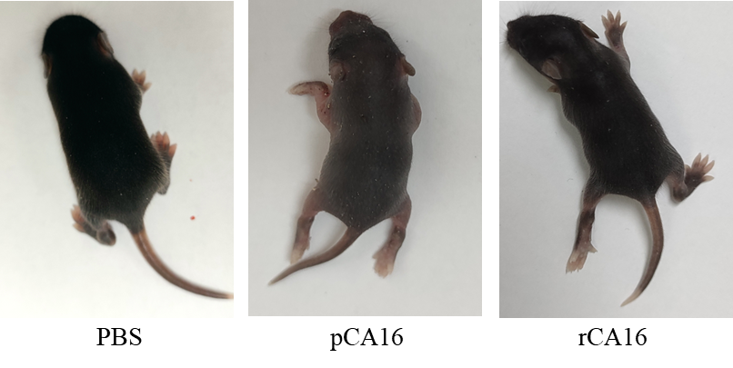

**Supplementary Figure 2.**  Paralysis in neonatal mice infected with the 105 TCID50 pCA16 and rCA16 viruses 3 days after infection, mice injected with an equal volume of PBS as the control group.

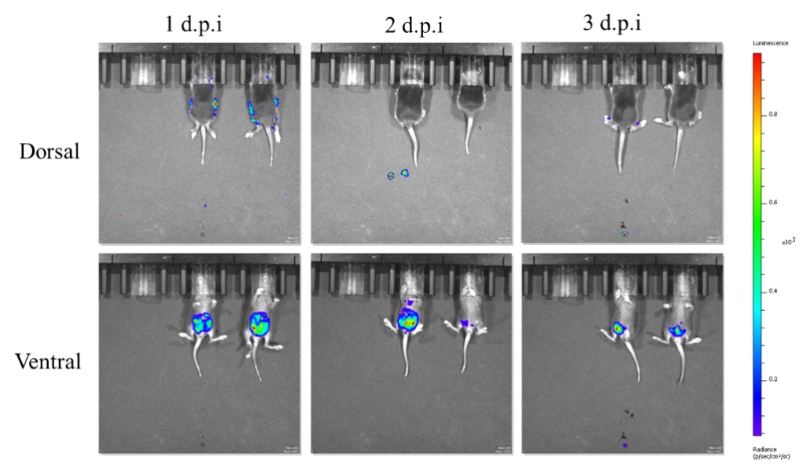

**Supplementary Figure 3.** One-week-old C57/B6 mice were infected with 105 TCID50 rCA16-Nluc virus, and the bioluminescence intensity was analyzed by *in vivo* imaging on the first, second and third days after infection. A significantly higher radiance was detected at 1 d.p.i.

**Supplementary Table 1**

The PCR parameters of Nluc gene.

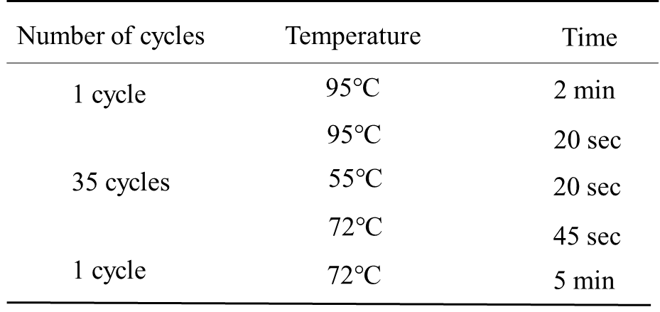

**Supplementary Table 2**

The primers for Nluc PCR and sequencing.

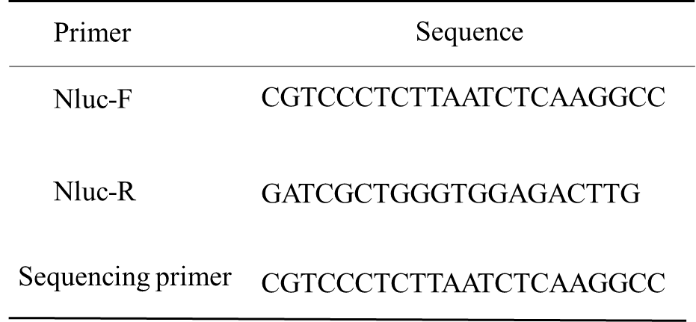

**Supplementary Table 3**

The primers for constructing the two infectious clones. We used the seamless cloning strategy (Hieff Clone® Plus One Step Cloning Kit, https://www.yeasen.com/products/detail/818, based on homologous recombination principle) to construct the infectious clones. For constructing the CA16 infectious clone: firstly, the primers (P1-F, P1-R; pcDNA-F, pcDNA-R) were used to amplify the P1 fragment and pcDNA vector for constructing of pcDNA-P1; the primers (P2-F, P2-R; P3-F, P3-R; pUC57-F, pUC57-R) were used to amplify the P2 fragment, P3 fragment and pUC57 vector for constructing of pUC57-P2+P3. Then the primers (P1-full-F, P1-full-R; P2+P3-full-F, P2+P3-full-R; pSVA-F, pSVA-F) were used to amplify the P1 fragment, P2+P3 fragment and pSVA vector for constructing of pSVA-CA16 infectious clone.

The CA16-Nluc infectious clone was constructed by adding Nluc gene to the CA16 infectious clone, the primers (CA16-Nluc-F, CA16-Nluc-R) were used to amplify the Nluc gene, and the primers (CA16-F, CA16-R) were used to amplify the CA16 infectious clone, and the CA16-Nluc infectious clone was constructed by recombination of the two fragments.

