Supplementary Material

## Supplementary Figures

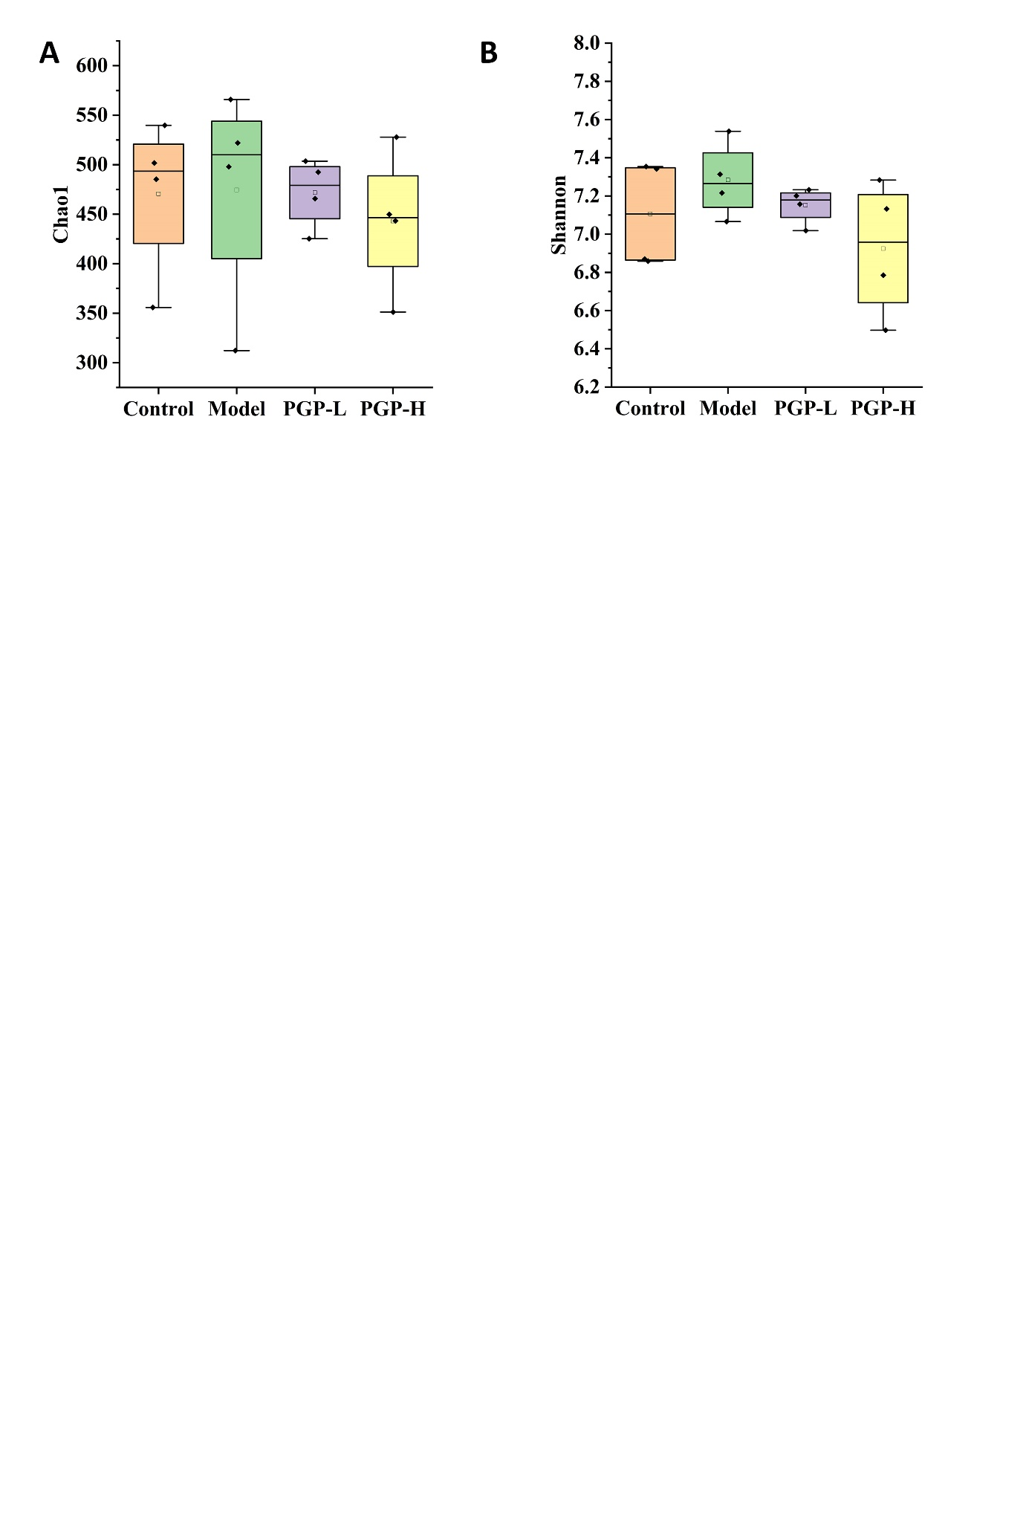

**Supplementary Figure S1**: α-Diversity based on Chao1 (A) and Shannon (B) indices.