Supplemental Material
Grassland management effect on ecosystems services in the livestock system in an oxisol from the Eastern highland plains of Colombia
Nubia S. Rodríguez-Hernández¹*†, Miguel Arango¹, Lina M. Moreno-Conn¹, José Orlando Arguello¹, Jaime H. Bernal-Riobo¹, Otoniel Pérez-López¹†
¹Colombian Agricultural Research Corporation - Agrosavia, La Libertad Research Center, Villavicencio, Meta 500008, Colombia.

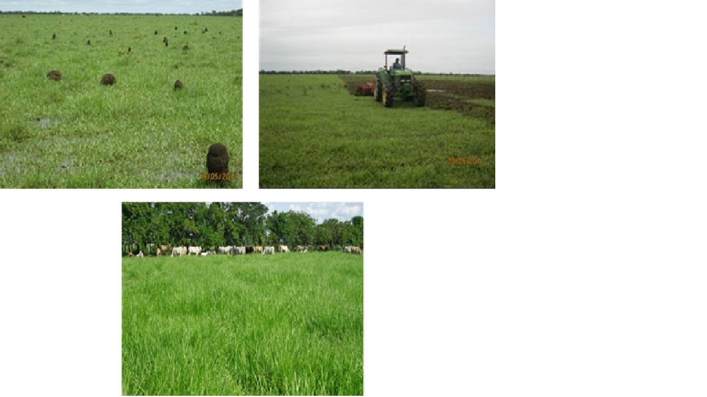
Figure 1. Panoramic view of grasslands before, during and after the intervention with recovery practices at CI Carimagua (Source: O. Pérez).
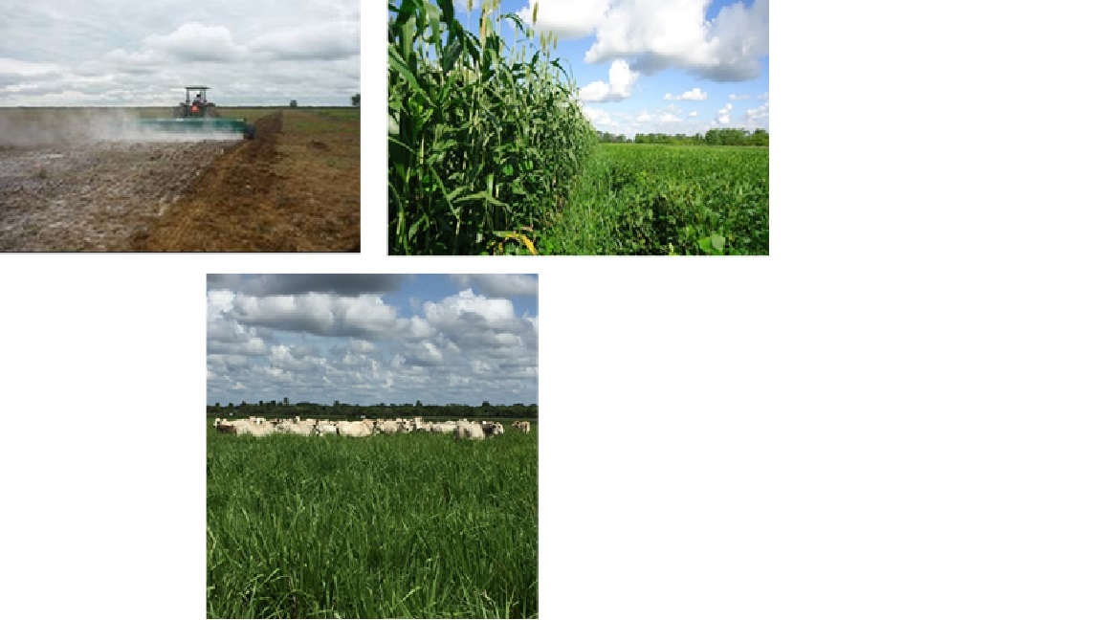
Figure 2. Production of sorghum-soybean crops for silage production and grassland renewal. CI Carimagua (Source: O. Perez)
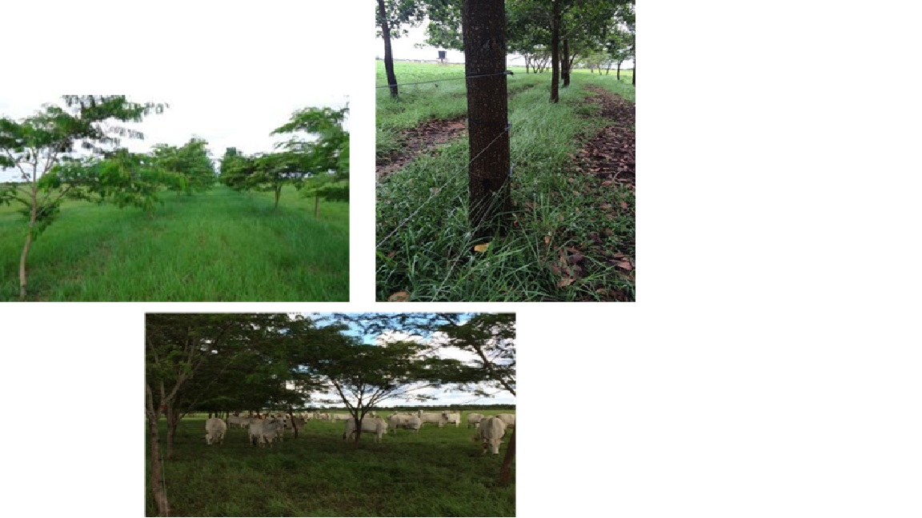
Figure 3. Silvopastoral arrangement in strips provides shade for animal comfort and the central groove of trees serves to support the electric fence (Source: O. Pérez).
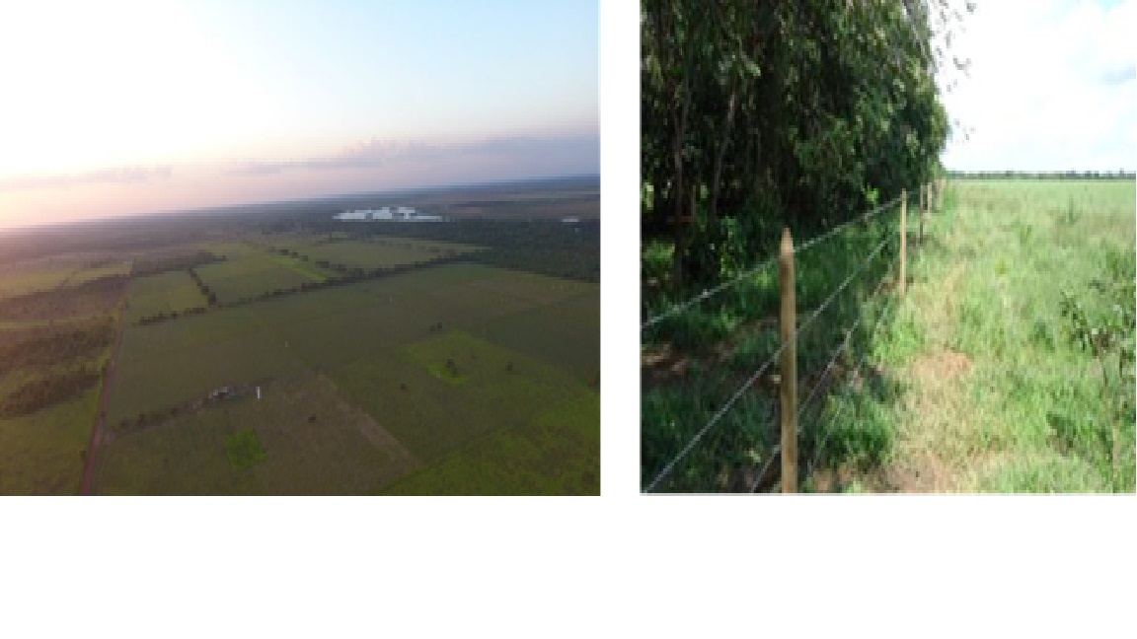
Figure 4. General view of the experiment showing the areas with protected forest relicts on the paddocks periphery (Source: R.A. Díaz, O. Pérez).

