Dislocation-driven growth of WS2/ WSe2 quantum well superlattices

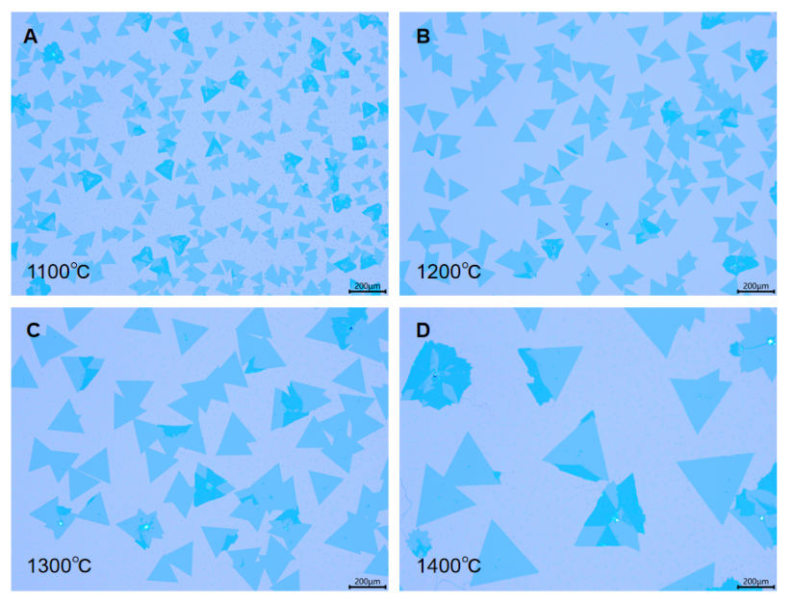

**Supplementary Figure 1.** Optical images of the synthesized monolayer WSe2 using the reverse airflow method at different growth temperature.

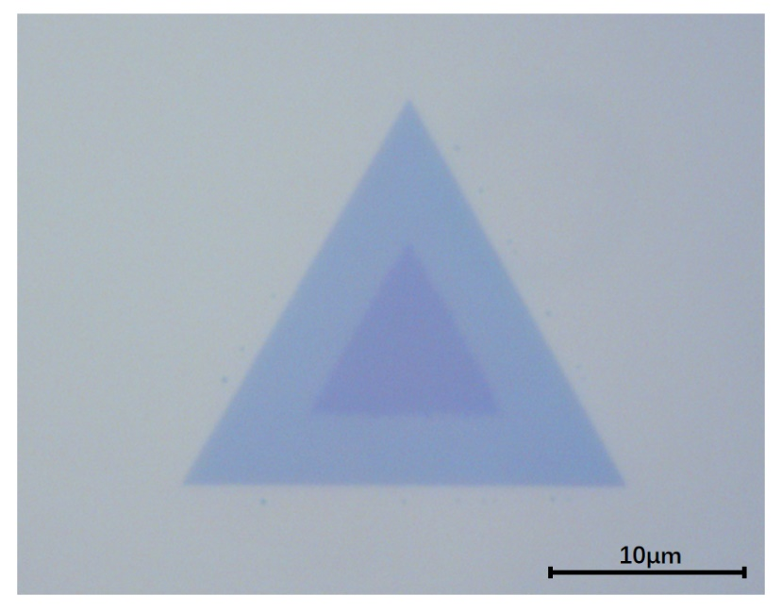

**Supplementary Figure 2.** Optical image of the WSe2/WS2 lateral heterojunction using the reverse airflow method.

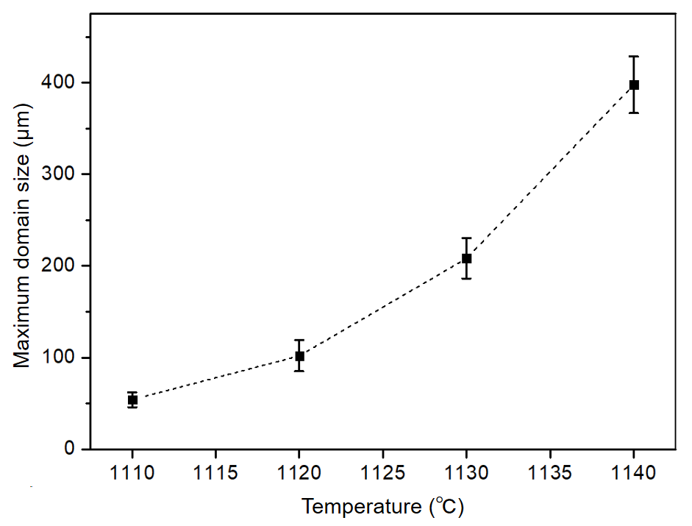

**Supplementary Figure 2.** Relationship between maximum crystal domain size of monolayer WSe2 and growth temperature.