**Supplementary material**

**Exploring the mechanism of anti-chronic heart failure effect of Qiweiqiangxin І granules based on metabolomics**

**Wanru Zhong1†, Yihua Li3†, Haixiang Zhong1, Yuanyuan Cheng1, Qi Chen1,2, Xinjun Zhao2, Zhongqiu Liu1*, Rong Li 2*, Rong Zhang 1\***

1Guangdong Provincial Key Laboratory of Translational Cancer Research of Chinese Medicines, Joint International Research Laboratory of Translational Cancer Research of Chinese Medicines, International Institute for Translational Chinese Medicine, School of Pharmaceutical Sciences, Guangzhou University of Chinese Medicine, Guangzhou, China.

2Department of Internal Medicine-Cardiovascular, The First Affiliated Hospital of Guangzhou University of Chinese Medicine, Guangzhou, Guangdong, China

3The first clinical medical college, Guangzhou University of Chinese Medicine, Guangzhou, China.

**†**These authors have contributed equally to this work and share first authorship

Table S1 Information on 33 characteristic compounds designated by QWQX І granules

|  |  |  |  |  |
| --- | --- | --- | --- | --- |
| No. | RT/min | name | molecular formula | source |
| 1  2  3  4  5  6  7  8  9  10  11  12  13  14  15  16  17  18  19  20  21  22  23  24  25  26  27  28  29  30  31  32  33 | 0.58  0.659  1.032  1.108  1.538  1.818  2.073  2.776  3.583  3.984  4.433  5.328  5.5  5.767  6.497  6.642  7.854  8.66  8.983  9.736  11.581  11.654  11.723  11.796  11.958  12.196  12.757  12.869  13.041  13.397  14.107  14.249  14.56 | *β*-(3,4-Dihydroxyphenyl)-D-lactic acid  Gamma-aminobutyric acid  L-Adenosine  Salviolone  Alangiside  Threonin  Dihydroisotanshinone I  Ononin  Hydroxytanshinone IIA  *β*-sitosterol  Ginsenoside La.qt  Trifolirhizin  Ethyl methoxycinnamate  Malyngamide J  Lithospermic acid  Buntansin A  Salvianolic acid G  Melitric acid B  Psuedohypericin  Dehydrouvaol  Agnosterone  Lupenone  20-Hexadecanoylingenol  Ilexoside A  21-Isopropyl-28,29,30-trinor-17,19,21-gammaceratriene  Ilexgenin A  20S-ginsenoside Rs3  Tanshinaldehyde  Perrottetin D  Isotanshinone II  Miltirone  Cryptotanshinone  Apollinine | C9H10O5  C4H9NO2  C10H13N5O4  C18H20O2  C25H31NO10  C4H9NO3  C18H14O3  C22H24O9  C19H18O4  C30H52O  C30H50O3  C22H22O10  C12H14O3  C33H53NO9  C27H22O12  C11H8O5  C18H12O7  C30H16O9  C18H26O10  C19H20O3  C30H46O  C36H58O4  C30H48O  C35H56O8  C30H46  C30H46O6  C19H22O5  C19H16O4  C19H20O3  C18H14O3  C19H22O2  C19H22O3  C22H18O5 | Radix Salviae  Hedysarum Multijugum Maxim.  Panax Ginseng C. A. Mey.  Radix Salviae  Cinnamomum cassia Presl  Radix Salviae  Radix Salviae  Hedysarum Multijugum Maxim.  Radix Salviae  Lepidii Semen Descurainiae Semen  Panax Ginseng C. A. Mey.  Panax Ginseng C. A. Mey.  Cinnamomi Ramulus  Radix Salviae  Radix Salviae  Radix Salviae  Radix Salviae  Panax Ginseng C. A. Mey  Radix Salviae Miltiorrhiae  Radix Salviae  Radix Ilicis Pubescentis  Panax Ginseng C. A. Mey  Astragalus membranaceus Bge  Radix Ilicis Pubescentis  Astragalus membranaceus Bge  Radix Ilicis Pubescentis  Hedysarum Multijugum Maxim.  Radix Salviae  Radix Salviae  Radix Salviae  Radix Salviae  Radix Salviae  Radix Salviae |

Table S2 Mass spectrometry conditions

|  |  |
| --- | --- |
| 6540 Q-TOF MS conditions | |
| Capillary voltage | 3500V |
| Gas temperature | 320℃ |
| Gas flow rate | 8 L/min |
| Nebulizer | 35 psig |
| Sheath gas temperature | 350℃ |
| Sheath gas flow rate | 1l L/min |
| Nozzle voltage | 1500V |
| Fragmentor | 175V |
| Skimmer | 65V |
| Scan rate | 4 spectra/s |

The instrument mode is Extended Mass Range (2 GHz), the acquisition mode is full scan, and the scan mass-to-charge ratio range is 50-1500, with positive mode reference ions of 121.0509 and 922.0098, and negative mode reference ions of 112.9855 and 1033.9881.

Table S3 Gradient elution conditions

|  |  |  |  |
| --- | --- | --- | --- |
| Time | Flow rate | Mobile phase A | Mobile phase B |
| (min) | (mL/min) | (%) | (%) |
| 0 | 0.4 | 98 | 2 |
| 1 | 0.4 | 98 | 2 |
| 15 | 0.4 | 0 | 100 |
| 18 | 0.4 | 0 | 100 |
| 18.01 | 0.4 | 98 | 2 |
| 20 | 0.4 | 98 | 2 |

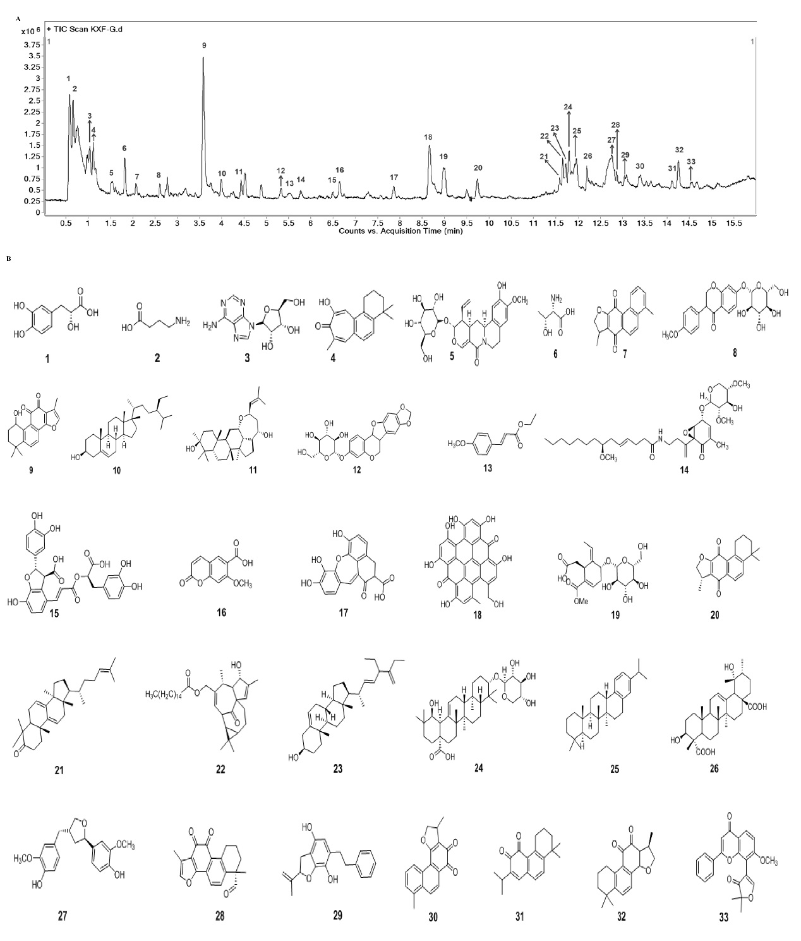

**Figure S1 Chemical composition in QWQX І.** (A)The chromatogram of the QWQX І (B) Assigned structures of 33 characteristic compounds in QWQX І.

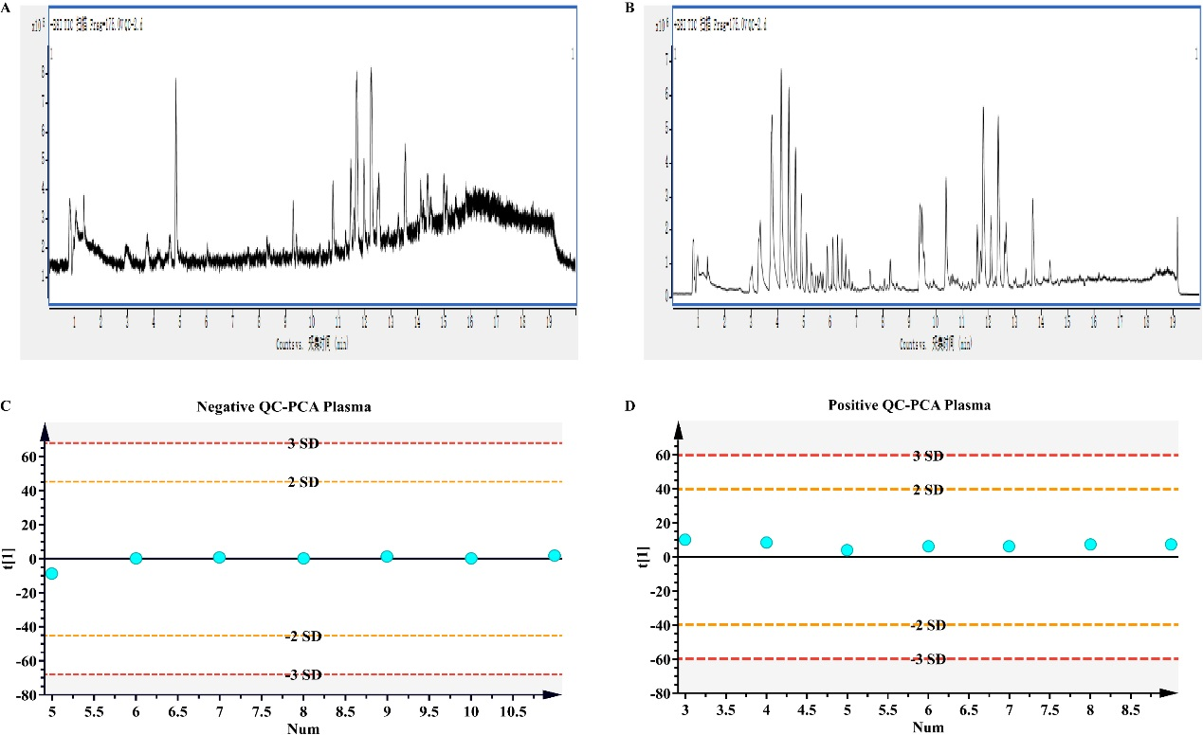

**Figure S2 Metabolic profile of rat plasma.** (A) Total ion flow chromatogram in negative mode; (B) Total ion flow chromatogram in positive mode; (C) Quality control samples PCA scores in negative mode; (D) Quality control samples PCA scores in positive mode.

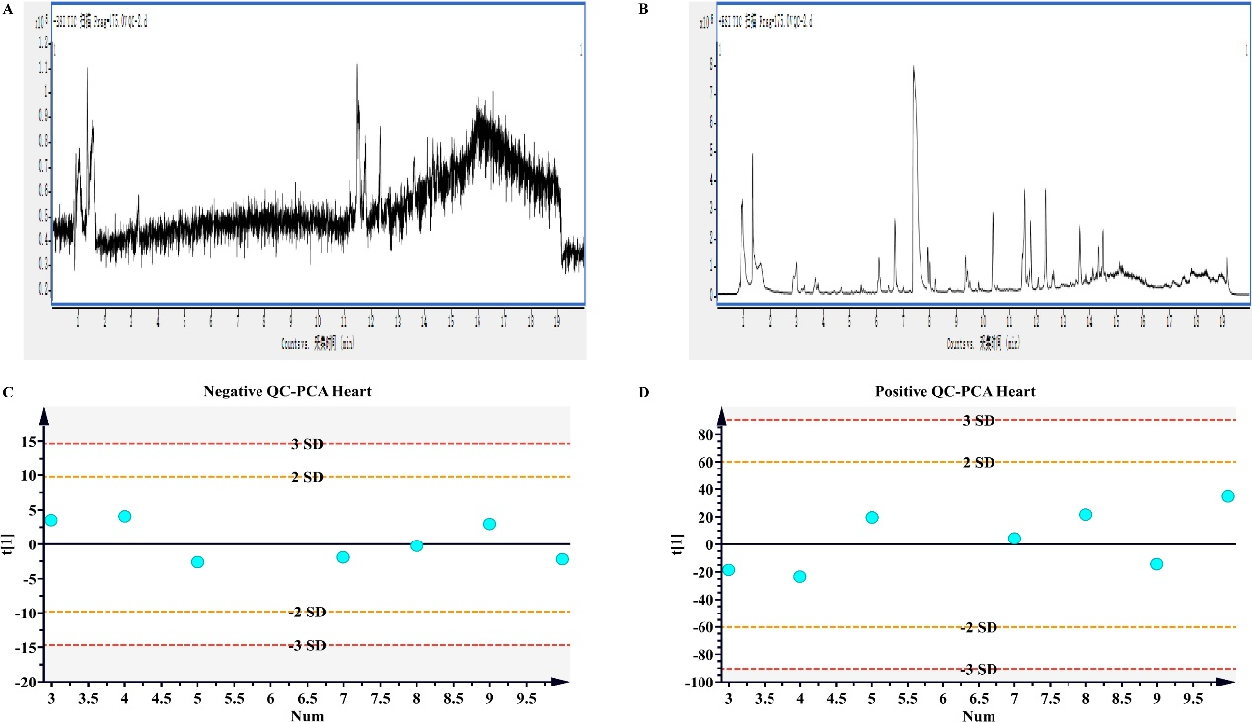

**Figure S3 Metabolic profile of rat cardiac tissue.** (A) Total ion flow chromatogram in negative mode; (B) Total ion flow chromatogram in positive mode; (C) Quality control samples PCA scores in negative mode; (D) Quality control samples PCA scores in positive mode.