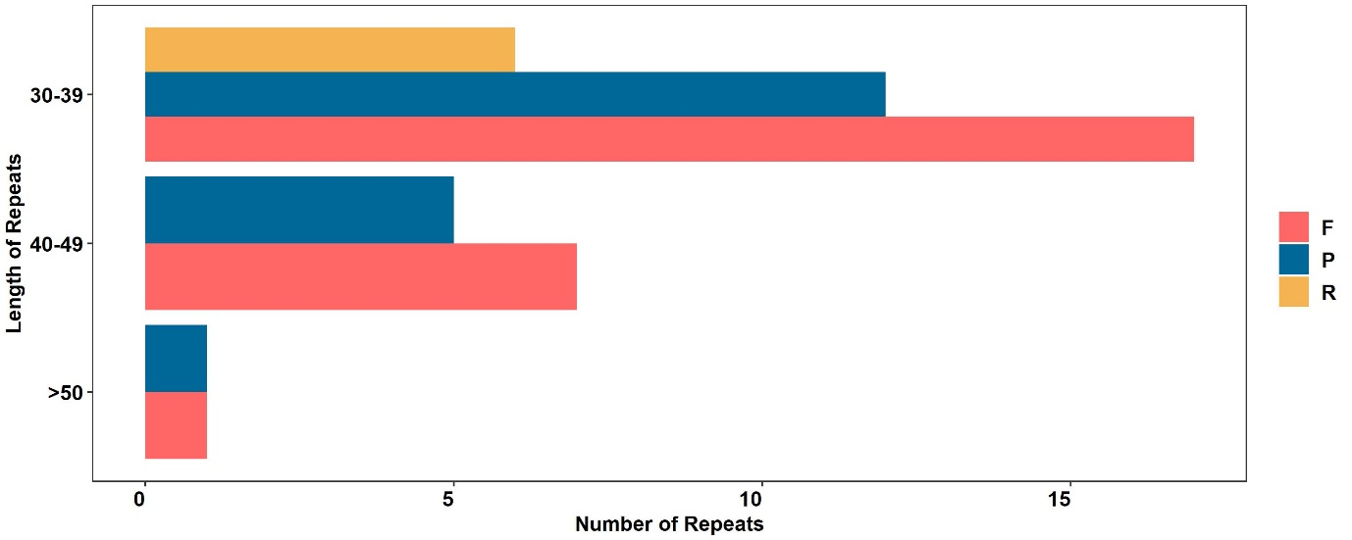

**Supplementary Figure 1.** Length and frequency of repeats in *H. syriacus* var. *Baekdansim* chloroplast genome.

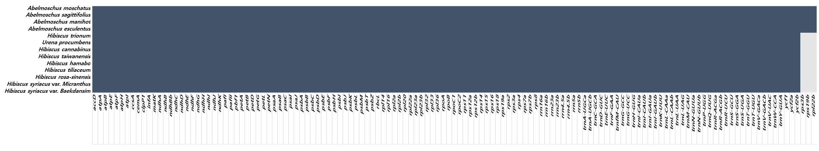

**Supplementary Figure 2.** Presence and absence of genes in 13 species belonging to the tribe Hibisceae.

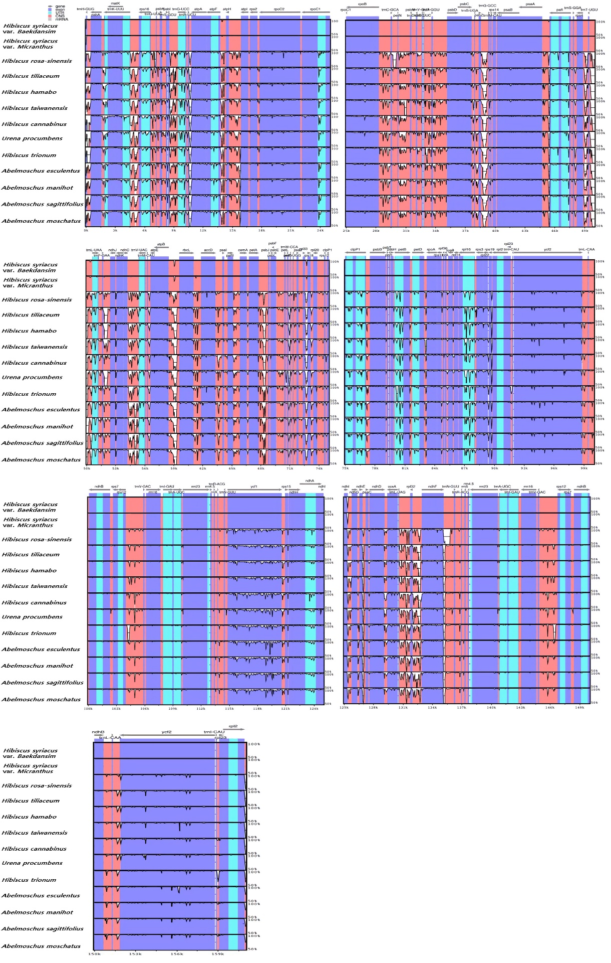

**Supplementary Figure 3.** Comparison of 13 chloroplast genomes using mVISTA program. Genome regions are color-coded as protein-coding (exon) and conserved noncoding sequences (CNS).



**Supplementary Figure 4.** Putative RNA-editing sites in the start and stop codon