Supplementary Material

A cohort study of clinically relevant prognostic and predictive markers for immune-checkpoint-inhibitor (ICI) therapy in non-small cell lung cancer (NSCLC)

Supplementary Figures and Tables

Supplementary Figures

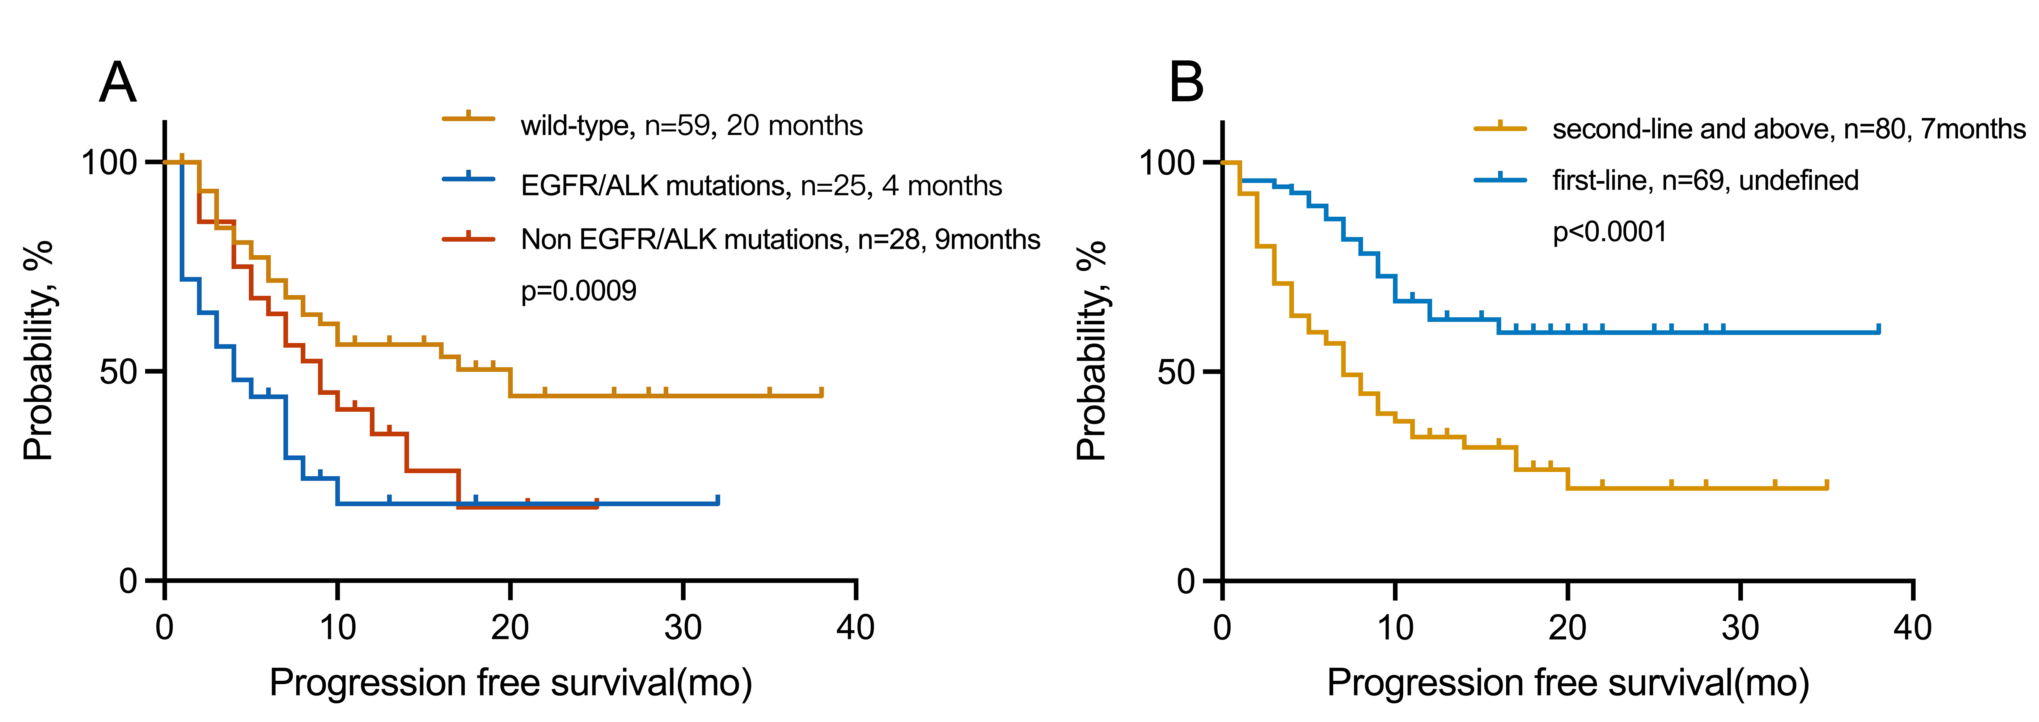

Supplementary Figure S1 PFS in patients with NSCLC treated with immunotherapy in the (A) wild-type, EGFR/ALK mutations and Non EGFR/ALK mutations cohorts (B) first-line and second-line and above cohorts.
Abbreviations: EGFR, epidermal growth factor receptor; ALK, anaplastic lymphoma kinase.

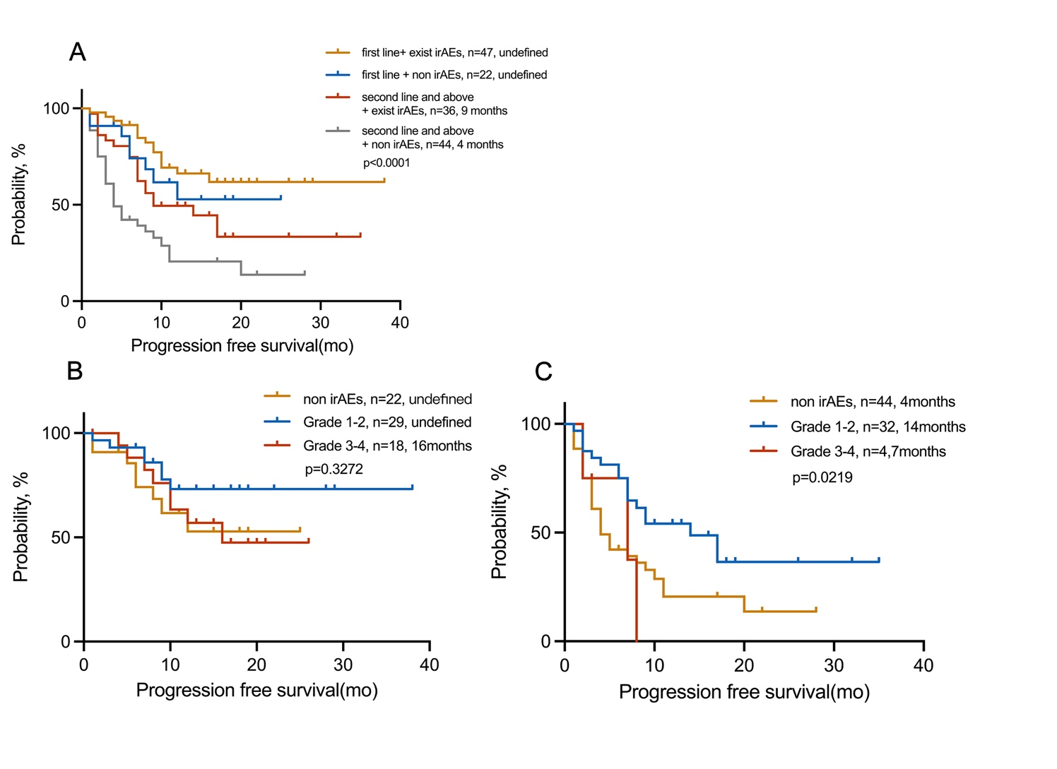
Supplementary Figure S2 PFS in patients with NSCLC treated with immunotherapy in the (A) exist irAEs and non irAEs cohorts in different lines; (B) non irAEs, 1-2 grade and 3-4 grade cohorts in first line therapy patients; (C) non irAEs, 1-2 grade and 3-4 grade cohorts in second line and above therapy patients.

Supplementary Tables

Supplementary Table S1 Immune checkpoint inhibitor therapy regimens
Therapeutic schedule | Total, N (%)
Monotherapy | 35 (23.5)
Combination therapy | 114 (76.5)
+Chemotherapy | 66 (44.3)
+Anti-angiogenic drugs | 23 (15.4)
+ Anti-angiogenic and chemotherapy | 25 (16.8)

Supplementary Table S2 Coordinate of ROC curve of EOS% for predicting the irAEs
cut-off value | sensitivity | specificity
-1 | 1 | 0
0.05 | 0.976 | 0.016
0.15 | 0.964 | 0.047
0.235 | 0.964 | 0.062
0.285 | 0.964 | 0.078
0.35 | 0.94 | 0.141
0.45 | 0.928 | 0.141
0.55 | 0.904 | 0.219
0.65 | 0.904 | 0.266
0.75 | 0.892 | 0.328
0.85 | 0.88 | 0.328
0.95 | 0.843 | 0.344
1.05 | 0.819 | 0.391
1.15 | 0.795 | 0.422
1.25 | 0.771 | 0.422
1.35 | 0.747 | 0.437
1.45 | 0.735 | 0.453
1.55 | 0.699 | 0.5
1.65 | 0.663 | 0.5
1.75 | 0.59 | 0.547
1.85 | 0.53 | 0.594
1.95 | 0.494 | 0.594
2.05 | 0.482 | 0.594
2.15 | 0.482 | 0.609
2.25 | 0.47 | 0.625
2.35 | 0.434 | 0.656
2.45 | 0.422 | 0.687
2.55 | 0.422 | 0.703
2.65 | 0.386 | 0.719
2.75 | 0.386 | 0.734
2.85 | 0.373 | 0.734
2.95 | 0.361 | 0.75
3.05 | 0.325 | 0.75
3.15 | 0.301 | 0.766
3.3 | 0.289 | 0.766
3.45 | 0.289 | 0.781
3.55 | 0.277 | 0.797
3.7 | 0.265 | 0.797
3.85 | 0.253 | 0.812
4.05 | 0.253 | 0.828
4.25 | 0.217 | 0.859
4.35 | 0.205 | 0.859
4.45 | 0.193 | 0.859
4.55 | 0.181 | 0.891
4.75 | 0.157 | 0.891
5 | 0.133 | 0.906
5.15 | 0.12 | 0.922
5.5 | 0.12 | 0.937
6.15 | 0.108 | 0.953
6.8 | 0.096 | 0.953
7.25 | 0.084 | 0.953
7.55 | 0.084 | 0.969
7.85 | 0.072 | 0.969
9.45 | 0.06 | 0.984
11.05 | 0.048 | 0.984
11.65 | 0.036 | 0.984
12.3 | 0.024 | 0.984
14.85 | 0.012 | 0.984
23.05 | 0.012 | 1
29.9 | 0 | 1
Note: The area under the curve (AUC) of the ROC curve was 0.608 (95% CI 0.515−0.701; p=0.025). The cut-off value is 1.15%, the sensitivity and specificity were 79.5% and 42.2%, respectively.

Supplementary Table S3 Coordinate of ROC curve of IFN-γ for predicting the irAEs
cut-off value | sensitivity | specificity
1.4 | 1 | 0
2.45 | 0.651 | 0.519
2.6 | 0.605 | 0.593
2.8 | 0.581 | 0.593
2.95 | 0.558 | 0.593
3.05 | 0.558 | 0.667
3.25 | 0.558 | 0.741
3.45 | 0.535 | 0.741
3.6 | 0.535 | 0.778
3.75 | 0.512 | 0.815
3.85 | 0.465 | 0.815
4 | 0.442 | 0.815
4.25 | 0.442 | 0.852
4.55 | 0.372 | 0.852
4.85 | 0.326 | 0.852
5.1 | 0.256 | 0.852
5.75 | 0.256 | 0.889
6.7 | 0.233 | 0.926
7.6 | 0.209 | 0.926
8.3 | 0.186 | 0.926
10.4 | 0.163 | 0.926
13.05 | 0.14 | 0.926
14.9 | 0.14 | 0.963
16.05 | 0.14 | 1
17.2 | 0.116 | 1
25.5 | 0.093 | 1
33.55 | 0.07 | 1
36.95 | 0.047 | 1
53.7 | 0.023 | 1
68.9 | 0 | 1
Note: The area under the curve (AUC) of the ROC curve was 0.642 (95% CI 0.511−0.772; p=0.025). The cut-off value is 3.75, the sensitivity and specificity were 51.2% and 81.5%, respectively.

