Supplementary Material

Immune microenvironment dynamics in breast cancer during pregnancy: Impact of gestational age on tumor-infiltrating lymphocytes and prognosis
Elham Sajjadi ^{1,2‡}, Konstantinos Venetis ^{1,2‡}, Mariia Ivanova ², Marianna Noale ³, Concetta Blundo ⁴, Eugenia Di Loreto ⁵, Giovanna Scarfone ⁵, Stefano Ferrero ^{6,7}, Stefania Maggi ³, Paolo Veronesi ^{1,8}, Viviana E. Galimberti ⁸, Giuseppe Viale ^{1,2}, Nicola Fusco^{1,2, +}*, Fedro A. Peccatori ^{9, +}, Elena Guerini-Rocco^{1,2, +}
¹ Department of Oncology and Hemato-Oncology, University of Milan, Via Festa del Perdono 7, 20122 Milan, Italy;
² Division of Pathology, IEO, European Institute of Oncology IRCCS, Via Giuseppe Ripamonti 435, 20141 Milan, Italy;
³ National Research Council (CNR), Neuroscience Institute Aging Branch, Via Giustiniani 2, 35128 Padua, Italy;
⁴ Breast Surgery Unit, Fondazione IRCCS Ca’ Granda—Ospedale Maggiore Policlinico, 20122 Milan, Italy;
⁵ Gynecology Unit, Fondazione IRCCS Ca’ Granda—Ospedale Maggiore Policlinico, 20122 Milan, Italy;
⁶ Division of Pathology, Fondazione IRCCS Ca’ Granda—Ospedale Maggiore Policlinico, 20122 Milan, Italy;
⁷ Department of Biomedical, Surgical, and Dental Sciences, University of Milan, Via Festa del Perdono 7, 20122 Milan, Italy;
⁸ Division of Breast Surgery, IEO, European Institute of Oncology IRCCS, 20141 Milan, Italy;
⁹ Fertility and Procreation Unit, Division of Gynecologic Oncology, IEO European Institute of Oncology IRCCS, 20141 Milan, Italy.
‡ These authors contributed equally to this work
⁺ These authors jointly directed this work.
* Correspondence:
nicola.fusco@ieo.it; +39-02-9437-2079

Supplementary Figure and Tables
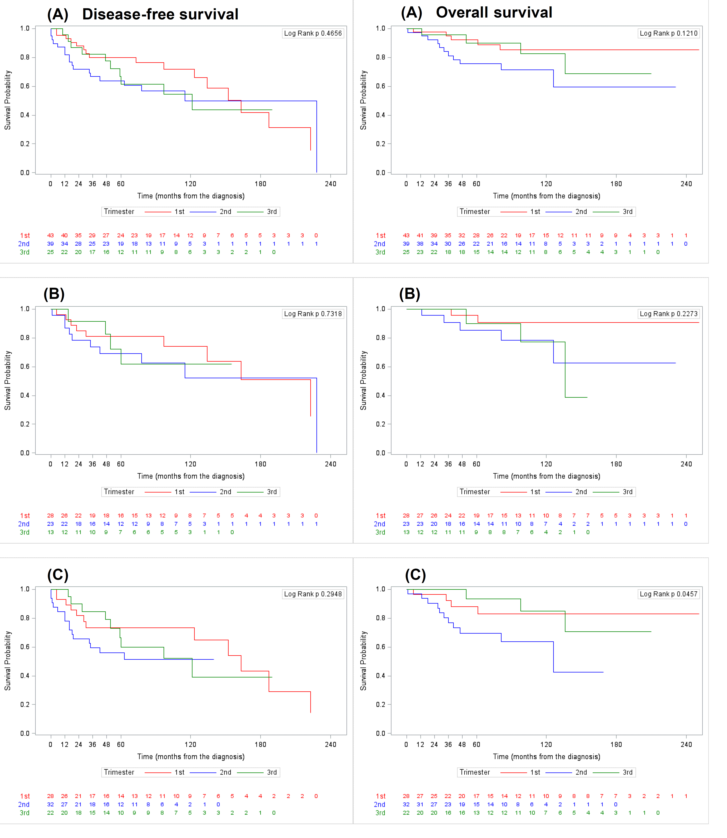
Supplementary Figure 1. Kaplan-Meier curves describing the disease-free survival and overall survival analysis of PrBC patients according to the trimester of pregnancy. (A) Overall population; (B) Endocrine therapy treated population; (C) Chemotherapy treated population.

Marker | Clone | Dilution | Antigen retrieval | Scoring
ER | EP1 | RTU | High pH, 20' | ASCO/CAP and St Gallen guidelines; positive if ≥1% of tumor cell nuclei are immunoreactive.
PgR | PgR 636 | 1:100 | High pH, 30’ | ASCO/CAP and St Gallen guidelines; positive if ≥1% of tumor cell nuclei are immunoreactive.
Ki-67 | MIB1 | RTU | High pH, 30’ | International Ki67 in Breast Cancer Working Group; high if ≥30% of tumor cell nuclei are immunoreactive
HER2 | Polyclonal | 1:400 | Low pH, 30' | ASCO/CAP guidelines; 3+ if complete membrane staining that is intense and >10% of tumor cells; 2+ if weak to moderate complete membrane staining in >10% of tumor cells or complete membrane staining that is intense but within ≤10% of tumor cells; 1+ if incomplete membrane staining that is faint/barely perceptible and within >10% of tumor cells; 0 if no staining observed or membrane stating that is incomplete and is faint/barely perceptible and within ≤10% of tumor cells.
TILs | n/a | n/a | n/a
CD4 | 4B12 | RTU | Low pH, 30' | Negative if complete loss of membrane staining within the lymphocytes.
CD8 | C8/144B | 1:50 | Low pH, 30' | Negative if complete loss of membrane staining within the lymphocytes; low, 1-30%; intermediate, 31-50%; high, >50%.
FOXP3 | Polyclonal | 1:200 | Low pH, 30' | Negative if complete loss of membrane staining within the lymphocytes.
PD-L1 | 22C3 | RTU | Low pH, 30' | Combined positive score (CPS), i.e. total number of PD-L1+ tumor cells, lymphocytes, and macrophages divided by the total number of viable tumor cells, multiplied by 100.
Supplementary Table S1. List of antibodies used for immunohistochemical analyses. The analyses were performed on a Dako Omnis staining platform using the polymer-based EnVision FLEX antigen retrieval system. PD-L1, programmed death-ligand 1; RTU, ready to use.

 | 3rd trimester, n=25
 | HR+/HER2-  n=11 | HER2+  n=4 | HR-/HER2-n=10 | p-value
High Grade, n (%) | 8 (81.8) | 4 (100) | 9 (90) | 0.355
Supplementary Table S2. Correlation between high histologic grade (G3) with breast cancer subtypes in the patients who were diagnosed with PrBC in the last trimester. PrBC, breast cancer during pregnancy; HR, hormone receptors. Significant associations (p<0.05) are highlighted with a star (*).

Total population
n=108
 | 1st trimester  n=44 | 2nd trimester  n=39 | 3rd trimester  n=25 | p-value
TILs, n (%)  Zero or Low  Intermediate or High | 31 (70.5)  13 (29.5) | 30 (76.9)  9 (23.1) | 20 (80.0)  5 (20.0) | 0.639
PD-L1CPS, n (%)  <10  ≥10 | 36 (94.7)  2 (5.3) | 39 (100.0)  0 (0.0) | 20 (90.9)  2 (9.1) | 0.118
FOXP3, n (%)  Absence  Presence | 22 (57.9)  16 (42.1) | 26 (66.7)  13 (33.3) | 19 (82.6)  4 (17.4) | 0.138
CD4, n (%)  Absence  Presence | 30 (79.0)  8 (21.0) | 28 (71.8)  11 (28.2) | 14 (63.6)  8 (36.4) | 0.433
CD8, n (%)  Absence  Presence | 7 (18.4)  31 (81.6) | 5 (12.8)  34 (87.2) | 4 (18.2)  18 (81.8) | 0.767
Supplementary Table S3. Relative prevalence of TILs subpopulation in the tumor stroma and PD-L1 expression among trimesters. PrBC, breast cancer during pregnancy; TILs, tumor-infiltrating lymphocytes; FOXP3, forkhead box P3; PD-L1, programmed death-ligand 1; CPS, combined positive score. Significant associations (p<0.05) are highlighted with a star (*).

 | All the patients  (n=107) |  |  | Chemotherapy+  (n=82) |  |  | Hormone therapy+  (n=64)
 | Disease recurrence |  |  | Disease recurrence |  |  | Disease recurrence
 | No  (n=63) | Yes  (n=44) | p-value | No  (n=46) | Yes  (n=36) | p-value | No  (n=41) | Yes  (n=23) | p-value
1st trimester | 27 (62.8) | 16 (37.2) | 0.707 | 16 (57.1) | 12 (42.9) | 0.902 | 19 (67.9) | 9 (32.1) | 0.640
2nd trimester | 21 (53.9) | 18 (46.2) |  | 17 (53.1) | 15 (46.9( |  | 13 (56.5) | 10 (43.5)
3rd trimester | 15 (60.0) | 10 (40.0) |  | 13 (59.1) | 9 (40.9) |  | 9 (69.2) | 4 (30.8)
Supplementary Table S4. Disease progression status based on the trimesters in different therapeutic approaches. Significant associations (p<0.05) are highlighted with a star (*).

 | All the patients  (n=107) |  |  | Chemotherapy+  (n=82) |  |  | Hormone therapy+  (n=64)
 | Death |  |  | Death |  |  | Death
 | No  (n=87) | Yes  (n=20) | p-value | No  (n=64) | Yes  (n=18) | p-value | No  (n=54) | Yes  (n=10) | p-value
1st trimester | 38 (88.4) | 5 (11.6) | 0.146 | 24 (85.7) | 4 (14.3) | 0.094 | 26 (92.9) | 2 (7.1) | 0.244
2nd trimester | 28 (71.8) | 11 (28.2) |  | 21 (65.6) | 11 (34.4) |  | 18 (78.3) | 5 (21.7)
3rd trimester | 21 (84.0) | 4 (16.0) |  | 19 (86.4) | 3 (13.6) |  | 10 (76.9) | 3 (23.1)
Supplementary Table S5. Death status based on the trimesters in different therapeutic approaches. Significant associations (p<0.05) are highlighted with a star (*).

 | Death (in Hormone therapy+: n=64)
 | 1st trimester |  |  | 2nd trimester |  |  | 3rd trimester
 | No  (n=26) | Yes  (n=2) | p-  value | No  (n=18) | Yes  (n=5) | p-  value | No  (n=10) | Yes  (n=3) | p-  value
TILs, n (%)  0 or Low  Intermediate or High | 17 (65.4)  9 (34.6) | 1 (50.0)  1 (50.0) | 1.000 | 16 (88.9)  2 (11.1) | 5 (100.0)  0 (0.0) | 1.000 | 10 (100.0)  0 (0.0) | 2 (66.7)  1 (33.3) | 0.231
PD-L1CPS, n (%)  0  ≥1 | 16 (69.6)  7 (30.4) | 2 (100)  0 (0.0) | 1.000 | 16 (88.9)  2 (11.1) | 4 (80.0)  1 (20.0) | 0.539 | 8 (88.9)  1 (11.1) | 2 (100.0)  0 (0.0) | 1.000
FOXP3, n (%)  Absence  Presence | 12 (52.2)  11 (47.8) | 1 (50.0)  1 (50.0) | 1.000 | 15 (83.3)  3 (16.7) | 4 (80.0)  1 (20.0) | 1.000 | 9 (100.0)  0 (0.0) | 2 (66.7)  1 (33.3) | 0.250
CD4, n (%)  Absence  Presence | 17 (73.9)  6 (26.1) | 2 (100)  0 (0.0) | 1.000 | 13 (72.2)  5 (27.8) | 5 (100)  0 (0.0) | 0.545 | 6 (66.7)  3 (33.3) | 2 (66.7)  1 (33.3) | 1.000
CD8, n (%)  Absence  Presence | 3 (13.0)  20 (87.0) | 0 (0.0)  2 (100) | 1.000 | 2 (11.1)  16 (88.9) | 2 (40.0)  3 (60.0) | 0.194 | 3 (33.3)  6 (66.7) | 0 (0.0)  3 (100.0) | 0.509
Supplementary Table S6. Death occurrence according to TILs populations status in patients with a history of hormone therapy. treatment. TILs, tumor-infiltrating lymphocytes; FOXP3, forkhead box P3; PD-L1, programmed death-ligand 1; CPS, combined positive score. Significant associations (p<0.05) are highlighted with a star (*).

 | Death (in chemotherapy+: n=82)
 | 1st trimester |  |  | 2nd trimester |  |  | 3rd trimester
 | No  (n=24) | Yes  (n=4) | p-  value | No  (n=21) | Yes  (n=11) | p-  value | No  (n=19) | Yes  (n=3) | p-  value
TILs, n (%)  0 or Low  Intermediate or High | 17 (70.8)  7 (29.2) | 3 (75.0)  1 (25.0) | 1.000 | 14 (66.7)  7 (33.3) | 10 (90.9)  1 (9.1) | 0.209 | 15 (79.0)  4 (21.0) | 2 (66.7)  1 (33.3) | 1.000
PD-L1CPS, n (%)  0  ≥1 | 14 (70.0)  6 (30.0) | 3 (100.0)  0 (0.0) | 0.539 | 16 (76.2)  5 (23.8) | 7 (63.6)  4 (36.4) | 0.681 | 11 (68.8)  5 (31.3) | 3 (100.0)  0 (0.0) | 0.530
FOXP3, n (%)  Absence  Presence | 10 (50.0)  10 (50.0) | 2 (66.7)  1 (33.3) | 1.000 | 10 (47.6)  11 (52.4) | 9 (81.8)  2 (18.2) | 0.128 | 14 (82.4)  3 (17.7) | 2 (66.7)  1 (33.3) | 0.509
CD4, n (%)  Absence  Presence | 13 (65.0)  7 (35.0) | 3 (100.0)  0 (0.0) | 0.526 | 11 (52.4)  10 (47.6) | 10 (90.9)  1 (9.1) | 0.050 | 9 (56.3)  7 (43.8) | 2 (66.7)  1 (33.3) | 1.000
CD8, n (%)  Absence  Presence | 4 (20.0)  16 (80.0) | 0 (0.0)  3 (100.0) | 1.000 | 1 (4.8)  20 (95.2) | 3 (27.3)  8 (72.7) | 0.106 | 3 (18.8)  13 (81.3) | 0 (0.0)  3 (100.0) | 1.000
Supplementary Table S7. Death occurrence according to TILs populations status in patients with a history of chemotherapy. treatment. TILs, tumor-infiltrating lymphocytes; FOXP3, forkhead box P3; PD-L1, programmed death-ligand 1; CPS, combined positive score. Significant associations (p<0.05) are highlighted with a star (*).

