In silico evaluation of the role of lisdexamfetamine on attention-deficit/hyperactivity disorder common psychiatric comorbidities: mechanistic insights on binge eating disorder and depression

Supplementary Figures

José Ramón Gutiérrez Casares¹٭, Cristina Segú-Vergés^{2,3}, Juncal Sabate Chueca⁴, Tamara Pozo-Rubio⁴, Mireia Coma², Carmen Montoto⁴, Javier Quintero⁵
¹ Unidad Ambulatoria de Psiquiatría y Salud Mental de la Infancia, Niñez y Adolescencia. Hospital Perpetuo Socorro. Badajoz, Spain
² Anaxomics Biotech, Barcelona, Spain
³ Research Programme on Biomedical Informatics (GRIB), Departament de Ciències Experimentals i de la Salut, Universitat Pompeu Fabra, Barcelona, Spain
⁴ Medical Department. Takeda Farmacéutica España, Madrid, Spain
⁵ Servicio de Psiquiatría. Hospital Universitario Infanta Leonor. Universidad Complutense. Madrid, Spain

Supplementary Figures

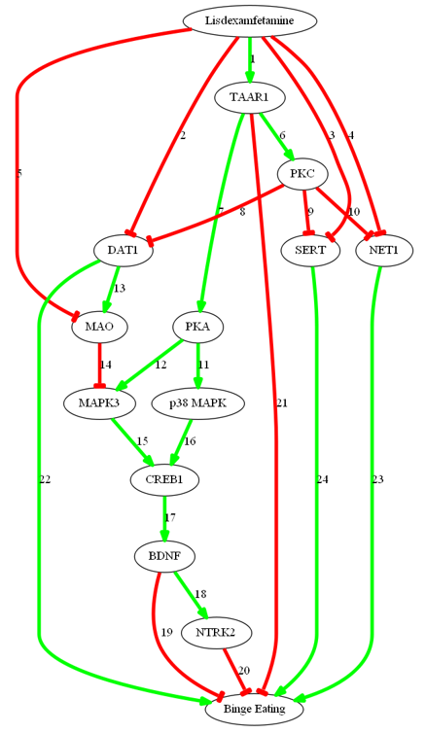

Figure A. Detailed predicted mechanism of action of virtual lisdexamfetamine over binge eating disorder in attention-deficit/hyperactivity disorder patients presenting this comorbidity. Supplementary Table C in the S2 File contains the sources of information found in the scientific literature supporting the predicted mechanisms.

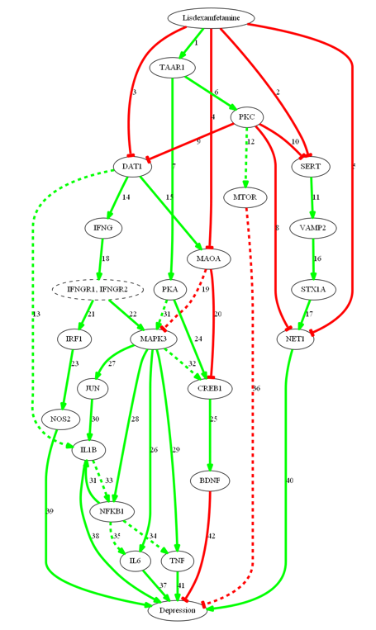
Detected
in
adults
Figure B. Detailed predicted mechanism of action of virtual lisdexamfetamine over depression in attention-deficit/hyperactivity disorder patients presenting this comorbidity. Supplementary Table D in the S2 File contains the sources of information found in the scientific literature supporting the predicted mechanisms.

