Supplementary Table S1

Sample information from 51 lakes of study area

|  |  |  |  |
| --- | --- | --- | --- |
| Lake name | ID | Longitude(°E) | Latitude(°N) |
| Anggu Co | AGC | 85.45 | 31.39 |
| Angrenijin Co | ARJC1 | 87.19 | 29.30 |
| Angrenijin Co | ARJC2 | 87.19 | 29.31 |
| Bangong Co | BGC | 79.83 | 33.53 |
| Bamu Co | BMC1 | 90.56 | 31.18 |
| Bamu Co | BMC2 | 90.59 | 31.19 |
| Dajiamang Co | DJMC | 85.73 | 29.66 |
| Dawa Co | DWC1 | 84.92 | 31.25 |
| Dawa Co | DWC2 | 84.93 | 31.23 |
| Kunzhong Co | KZ | 80.38 | 33.07 |
| Lang Co | LC | 87.41 | 29.21 |
| Qige Co | QGC | 85.51 | 31.20 |
| Qixiang Co | QXC | 89.14 | 32.38 |
| Mandong Co | MD | 79.83 | 33.51 |
| Xiada Co | XDC1 | 79.70 | 33.39 |
| Xiada Co | XDC2 | 79.36 | 33.39 |
| Cuihu | CH | 103.71 | 24.58 |
| Changqiaohu | CQH | 103.36 | 23.44 |
| Erhai | EH | 100.19 | 25.75 |
| Haixihai | HXH | 99.96 | 26.28 |
| Lashihai | LSH | 100.14 | 26.88 |
| Napaihai | NPH | 99.64 | 27.88 |
| Qinghuahu | QHH | 100.60 | 25.44 |
| Fuxianhu | FX | 102.88 | 24.55 |
| Shenjinhu | SJH | 103.30 | 23.59 |
| Tianchi | TC | 99.28 | 25.87 |
| Wenhai | WBH | 100.19 | 27.06 |
| Changdanghu | CD | 119.08 | 31.63 |
| Chaohu | CH | 117.66 | 31.62 |
| Cihu | CIH | 115.06 | 30.21 |
| Caizihu | CZ | 117.38 | 30.81 |
| Bohu | BH | 116.36 | 30.01 |
| Donghu | DH | 114.38 | 30.55 |
| Dayehu | DY | 115.14 | 30.09 |
| Gehu | GH | 119.11 | 31.53 |
| Honghu | HH | 113.35 | 29.83 |
| Junshanhu | JS | 116.32 | 28.55 |
| Kunchenghu | KC | 120.07 | 31.58 |
| Longganhu | LG | 116.21 | 29.95 |
| Liangzihu | LZ | 114.59 | 30.20 |
| Nanyihu | NY | 118.15 | 31.09 |
| Poganghu | PG | 117.17 | 30.66 |
| Qingshanhu | QS | 115.93 | 28.71 |
| Saichenghu | SC | 115.8 | 29.96 |
| Shijuhu | SJ | 118.06 | 31.43 |
| Taihu | TH | 120.16 | 31.44 |
| Tangxunhu | TX | 114.36 | 30.43 |
| Wuchanghu | WC | 116.67 | 30.27 |
| Wahnghu | WH | 115.32 | 29.86 |
| Yangchenghu | YC | 120.11 | 31.58 |
| Yaohu | YH | 116.06 | 28.69 |

Supplememntary Table S2

Environmental factors of 51 lakes.

|  |  |  |  |  |  |  |  |  |
| --- | --- | --- | --- | --- | --- | --- | --- | --- |
|  | Elevation  m | Temp  ℃ | Salinity  g/L | PH | DO  mg/L | TN  mg/L | TP  mg/L | Chla  ug/L |
| CH_Y | 1889 | 18.37 | 0.09 | 9.34 | 8.19 | 0.21 | 0.01 | 6.72 |
| CQH | 1283 | 28.67 | 0.22 | 9.41 | 8.13 | 2 | 0.02 | 8.61 |
| EH | 1971 | 22.2 | 0.13 | 8.66 | 7.49 | 0.59 | 0.03 | 7.31 |
| HXH | 2130 | 19.23 | 0.09 | 8.76 | 7.08 | 0.03 | 0.01 | 1 |
| LSH | 2438 | 14.57 | 0.1 | 9.44 | 9.6 | 0.11 | 0.02 | 1.23 |
| NPH | 3266 | 25.4 | 0.11 | 7.55 | 3.99 | 1.24 | 0.11 | 1.68 |
| QHH | 1975 | 23.27 | 0.25 | 7.97 | 6.97 | 0.65 | 0.01 | 2.67 |
| FX | 1721 | 22.4 | 0.13 | 8.94 | 7.53 | 0.44 | 0.02 | 4.33 |
| SJH | 1273 | 26.07 | 0.18 | 7.26 | 7.3 | 0.47 | 0.04 | 18.83 |
| TC | 2555 | 16.63 | 0.04 | 8.01 | 5.77 | 0.19 | 0.03 | 0.05 |
| WBH | 3078 | 21.6 | 0.08 | 9.06 | 6.47 | 0.05 | 0.02 | 0.11 |
| CD | 4 | 25.4 | 0.2 | 8.44 | 5.29 | 1.11 | 0.04 | 15.14 |
| CH | 21 | 32.03 | 0.1 | 9.66 | 6.59 | 0.93 | 0.04 | 10.5 |
| CIH | 16 | 31.55 | 0.14 | 9 | 4.94 | 0.74 | 0.09 | 48.05 |
| CZ | 9 | 32.49 | 0.05 | 9.33 | 7.39 | 0.94 | 0.03 | 16.87 |
| BH | 13 | 28.94 | 0.13 | 8.34 | 8.3 | 0.4 | 0.09 | 18.22 |
| DH | 10 | 31.2 | 0.12 | 9.5 | 6.56 | 1.09 | 0.13 | 64.71 |
| DY | 16 | 29.31 | 0.17 | 8.56 | 11.21 | 0.33 | 0.08 | 22.14 |
| GH | 3 | 24.91 | 0.21 | 8.8 | 6.32 | 1.86 | 0.11 | 42.47 |
| HH | 25 | 30.78 | 0.12 | 9.82 | 8.62 | 1.35 | 0.08 | 73.49 |
| JC | 14 | 30.11 | 0.1 | 7.87 | 7.1 | 1.52 | 0.14 | 53.64 |
| KC | 10 | 25.14 | 0.28 | 8.76 | 6.29 | 1.53 | 0.15 | 5.04 |
| LG | 15 | 32.63 | 0.08 | 9.6 | 8.93 | 0.77 | 0.04 | 15.57 |
| LZ | 20 | 31.06 | 0.06 | 10.01 | 7.99 | 0.67 | 0.04 | 30.38 |
| NY | 16 | 24.98 | 8.37 | 0.06 | 5.28 | 2.34 | 0.02 | 2.54 |
| PG | 12 | 33.97 | 0.08 | 9.63 | 7.96 | 1.9 | 0.22 | 111.97 |
| QS | 16 | 31.04 | 0.06 | 10.11 | 10.43 | 2.3 | 0.19 | 113 |
| SC | 19 | 31.51 | 0.09 | 9.34 | 7.26 | 0.75 | 0.03 | 21.43 |
| SJ | 9 | 26.35 | 0.09 | 7.79 | 6.44 | 1.21 | 0.01 | 5.42 |
| TH | 3 | 27.05 | 0.2 | 9.83 | 12.89 | 1.61 | 0.04 | 67.35 |
| TX | 10 | 30.33 | 0.12 | 9.28 | 3.14 | 1.8 | 0.09 | 46.14 |
| WC | 18 | 32.39 | 0.04 | 9.57 | 7.27 | 0.63 | 0.03 | 14.23 |
| WH | 20 | 31.81 | 0.12 | 9.89 | 6.7 | 1.16 | 0.27 | 56.36 |
| YC | 6 | 25.14 | 0.23 | 8.75 | 6.78 | 3.56 | 0.26 | 24.17 |
| YH | 9 | 29.66 | 0.09 | 7.88 | 7.07 | 1.54 | 0.17 | 73.52 |
| AGC | 4658 | 13.86 | 1.48 | 9.25 | 5.71 | 0.89 | 0.03 | 0.44 |
| ARJC1 | 4303 | 16.46 | 5.22 | 9.91 | 5.2 | 3.19 | 0.31 | 7.07 |
| ARGC2 | 4303 | 16.28 | 5.24 | 9.91 | 5.21 | 3.3 | 0.3 | 7.38 |
| BGC1 | 4252 | 15.86 | 0.56 | 9.61 | 6.38 | 0.3 | 0.01 | 0.5 |
| BMC1 | 4555 | 13 | 0.2 | 9.75 | 6.33 | 1.21 | 0.05 | 1.09 |
| BMC2 | 4555 | 13.1 | 0.35 | 9.74 | 6.4 | 1.23 | 0.04 | 0.48 |
| DJMC | 5069 | 10.1 | 0.14 | 10.14 | 6.73 | 0.27 | 0.01 | 0.16 |
| DWC1 | 4628 | 13.9 | 18.18 | 9.46 | 5.65 | 0.88 | 0.02 | 1.05 |
| DWC2 | 4628 | 13.9 | 18.77 | 9.52 | 5.3 | 1.28 | 0.03 | 0.77 |
| KZC | 4348 | 17.09 | 2.35 | 9.71 | 5.3 | 2.76 | 0.04 | 4.07 |
| LC | 4296 | 15.2 | 0.01 | 9.6 | 6.16 | 0.94 | 0.03 | 0.67 |
| QGC | 4667 | 11.29 | 1.25 | 9.66 | 7.78 | 0.81 | 0.1 | 0.38 |
| QXC1 | 4620 | 12.37 | 30.08 | 10.19 | 5.46 | 1.15 | 0.03 | 0.21 |
| MDC | 4305 | 17.22 | 2.16 | 9.68 | 6.12 | 2.71 | 0.21 | 0.51 |
| XDC1 | 4368 | 16.54 | 2.22 | 9.88 | 6.24 | 2.88 | 0.22 | 0.46 |
| XDC2 | 4366 | 16.91 | 2.24 | 9.87 | 6.31 | 2.86 | 0.24 | 0.44 |

Supplementaryary Table S3

Calculation method for metabolic potential of carbon, nitrogen and sulfur

|  |  |  |  |  |
| --- | --- | --- | --- | --- |
| Cycle | Metabolic | K | | formula |
| CARBON | Aerobic C fixation(Calvin cycle) | | K00855,K01602 | (K00855+K01602)/2 |
| CARBON | Aerobic CH4 oxidation | K08684 | | K08684 |
| CARBON | Areobic respiration | K02256, K02262, K02274, K02276 | | (K02256+K02262)/2+(K02274+K02276)/2 |
| CARBON | Anaerobic C fixation | K00174, K00175, K01648, K00197 | | (K00174+K00175+K00244+K01648)/4+(K00194+K00197)/2 |
| CARBON | CO oxidation | K03518, K03519, K03520 | | (K03518+K03519+K03520)/3 |
| CARBON | Fermenation | K00016 | | K00016 |
| CARBON | Methanogenesia | K00400, K00401 | | (K00400+K00401)/2 |
| NITROGEN | Ammonification | K03385, K05904 | | (K03385+K05904)/2 |
| NITROGEN | Anammox | K10535 | | K10535 |
| NITROGEN | Denitrification | K00376, K02305, K04561 | | (K00376+K02305+K04561)/3 |
| NITROGEN | Nitrate reduction+Nitrite oxidation | K00370, K00371 | | (K00370+K00371)/2 |
| NITROGEN | Nitrate reduction | K02567, K02568 | | (K02567+K02568)/2 |
| NITROGEN | Nitrification | K10944, K10945, K10946 | | (K10944+K10945+K10946)/3 |
| NITROGEN | Nitrification assimilation | K00265, K00284, K00360, K00367, K01915 | | (K00265+K00284+K00360+K00367+K01915)/3 |
| NITROGEN | Nitrogen fixation | K00531, K02586, K02588, K02591 | | (K00531+K02586+K02588+K02591)/4 |
| NITROGEN | Nitrogen Mineralization | K00260, K00261, K00262 | | K00260+K00261+K00262 |
| SULFUR | Assimillatory sulfate reduction | K00860, K00956, K00957 | | (K00860+K00956+K00957)/3 |
| SULFUR | Dissimilatory sulfate reduction and sulfide oxidation | K00394, K00395, K11180 | | (K00394+K00395+K11180)/3 |
| SULFUR | Sulfur Mineralization | K00456, K01011 | | K00456+K01011 |
| SULFUR | Polysulfide reduction | K08352 | | K08352 |

Supplementary Table S4

Lake metabolic potential

|  |  |  |  |  |  |  |  |  |  |
| --- | --- | --- | --- | --- | --- | --- | --- | --- | --- |
|  | MD | KZ | FX | EH | BH | DY | TL 1 | TL 2 | TL 3 |
| Calvin cycle | 4.362289 | 10.11649 | 10.95423 | 14.75201 | 18.1693 | 18.74828 | 14.47878 | 25.70624 | 36.91758 |
| Areobic respiration | 77.40476 | 74.21317 | 80.551 | 74.2914 | 66.12127 | 68.95312 | 151.6179 | 154.8424 | 135.0744 |
| Anaerobic C fixation | 29.56717 | 33.54035 | 24.78503 | 32.78711 | 24.59065 | 33.83998 | 63.10752 | 57.57214 | 58.43063 |
| CO oxidation | 24.1888 | 25.60147 | 19.96249 | 10.80068 | 30.37221 | 46.02656 | 49.79027 | 30.76317 | 76.39877 |
| Fermenation | 22.12527 | 8.551704 | 18.97925 | 11.24837 | 15.41644 | 8.236044 | 30.67697 | 30.22762 | 23.65248 |
| Methanogenesis | 18.00867 | 50.3513 | 38.9626 | 46.77731 | 49.8063 | 25.2887 | 68.35997 | 85.7399 | 75.095 |
| Ammonification | 3.622549 | 4.200488 | 1.242982 | 1.22779 | 0 | 0 | 7.823037 | 2.470772 | 0 |
| Anammox | 0 | 0 | 0 | 1.218396 | 0 | 0 | 0 | 1.218396 | 0 |
| Denitrification | 43.61705 | 23.62923 | 45.65505 | 45.71527 | 18.81101 | 32.58754 | 67.24628 | 91.37032 | 51.39855 |
| Nitrate reduction+Nitrite oxidation | 1.612766 | 0 | 0 | 0.842949 | 0 | 0 | 1.612766 | 0.842949 | 0 |
| Nitrate reduction | 0 | 0 | 3.830856 | 0 | 0 | 0 | 0 | 3.830856 | 0 |
| Nitrification | 0 | 0 | 0 | 2.18186 | 8.417619 | 3.195112 | 0 | 2.18186 | 11.61273 |
| Nitrification assimilation | 52.13473 | 43.30714 | 35.0232 | 39.26591 | 40.31875 | 37.44646 | 95.44188 | 74.28911 | 77.76521 |
| Nitrogen fixation | 0 | 0 | 1.138509 | 2.066969 | 0 | 0 | 0 | 3.205478 | 0 |
| Nitrogen Mineralization | 42.12187 | 38.86672 | 47.13546 | 35.40554 | 42.08621 | 53.81168 | 80.9886 | 82.541 | 95.89789 |
| Assimillatory sulfate reduction | 63.03101 | 64.0078 | 67.96918 | 64.89064 | 50.983 | 45.9274 | 127.0388 | 132.8598 | 96.9104 |
| Dissimilatory sulfate reduction and sulfide oxidation | 0 | 0 | 0 | 4.558064 | 9.370573 | 20.02446 | 0 | 4.558064 | 29.39503 |
| Sulfur Mineralization | 82.7317 | 101.8523 | 73.59644 | 68.5428 | 128.1017 | 82.12414 | 184.584 | 142.1392 | 210.2258 |
| Polysulfide reduction | 1.182912 | 0 | 0 | 0 | 0 | 0 | 1.182912 | 0 | 0 |

Supplementary Table S5

The indicator value and P value for every phylum

|  |  |  |  |  |
| --- | --- | --- | --- | --- |
| phylum | TL1 | TL2 | TL3 | P |
| Actinobacteria | 0.5012025170 | 0.123348598 | 0.3754488848 | 0.001 |
| Proteobacteria | 0.3092797114 | 0.645223743 | 0.0436008565 | 0.001 |
| Bacteroidetes | 0.4436728131 | 0.380965413 | 0.1753617735 | 0.02 |
| Cyanobacteria | 0.1940123010 | 0.290488094 | 0.2285507546 | 0.80 |
| Verrucomicrobia | 0.8149803284 | 0.089571735 | 0.0006272095 | 0.001 |
| Planctomycetes | 0.2299408784 | 0.009213759 | 0.6596283784 | 0.001 |
| Firmicutes | 0.0009879451 | 0.348366307 | 0.2087125446 | 0.29 |
| others | 0.0578412222 | 0.021309048 | 0.8893927238 | 0.001 |

Supplementary Table S6

Statistics of bin information

|  |  |  |  |  |  |  |  |
| --- | --- | --- | --- | --- | --- | --- | --- |
| Bin | Genome_size | GC_content | Class | Bin | Genome_size | GC_content | Class |
| M_56 | 3732159 | 0.68 | Actinobacteria | E_102 | 3812410 | 0.54 | NA |
| M_67 | 2357821 | 0.59 | Acidimicrobiia | E_104 | 4713103 | 0.62 | Verrucomicrobiae |
| M_52 | 4492154 | 0.65 | NA | E_107 | 2826326 | 0.57 | Spartobacteria |
| M_33 | 6909154 | 0.56 | Planctomycetia | E_114 | 5789015 | 0.66 | NA |
| M_80 | 4224529 | 0.61 | Verrucomicrobiae | E_12 | 2836140 | 0.50 | NA |
| M_29 | 2448579 | 0.66 | NA | E_125 | 1748696 | 0.48 | Alphaproteobacteria |
| M_68 | 5006173 | 0.69 | Acidimicrobiia | E_157 | 1282348 | 0.37 | Alphaproteobacteria |
| M_73 | 3328696 | 0.65 | Alphaproteobacteria | E_162 | 5429445 | 0.62 | NA |
| M_50 | 1558124 | 0.61 | Actinobacteria | E_186 | 1694770 | 0.39 | Betaproteobacteria |
| M_8 | 1638306 | 0.57 | Nitriliruptoria | E_201 | 1758329 | 0.46 | Alphaproteobacteria |
| M_62 | 2713783 | 0.62 | Spartobacteria | E_205 | 2407339 | 0.61 | Alphaproteobacteria |
| M_47 | 1958412 | 0.62 | Cyanophyceae | E_235 | 1759201 | 0.64 | Phycisphaerae |
| M_7 | 2244668 | 0.60 | Acidimicrobiia | E_240 | 3493415 | 0.64 | Alphaproteobacteria |
| M_20 | 1966406 | 0.57 | Actinobacteria | E_259 | 1256402 | 0.41 | Alphaproteobacteria |
| M_66 | 3002341 | 0.61 | Verrucomicrobiae | E_27 | 3668365 | 0.62 | Caldilineae |
| M_71 | 2505526 | 0.65 | Acidimicrobiia | E_3 | 4505585 | 0.57 | NA |
| M_46 | 5467541 | 0.60 | Planctomycetia | E_300 | 2891007 | 0.35 | NA |
| M_43 | 1943577 | 0.60 | Acidimicrobiia | E_302 | 2200508 | 0.64 | Actinobacteria |
| M_42 | 1675351 | 0.52 | Acidimicrobiia | E_304 | 2875557 | 0.55 | Betaproteobacteria |
| M_31 | 1458446 | 0.71 | Nitriliruptoria | E_311 | 3738161 | 0.43 | NA |
| M_83 | 1761133 | 0.52 | Actinobacteria | E_323 | 6241803 | 0.38 | NA |
| M_55 | 1291628 | 0.58 | Actinobacteria | E_33 | 6331695 | 0.54 | Verrucomicrobiae |
| K_55 | 4013634 | 0.72 | Alphaproteobacteria | E_334 | 3706230 | 0.67 | Chloroflexia |
| K_54 | 2991236 | 0.64 | Alphaproteobacteria | E_351 | 3173093 | 0.61 | Betaproteobacteria |
| K_60 | 5494750 | 0.60 | Planctomycetacia | E_354 | 4777784 | 0.53 | Planctomycetacia |
| K_106 | 3592584 | 0.68 | Betaproteobacteria | E_357 | 2168252 | 0.41 | Gammaproteobacteria |
| K_110 | 2674915 | 0.62 | Spartobacteria | E_49 | 5030652 | 0.52 | Planctomycetacia |
| K_104 | 2490484 | 0.65 | Alphaproteobacteria | E_56 | 2007811 | 0.69 | NA |
| K_74 | 3146383 | 0.62 | Alphaproteobacteria | E_70 | 3936815 | 0.40 | NA |
| K_36 | 2706555 | 0.67 | NA | E_8 | 1136161 | 0.37 | Alphaproteobacteria |
| K_44 | 2732651 | 0.59 | NA | F_111 | 3023759 | 0.72 | Actinobacteria |
| K_25 | 3230215 | 0.64 | Alphaproteobacteria | F_112 | 2770472 | 0.39 | Bacteroidia |
| K_67 | 6860220 | 0.56 | Planctomycetacia | F_117 | 6709632 | 0.63 | Planctomycetia |
| K_77 | 2237377 | 0.66 | NA | F_131 | 5225011 | 0.59 | Verrucomicrobiae |
| K_98 | 3038190 | 0.66 | Phycisphaerae | F_134 | 3918261 | 0.43 | NA |
| K_14 | 5819165 | 0.53 | Planctomycetacia | F_149 | 3464912 | 0.69 | NA |
| K_96 | 1773222 | 0.70 | NA | F_15 | 2258017 | 0.54 | NA |
| K_93 | 3856293 | 0.67 | Actinobacteria | F_16 | 3786011 | 0.70 | Planctomycetacia |
| K_61 | 4722831 | 0.63 | Alphaproteobacteria | F_161 | 2119966 | 0.63 | NA |
| K_45 | 4697294 | 0.72 | NA | F_162 | 3051887 | 0.67 | Alphaproteobacteria |
| K_80 | 4425258 | 0.67 | Alphaproteobacteria | F_167 | 3174900 | 0.36 | NA |
| K_85 | 2971236 | 0.55 | Betaproteobacteria | F_173 | 1188866 | 0.31 | Alphaproteobacteria |
| K_62 | 2511887 | 0.67 | NA | F_178 | 1905290 | 0.69 | NA |
| K_33 | 1934947 | 0.54 | Actinobacteria | F_189 | 2181182 | 0.55 | Alphaproteobacteria |
| K_48 | 2323457 | 0.65 | Actinobacteria | F_195 | 4354162 | 0.70 | Planctomycetacia |
| K_87 | 1301654 | 0.60 | Actinobacteria | F_20 | 3782531 | 0.48 | Gammaproteobacteria |
| K_105 | 3506208 | 0.51 | NA | F_202 | 2685781 | 0.49 | NA |
| K_24 | 2300144 | 0.60 | Actinobacteria | F_212 | 2464233 | 0.62 | Betaproteobacteria |
| K_91 | 2648913 | 0.62 | Actinobacteria | F_218 | 2106098 | 0.69 | NA |
| K_28 | 1899302 | 0.62 | Cyanophyceae | F_219 | 3165257 | 0.69 | Planctomycetacia |
| B_11 | 2187585 | 0.48 | Alphaproteobacteria | F_82 | 4542943 | 0.42 | NA |
| B_115 | 3667365 | 0.51 | NA | F_226 | 4283393 | 0.62 | Caldilineae |
| B_14 | 2106241 | 0.47 | Bacteroidetes | F_31 | 3032856 | 0.48 | NA |
| B_147 | 2930500 | 0.61 | Betaproteobacteria | F_49 | 1738765 | 0.57 | Betaproteobacteria |
| B_157 | 4514718 | 0.54 | Synechococcales | F_53 | 5654990 | 0.54 | Planctomycetacia |
| B_168 | 1625898 | 0.59 | Betaproteobacteria | F_61 | 2458462 | 0.59 | Spartobacteria |
| B_176 | 1625500 | 0.54 | Betaproteobacteria | F_77 | 2524655 | 0.57 | NA |
| B_193 | 3668797 | 0.67 | Chloroflexi | F_84 | 1360730 | 0.70 | Deinococci |
| B_194 | 1620038 | 0.60 | Actinobacteria | F_85 | 2527225 | 0.39 | Chitinophagia |
| B_21 | 954594 | 0.30 | Alphaproteobacteria | F_88 | 2829991 | 0.71 | Alphaproteobacteria |
| B_55 | 1715527 | 0.67 | NA | F_97 | 5264107 | 0.52 | Planctomycetacia |
| B_63 | 3779741 | 0.63 | NA | D_1 | 2480755 | 0.68 | Actinobacteria |
| B_9 | 3190419 | 0.72 | Actinobacteria | D_105 | 3585282 | 0.72 | Actinobacteria |
| B_90 | 2670580 | 0.48 | Betaproteobacteria | D_114 | 2429707 | 0.50 | Betaproteobacteria |
| B_99 | 3213910 | 0.60 | Betaproteobacteria | D_119 | 4533735 | 0.66 | NA |
| D_22 | 2072540 | 0.38 | Sphingobacteriia | D_120 | 2780829 | 0.45 | NA |
| D_32 | 2518462 | 0.66 | Actinobacteria | D_125 | 2538593 | 0.55 | Betaproteobacteria |
| D_35 | 3596791 | 0.67 | NA | D_126 | 2660111 | 0.65 | Betaproteobacteria |
| D_38 | 2171675 | 0.46 | Bacteroidetes | D_138 | 2898332 | 0.57 | Betaproteobacteria |
| D_66 | 2385347 | 0.68 | Opitutae | D_139 | 3035479 | 0.65 | Betaproteobacteria |
| D_68 | 2401721 | 0.54 | Betaproteobacteria | D_146 | 2150111 | 0.44 | Flavobacteriia |
| D_78 | 3521551 | 0.62 | Betaproteobacteria | D_154 | 1914403 | 0.54 | Actinobacteria |
| D_92 | 1966380 | 0.72 | Actinobacteria | D_18 | 2239086 | 0.40 | NA |

Supplementary Figure S1



S1 | Bar chart of microbial abundance groups for 51 lakes

Supplement Figure S2

Carbon

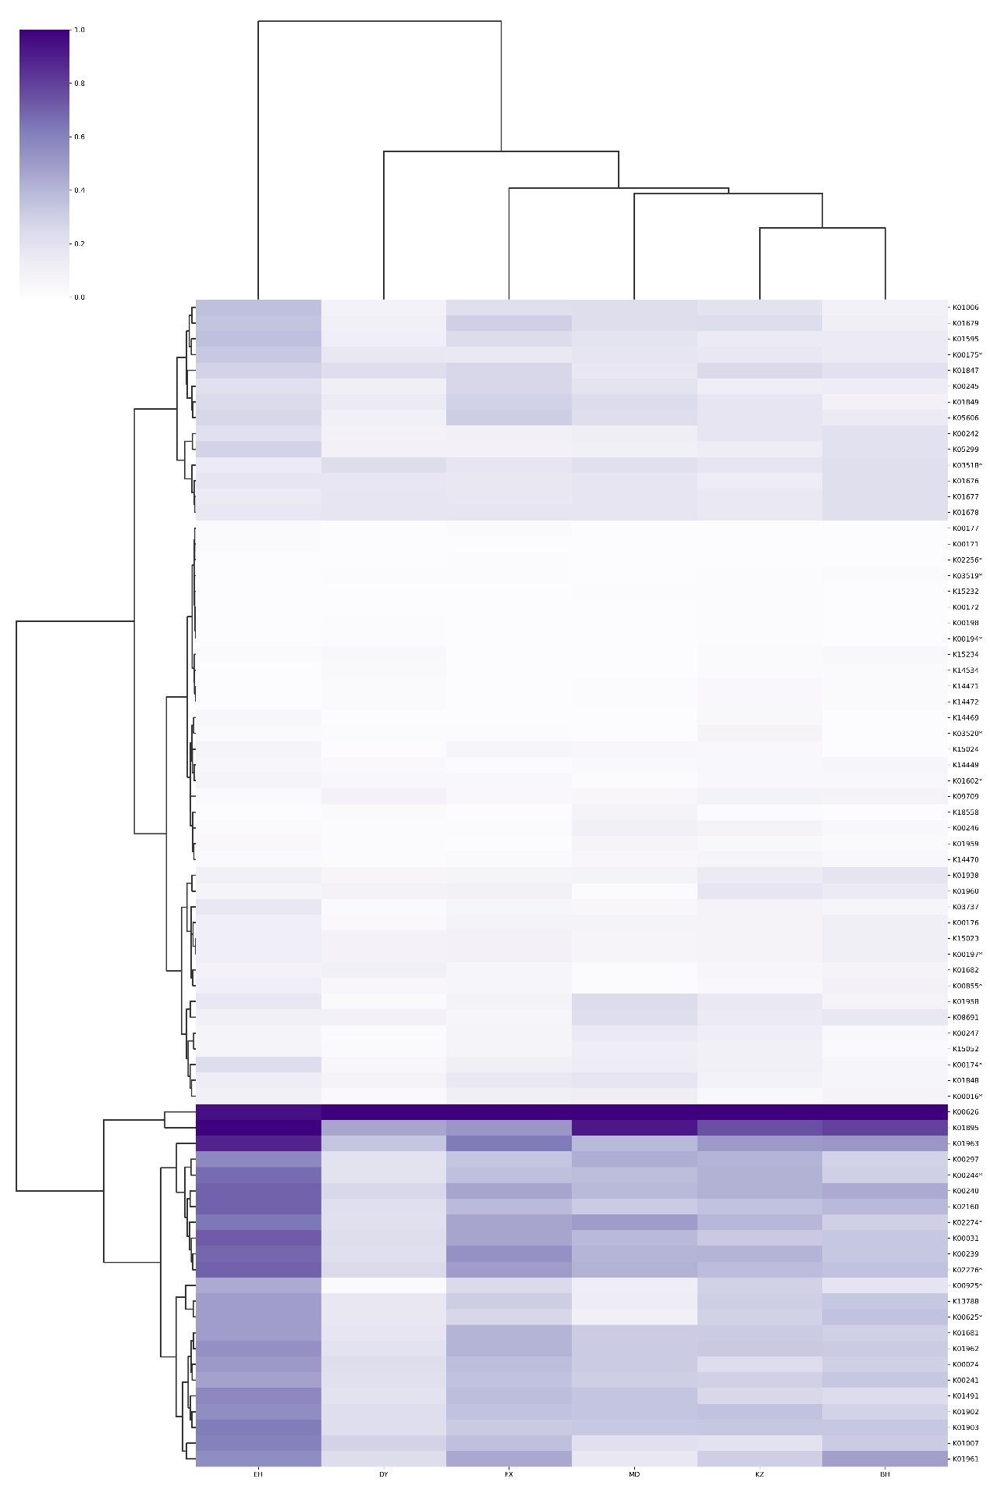

Methane

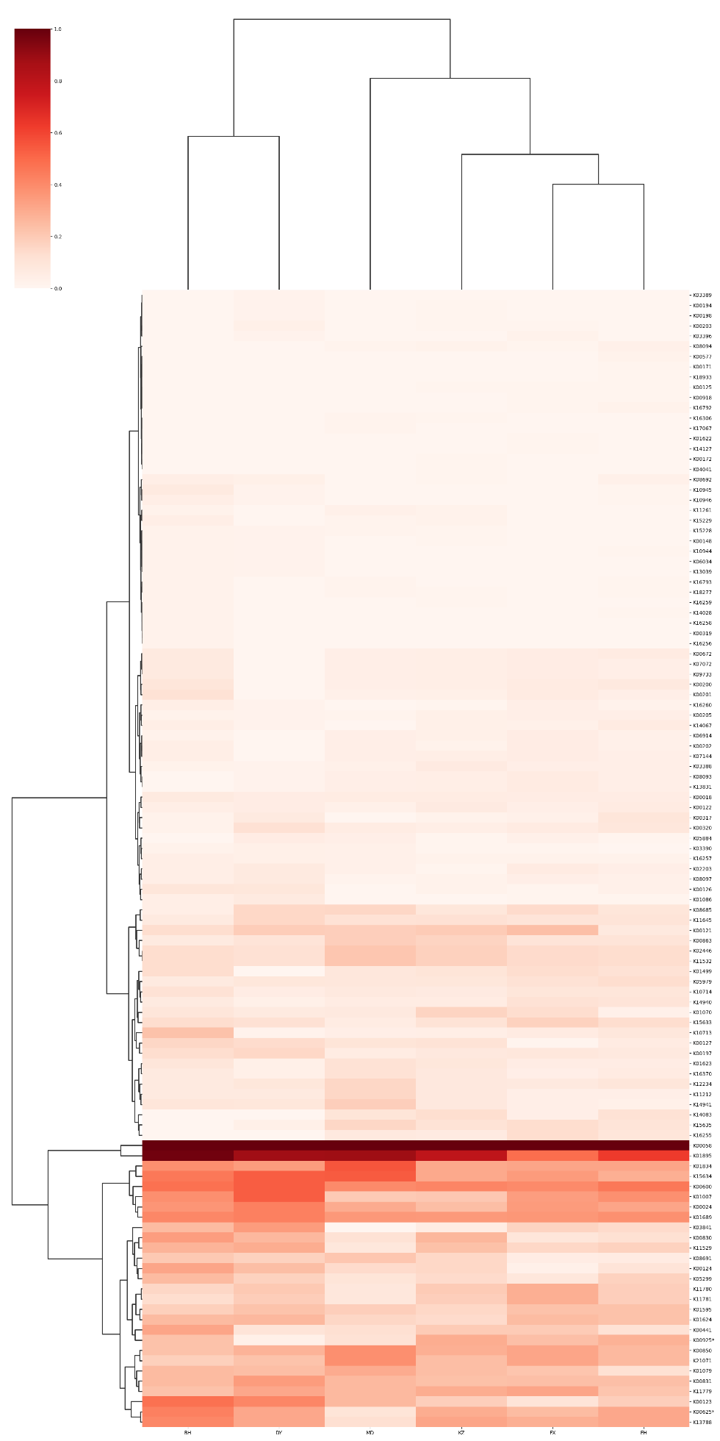

Nitrogen

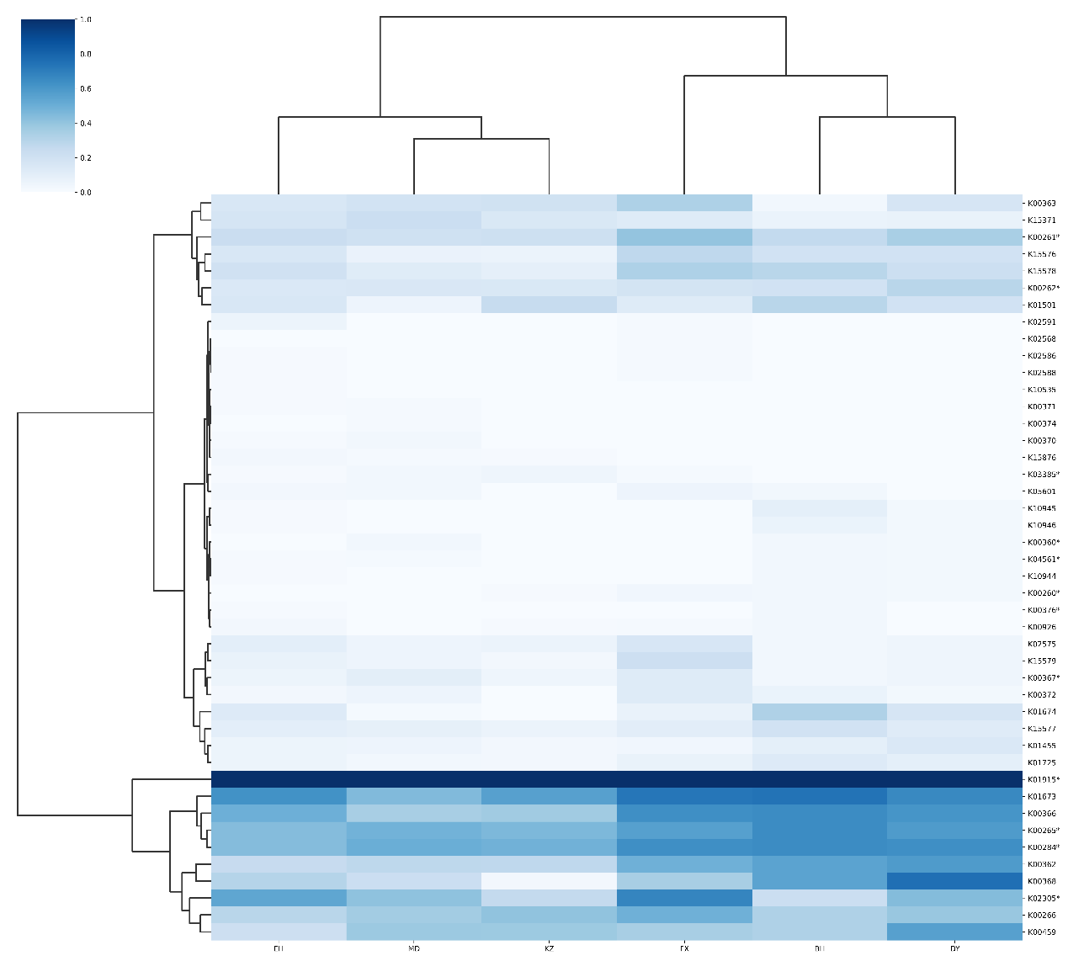

Sulfur

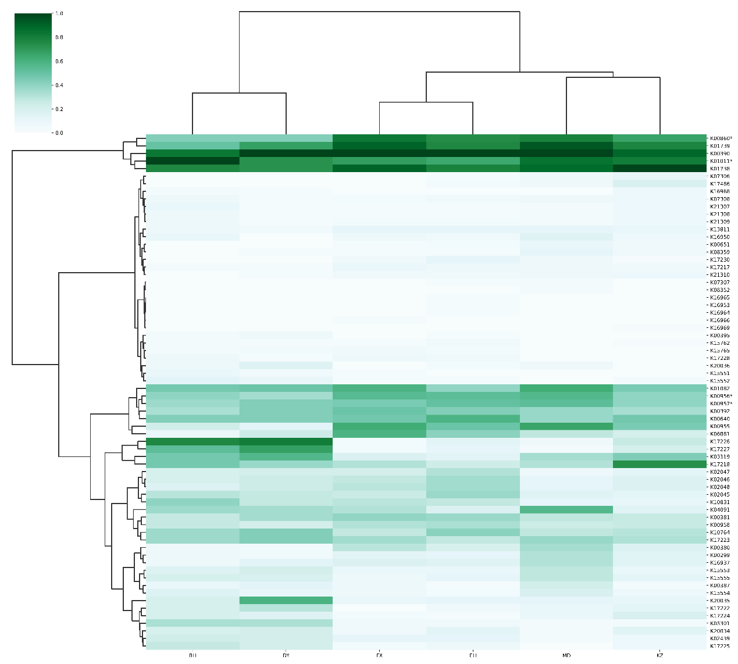

S2 | The four heatmaps represent the distribution of functional K numbers for carbon (purple), methane (red), nitrogen (blue), and sulfur (green) based on the assembled genome.