Supplementary materials
The longitudinal relationship between hearing loss and cognitive decline in tonal language-speaking older adults in China
Xinxing Fu, Robert H. Eikelboom, Bo Liu, Shuo Wang, Dona M.P. Jayakody
Figure S-1.
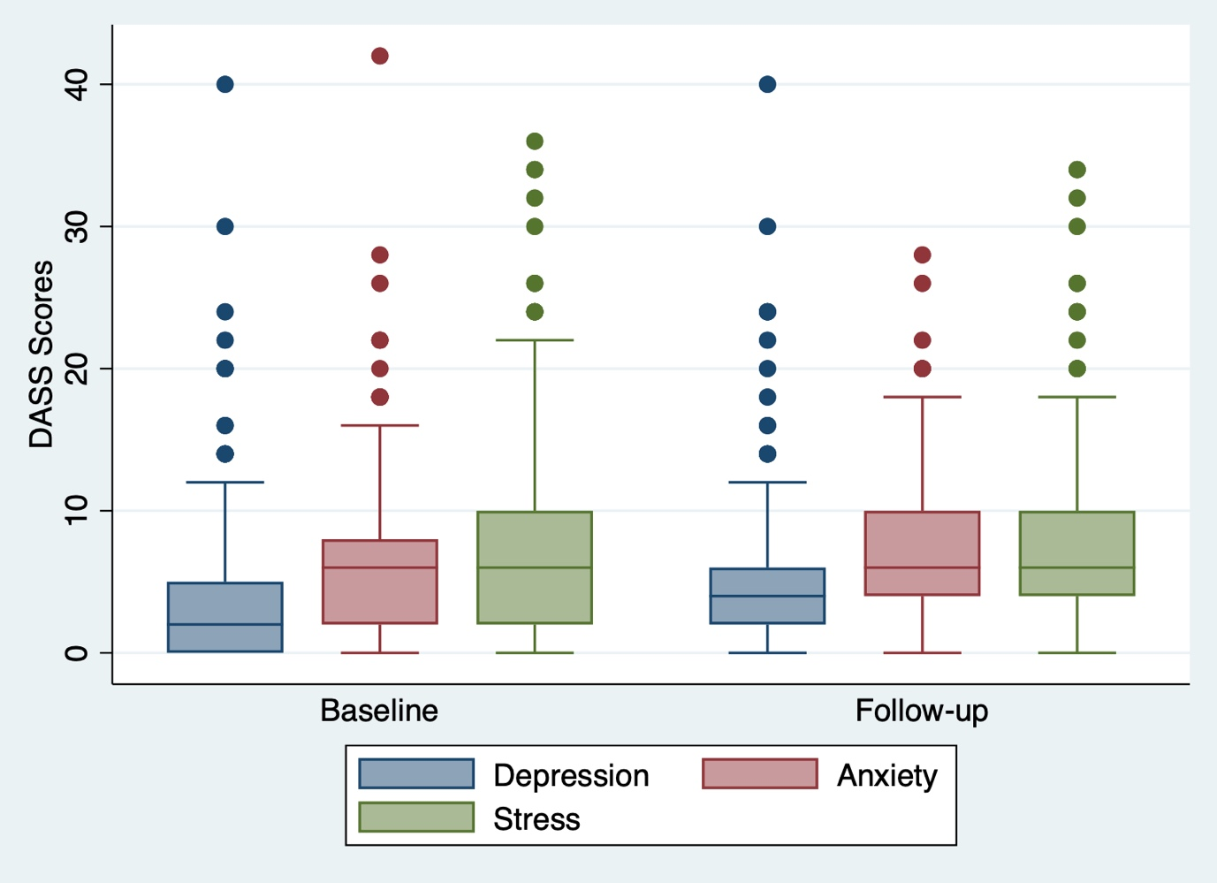
Box and whisker plot of DASS depression, anxiety and stress scores at baseline and follow-up. Any outlier at baseline/follow-up is shown by a dot. DASS: Depression Anxiety Stress Scale.

Figure S-2.
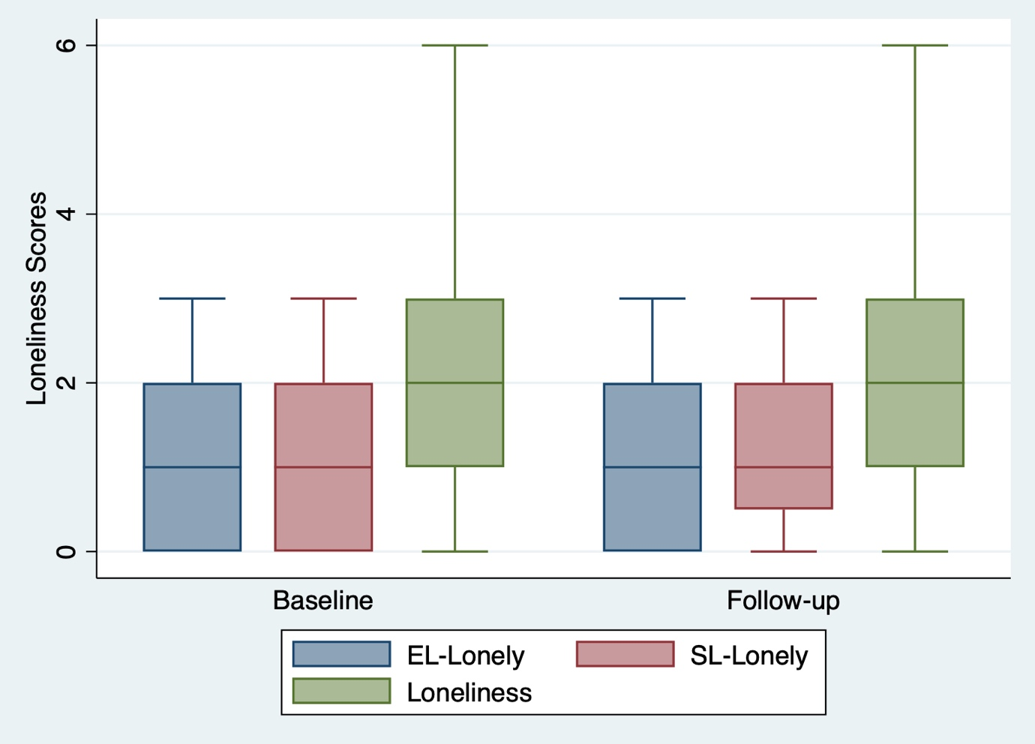
Box and whisker plot of loneliness scores at baseline and follow-up.

