**Supplementary Material for**

**Improved accuracy and spatial resolution for bio-logging-derived chlorophyll a fluorescence measurements in the Southern Ocean**

Loïc Le Ster1,2*, Hervé Claustre1, Francesco d’Ovidio3, David Nerini4, Baptiste Picard2, Christophe Guinet2

1 Sorbonne Université, CNRS, Laboratoire d’Océanographie de Villefranche, LOV, 06230 Villefranche-sur-Mer, France

2 Centre d’Études Biologiques de Chizé, CNRS, 79360Villiers-en-Bois, France

3 Sorbonne Université, Laboratoire d’Océanographie et du Climat, Institut Pierre Simon Laplace (LOCEAN, SU/CNRS/IRD/MNHN), 75252 Paris Cedex 05, France

4 Aix-Marseille Université, CNRS/INSU, Université de Toulon, IRD, Mediterranean Institute of Oceanography, UM 110, 13288 Marseille, France

**\* Correspondence:** loic.lester@imev-mer.fr

**Contents of this file**

Texts S1 to S7

Figures S1 to S9

Tables S1 to S2

**Introduction**

This supporting information:

- Presents the metadata of the tags included in the present study (Table S1);

- Gives the calibration coefficients (unitless) from LFM-based tag inter-calibration for all the tags included in the present study (Table S2);

- Provides graphical support for the processing of the light (Text S1, Figure S1) and Fluo (Text S2, Figure S2) data;

- Provides graphical support for the examination of the consistency of the NPQ correction applied in the present study (Text S3, Figure S3);

- Provides detailed information about the adjustment of the LFM parameters (Text S4), namely the number of basis functions (Figure S4) and the smoothing parameter (Figure S5);

- Describes the bagging procedure performed to test the robustness of the LFM against modifications of the statistical sample used to construct the LFM (Text S5, Figure S6);

- Presents the distribution of the LFM prediction error according to the solar angle (Text S6, Figure S7);

- Provides extended interpretation of the variance spectra through the assessment of the upper limit of the observable wave number domain enabled by the predicted variable <ChlaLFM>(Text S7, Figures S8-S9).

**Table S1. Summary of tag metadata**

|  |  |  |  |  |  |  |  |  |
| --- | --- | --- | --- | --- | --- | --- | --- | --- |
| **Tag Number** | **SMRU Tag Reference** | **Date Start** | **Date End** | **Min Latitude** | **Max Latitude** | **Min Longitude** | **Max Longitude** | **Number of Profiles** |
| 1 | ct152-059-19 | 29-Oct-2019 | 28-Dec-2019 | 51ºS | 47ºS | 63ºE | 72ºE | 3 012 |
| 2 | ct152-060-19 | 26-Oct-2019 | 12-Nov-2019 | 52ºS | 49ºS | 70ºE | 80ºE | 1 266 |
| 3 | ct152-873-BAT-19 | 25-Oct-2019 | 02-Jan-2020 | 58ºS | 49ºS | 70ºE | 97ºE | 4 365 |
| 4 | ct152-876-BAT-19 | 29-Oct-2019 | 05-Jan-2020 | 55ºS | 48ºS | 70ºE | 95ºE | 5 113 |
| 5 | ct152-943-19 | 23-Oct-2019 | 06-Jan-2020 | 54ºS | 48ºS | 70ºE | 89ºE | 5 452 |
| 6 | ct159-873-BAT2-19 | 22-Oct-2020 | 03-Jan-2021 | 54ºS | 45ºS | 70ºE | 90ºE | 5 087 |
| 7 | ct159-881-BAT2-19 | 23-Oct-2020 | 30-Dec-2020 | 57ºS | 49ºS | 70ºE | 93ºE | 4 447 |
| 8 | ct159-943-BAT-19 | 21-Oct-2020 | 06-Jan-2021 | 54ºS | 49ºS | 70ºE | 101ºE | 4 642 |
| 9 | ct159-F905-BAT2-19 | 23-Oct-2020 | 09-Jan-2021 | 62ºS | 48ºS | 70ºE | 95ºE | 5 780 |
| 10 | ft22-686-18 | 21-Oct-2018 | 02-Jan-2019 | 50ºS | 43ºS | 55ºE | 71ºE | 4 501 |
| 11 | ft22-873-18 | 19-Oct-2018 | 08-Jan-2019 | 56ºS | 49ºS | 55ºE | 71ºE | 6 028 |
| 12 | ft22-874-18 | 21-Oct-2018 | 05-Jan-2019 | 57ºS | 49ºS | 35ºE | 71ºE | 6 430 |
| 13 | ft22-875-18 | 21-Oct-2018 | 09-Jan-2019 | 57ºS | 48ºS | 70ºE | 96ºE | 4 999 |
| 14 | ft22-876-18 | 20-Oct-2018 | 08-Jan-2019 | 51ºS | 48ºS | 70ºE | 96ºE | 6 720 |
| 15 | ft22-878-18 | 22-Oct-2018 | 01-Jan-2019 | 53ºS | 46ºS | 70ºE | 87ºE | 4 834 |
| 16 | ft22-879-18 | 21-Oct-2018 | 08-Jan-2019 | 55ºS | 49ºS | 70ºE | 90ºE | 5 554 |
| 17 | ft22-881-18 | 25-Oct-2018 | 06-Jan-2019 | 53ºS | 49ºS | 70 | 97 | 5 473 |
| 18 | ft22-882-18 | 21-Oct-2018 | 31-Dec-2018 | 54ºS | 46ºS | 51 | 71 | 5 494 |

**Table S2.** Calibration coefficients (unitless) from LFM-based tag inter-calibration

|  |  |  |
| --- | --- | --- |
| **Tag Number** | **Median $Γ_{e}^{LFM}$ coefficient (1 000 iterations)** | **Std** |
| 1 | 1.00 | 0.09 |
| 2 | 0.29 | 0.19 |
| 3 | 1.05 | 0.25 |
| 4 | 1.01 | 0.20 |
| 5 | 0.90 | 0.11 |
| 6 | 1.24 | 0.09 |
| 7 | 1.02 | 0.12 |
| 8 | 0.94 | 0.05 |
| 9 | 0.88 | 0.07 |
| 10 | 0.81 | 0.06 |
| 11 | 1.15 | 0.07 |
| 12 | 1.25 | 0.09 |
| 13 | 1.38 | 0.13 |
| 14 | 1.39 | 0.13 |
| 15 | 0.65 | 0.05 |
| 16 | 1.18 | 0.13 |
| 17 | 1.55 | 0.74 |
| 18 | 0.79 | 0.09 |

**Text S1. Processing of the light data**

The following steps describe the processing of the raw light vertical profiles (for graphical support, see Figure S1).

(i) A correction was applied to the light profiles on a per-profile basis according to the method described in Organelli et al. (2016) to deal with deep values of measured radiometric profiles and eliminate sensor noise. The method consists in detecting, for each profile, the depth below which no more information is present in the signal, called “dark depth”. Data below the detected “dark depth” may contain only pure noise and were discarded from the analysis. The median value of L below the dark depth is called “dark value” and characterizes the noise level of the sensor. The offset due to the noise present in the signal (i.e. dark value) was subtracted from the raw signal in order to systematically set to zero the light values corresponding to depths greater than the dark depth (see IOCCG Protocol Series, 2019). The dark value offset for a given sensor may change with time due to sensor drift and because environmental conditions can have an impact on the sensor response (mainly temperature). For the analysis to be robust against such changes, the dark values time series of dark values were computed on a daily basis for each tag by averaging the dark values of the 5 deepest profiles per day. It is important to note that the main variable derived from L in the present study (namely KL) is not sensitive to the offset of the light signal. Absolute light values were only required for the correction of the Fluo profiles (see Section 2.2.3) and were picked up in relatively shallow portions of the profile where the dark value was very small in relation to the light signal itself (<<1%).

(ii) Vertical profiles of light were often subject to sensor saturation in the near-surface. Saturated portions of the light signal (i.e. where $\frac{dL\left(z\right)}{dz}=0$) were discarded.

(iii) To ensure physical and optical consistency of the light data in relation to classic radiometry sensing issues such as the passage of a cloud or a wave focusing at surface (see for example Mueller et al., 2003; Xing et al., 2011; Organelli et al., 2016; IOCCG Protocol Series, 2019), as well as animal head movements, a constrained fit was applied to the light profiles so that L monotonously decreases with depth. The fit was performed on the log-transformed vertical profile of light and defined as a piecewise cubic polynomial (see details in Section 2.3.1).

(iv) KL vertical profiles were computed as the derivative of the fitted (log-transformed) light profiles. Vertical profiles of KL were defined with the same vertical resolution as light profiles (i.e. 1 m).

$K_{L}\left(z\right)=\frac{d}{dz}\left(log\left(L\left(z\right)\right)\right)$ (1)

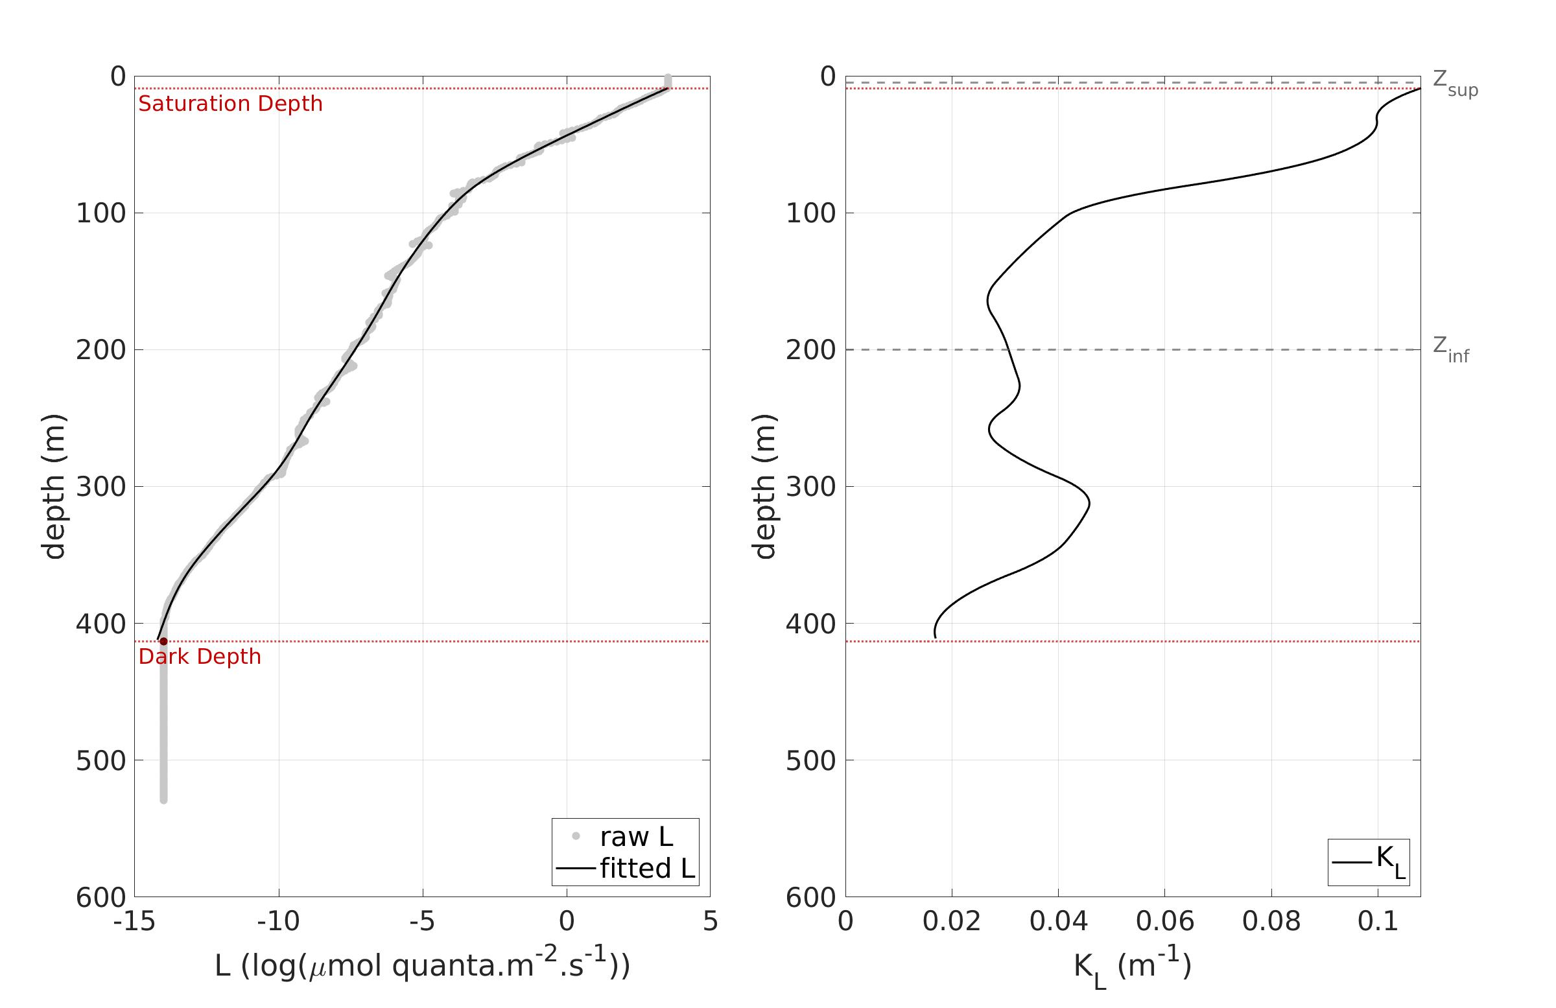

(a)

(b)

**Figure S1.** Example of light (L) and corresponding KL vertical profiles summarizing the processing of the irradiance data. (a) The raw light profile is represented with the gray dots, the black continuous line represents the fit applied to the raw L data, the upper and lower red dotted lines represent the Saturation Depth and the Dark Depth, respectively. The sections of the light profile located above the Saturation Depth or below the Dark Depth were discarded. (b) The corresponding KL profile profile is represented with the continuous black line, the upper and lower gray dashed lines represent the shallower (Zsup) and deeper (Zinf) boundaries of the LFM prediction. Note that the profile of the present figure was only displayed to illustrate the processing of the light data but was not included in the LFM because the Saturation Depth (9 m) was deeper than Zsup = 5 m.

**Text S2.** **. Processing of the Fluo data**

The raw Fluo vertical profiles were processed and quality controlled using the following procedure (for graphical support, see supplementary material, Figure S2):

(i) The raw Fluo was firstly corrected to remove instrumental noise, namely the fluorescence dark signal (darkFluo). A single value of darkFluo was computed for every tag. The procedure described in Schmechtig et al. (2014) (originally designed for BGC-Argo floats) that deals with non-zero values of Fluo observed at depth was applied to SRDL Fluo data. However, because SRDLs do not sample Fluo as deep as BGC-Argo floats do, Schmechtig et al. (2014) was adapted to match SRDL data characteristics. The intensity of the fluorescence dark signal was calculated on a per-profile basis by computing the median value of Fluo between 190 m and 200 m. For a given tag, darkFluo corresponds to the median value of all the successive fluorescence dark signal values computed in the tag’s time series. The fluorescence dark signal was subsequently subtracted from the Fluo signal for the entire tag data set. Given the distribution of Zeu and ZMLD, computing darkFluo between 190 m and 200 m was appropriate and suitable for the studied zone (on average, ZMLD = 78 +- 37 m and Zeu = 84 +- 19 m).

(ii) Vertical profiles of Fluo were corrected for the Non-Photochemical Quenching (NPQ) effect according to the method described in Xing et al. (2018). The method relies on the identification of a so-called “NPQ layer” from the surface to the shallowest value between ZMLD and ZNPQ. ZNPQ corresponds to the depth above which the light signal is greater than a given threshold, fixed at 15 μmol quanta.m-2.s-1. For each profile, the maximum value of Fluo encountered within the “NPQ layer” was thus extrapolated up to the surface.

(iii) The dark- and NPQ-corrected Fluo profiles were fitted to smooth any spikes. The fit is similar to the fit applied to light profiles (i.e. a piecewise cubic polynomial, except that no monotonicity constraint was imposed on the Fluo fit).

(iv) Finally, the smoothed, dark- and NPQ-corrected Fluo data (hereafter denoted [FFluo]) were converted into [Chla]. [ChlaFluo], the actual Chla concentration derived from [FFluo], was obtained by applying a calibration coefficient to the [FFluo] data. A calibration coefficient is by default provided by manufacturer Valeport, based on factory calibration tests performed on samples with known concentrations of [Chla]. However, in the present study, a specific calibration coefficient was computed for each tag, based on both KL and the comparison of *in-situ* data with concomitant satellite-based [Chla] observations (see details in Section 2.3.2).

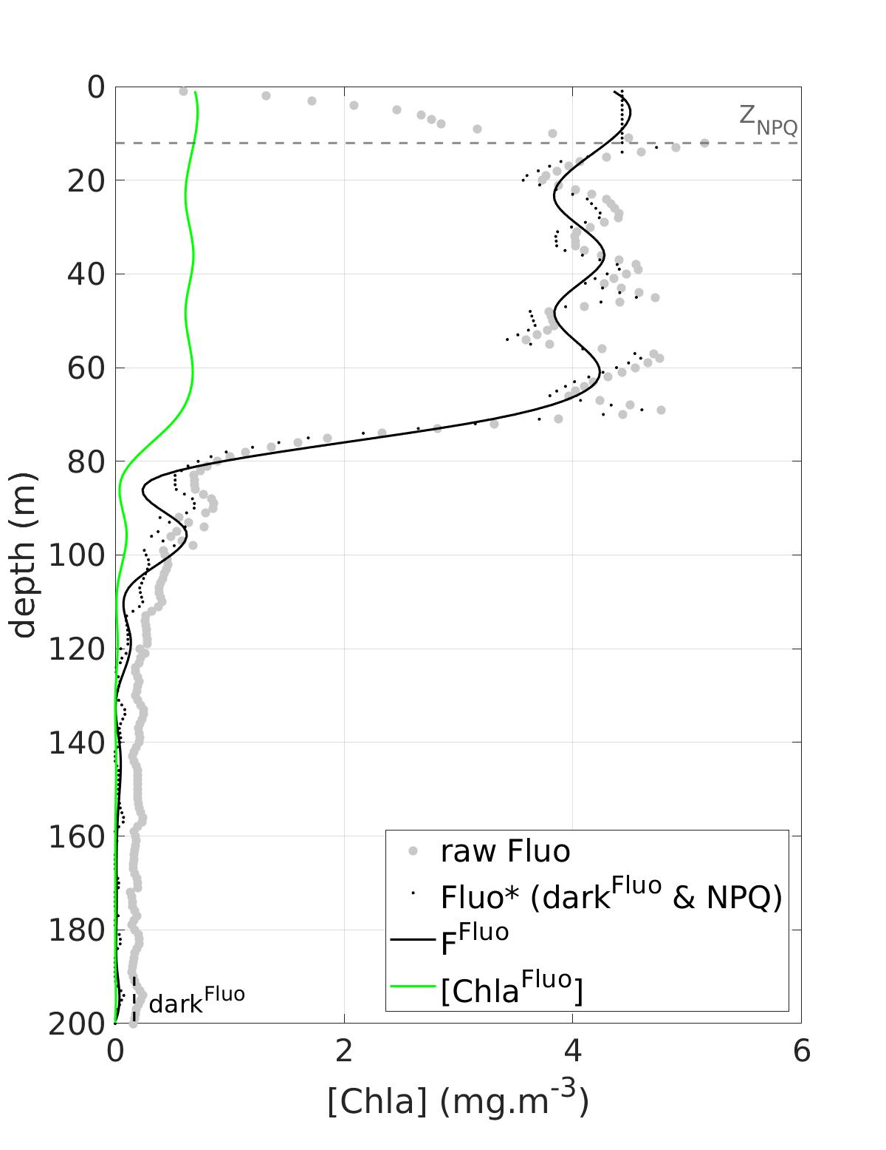

**Figure S2.** Example of Fluo vertical profile summarizing the processing of the Fluo data. The gray dots represent the raw Fluo data (Fluo), the thin black dots represent the Fluo data corrected from the fluorescence dark signal (darkFluo) and from the NPQ (Non-Photochemical Quenching), denoted Fluo*, the continuous black line represents FFluo, and finally, the continuous green line represents the [ChlaFluo] data obtained after calibration. Note that the profile displayed in Figure S2 corresponds to the profile displayed in Figure S1 (i.e. was concomitantly sampled).

**Text S3. NPQ correction**

Vertical profiles of Fluo were corrected for the Non-Photochemical Quenching (NPQ) effect according to the method described in Xing et al. (2018). The method relies on the identification of a so-called “NPQ layer”, which takes into account ZMLD and the depth above which the light signal is greater than a threshold fixed at 15 μmol quanta.m-2.s-1 (see Text S2 and Figure S2). Xing et al. (2018) use the downwelling irradiance to determine the light threshold. Given that the light sensor of the SRDL does not strictly measure the downwelling irradiance but a diffused light level in the animal’s environment, the threshold value of 15 μmol quanta.m-2.s-1 used in the present study for the quenching correction needs to be verified. For this purpose, we compared the values of <ChlaFluo> between day and night profiles to assess the consistency of the NPQ correction. The distribution of the values differ very few between day and night, which reinforces the validity of the quenching correction applied to the Fluo profiles in the present study.

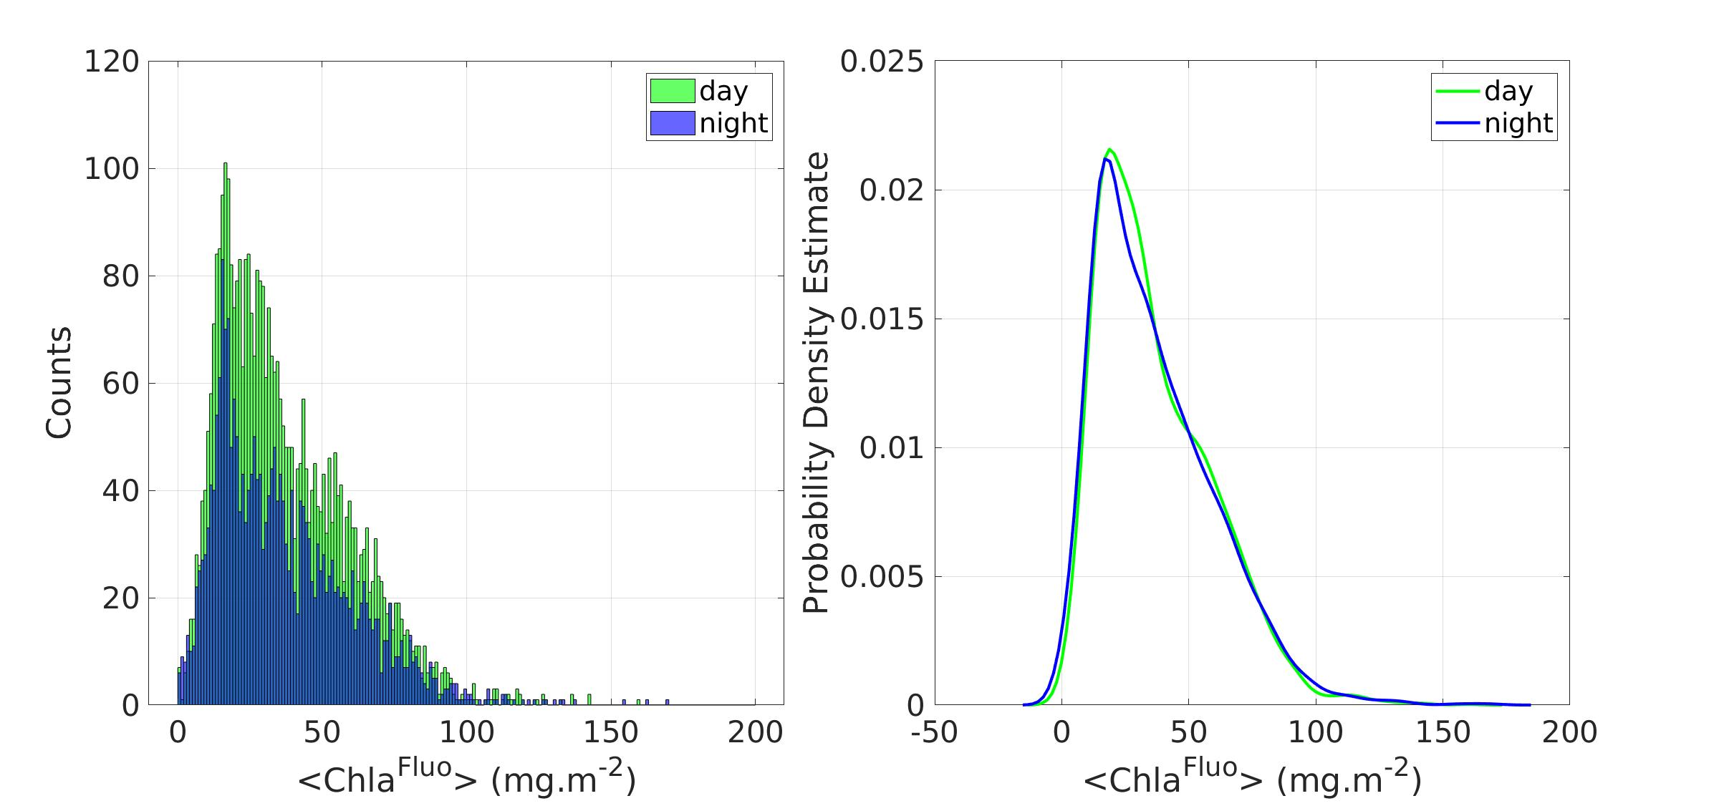

(a)

(b)

**Figure S3.** Comparison of water-column integrated values of [ChlaFluo] between day and night. The histogram of the values of <ChlaFluo> are shown in (a) and the estimates of the probability density function are shown in (b). In both panels, green color refers to day profiles and blue color refers to night profiles.

**Text S4. Number of basis functions and Smoothing parameter**

To develop the LFM, the handled variables (i.e. vertical profiles of KL and [Chla]Fluo) are converted into functional objects. In a functional space, vertical profiles are not classically defined as vectors expressed along a geo-referenced vertical axis (of *j* discrete depth values), but instead, they are expressed as a linear combination of *m* basis functions (*m* < *j*). The basis functions are the same for all profiles, meaning that the functional basis is unique for all the profiles. The *m* (*m* = 30 in our study) basis functions define the reference frame of the study. The *m* profiles’ coefficients can be considered as their coordinates in that frame.

The basis functions in the present study are B-spline functions. B-spline functions are piecewise polynomials of degree *n* (in the present study, *n* = 3) with continuity and derivability constraints on some well-suited depths called knots. We chose a uniform distribution of the fit knots along the vertical. The regularity of the B-spline fit is ensured by a smoothing parameter (λ) that enables dampening high local variations in the vertical dimension.

The fit performed on the raw vertical profiles of L and Fluo (see Sections 2.2.1 and 2.2.3) therefore has two functions: (1) smoothing the data with, eventually, some constraints applied to the fitted data (e.g. monotonicity for L) and (2) converting the vertical profiles into functional objects, i.e. expression of each vertical profile as a linear combination of the *m* B-spline basis functions.

Once placed in a functional workspace, many classic statistical tools can be adapted to functional data (see Ramsay and Silverman, 1997). In the present study, the core operator of the LFM is obtained after computing a Functional Principal Component Analysis (FPCA) based on the *m* coefficients (i.e. coordinates in the functional space) of the predictor and the predicted variables.

From the FPCA, a linear functional relationship is derived between the functional objects associated with the vertical profiles of KL (the derivative of the log-transformed light profile, also expressed as a functional object) and [Chla]Fluo.

The (invertible) linear functional relationship on which the LFM relies is subsequently used as an inference tool to predict [Chla]Fluo from KL.

Converting vertical profiles into functional objects using a B-spline basis is achieved when fitting the data with piecewise polynomials of degree *n* (in the present study, *n* = 3), with specific constraints imposed to the fit (Meyer 2012), such as the smoothness of the curve or monotonicity.

The smoothing parameter (λ) enables to constrain the distance between raw data and the functional fit. Although the LFM models used in the present study were developed following precisely the same method as described in Bayle et al. 2015, the vertical profiles processed in the present study have a much higher vertical resolution (1 m resolution in the present study versus 10 m in Bayle et al. 2015). The number *m* of B-spline basis functions had consequently to be re-adjusted, as well as the smoothing parameter λ. The optimization of *m* and λ is addressed in this section.

The optimum number of basis functions was *m* = 30 and the optimum value for the smoothing parameter was λ = 0.03. The knots of the fit were uniformly distributed along the vertical.

The prediction error was defined as the difference between [ChlaLFM] and [ChlaFluo].

Subsequently, the root-mean-square error of the LFM (RMSELFM) was defined based on the prediction performed on the independent validation sample (see Sections 2.4 and 2.5) by positively summing the prediction error at every point (i.e. every depth of every profile of the validation sample) and then dividing by the number of profiles included in the prediction exercise. RMSELFM (expressed in mg.m-2) is positive and characterizes the distance between the prediction [ChlaLFM] and the targeted [ChlaFluo]. RMSELFM is explicitly defined as follows:

${RMSE}^{LFM}=\frac{1}{n_{val}}\sum_{i=1}^{n_{test}}{\int_{z=Z_{inf}}^{z=0}{\sqrt{{\left({\left[{Chla}^{LFM}\right]}^{\left(i\right)}\left(z\right)−{\left[{Chla}^{Fluo}\right]}^{\left(i\right)}\left(z\right)\right)}^{2}}}}dz$ (S2)

Where $V^{\left(i\right)}$ is the *i*th profile of variable *V* in the validation sample, nval is the number of validation profiles (nval = 417) and z is the depth of the measurement (Zinf < z < 0 m).

Similarly, we define RMSEFluo, the root-mean-square error of the fit applied to the Fluo data (see Section 2.2.3) by positively summing the difference between the raw Fluo* data (the dark- and NPQ-corrected Fluo data, see Figure S2) and FFluo, the functional fit of Fluo*, at every point (i.e. every depth of every profile of the validation sample) and then dividing by the number of profiles included in the prediction exercise. RMSEFluo (expressed in mg.m-2) is positive and characterizes the distance between the smoothed Fluo* data and the raw Fluo data. RMSEFluo is explicitly defined as follows:

${RMSE}^{Fluo}=\frac{1}{n_{test}}\sum_{i=1}^{n_{test}}{\int_{z=Z_{inf}}^{z=0}{\sqrt{{\left({FChla}^{Fluo\left(i\right)}\left(z\right)−Fluo{\text{*}}^{\left(i\right)}\left(z\right)\right)}^{2}}}}dz$ (S3)

The number *m* of basis functions was adjusted by testing equally spaced values of *m* ranging from 5 to 50 and computing RMSELFM for each resulting model, based on the prediction performed on the independent validation sample. The effect of the number *m* of basis functions on RMSELFM is displayed in Figure S4. The lowest RMSELFM value corresponds to *m* = 5. However the associated value of RMSEFluo is at its highest. This means that when the number of basis functions is reduced (*m* = 5-6), although [ChlaLFM] appears to be quite close to [ChlaFluo], the Fluo fit (FFluo) is coarse and far away from the Fluo* data. It is hence preferable to consider higher values of *m* so that the Fluo* is not too degraded when computing FFluo. For *m* > 12, RMSELFM decreases continuously as *m* increases, however it appears clearly that the gain becomes negligible for *m >* 30. One idea beneath the model is to reduce as much as possible the dimension of the problem, hence the number *m* of parameters necessary to express the handled objects, while minimizing the prediction error.

As a result, a functional space defined with *m* = 30 basis functions was found to be the best compromise to jointly minimize RMSEFluo, RMSELFM and model complexity.

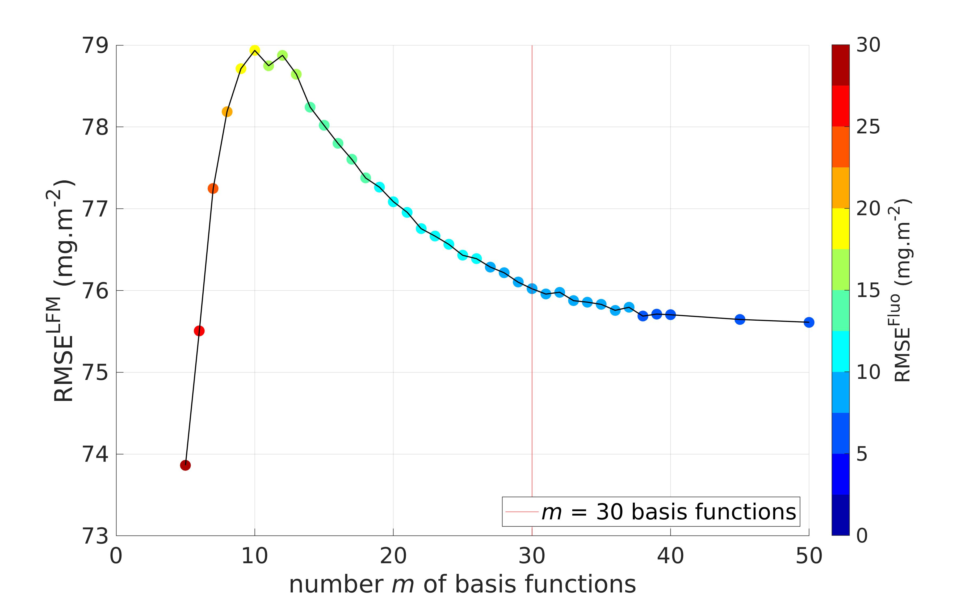

**Figure S4.** Root-mean-square error of the LFM (RMSELFM) according to number *m* of basis functions. The continuous red vertical line represents the number of basis functions selected for the model (*m* = 30). The color of the points refer to the value of RMSEFluo.

The smoothing parameter λ was adjusted by testing values of λ equally spaced on a logarithmic scale from 10-4 to 101.5 (i.e. approximately from 0.0001 to 30). The testing of λ was performed with a fixed number of basis functions *m* = 30, as previously adjusted. A high smoothing parameter means that the fit will be highly constrained and thus local variations of the raw data will be highly smoothed. While the RMSE seems to be quite constant for low values of λ, it increases rapidly for λ > 1, after reaching an optimum around 0.03 (Figure S5). For this reason, we chose λ = 0.03.

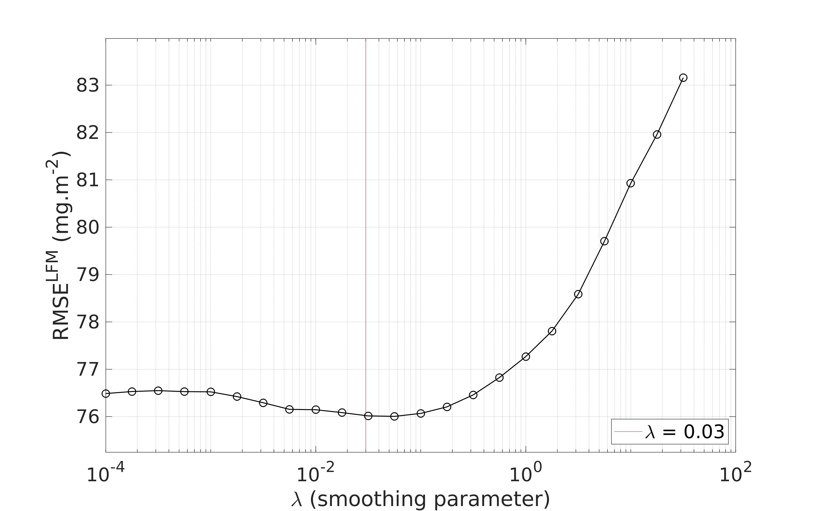

**Figure S5.** Root-mean-square error of the LFM (RMSELFM) according to smoothing parameter λ. The continuous red vertical line represents the value selected for the model (λ = 0.03).

**Text S5. Bagging procedure**

To test the robustness of the model against modifications of the statistical sample used to construct the LFM, a bagging (bootstrap aggregating) validation procedure was carried out. In addition to testing the sensibility of the model to slight changes in the composition of the statistical sample of concomitant [ChlaFluo] and KL profiles , the bagging procedure, by averaging numerous versions of a given model, can potentially bring a substantial gain in accuracy to the bagged model (Breiman 1996, Nerini and Ghattas 2007). The bagging procedure consists in conducting a series of *N* iterations, where at each step a new statistical sample is created from the existing one by randomly sampling the set of available concomitant [ChlaFluo] and KL profiles (1 387 profiles, see Table 2). The modification of the statistical sample used to construct the LFM creates a new version of the LFM. The sampling is performed with replacement so that (i) the sample has always the same number of profiles but (ii) the set of selected profiles slightly differs from one iteration to the next. At step *j* (1 $⩽$*j $⩽$* *N*), the procedure is repeated *j* times so that *j* versions of the LFM are produced, each one corresponding to a different sample. A unique model LFM(j) is computed as the average of the *j* versions of the LFM created at step *j*. At each iteration of the bagging procedure, model LFM(j) was applied to the validation sample and RMSELFM(j) was computed. The same dataset split as previously used was kept for the bagging (70% for the construction of the model / 30% for validation). *N* = 500 iterations of this procedure were carried out.

The dependency of the LFM relatively to the composition of the statistical sample used to construct the model (970 profiles) was examined through the RMSELFM resulting from the bagging procedure. The values of RMSELFM(j) computed at each iteration of the bagging procedure (*N* = 500 iterations in total) were reported in Figure S6. The convergence of the model in terms of prediction error primarily testifies to the robustness of the aggregated model against the presence of potential outlier profiles in the statistical sample (assuming that the sample is large enough). But mostly, the gain in accuracy enabled by the bagging procedure of less than 2% after 500 iterations points out the initial stability inherent to the LFM method developed in this study.

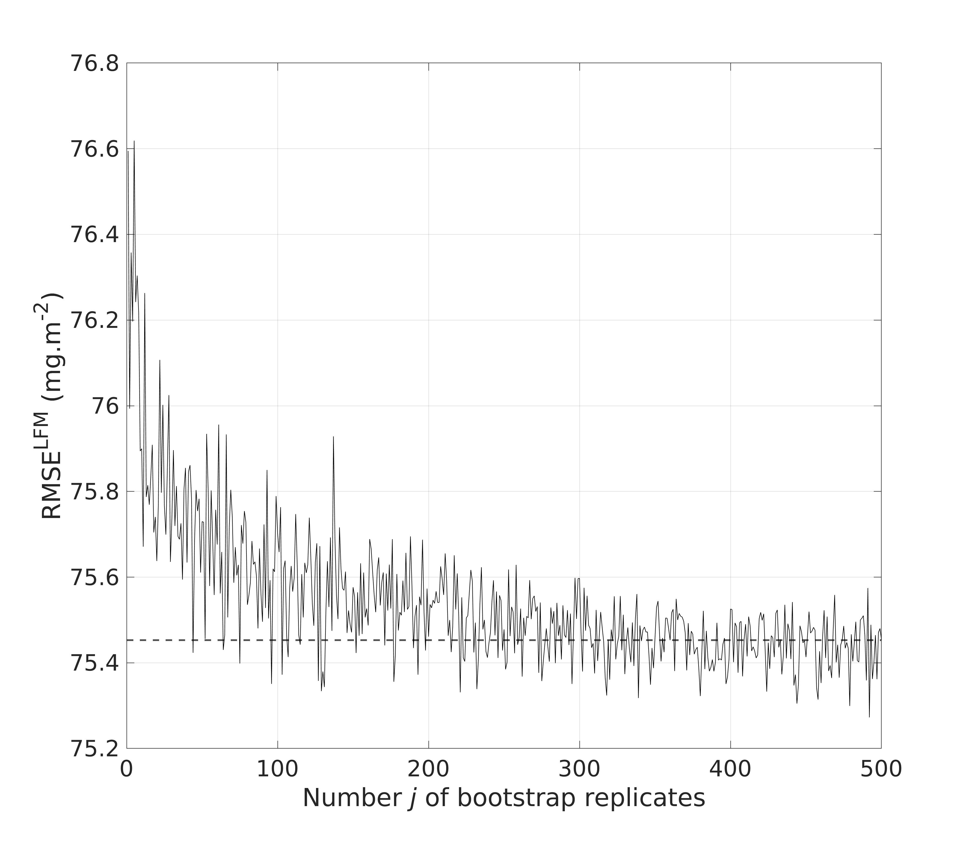

**Figure S6.** RMSELFM of the bagged predictions based on the bootstrap replicates of the statistical sample of 970 (70%) concomitant [ChlaFluo] and KL profiles, with *N* = 500 iterations. The dashed line represents the convergence value of RMSELFM, computed as the median value of RMSELFM(j) between the 300th and 500th iterations.

**Text S6. Distribution of the prediction error according to the solar angle**

The prediction error, computed as the difference (positive of negative) between <ChlaLFM> and <ChlaFluo>, was computed on the sample used to assess the LFM performance (validation sample, nval = 417 profiles, see Section 2.3.3). The distribution of the prediction error was examined in Figure S7. The solar angle intervals were 0º to 15º, 15º to 30º, 30º to 45º, and higher than 45º. The prediction error presented a similar distribution for all positive values of the solar angle (note that no predictions were computed for negative solar angles, i.e. at night, see Section 2.2.1). The significance of the difference between the distributions of the prediction error for different intervals of solar angle was tested. The four distributions corresponding to the four solar angle intervals were not significantly different from one another (Mann-Whitney-Wilcoxon test, lowest p-value of 0.13).

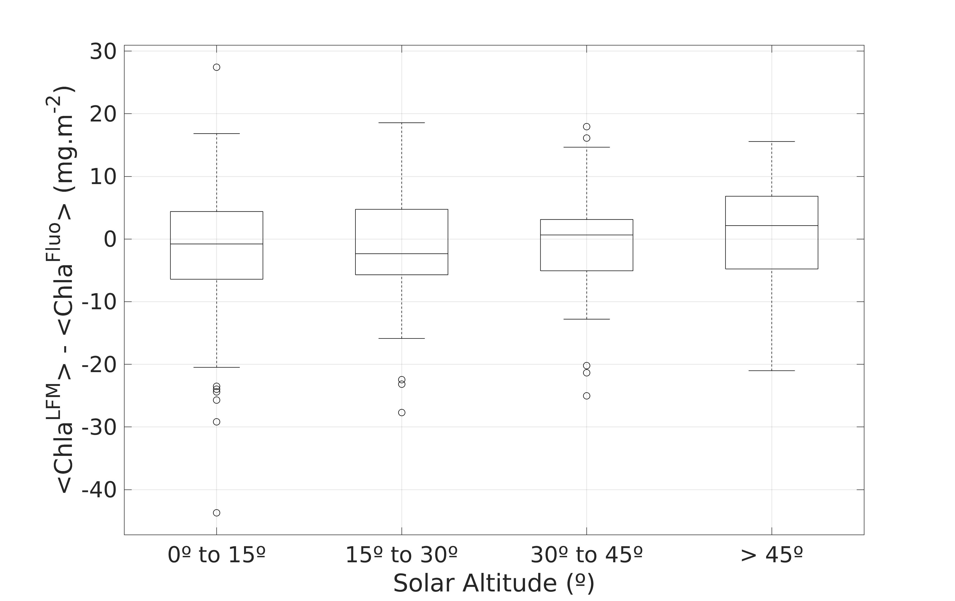

**Figure S7.** Distribution of the prediction error for each (positive) solar angle intervals (0º to 15º, 15º to 30º, 30º to 45º and higher than 45º). For each box (i.e. each solar angle interval) the upper and lower limits of the box represent the 25th and 75th percentiles, respectively, the central line in the box represents the median value, the whiskers extend from the minimum to the minimum values of the data (excluding outliers) and the black circles represent the outliers.

**Text S7. Assessing the upper limit of the observable wave number domain**

In the present study, the variance spectra of <ChlaFluo> and <ChlaLFM> were computed for each tag and compared. Prior to the calculation of the Fourier transform, a symmetric Hamming window was applied to the analyzed signals. A pronounced drop in the energy of the <ChlaLFM> signal was observed for each tag at a different spatial scale (see Section 3.4.2), marking a threshold above which the spectrum was much noisier and lost the clear power-law behavior described for larger spatial scales (see Section 4.3.4). It is consequently reasonable to consider that the interpretations of the structures depicted by the <ChlaLFM> signal are valid up to the scale of the energy-drop threshold and should be discarded for higher wave numbers.

The spatial scale corresponding to the energy-drop threshold (fE-drop) was computed for each tag. For this purpose, the variance spectrum of <ChlaLFM> was smoothed using B-splines functions. More precisely, the smoothed variance spectrum was computed independently for each tag and was defined as a piecewise cubic polynomial. The smoothed variance spectrum of <ChlaLFM> is hence derivable and fE-drop corresponds to the minimum of its derivative (i.e. the wave number for which the variance spectrum is the steepest). An example with Tag 11 is shown in Figure 8. The consistency of the obtained value of fE-drop was visually checked for the 18 tags.

In order to characterize the spatial frequency of the light sampling of each tag, fmean was defined as the inverse of the mean distance between two consecutive light profiles and was computed for each equipped SES.

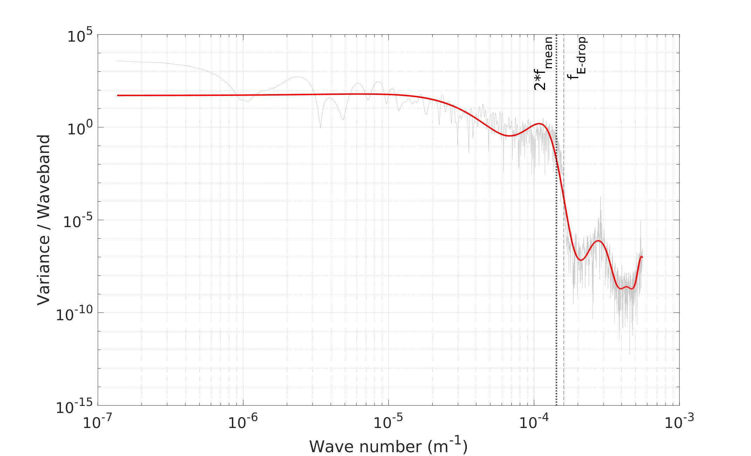

**Figure S8.** Computation of fE-drop and comparison with fmean through the example of Tag 11. The continuous gray (red) line represents the (smoothed) variance spectrum of <ChlaLFM>. The black dashed vertical line represents fE-drop and the black dotted vertical line represents twice fmean. In the present example, fE-drop = 1.6 10-4 m-1, which corresponds to a spatial scale of ~6.2 km and 2*fmean = 1.4 10-4 m-1, which corresponds to a spatial scale of ~7.0 km.

As exemplified in Figure S8 for Tag 11, fE-drop was subsequently compared to fmean for all the tags (Figure S9). The spatial scale of the <ChlaLFM> signal energy drop appeared to be closely linked to the spatial frequency of the light sampling of each tag (i.e. the mean distance between two consecutive valid vertical profiles of light) and corresponds to twice the mean spatial frequency of the SRDL light measurements that were included in the model (see Figure S9, slope = 1.07, R2 = 0.99). This result is to be linked with the Nyquist-Shannon theorem, that relates the sampling frequency of a signal with the maximum observable frequency in the sampled signal (Nyquist, 1928; Shannon, 1949; Jerri, 1977). The Nyquist-Shannon theorem states that for the reconstruction of a periodic signal with no loss, the sampling frequency must be at least twice the maximum frequency of the signal to be reconstructed. Here, the signal to be reconstructed is the <Chla> field along the trajectory of the animal and <ChlaLFM>, based on the vertical profiles of light sampled during the trip of the animal, is equivalent to a spatial subsampling of the <Chla> field. Interpreting reversely the Nyquist-Shannon theorem leads to the conclusion that it may be reasonable to give a much lower confidence level to the method when trying to detect structures in the <ChlaLFM> signal at a scale smaller than twice the mean spatial frequency of the SRDL light measurements (< ~7 km in the case of Tag 11).

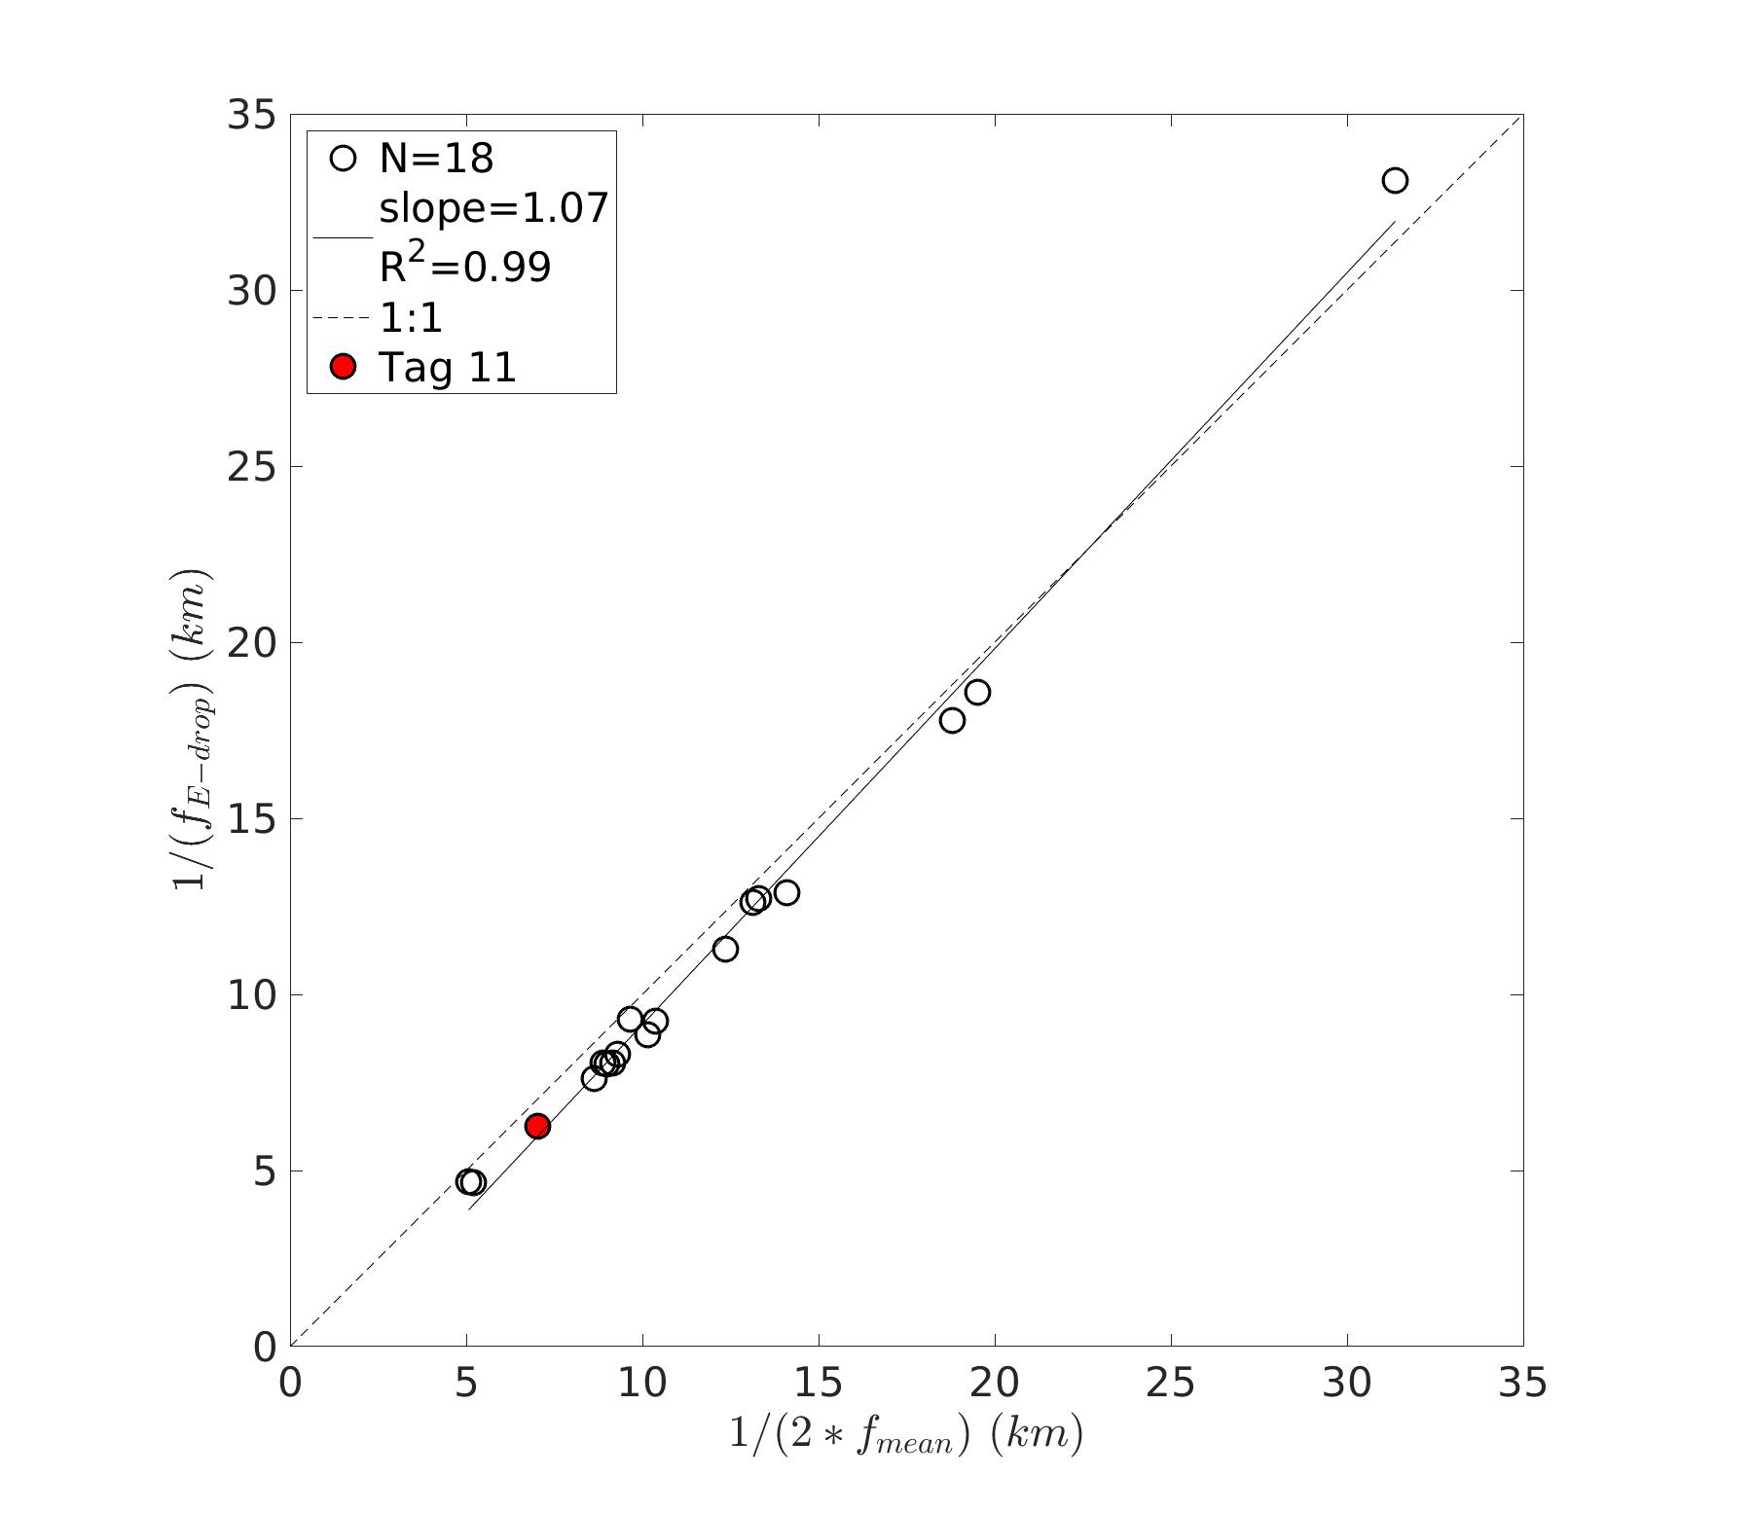

**Figure S9.**Energy-drop threshold (fE-drop) versus mean distance between two consecutive valid light profiles (fmean). The black circles represent the data from the 18 tags included in the present study, the continuous black line materializes the linear regression of all the sample points (slope = 1.07; R2 = 0.99; N = 18 points) and the black dashed line represents the 1:1 reference line. The red point represents the data from Tag 11, highlighted in Figure S8.

The threshold materializing the validity domain of the predictions directly depends on the inherent properties of the corresponding transect. Indeed, independently of the bio-physical processes occurring along the transect of the tag, the spatial scale of the energy drop is inherent to the spatial resolution of the measurements performed by the tag, which directly depends on the horizontal speed of the SES and also quite frequently, on the quality and validity of the measurements (e.g. the saturation issue clearly lowers the spatial resolution achieved by the light measurements). The mean distance between two valid consecutive Fluo profiles is 14.9 km +- 4.1 and this distance is reduced to 5.9 km +- 3.1 for light profiles. As a result, while on average the SRDL Fluo measurements enable observation of phytoplankton dynamics at spatial scales up to ~30 km, LFM predictions extend the spatial scale of the observations up to ~12 km. In the present study, the gain enabled by the use of <ChlaLFM> as a proxy for <ChlaFluo> is on average a factor 2.8 +- 0.9 towards finer observation scales.

**Supporting references**

Nyquist, H. (1928). Certain Topics in Telegraph Transmission Theory. *Trans. Am. Inst. Electr. Eng.* 47, 617–644. doi: [10.1109/T-AIEE.1928.5055024](https://doi.org/10.1109/T-AIEE.1928.5055024).

Shannon, C. E. (1949). Communication in the Presence of Noise. *Proc. IRE* 37, 10–21. doi: [10.1109/JRPROC.1949.232969](https://doi.org/10.1109/JRPROC.1949.232969).

Jerri, A. J. (1977). The Shannon sampling theorem - Its various extensions and applications: A tutorial review. *Proc. IEEE* 65, 1565–1596. doi: [10.1109/PROC.1977.10771](https://doi.org/10.1109/PROC.1977.10771).

Meyer, M. C. (2012). Constrained penalized splines. *Can J Statistics* 40, 190–206. doi: [10.1002/cjs.10137](https://doi.org/10.1002/cjs.10137).

Nerini, D., and Ghattas, B. (2007). Classifying densities using functional regression trees: Applications in oceanology. *Computational Statistics & Data Analysis* 51, 4984–4993. doi: [10.1016/j.csda.2006.09.028](https://doi.org/10.1016/j.csda.2006.09.028).

Breiman, L. (1996). Bagging predictors. *Mach Learn* 24, 123–140. doi: [10.1007/BF00058655](https://doi.org/10.1007/BF00058655).

IOCCG Protocol Series (2019). Protocols for Satellite Ocean Colour Data Validation: In Situ Optical Radiometry. Zibordi, G., Voss, K. J., Johnson, B. C. and Mueller, J. L. IOCCG Ocean Optics and Biogeochemistry Protocols for Satellite Ocean Colour Sensor Validation, Volume 3.0, IOCCG, Dartmouth, NS, Canada. http://dx.doi.org/10.25607/OBP-691.

Mueller, J. L., Morel, A., Frouin, R., Davis, C., Arnone, R., Carder, K., et al. (2003). Ocean Optics Protocols For Satellite Ocean Color Sensor Validation, Revision 4.Ocean Optics Protocols For Satellite Ocean Color Sensor Validation, Revision 4. Volume III: Radiometric Measurements and Data Analysis Protocols. doi: 10.25607/OBP-62.

Schmechtig, C., Claustre, H., Poteau, A., and D’Ortenzio, F. (2014). Bio-Argo quality control manual for Chlorophyll-A concentration. Version 1.0, December 17th 2014. doi: [10.25607/OBP-38](https://doi.org/10.25607/OBP-38).

Xing, X., Briggs, N., Boss, E., and Claustre, H. (2018). Improved correction for non-photochemical quenching of in situ chlorophyll fluorescence based on a synchronous irradiance profile. Opt. Express 26, 24734. doi: 10.1364/OE.26.024734.