Supplementary information

Additional file 1: Table S1 Primers used in this study
Additional file 2: Table S2 The data of transcriptome in Osv-ATPase d knocking-out line 5 and NIP rice
Additional file 3: Figure S1 Gene Ontology (GO) analysis of the upregulated differentially expressed genes
Additional file 4: Figure S2 Gene Ontology (GO) analysis of the downregulated differentially expressed genes
Additional file 1. Table S1 Primers used in this study

Table S1 Primers used in this study
Primer name | Sequence
For vector construction
Crispr/Osv-ATPase d/1F | AGATGATCCGTGGCAGACCCAGTCCTTCCCATCGTGCGGGGGAACCGGTCGG
Crispr/Osv-ATPase d/1R | GCATAGCTCTAAAACTTGGGGAAGGACCCGACCGGTTCCCCCGCACGATG
Crispr/Osv-ATPase d/2F | AGATGATCCGTGGCAGACCCAGTCCTTCCCCCAGTGCGAGAACCTCGACGACG
Crispr/Osv-ATPase d/2R | GCATAGCTCTAAAACTTGGGGAAGGACTGGGCGTCGTCGAGGTTCTCGCACTGG
For verification of Crispr mutants
Osv-ATPase d/F | ATGTACGGGTGGGAGATGCT
Osv-ATPase d/R | GTTCTGGAGGTAGGGGCC
For cas9 detection
35S-F1 | CAAGACCCTTCCTCTATATAAGGA
zCas9-951R | GAGGTTATCCAGGTCATCG
For RT-qPCR
qUbiquitin/F | GCTCCGTGGCGGTATCAT
qUbiquitin/R | CGGCAGTTGACAGCCCTAG
SRBSDV/qCP/F | CGCGTCATCTCAAAACTACAG
SRBSDV/qCP/R | TTTGTCAGCATCTAAAGCGC
RSV/qCP/F | AGTGCTGATCGTATTGACAGA
RSV/qCP/R | GATGAAGTACACAACTGGTC
qOsLBD12/F | G GTAATCGTTG ATGGCCAAAT C
qOsLBD12/R | GATTGATTTTCATAGACGGTGC
qOsATL79/F | GTTGGGACAG CGATGATCAG GT
qOsATL79/R | TAAGGATTACTCCATTGTCCTG
qOsGSTT3/F | GGCAGCCATGGAGCACAAGGAG
qOsGSTT3/R | ATACTCTTCAATGCCATCAC
qOsMYB5/F | AGCTCAACCAGCGCTTCTAC
qOsMYB5/R | CCTTCTTGAGCGACTCCATC
qOsAOX1B/F | GAATCGGCGAACTTTACAGC CG
qOsAOX1B/R | TGGGCCCGGAGATCACTGTTCCG
qOsRGA5/F | GGAAGATCGA AATCGATGTG TCCG
qOsRGA5/R | ATATTAGGATTCTGACCGACCGG
qOsNCED4/F | ACATCCGAGCTCCTCGTCGTGAA
qOsNCED4/R | TTGGAAGGTGTTTTGGAATGAACCA
qOsCHX15/F | CCCTTCCACAAGTCGTCGGACG
qOsCHX15/R | AAGTACAACGCCACCCGCTGCA
qOsCKX1/F | GG TTGGCCGGCG ACGTCTTTGA
qOsCKX1/R | CCTTGGAGCACGTCACCGTCTC
qOsWRKY27/F | TCCGAAGCAA CAGGAGGTGC TT
qOsWRKY27/R | CGGTCATCAGCCAGCGAGCGAA
Additional file 2: Tables S2 The data of transcriptome in Osv-ATPase d knocking-out line 5 and NIP rice

Table S2 The data of transcriptome in Osv-ATPase d knocking-out line 5 and NIP rice
Sample | Raw Reads | Raw Bases | Clean Reads | Clean Bases | Valid Bases | GC
NIP_1 | 47.32M | 7.10G | 46.31M | 6.53G | 91.93% | 52.83%
NIP_2 | 45.18M | 6.78G | 44.28M | 6.26G | 92.33% | 52.54%
NIP_3 | 47.12M | 7.07G | 46.08M | 6.48G | 91.73% | 52.78%
line 5_1 | 48.50M | 7.28G | 47.46M | 6.71G | 92.18% | 52.71%
line 5_2 | 50.21M | 7.53G | 49.14M | 6.91G | 91.73% | 52.21%
line 5_3 | 44.94M | 6.74G | 43.98M | 6.23G | 92.48% | 52.45%
Additional file 3: Figure S1 Gene Ontology (GO) analysis of the upregulated differentially expressed genes

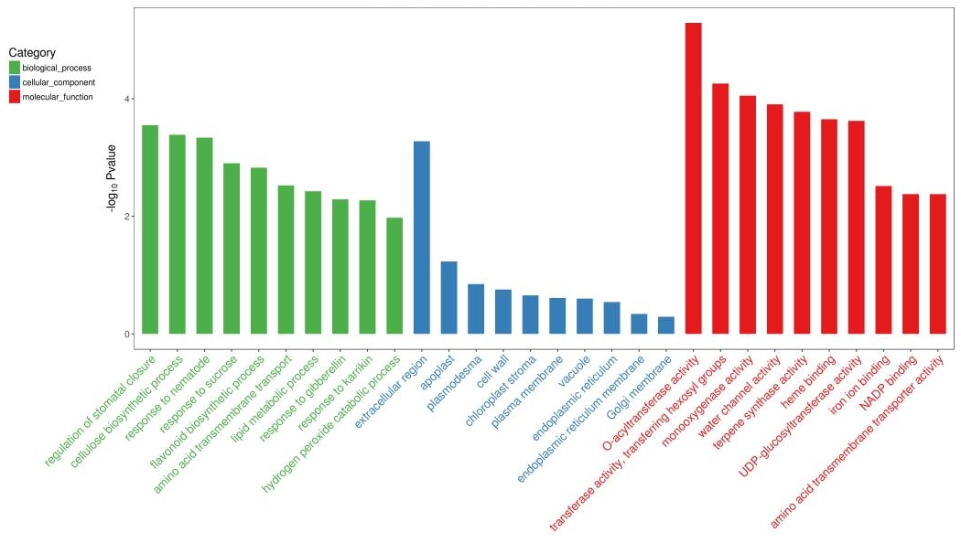
Figure S1 Gene Ontology (GO) analysis of the upregulated differentially expressed genes
Additional file 4: Figure S2 Gene Ontology (GO) analysis of the downregulated differentially expressed genes

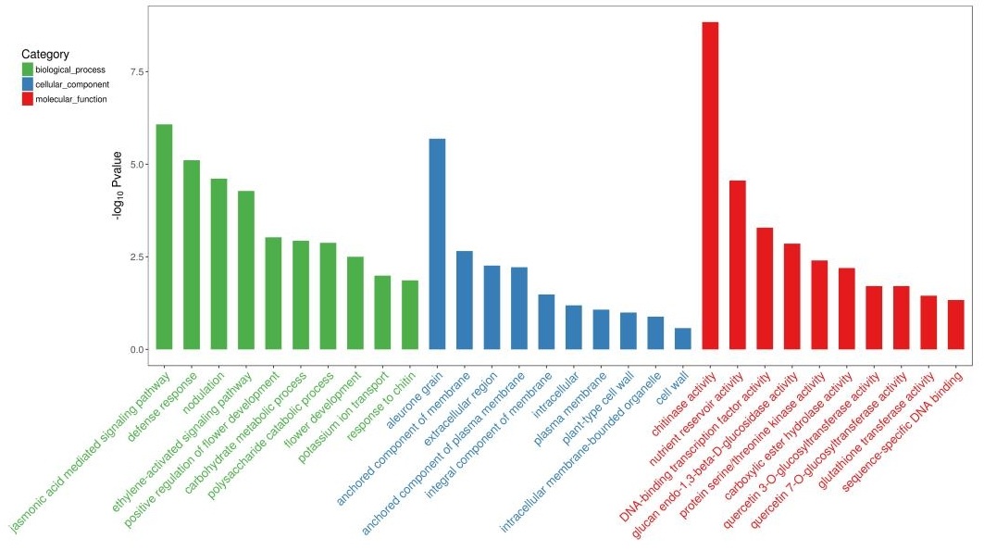

Figure S2 Gene Ontology (GO) analysis of the downregulated differentially expressed genes

