Supplementary Figures:

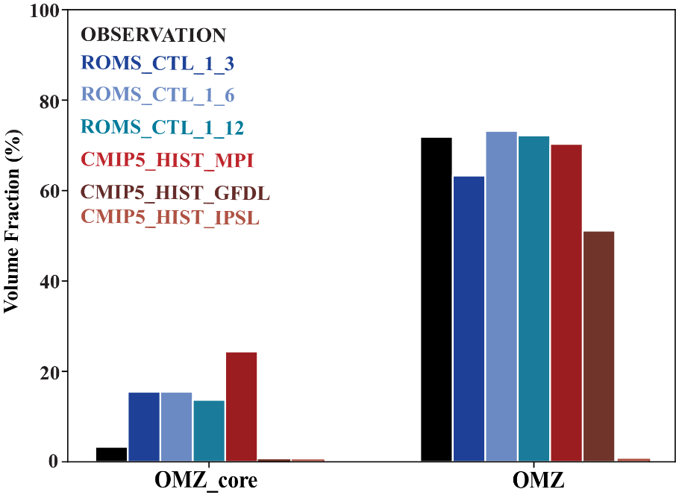

**Figure SI 1.** **Quantitative evaluation of present day OMZ from CMIP5 and ROMS against** **Word Ocean Atlas observations.** Volume fraction occupied by suboxic water masses (OMZ_core, O2 < 4 mol/L) and by hypoxic water masses (OMZ, O2 <60 mol/L) in the 0 – 1000 m top layer of the Arabian Sea, in Word Ocean Atlas observations (WOA 2018, black), in CMIP5 historical simulations (marked as: CMIP5_HIST_MPI, CMIP5_HIST_GFDL, CMIP5_HIST_IPSL), and in the downscalled ROMS present-day simulation at 3 different resolutions (marked as ROMS_CTL_resolution). Note that the only CMIP5 model that simulates OMZ_core waters is the MPI model, and also that the IPSL CMIP5 model does not even simulate OMZ waters.

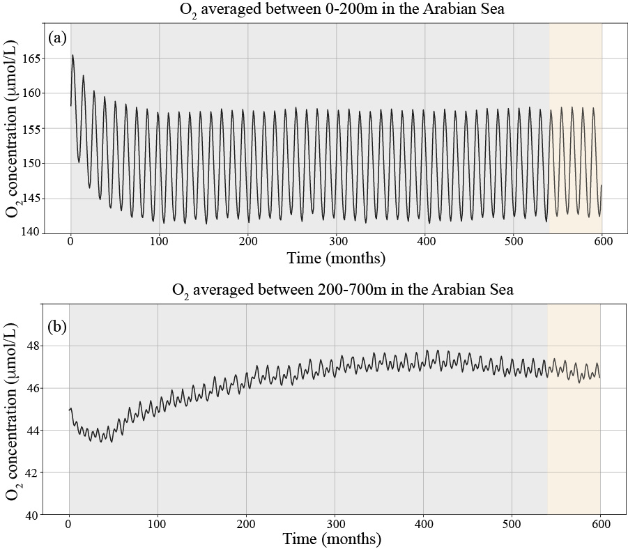

**Fig. SI 2. Temporal evolution of O2:** The O2 simulated from ROMS_CTL averaged over (a) 0-200m and (b) 200-700m layer in the Arabian Sea. The gray shaded region indicates spin-up and yellow shaded the analyzed period respectively.

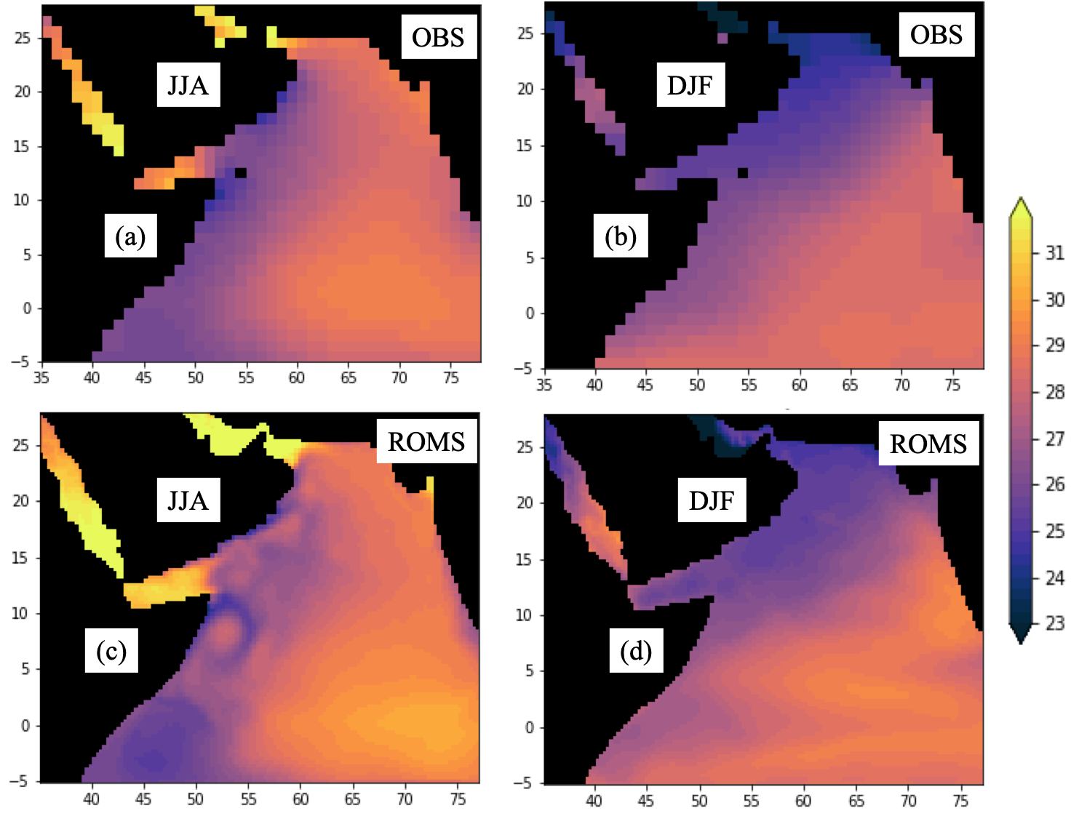

**Figure SI 3**. **Evaluation of seasonal SST from ROMS_CTL.** SST (oC) averaged over summer (JJA) and winter (DJF) seasons from Observation (OBS, WOA2018) and ROMS control experiment.

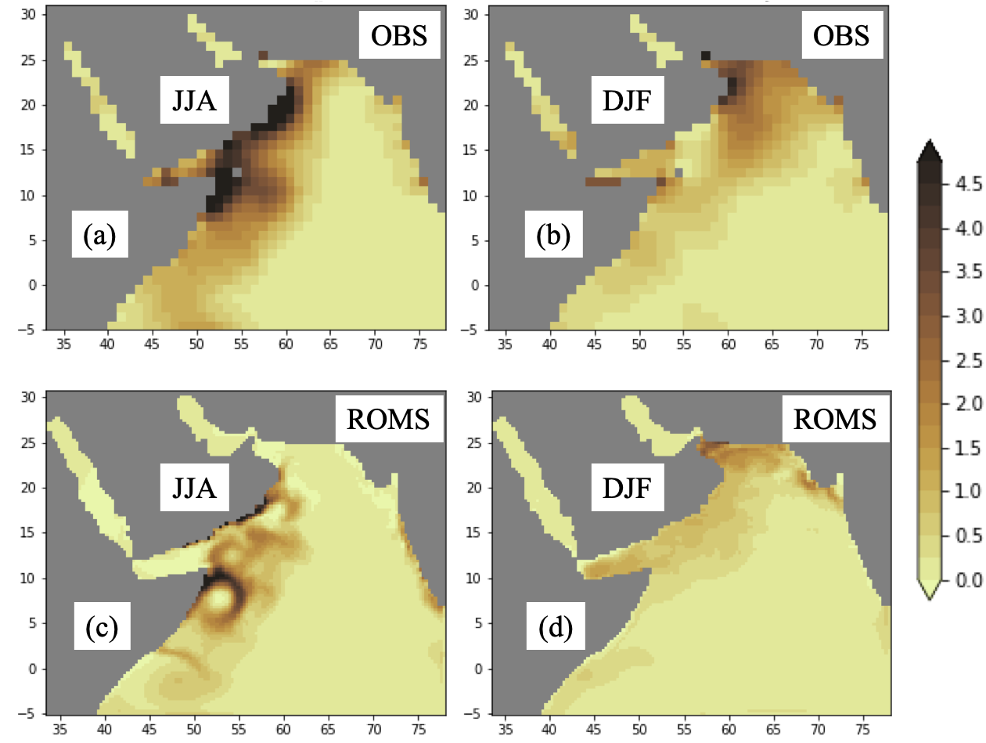

**Figure SI 4**. **Evaluation of seasonal NO3 from ROMS_CTL.** Surface NO3 concentration (mol/L) averaged over summer (JJA) and winter (DJF) seasons from Observation (OBS, WOA2018) and ROMS control experiment.

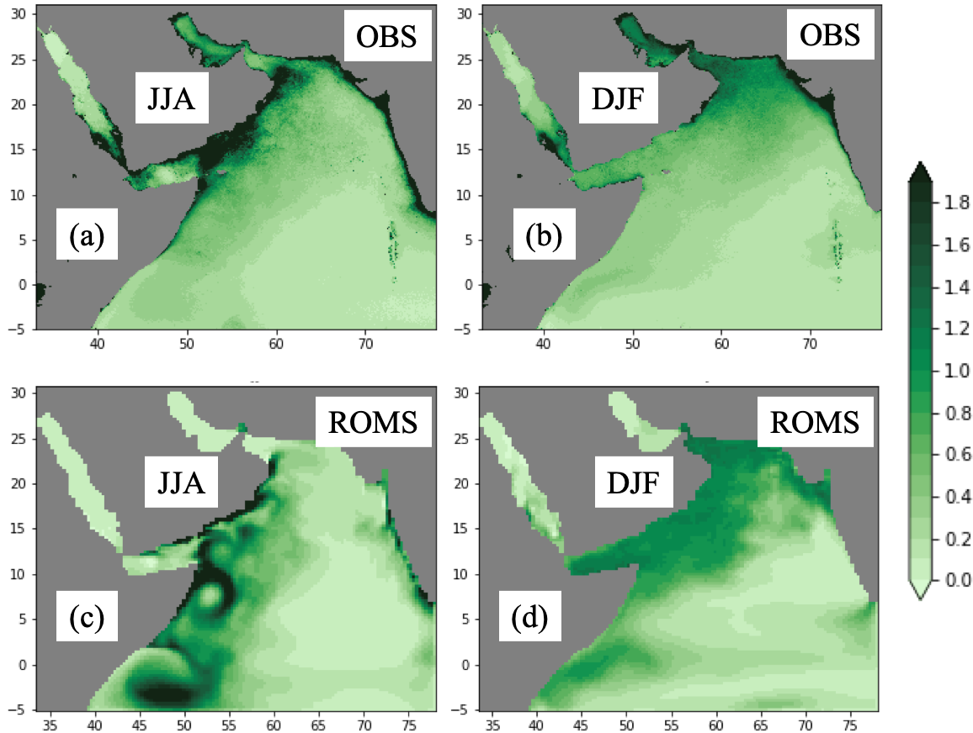

**Figure SI 5**. **Evaluation of seasonal surface chlorophyll from ROMS_CTL**. Surface Chlorophyll (mg/L) averaged over summer (JJA) and winter (DJF) seasons from Observation (OBS, ESA chlorophyll) and ROMS control.

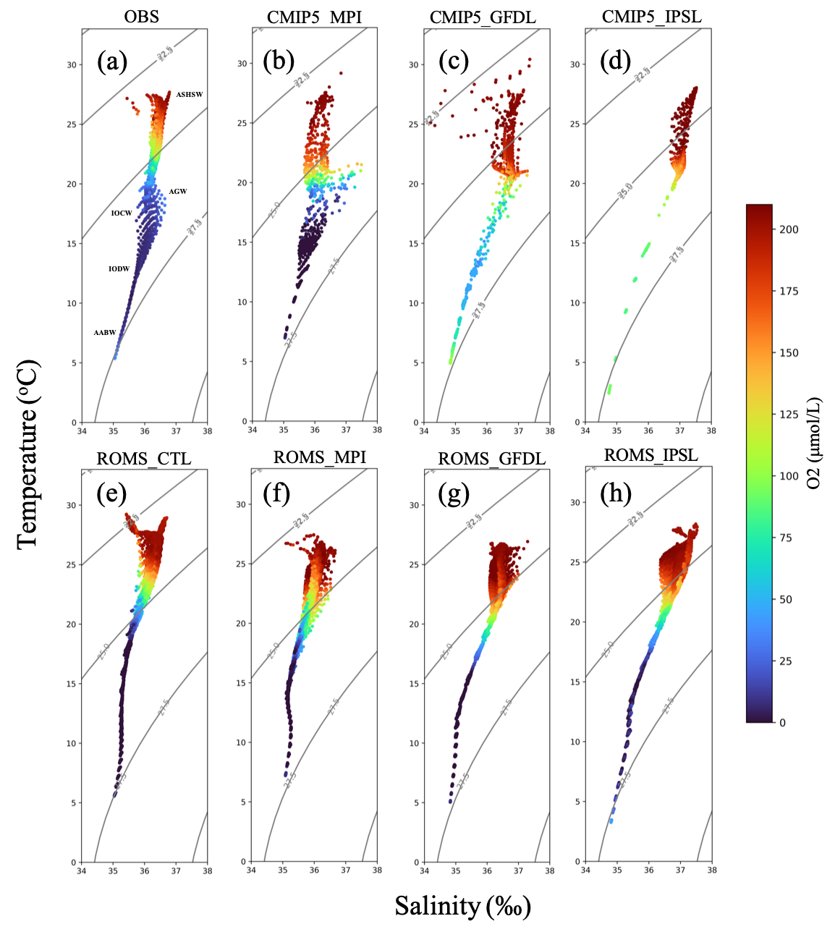

**Figure SI 6**. **Evaluation of main water masses in the models.** The T_S (with O2 concentration) diagram at northern Arabian Sea (north of 20o N) from Observation, CMIP5_HIST, ROMS_CTL, ROMS_DD_HIST. The main water masses in the Arabian Sea are marked on panel (a)

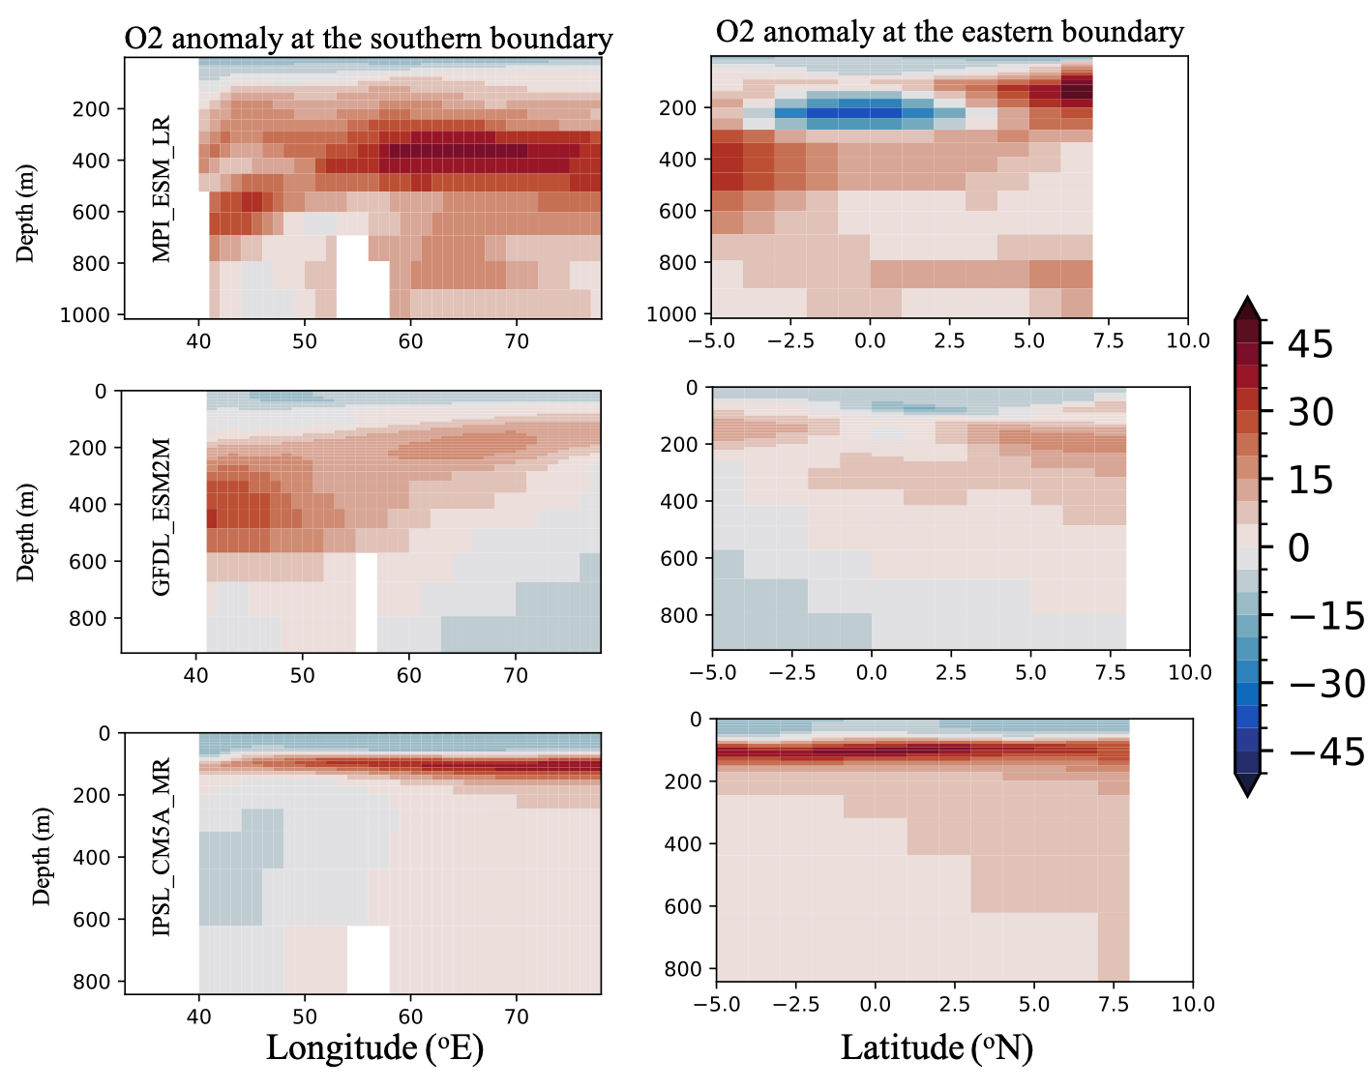

**Figure SI 7**. **Climate change anomalies added at the lateral boundaries.** The O2 (mol/L) annual anomalies at the southern and eastern boundaries from 3 CMIP5 models.

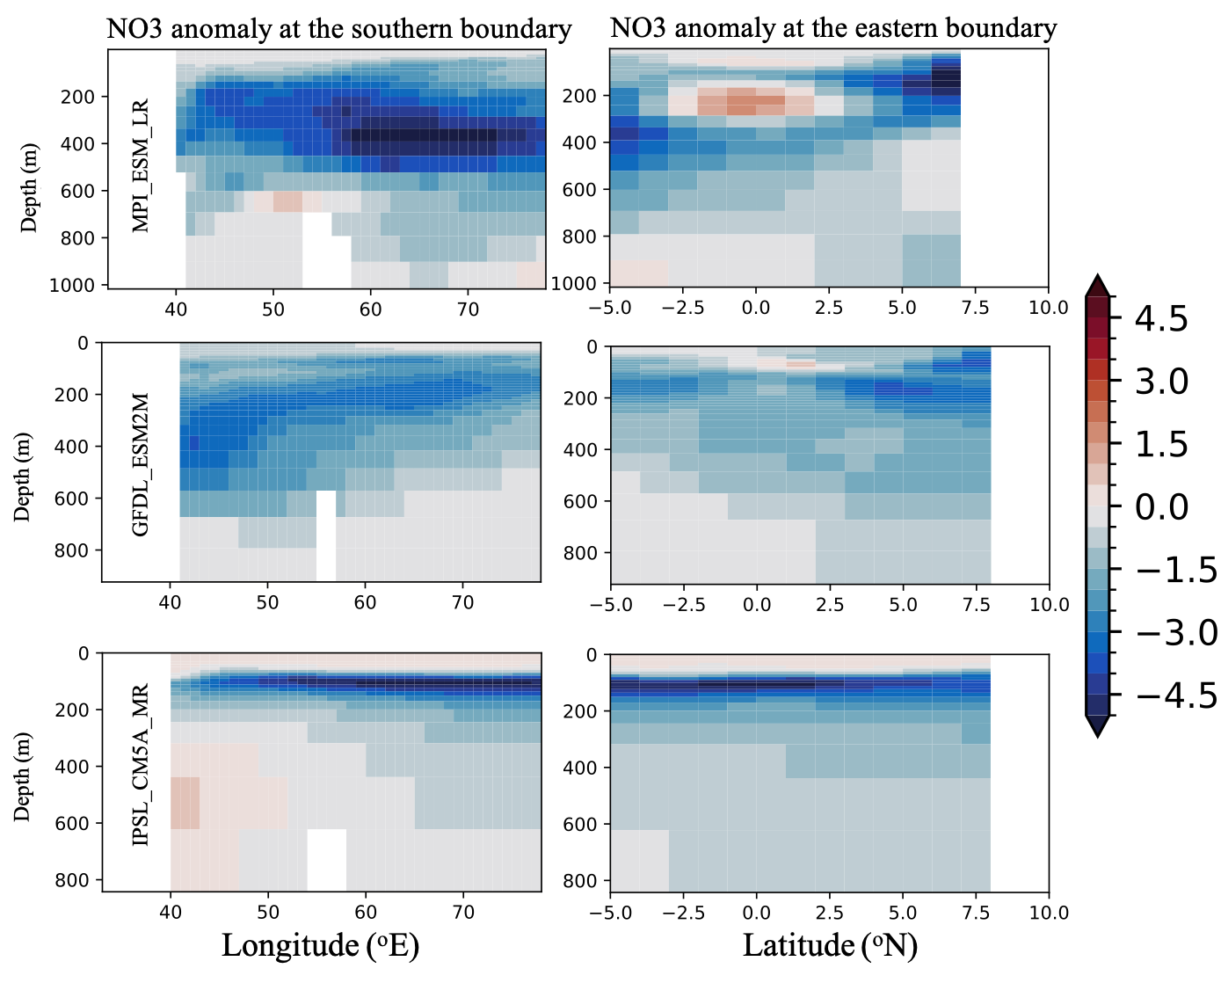

**Figure SI 8**. **Climate change anomalies added at the lateral boundaries.** The NO3 (mol/L) annual anomalies at the southern and eastern boundaries from 3 CMIP5 models.